Seismometer Cable and Box
To connect the 14-pin output of the Titan Accelerometer you would either have to buy the proprietary cable with it's connectors and analyzer from Nanometrics or use the box and cable described here.

Schematics Used
Titan User Guide [Page 51 is important]

Box
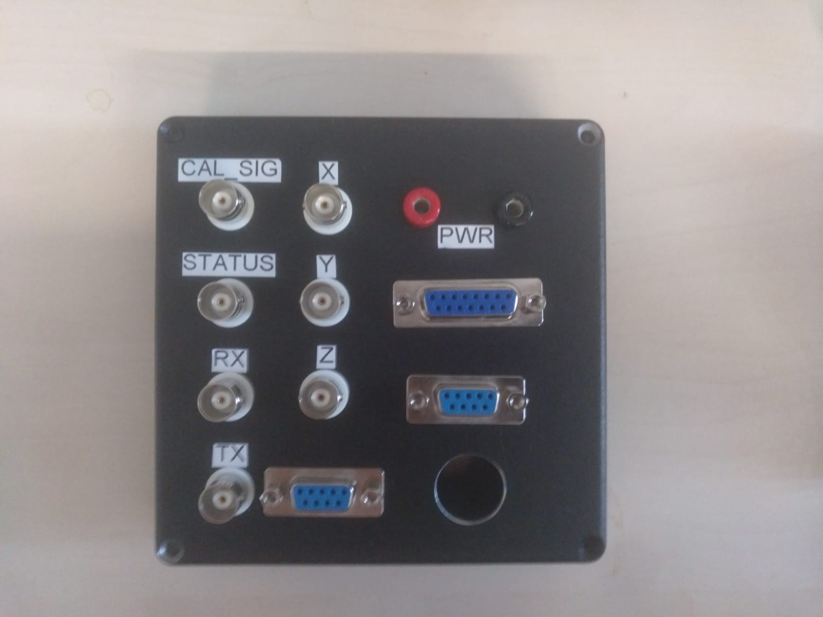 IO
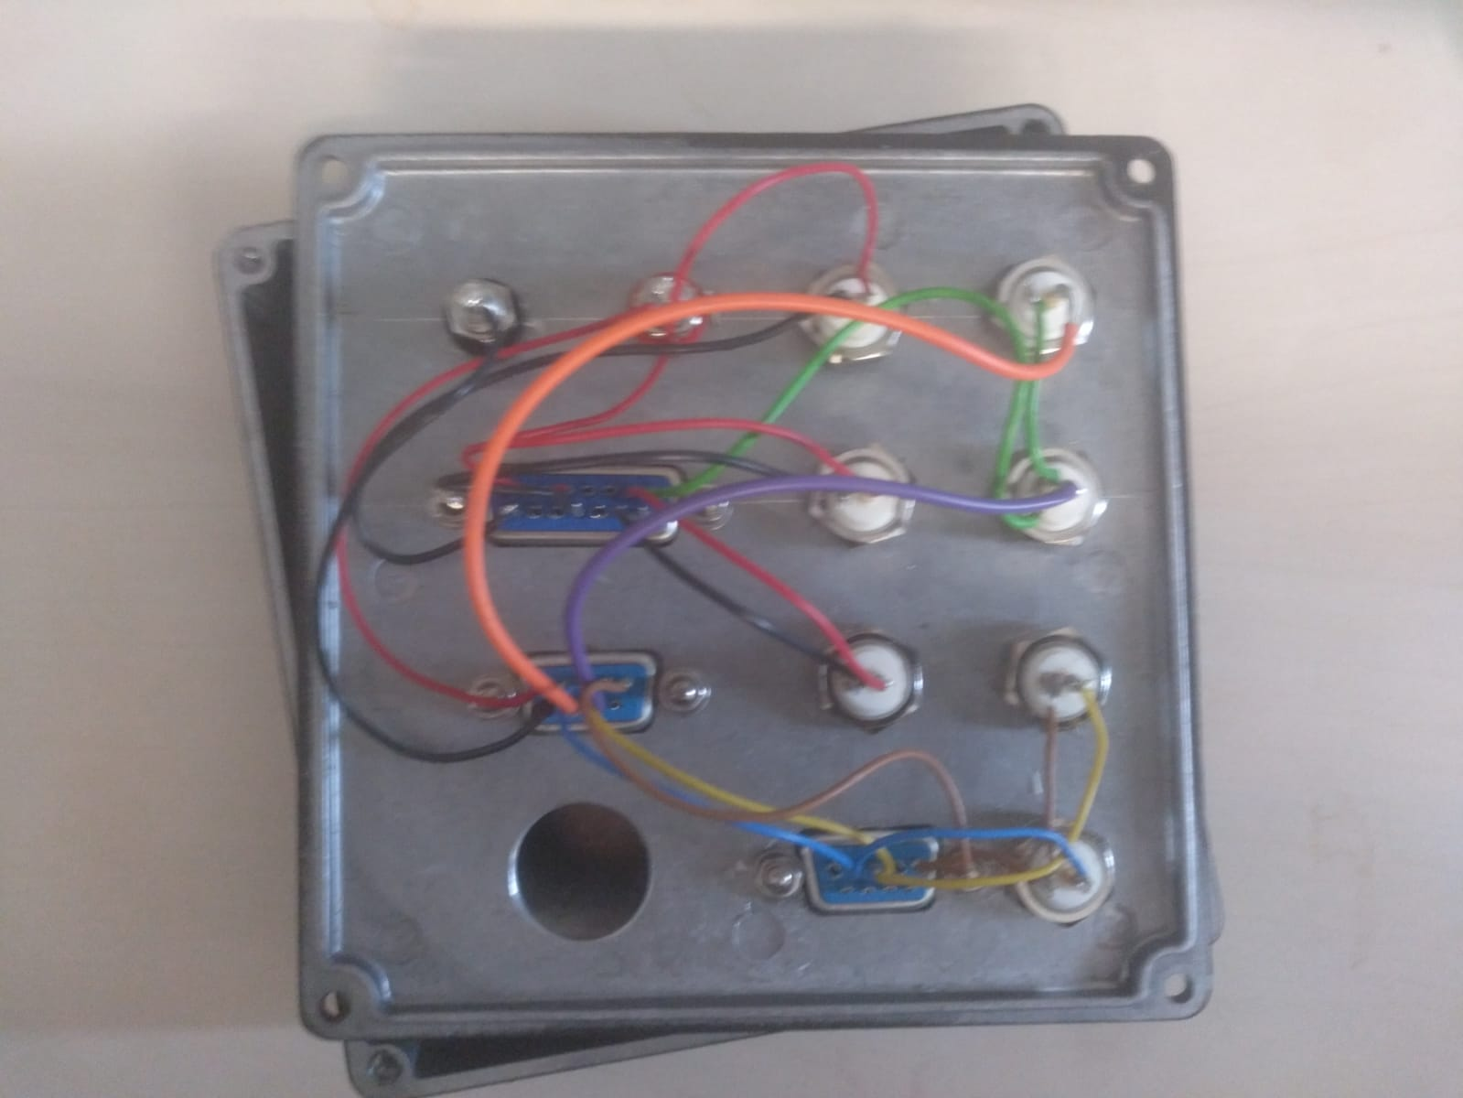 Inside

SubD-9 and SubD-15 Link
The two cables coming from the seismometer have to be plugged into the corresponding [XYZ Connect] and [Signal Connect].
Do not plug the SubD-9 [Signal Connect] cable into the other SubD-9 connector; else ±PWR, CAL_SIG and STATUS won't be passed to the seismometer or back to the box.
You will risk destroying your computer (or any other device) if you connect your device via SubD-9 cable directly to SubD-9 [Signal Connect]!

BNC
The BNC connectors are directly chained to the corresponding output pins of the connected seismometer. Here is a detailed layout for that:
Description | CAL_SIG | STATUS | RX | TX | X | Y | Z
Inner Connector | CAL_SIG | STATUS | RX | TX | +X | +Y | +Z
Outer Ring | AGND | AGND | DGND | DGND | -X | -Y | -Z

PWR
PWR marks the power input. You plug the positive pin into the red connector and the negative one into the black one.
The seismometer needs a voltage from 9V ~ 36V DC isolated. A maximum current load of about 100mA [?] is allowed.

Cable
For the connecting cable between the 14-pin connector and the box we used a CAT network-cable (orange) connected via SubD-15 and a standardized SubD-9 cable (grey) with it's connector. The wires are split up into two different cables to ensure that the X-, Y- and Z-axis signals are completely shielded, hence the CAT network-cable. The analog ground signal is also fed through the shielded network cable. All the other wires go through the SubD-9 cable.

14-Pin Side
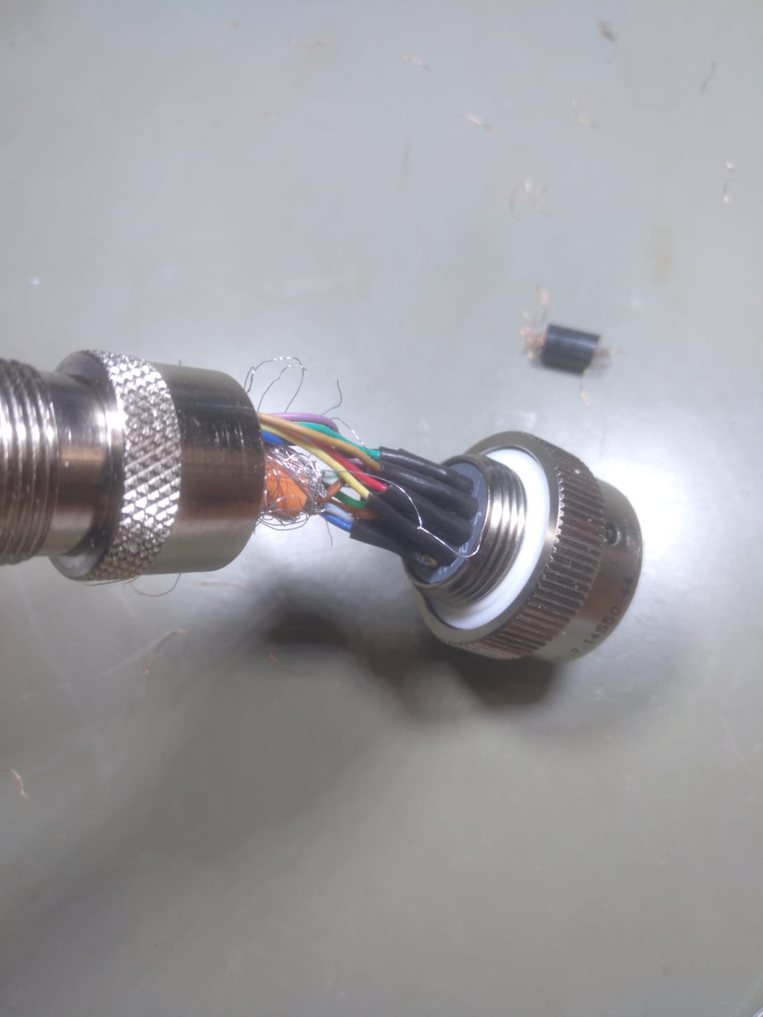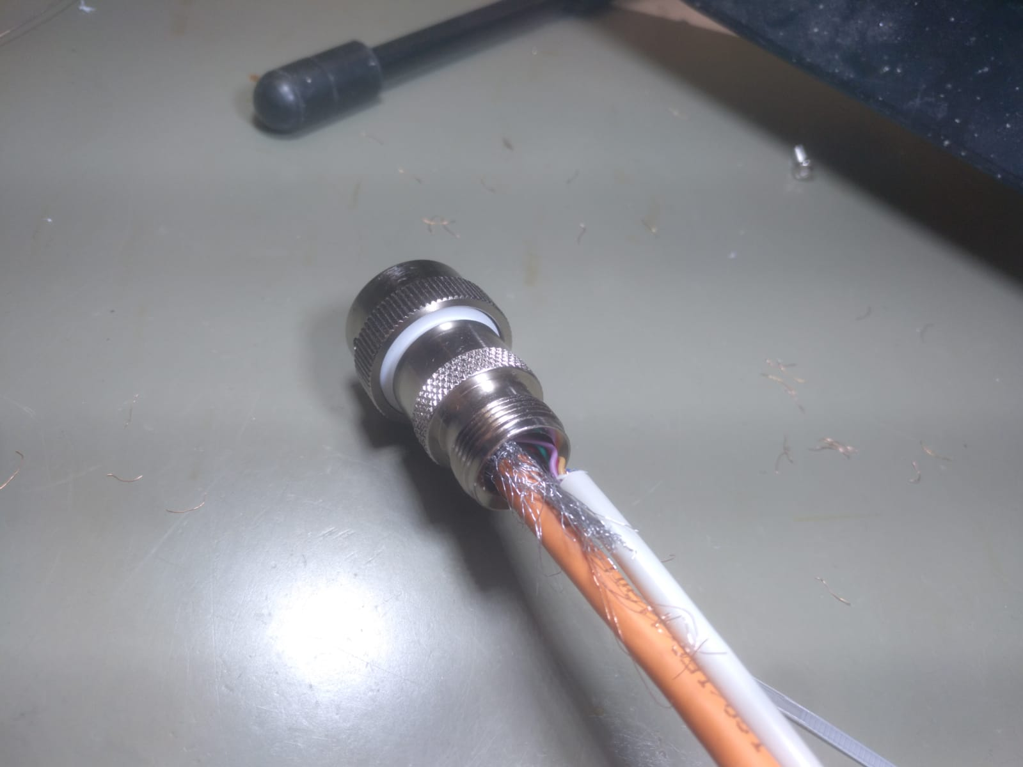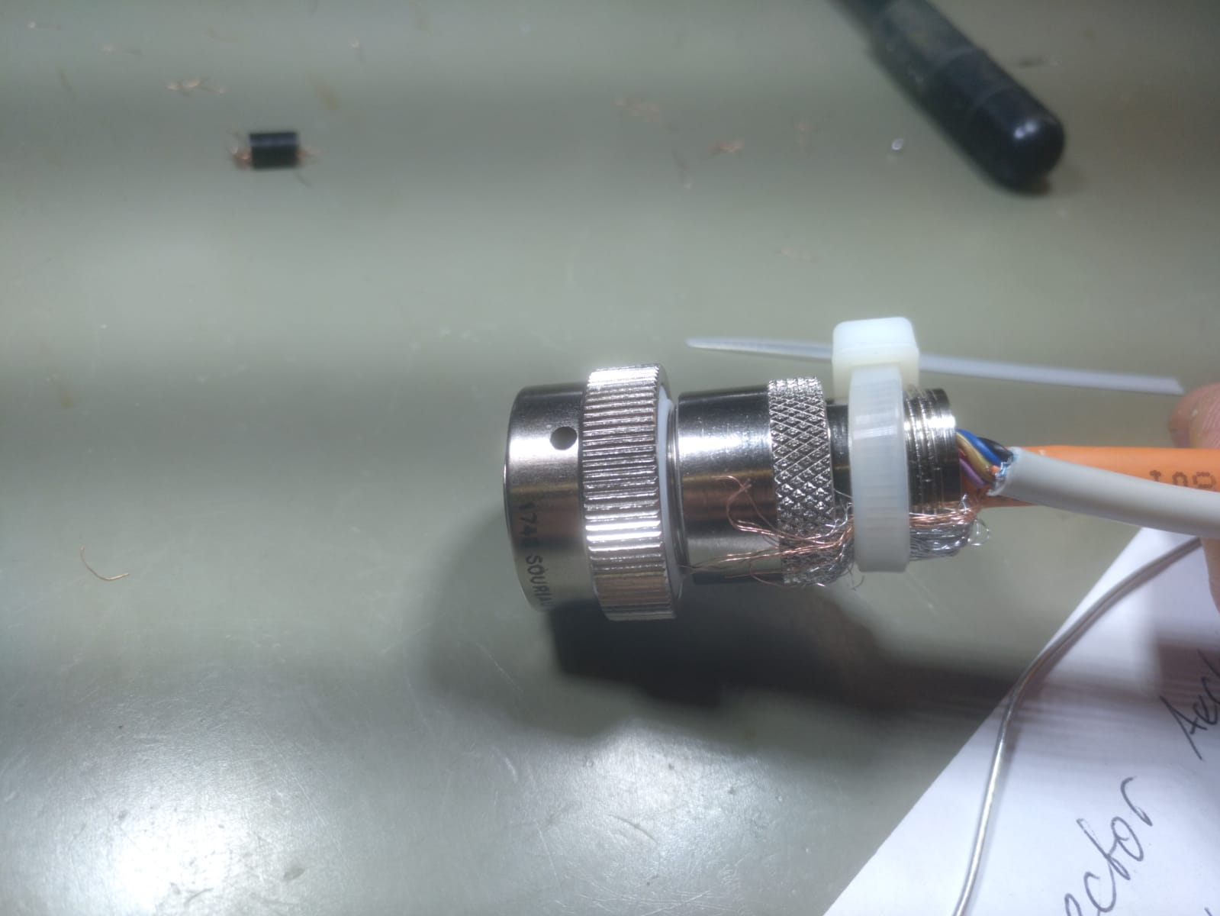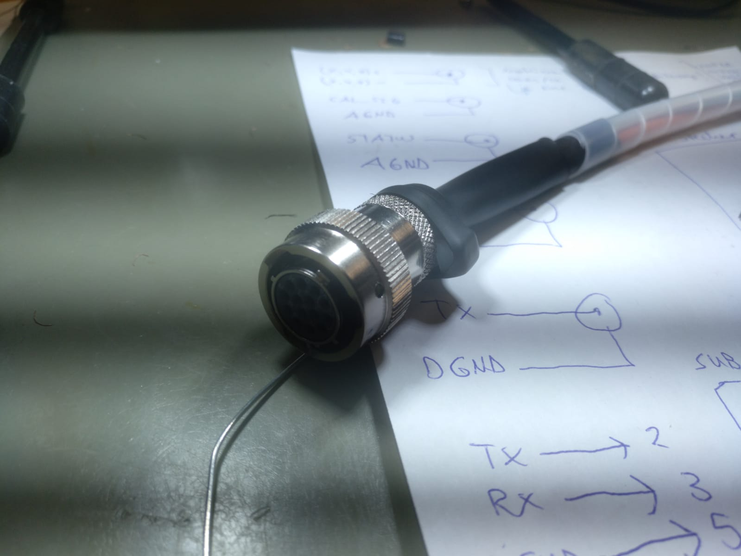

SubD-15 Side - XYZ Connect
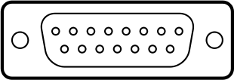
Pin No. | 1 | 2 | 3 | 4 | 5 | 6 | 7 | 8 | 9 | 10 | 11 | 12 | 13 | 14 | 15
Name | +X | free | free | +Y | free | free | +Z | AGND | -X | free | free | -Y | free | free | -Z
Function | positive X axis output | none | none | positive Y axis output | none | none | positive Z axis output | analog ground | negative X axis output | none | none | negative Y axis output | none | none | negative Z axis output
Color | blue | none | none | orange | none | none | green | brown | white with blue stripe | none | none | white with orange stripe | none | none | white with green stripe

SubD-9 Side - Signal Connect
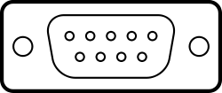
Pin No. | 1 | 2 | 3 | 4 | 5 | 6 | 7 | 8 | 9
Name | +PWR | TX | RX | free | DGND | -PWR | CAL_SIG | STATUS | free
Function | positve power input | serial RS-232 transmit | serial RS-232 receive input | none | digital ground | negative power in | calibration signal input | state-of-health output | none
Color | black | brown | red | none | yellow | green | blue | purple | none

