Photodiode Étienne
These photodiodes were developed by Étienne in cooperation with the AEI and altered to peak at about 16.2MHz.

Schematics Used
- Schematic
- Interactive Schematic
- HAMAMATSU S5971: Photodiode @ 960NM, 100MHz

Notable Changes Made
To achieve a peak at around 16.2MHz, components had to be changed.
Changed components:
 | Schematic Component | Used Component
L1 | 6u8 | 6u8
C3 | 6p | 2 x 4.7p
R2 | 40.2R | 40.2R
 | Changed only for the 3rd and 4th build
U5 | AD587 | LT1236A-10
C19 | 1u | none
- For Coil L1 the part 1812CS-682XJLC (or at least a part with the same form factor) has to be used
- C3 influences at which frequency the peak will be
- Instead of the AD587, LT1236A-10 can be used
  - When doing this, the C19 component must not be soldered.
  - C19 connects pin 8 of U5 to ground. Pin 8 is not in use in LT1236A-10.

Using The Photodiode
- The photodiode requires a power input of +/- 15V
- AC Output: right SMA connector
- DC Output: left SMA connector
- When using a spectrum-analyzer (e.g. RIGOL DSA815) in combination with the ROHDE&SCHWARZ signal-generator, a 50Ω terminator must be used, too
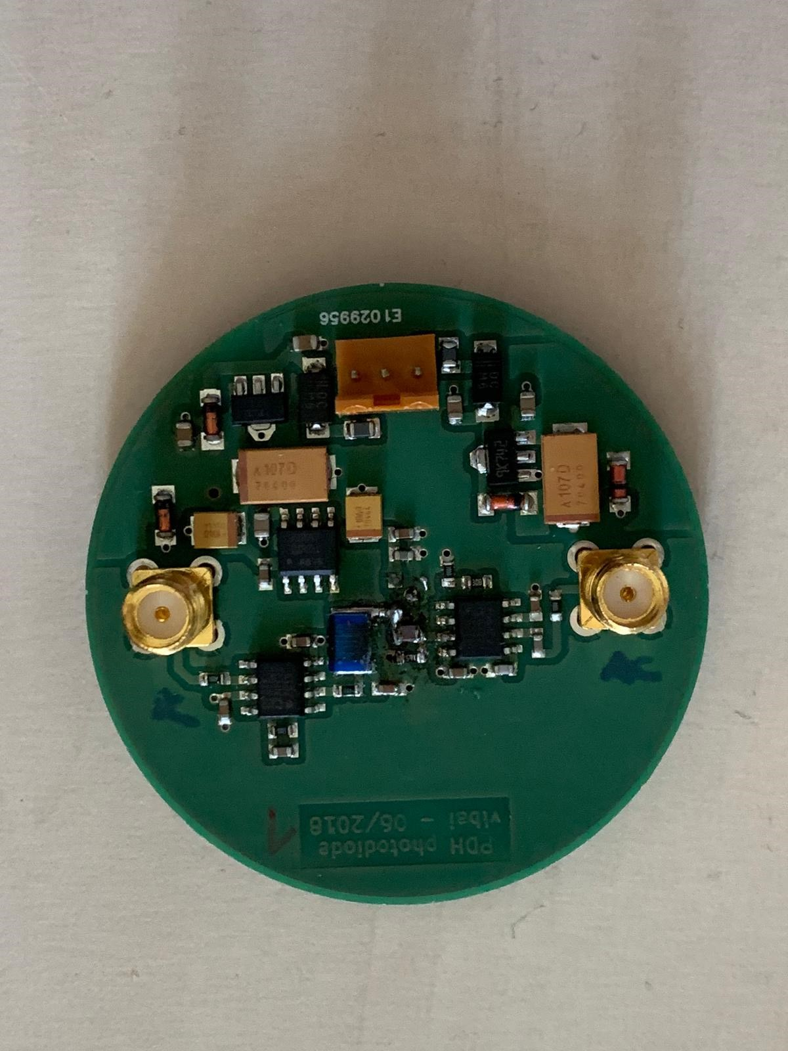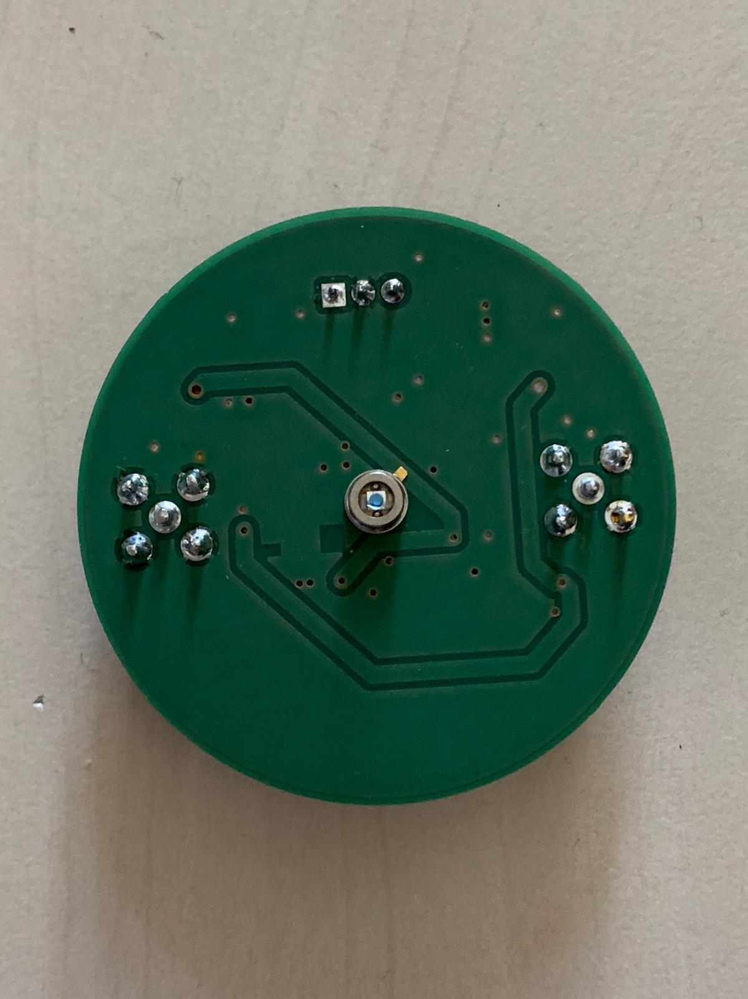

Measured Data
The traces of the amplitude and phase were measured.
- A RIGOL Network Analyzer was used to gather that data from the AC output
- A 9V test-laser with a modulation of -10dB @ 100MHz was used in this experimental setup
- The traces of the diodes were fitted in Python

The results:
Diode | Resonance frequency [MHz] | Peak to 15MHz Ratio [dB] | P14R [dB] | P17R [dB] | P18R [dB] | FWHM with Gauß-Fit [kHz] | Phase #1 | Comment
1 | 16.11 [+/- 0.015] | 8.65 | 13.71 | 6.99 | 12.44 | 271.75
2 | 16.14 [+/- 0.01] | 8.92 | 13.46 | 6.53 | 11.34 | 270.98
3 | 16.13 [+/- 0.01] | 9.17 | 14.75 | 6.66 | 12.13 | 271.45
4 | 16.16 [+/- 0.01] | 9.39 | 14.81 | 6.5 | 12.09 | 269.72
#1 Was bedeutet P17 etc? #2 Peak to 17MHz Ratio [Name sollte besser noch geändert werden]
- X = MAx dazu Y Wert = Peak hight over ..
- Es feht der Fehler von der Linienbreite und des Max Peaks
- Höhe des Resonanz-Peaks über Rauschen
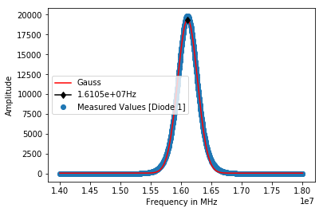FWHM [Diode 1]: 271750.86662876786Hz
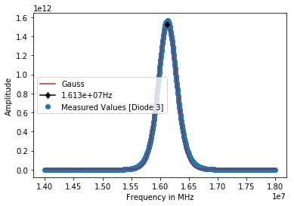FWHM [Diode 3]: 271450.8282159102Hz
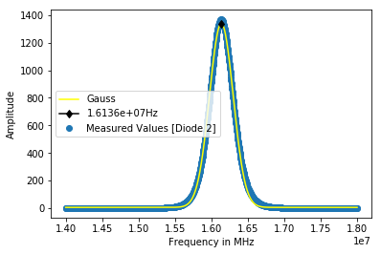FWHM [Diode 2]: 270984.2391765082Hz
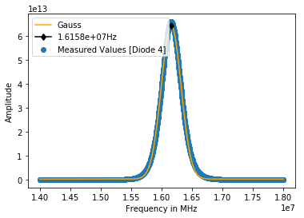FWHM [Diode 4]: 269724.22527546244Hz

Wechselwirkung (WW) EOM und PD Nr.4
Spektrometer Rhode&Schwarz RBW: 100Hz VBW: 10Hz SWT: 30s Ref: 0dBm Att: 10dB


