Magnesium
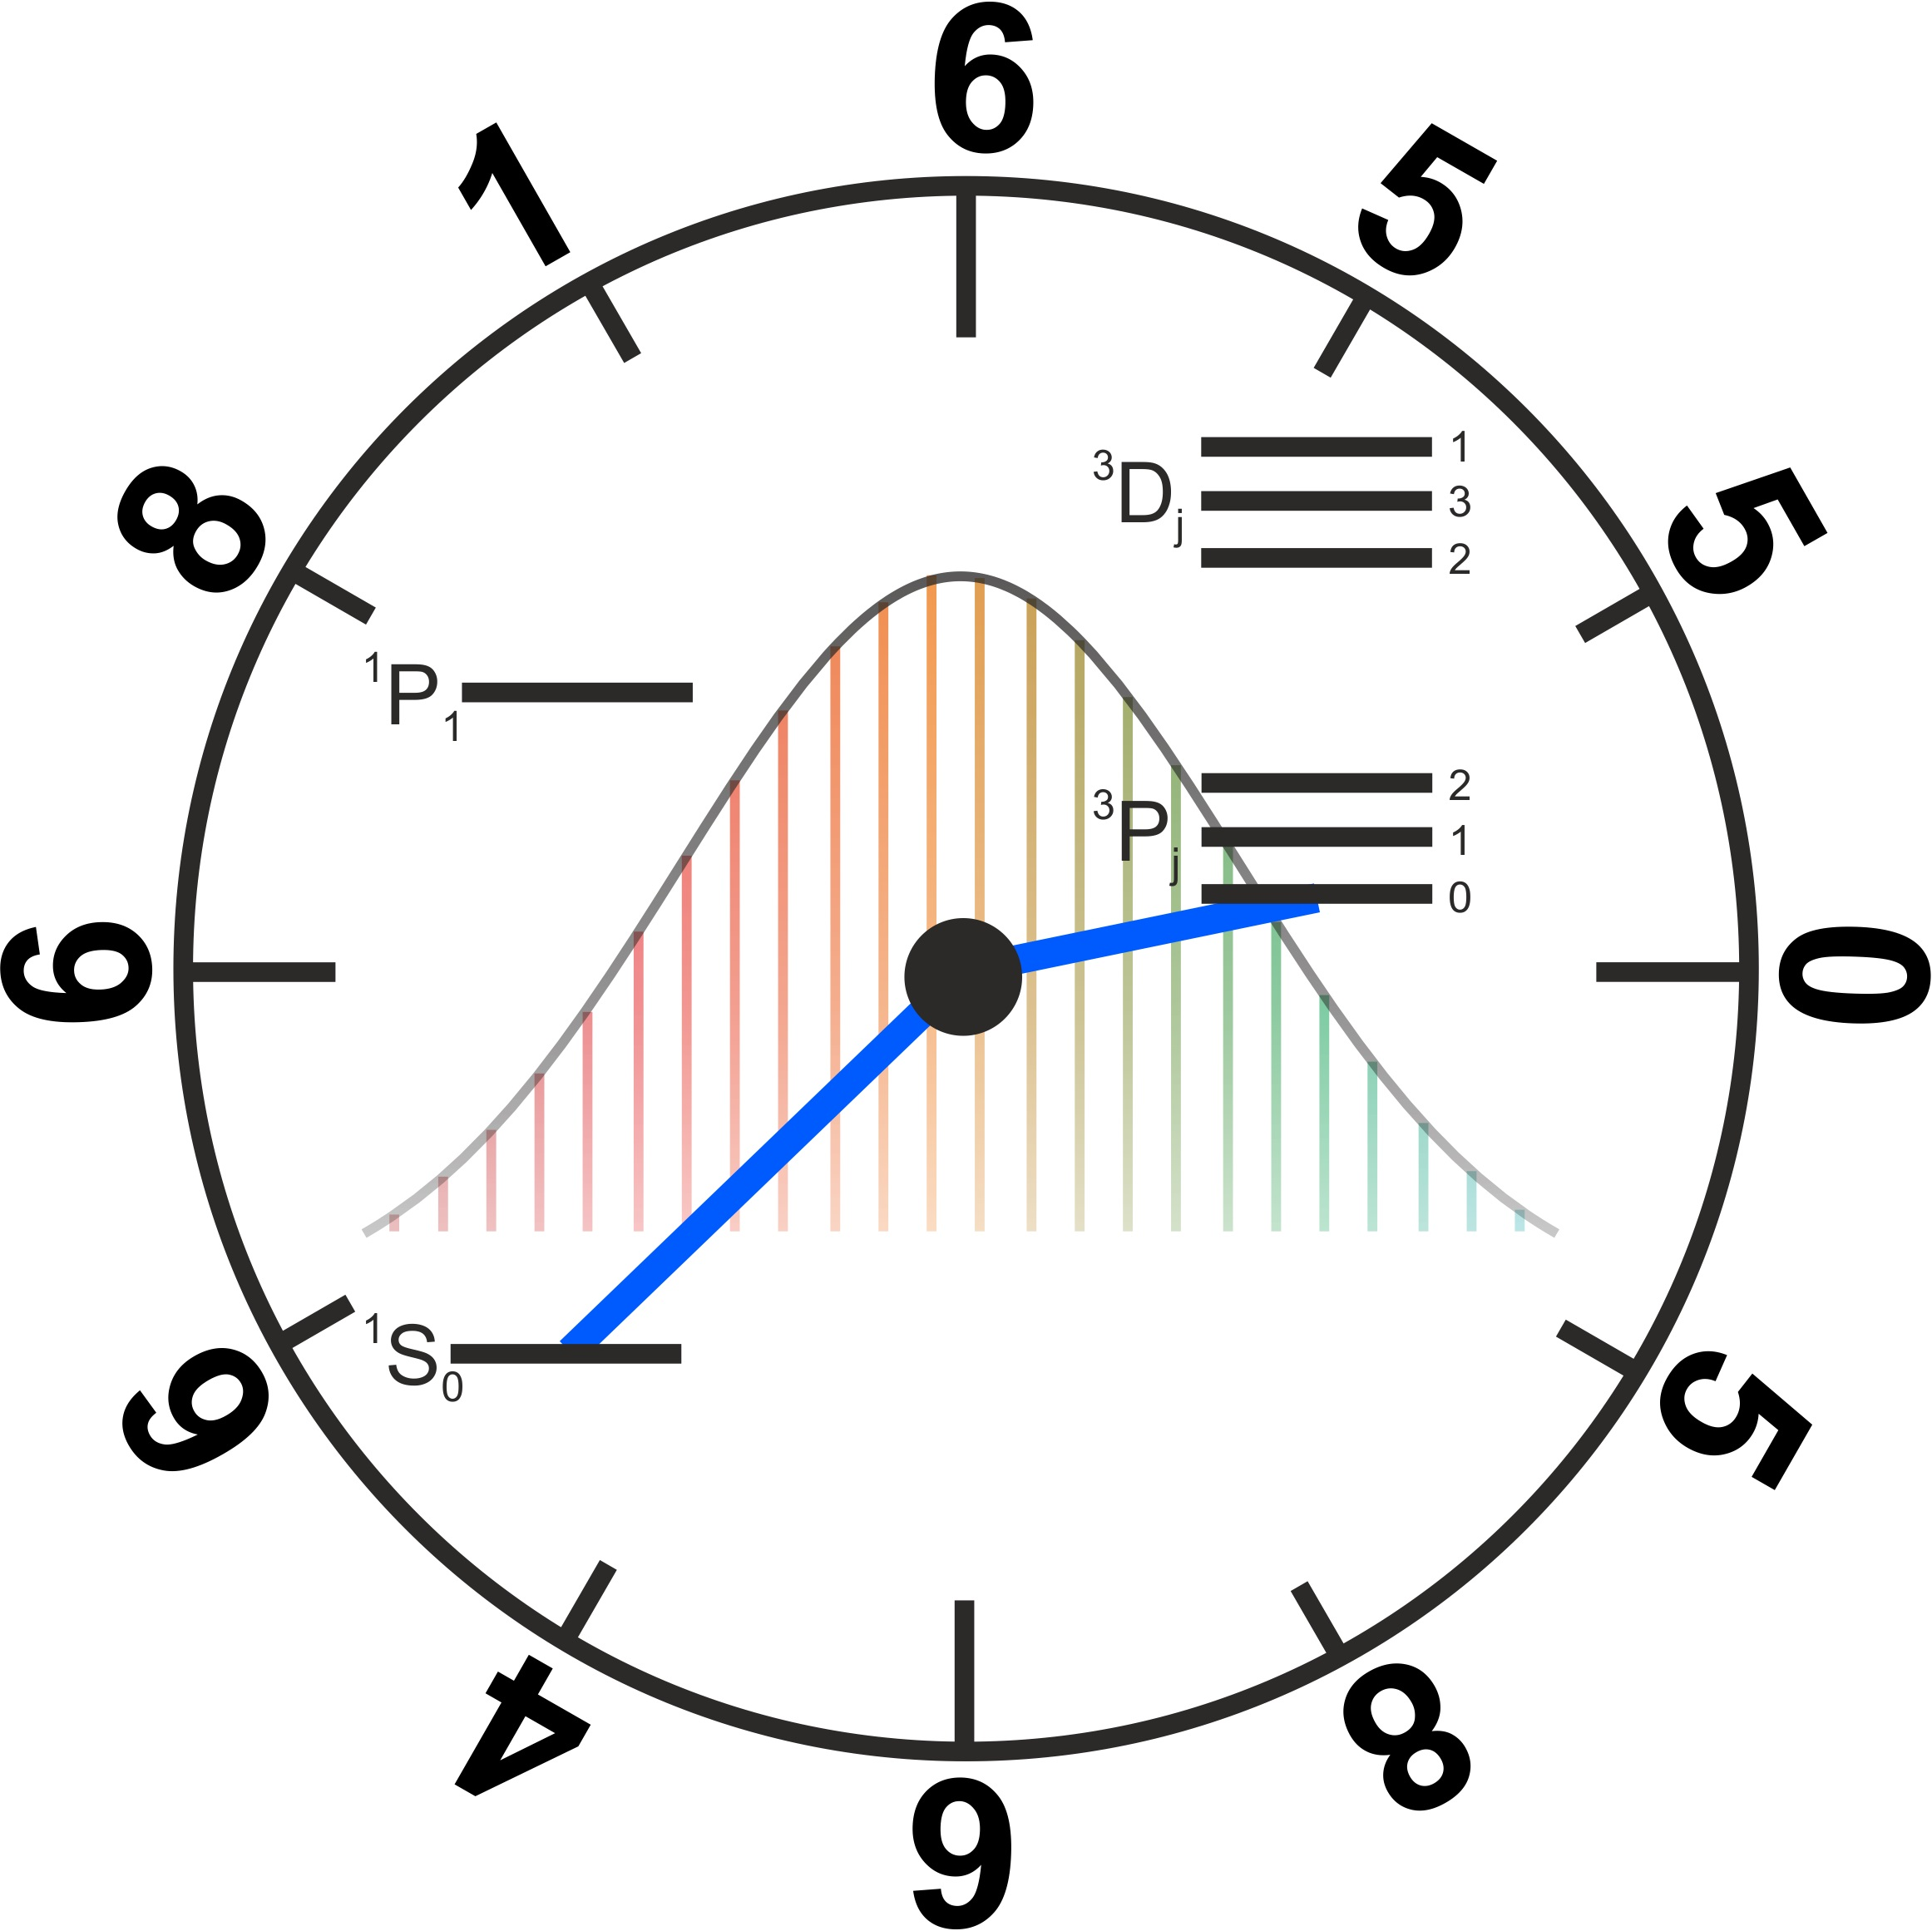
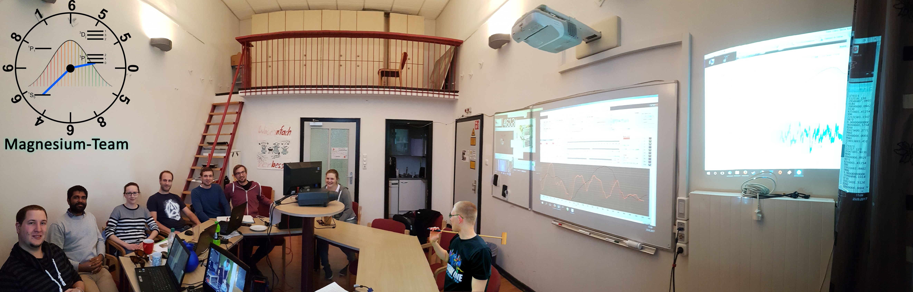

Group Members
Name | Email | Birthday
Dominika Fim | fim@iqo.uni-hannover.de | 26.10
Ernst M. Rasel | rasel@iqo.uni-hannover.de | 02.02
Klaus Zipfel | zipfel@iqo.uni-hannover.de | 24.08
Nandan Jha | jha@iqo.uni-hannover.de | 29.11
Josephine Wolf | wolf@iqo.uni-hannover.de | 15.08
Philipp Gehrke | gehrke@iqo.uni-hannover.com | 29.07
Steffen Sauer | sauer@iqo.uni-hannover.de | 26.01
Waldemar Friesen-Piepenbrink | friesen@iqo.uni-hannover.de | 20.04
Fiene Weber | f.weber@iqo.uni-hannover.de | 10.09

Former Group Members
Name | Email | Birthday
Steffen Rühmann | ruehmann@iqo.uni-hannover.de | 10.08
Nephtali Garrido | nephtali.garrido-gonzalez@nottingham.ac.uk
Pia Koopmann | koopmann@iqo.uni-hannover.de | 14.09
Rasmus Holst | holst@iqo.uni-hannover.de | 19.08
Lukas Köpp | koepp@iqo.uni-hannover.de | 23.12

AtomLab
- AtomLab Devices and Data sheets

ResLab
- ResLab (Public Area)
- ResLab (Private Area)
- Project PTB-Cavity

FWJ
- FWJ Tasks & Status

Frequency measurement
- Necessary things to do until the frequency measurement
- Notes/Informations

Paper
- Current papers from arxiv:
  - Structured squeezed light allows for high-harmonic generation in classical forbidden geometries
  - Quantum coarsening and collective dynamics on a programmable simulator
  - Stable singular fractional skyrmion spin texture from the quantum Kelvin-Helmholtz instability
  - Phase-locked amplification enhanced by spin squeezing
  - A Liquid-Nitrogen-Cooled Ca+ Ion Optical Clock with a Systematic Uncertainty of 4.6E-19
  - 88Sr+ ion trap apparatus for generating 408 nm photons
  - Sub-Doppler cooling of bosonic strontium in a two-color MOT
  - Measurement of the Differential Static Scalar Polarizability of the $^\mathbf{88}$Sr$^{+}$ Clock Transition
- Recent interesting papers
- Other clocks Status, results and important values of other clock experiments
- Magnesium paper
- List of Doctor/Master/Diplom/Bachelor-Thesis from Magnesium
- Printed Thesis that are in the cabinet

Useful informations
- Tips and tricks for working in the Lab …how to….
- Protocols (**DEPRECATED**) Summary of the meetings (→ Moved to Internal Area)
- Phone List Phone List of partners
- Mg Members Current and former Mg Members
- New designs for Laser and Lasersystems : Whats should be implemented in new designs
- New by Mg Informations for new members
- List of the university management: https://www.intern.uni-hannover.de/fileadmin/luh/content/dezernat1_intern/GVP/Telefonliste_kurz_Nachnamen.pdf
- Technology for Denmark Technology List for Denmark
- Calendar Magnesium Kalender like holidays, meetings with Ernst and so on…
- Good Scientific Practice Information about “Good-Scientific-Practice”
- Shopping Wish List Wish list for things we would like to buy in case there are funds available
- Talks A summary about talk which has been given

Mensa
- Freitag 04.07.2025
Internal area (not accessible to non-members of the LDAP group mg)

