Virtual Beat Measurement

Theory
Equations: 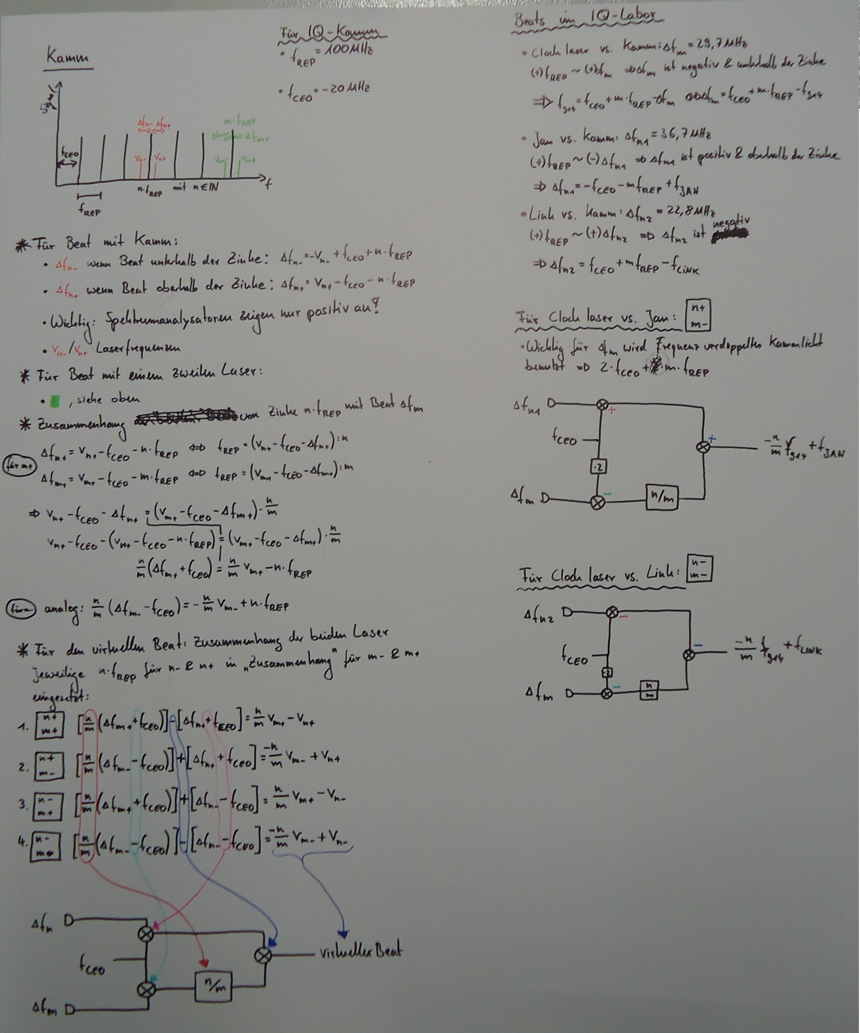
- For Total Virtual Beat double f_CEO
- Compare to Postprocessing Virtual Beat Measurement!
Scheme from:Kerr-lens mode-locked lasers as transfer oscillators for optical frequency measurements, H. R. Telle et al., arXiv:physics/0107037v1 [physics.optics] (2001)
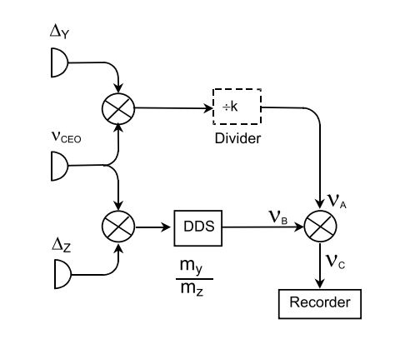

Frequencies
- Jan's Laser = 194.401.549 MHz (fine with Protocolbook 194.401.556 MHz).
- 916nm clock laser: 327.5291 THz (accuracy maybe worse than 100 MHz)
Measured with wavemeter in PTB (accuracy: +-30 MHz):
- 194.400.001 MHz Laser
- -47 MHz Regel-AOM
- +36 MHz Manypoint-extraktion-AOM
→ 194.399.990 MHz
Jan's transportable laser has a higher frequency:
- Mixer in Hannover run with +1515 MHz
- Beat is +44 MHz
- Jan's Laser = 194.401.549 MHz (fine with Protocolbook 194.401.556 MHz)

DDS-Programming
- → ratio of ~ 1,684807
- → 474231011086950,203392
- [Hex]: 1AF4F82F51266
- → Inverted Ratio: 0,5935397770762964267907798116259
- 0,5935397770762964267907798116259 * 2^48 = 167066594929398,49071775301797611
- 167066594929398 [Deg] entspricht 97F2390B6AF6 [Hex]
→ Type 97F2390B6AF6 into the divider!!!

Setup for measurements

Jan´s laser vs. Comb Hannover
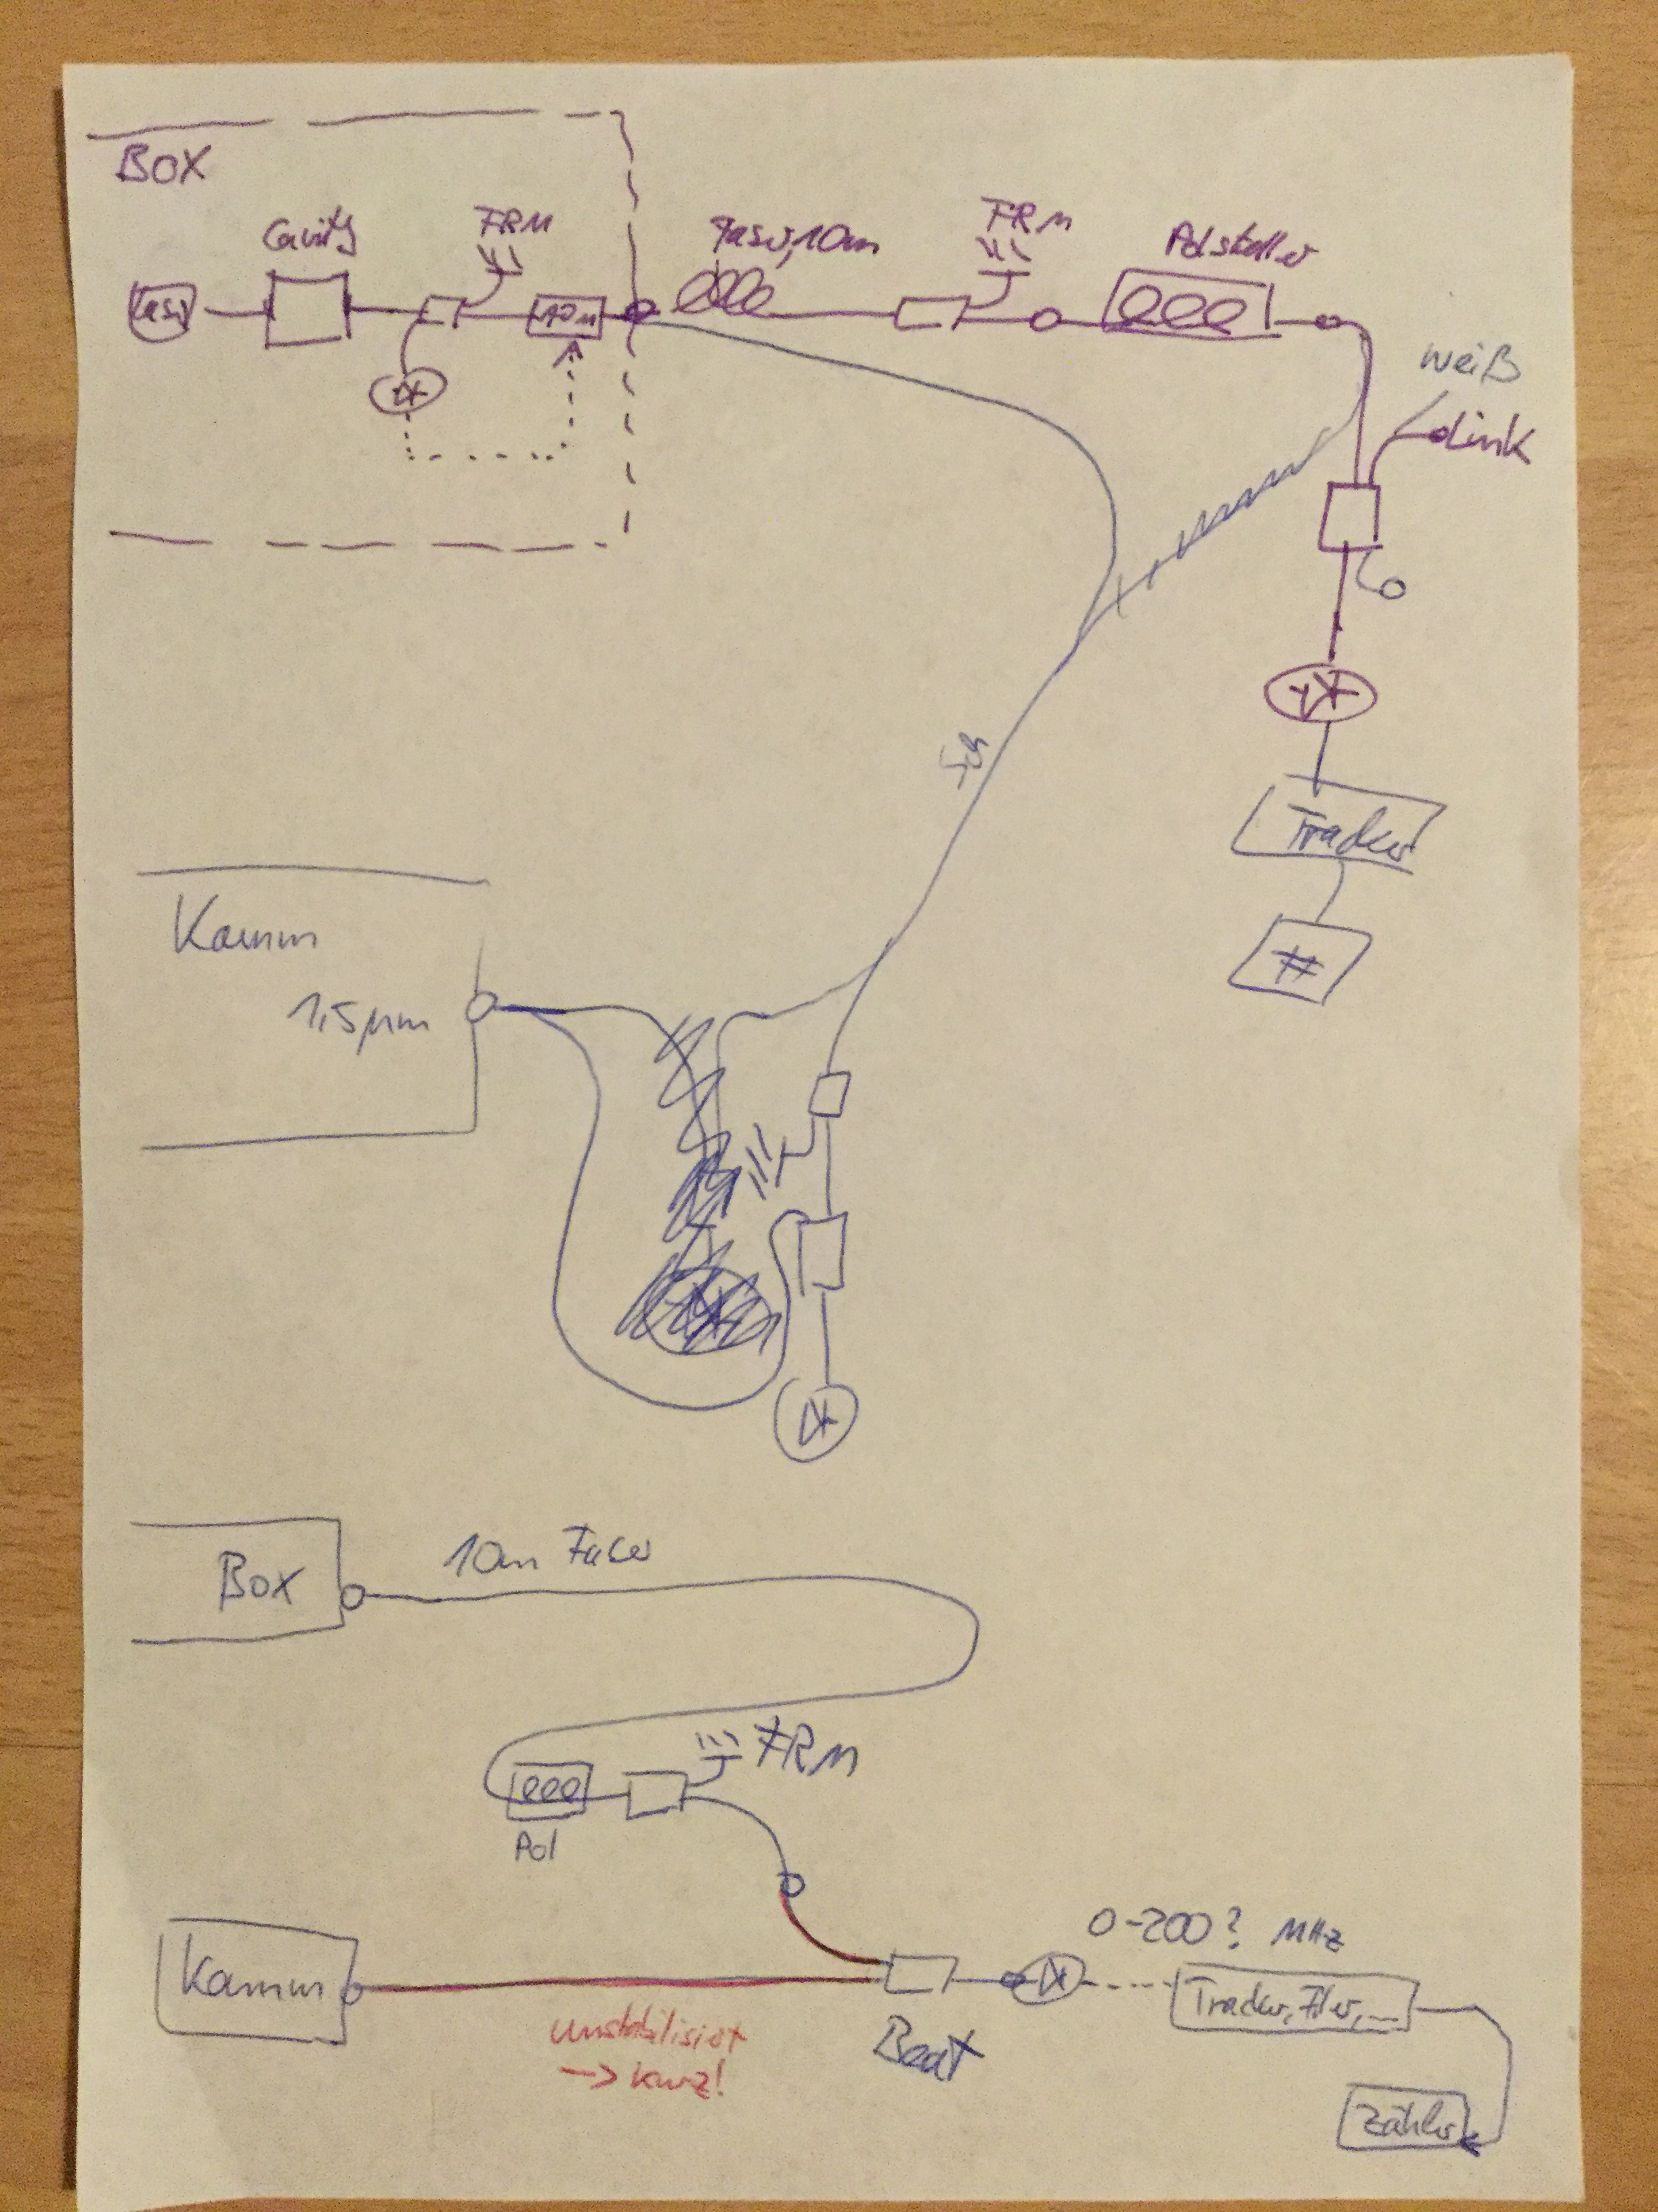
- purple = current setup (06.10.2016)
- blue = setup for measurement
- red = unstabilized fiber → keep it short!

Jan´s laser vs. Comb Hannover and Link vs. Comb Hannover
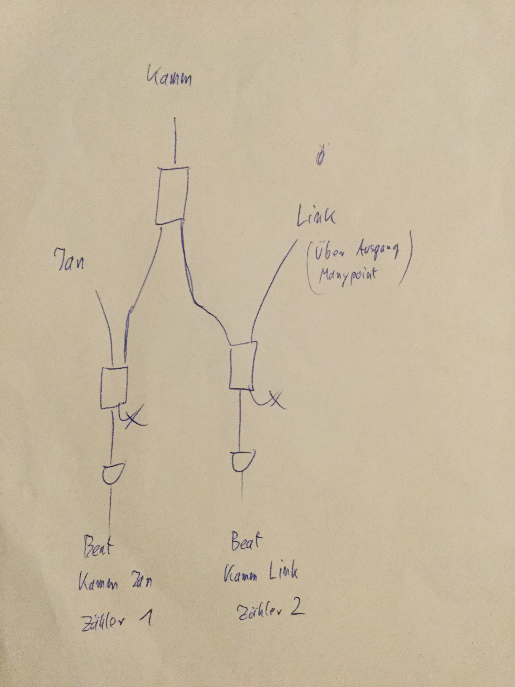
- Shift the ManyPointBox and Link to the optical table

