Temperature Controller
The temperature controller used for regulating and stabilizing the temperature of the laser diode is a Meerstetter TEC-1091-NTC56k-Pinheader - IQWiki entry

Current Setup - Rack Mount
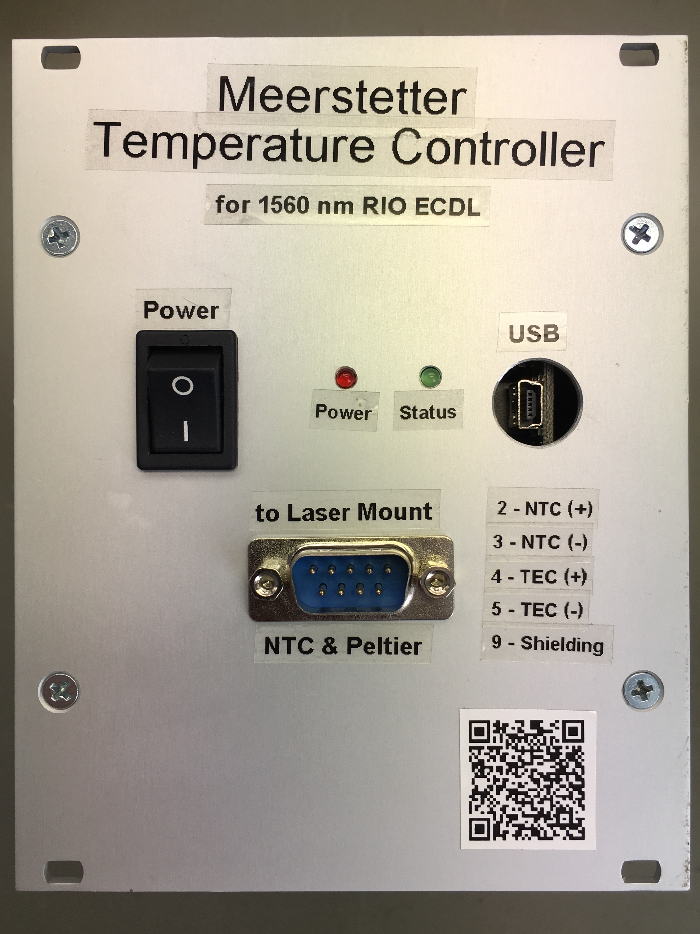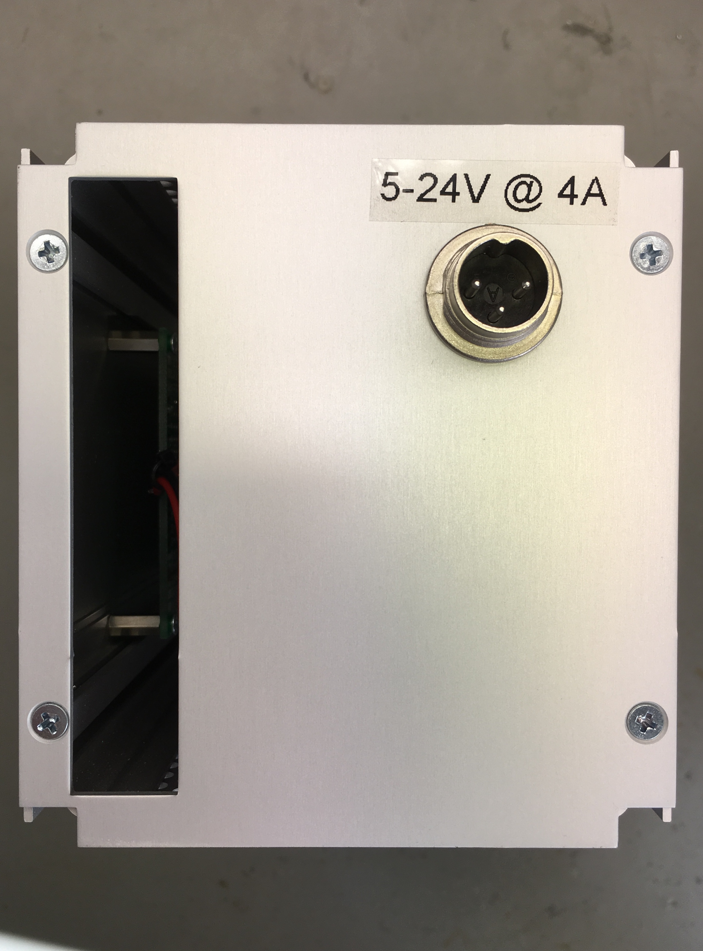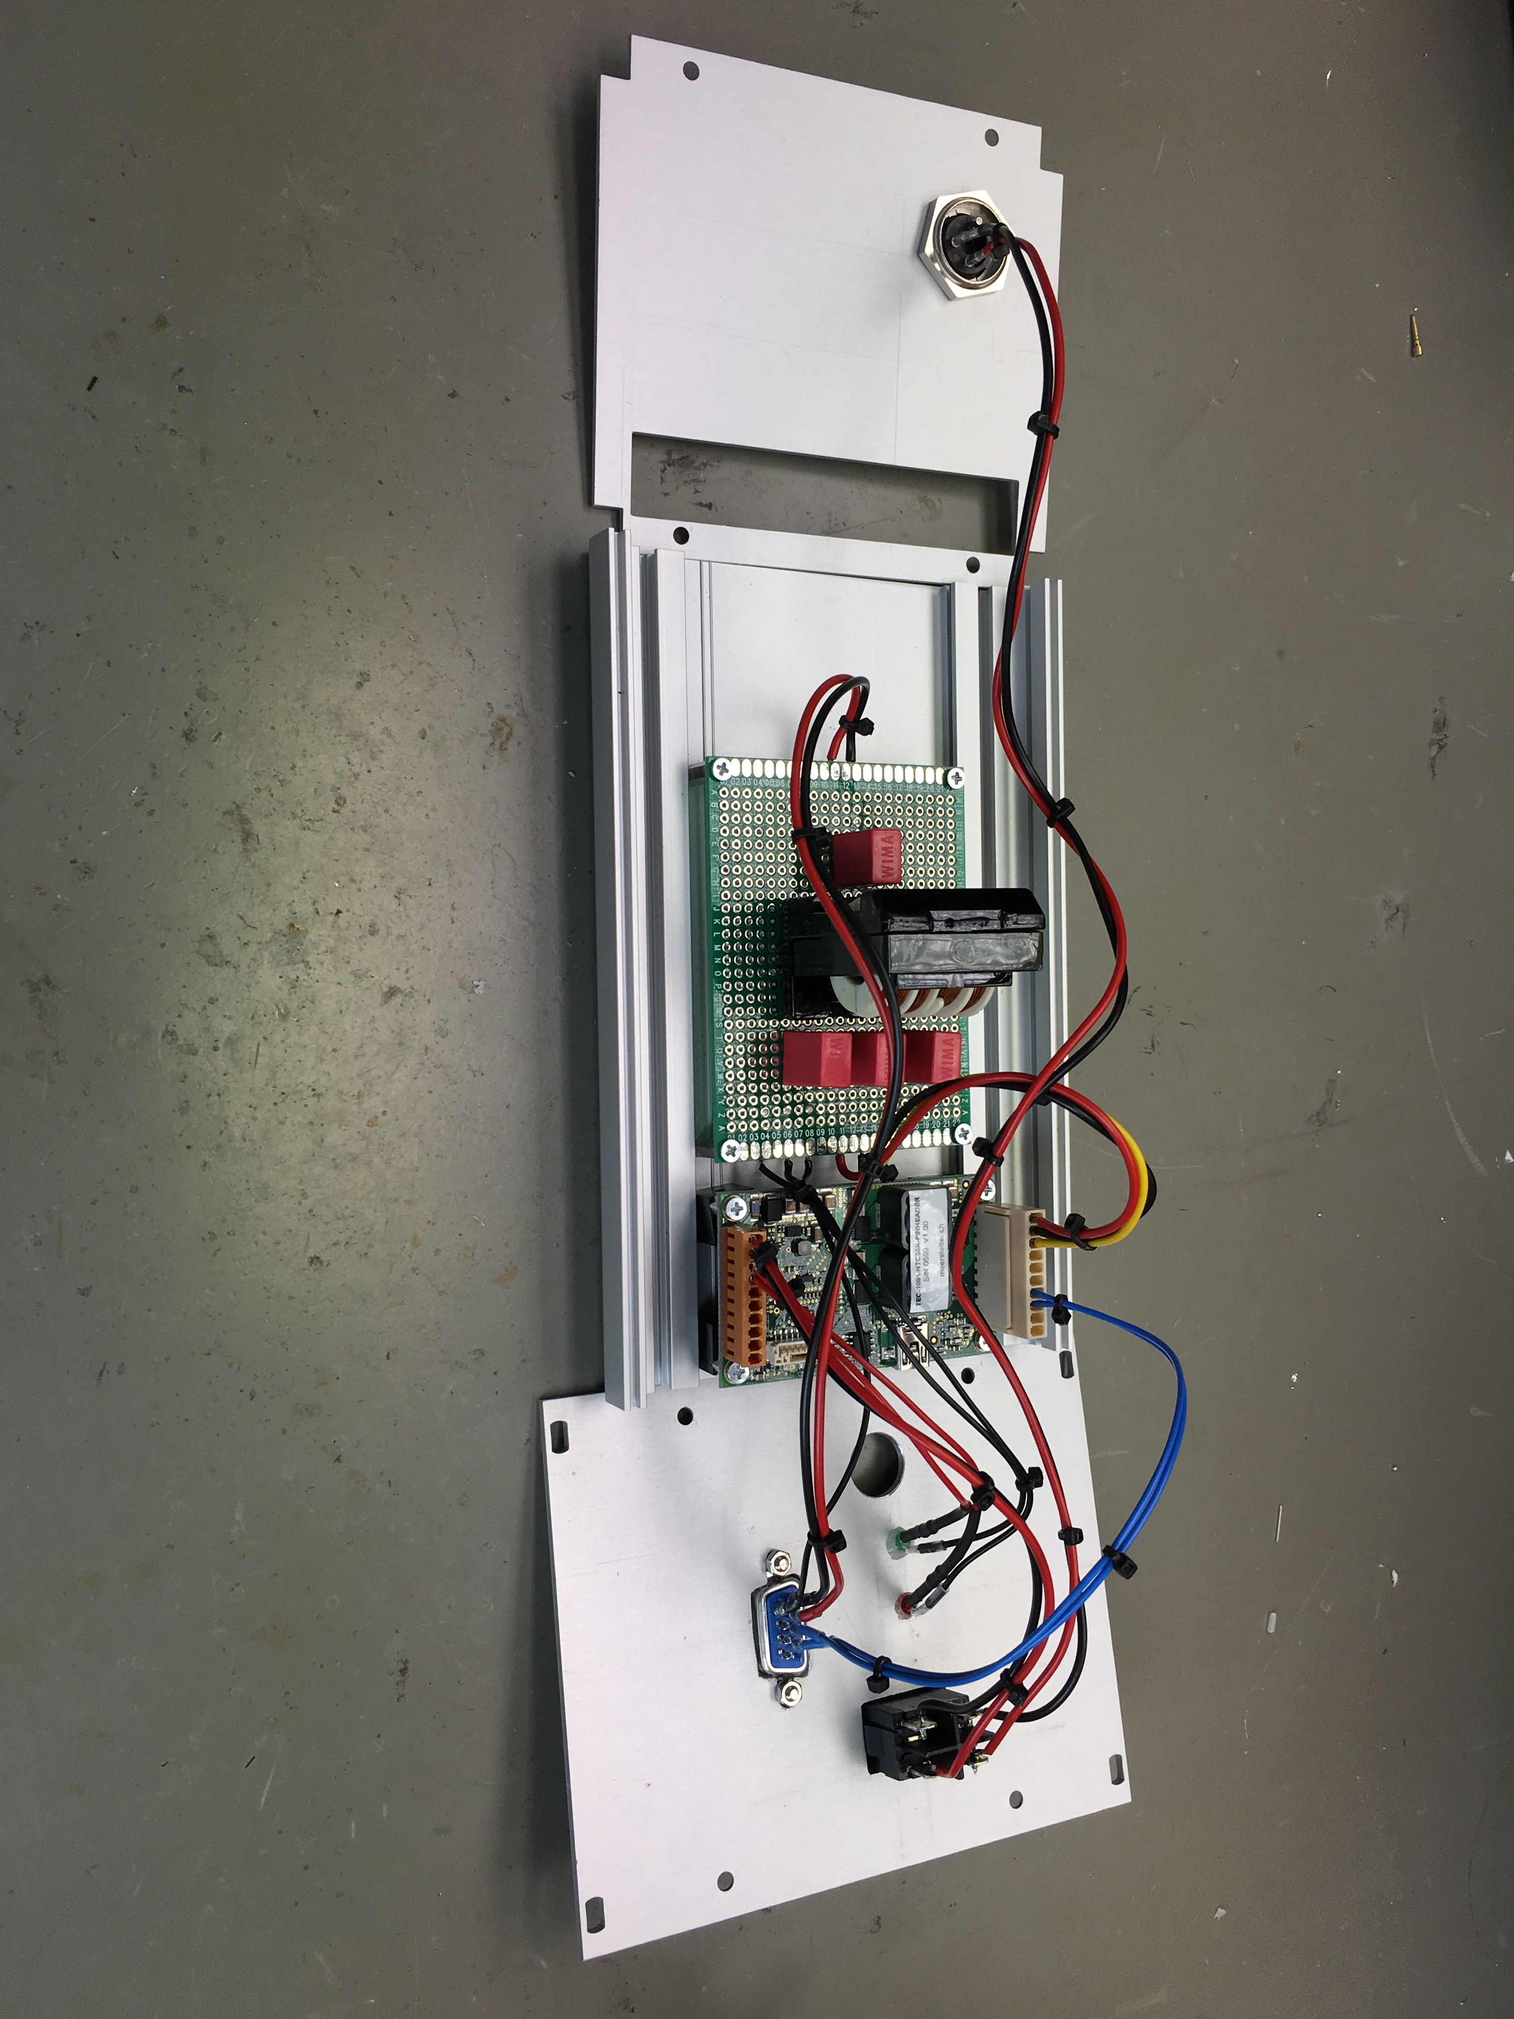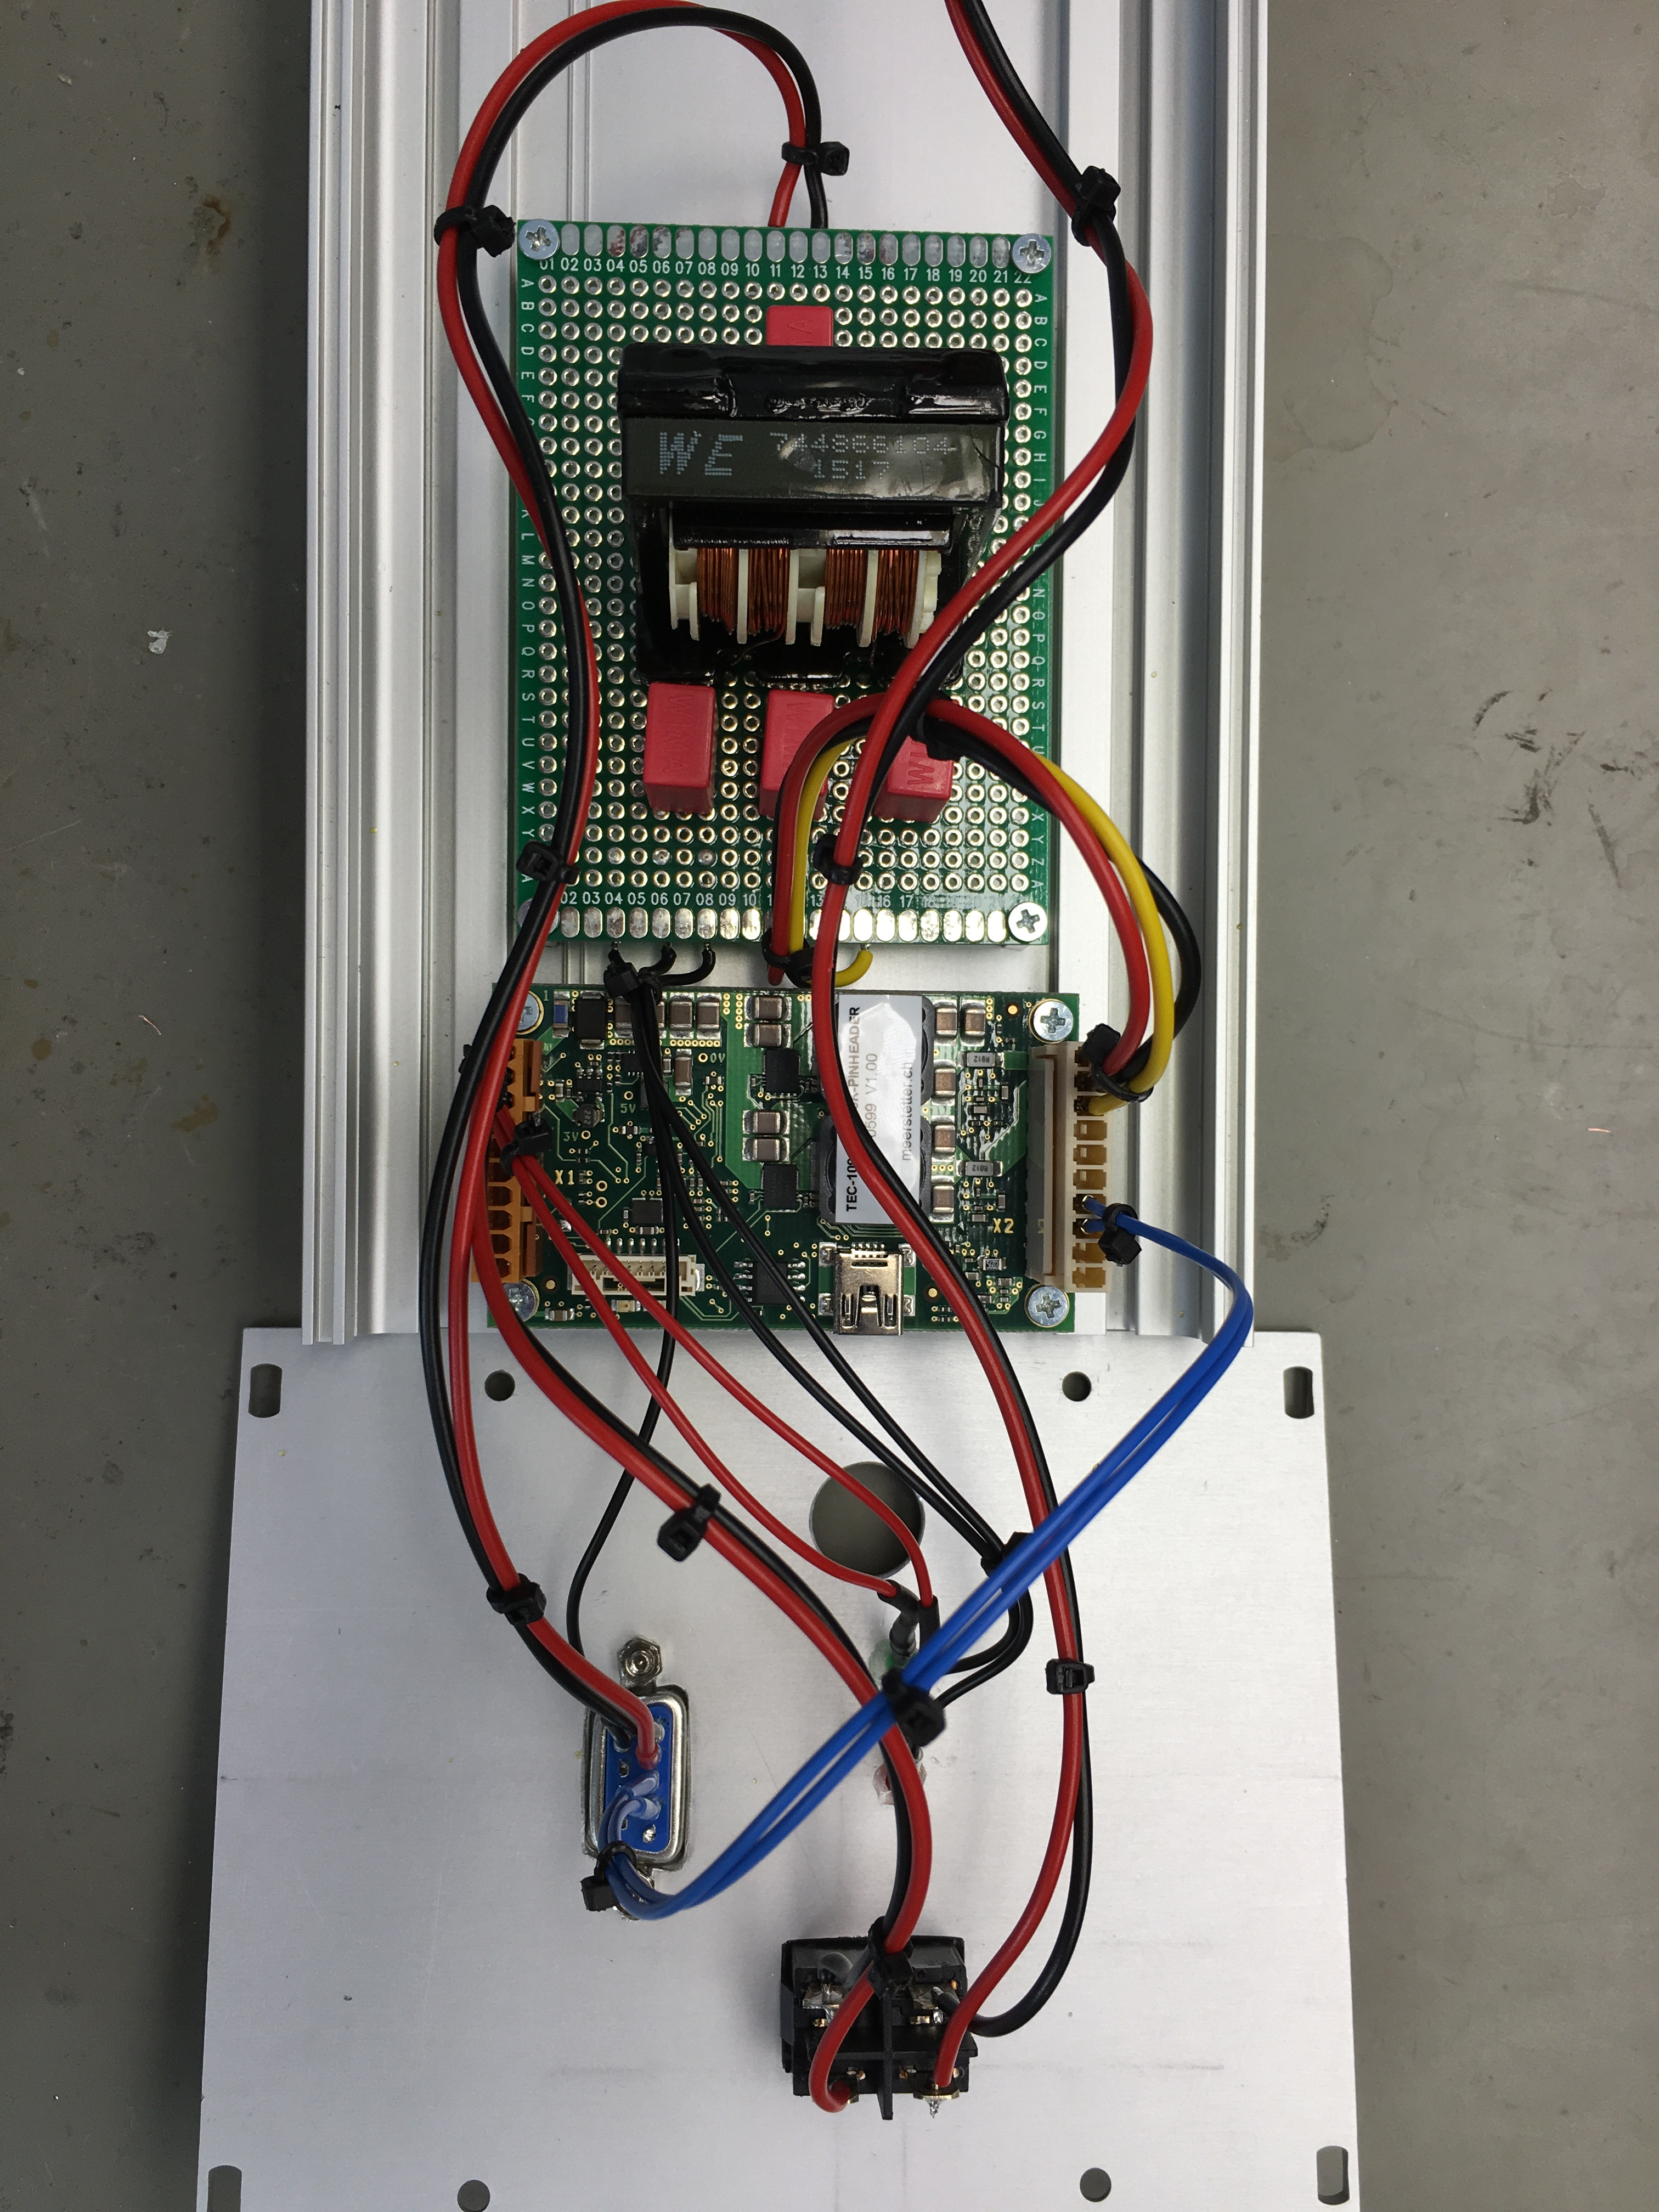
- Switch: controls connection between lab power supply and meerstetter
- Power LED: on = power on, off = power off
- Status LED: on = Temperature at setpoint, blinking = ramping to setpoint, off = power off or error
- USB: connection to PC, see Meerstetter wiki entry for more information
- SUB D-9: male connector, connects to laser mount
- Tuchel socket: connection to 5-24V @ 4A max
Socket | Pin Name | Connected To | Explanation
X1 | VIN | XLR Plus | connections for the power supply
X1 | GND | XLR GND | connections for the power supply
X1 | RES1 | LED Anode | power LED
X1 | RES2 | LED Anode | status LED
X2 | OUT + | SUB D Pin 4 | TEC (+)
X2 | OUT - | SUB D Pin 5 | TEC (-)
X2 | OBJ T° UA | SUB D Pin 3 | NTC (-)
X2 | OBJ T° UB | SUB D Pin 2 | NTC (+)
X2 | GND | SUB D Pin 9 | GND for shield of cable

Old setup - in a Box

Overview
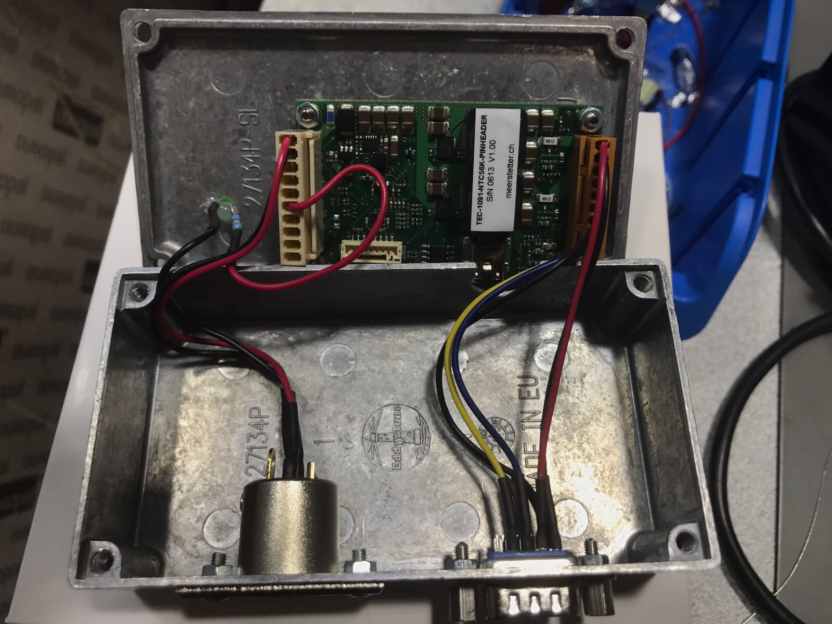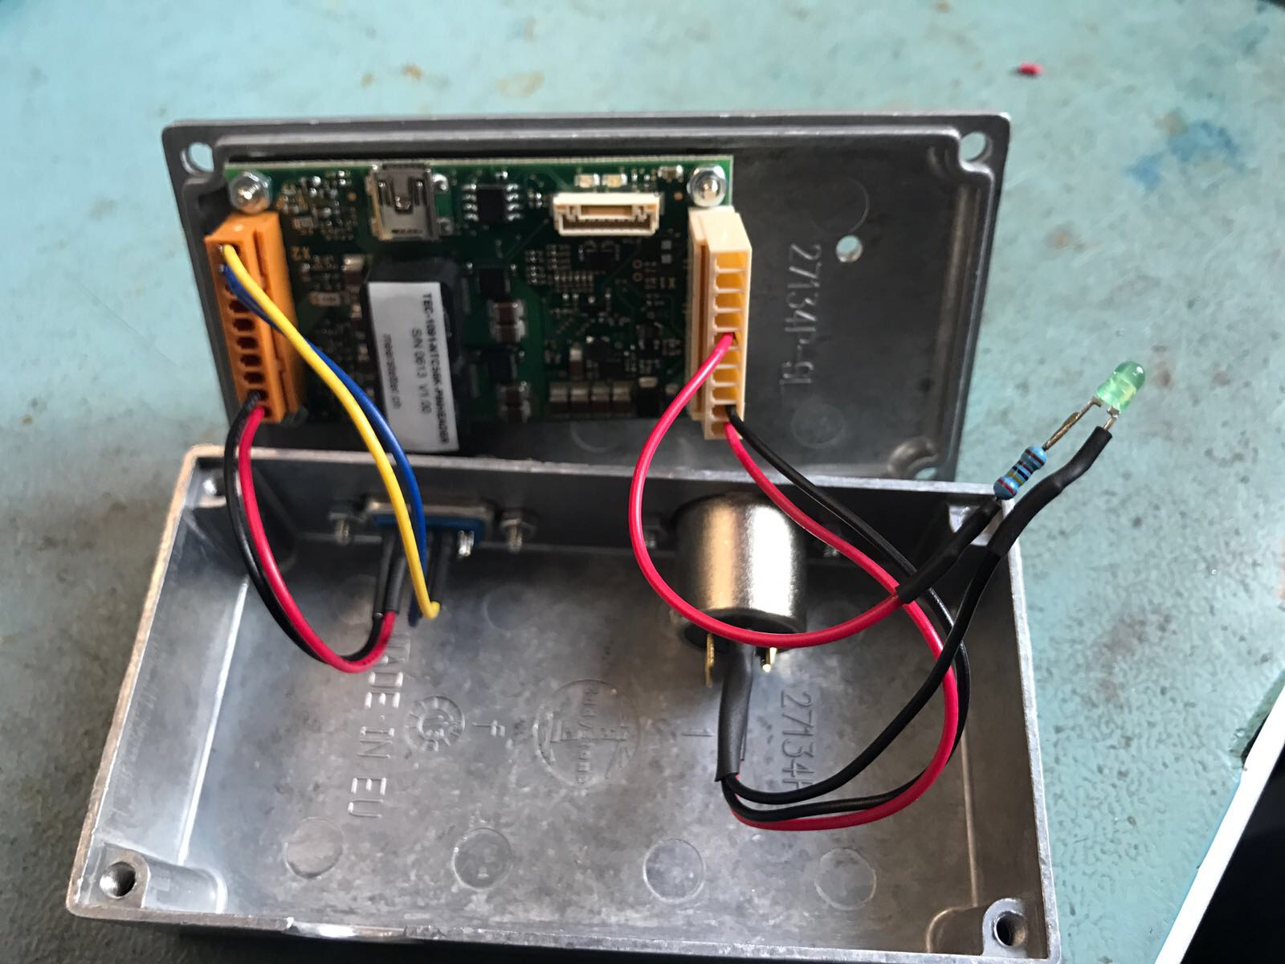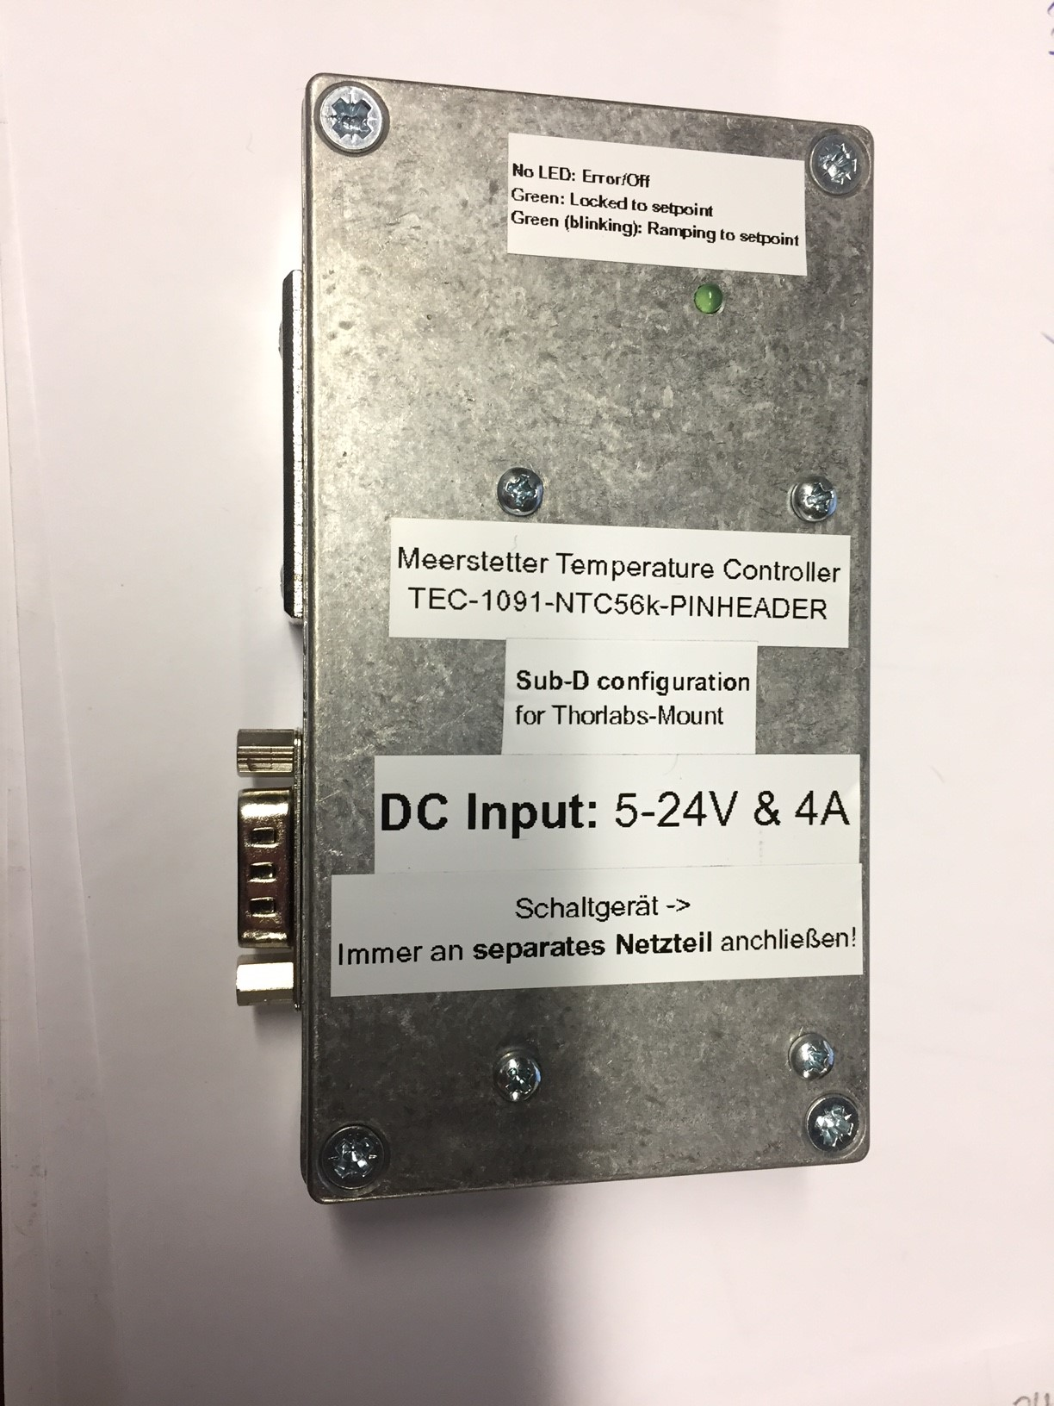
- The subD9 connector is used to connect the Meerstetter to the Thorlabs mount for the laser diode and is configured specially for that purpose.
- The XLR socket is used to connect the Meerstetter to a power supply.
- The Mini-USB socket is used to connect the Meerstetter to a PC for configuration and data logging.
There is also a status LED connected to the Meerstetter. If the LED is constantly on, the wanted temperature is reached. A blinking LED means that the system is currently ramping towards the wanted temperature and if the led is off, there is an error or the Meerstetter is currently turned off.

Power Supply
The voltage range with which the Meerstetter can be powered is 5-24V DC, currently it is driven with 18V DC. The power supply should be capable of delivering 4A. Always use a seperate power supply for powering the Meerstetter.

Connections within the Case

Current Connections
Currently the connections are as shown in the table below:
Socket | Pin Name | Connected To | Explanation
X1 | VIN | XLR Plus | connections for the power supply
X1 | GND | XLR GND | connections for the power supply
X1 | RES4 | LED Anode | status LED
X2 | OUT + | SUB D Pin 4 | TEC (+)
X2 | OUT - | SUB D Pin 5 | TEC (-)
X2 | OBJ T° UA | SUB D Pin 3 | NTC (-)
X2 | OBJ T° UB | SUB D Pin 2 | NTC (+)
X2 | Shielding | SUB D Pin 9 | GND for shield of cable
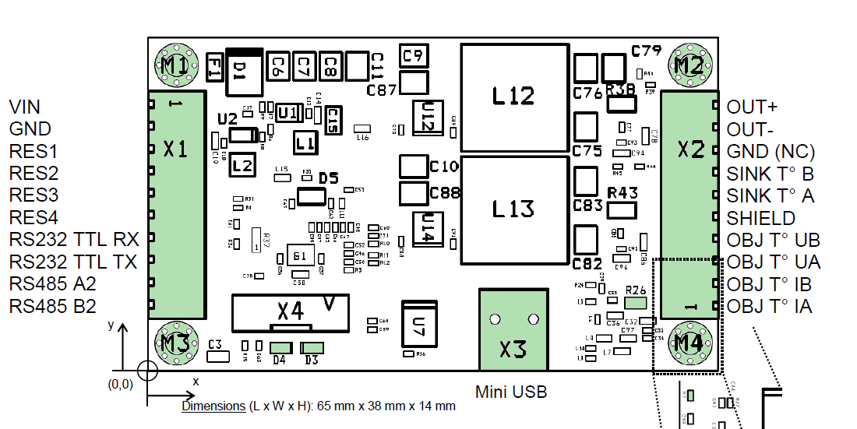
Different connectors were used for X1 and X2:
PSK for X1
JAE for X2
The SUB-D connector is wired up especially for the thorlabs mount. It is probably not compatible with other systems that use a SUB-D connector!

Previous Connections
These were the previous connections. Differing connections were marked yellow.
Socket | Pin Name | Connected to
X1 | VIN | XLR Plus | connections for the power supply
X1 | GND | XLR GND | connections for the power supply
X1 | RES4 | LED Anode | status LED
X2 | OUT + | SUB D Pin 4 | TEC (+)
X2 | OUT - | SUB D Pin 5 | TEC (-)
X2 | <hi #fff200>OBJ T° IB</hi> | SUB D Pin 3 | NTC (-)
X2 | <hi #fff200>OBJ T° IA</hi> | SUB D Pin 2 | NTC (+)
X2 | <hi #fff200>OBJ T° UB</hi> | SUB D Pin 9 | GND for shield of cable

Status LED

Current Setup
An extra LED is installed at the “RES4”-Pin at the X1 side with a 2,4 kΩ resistor and connected to GND.
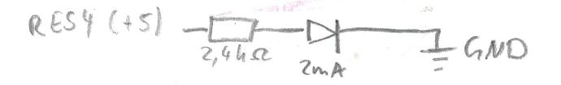
The Meerstetter is currently set up to control the LED like this:
LED | Meaning
constanly on | target temperature is reached
blinking | ramping towards target temperature
off | error/Meerstetter is off
To add another status LED to the Meerstetter, you can follow this step-by-step guide

Other Modifications
What's the meaning of this?
On the back side of the circuit board at these two places, two soldering points have to be soldered together, so that 2 wires can be used to connect the NTC.


