Ring-down Box

Application of the ring-down box
You can measure the finesse of a resonator with the ring-down box.
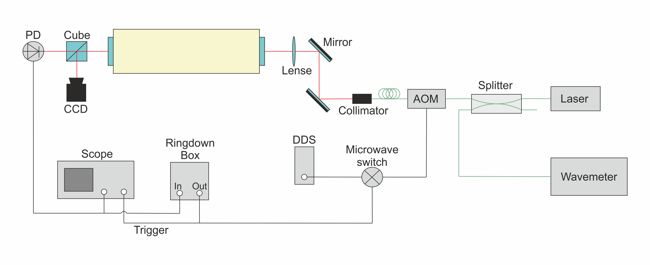

Measurement Method

Evaluation
Use this formula to analyse the datapoints:
y(x)=A*exp^(-x/t)+y0 with x:=time, t:= delay time
Afterwards calculate the finesse with F=2pi*t*FSR with FSR:=free spectral range.

Electronic setup

