Bake out
- We use the temperature monitoring design, made by E. Wodey, for the out of loop measurements during the out baking.
  - Talk by E. Wodey for the explanation of the monitoring system:2016-08_geoq_ctp_ew.pdf
  - Box-design made by S. Sauer: 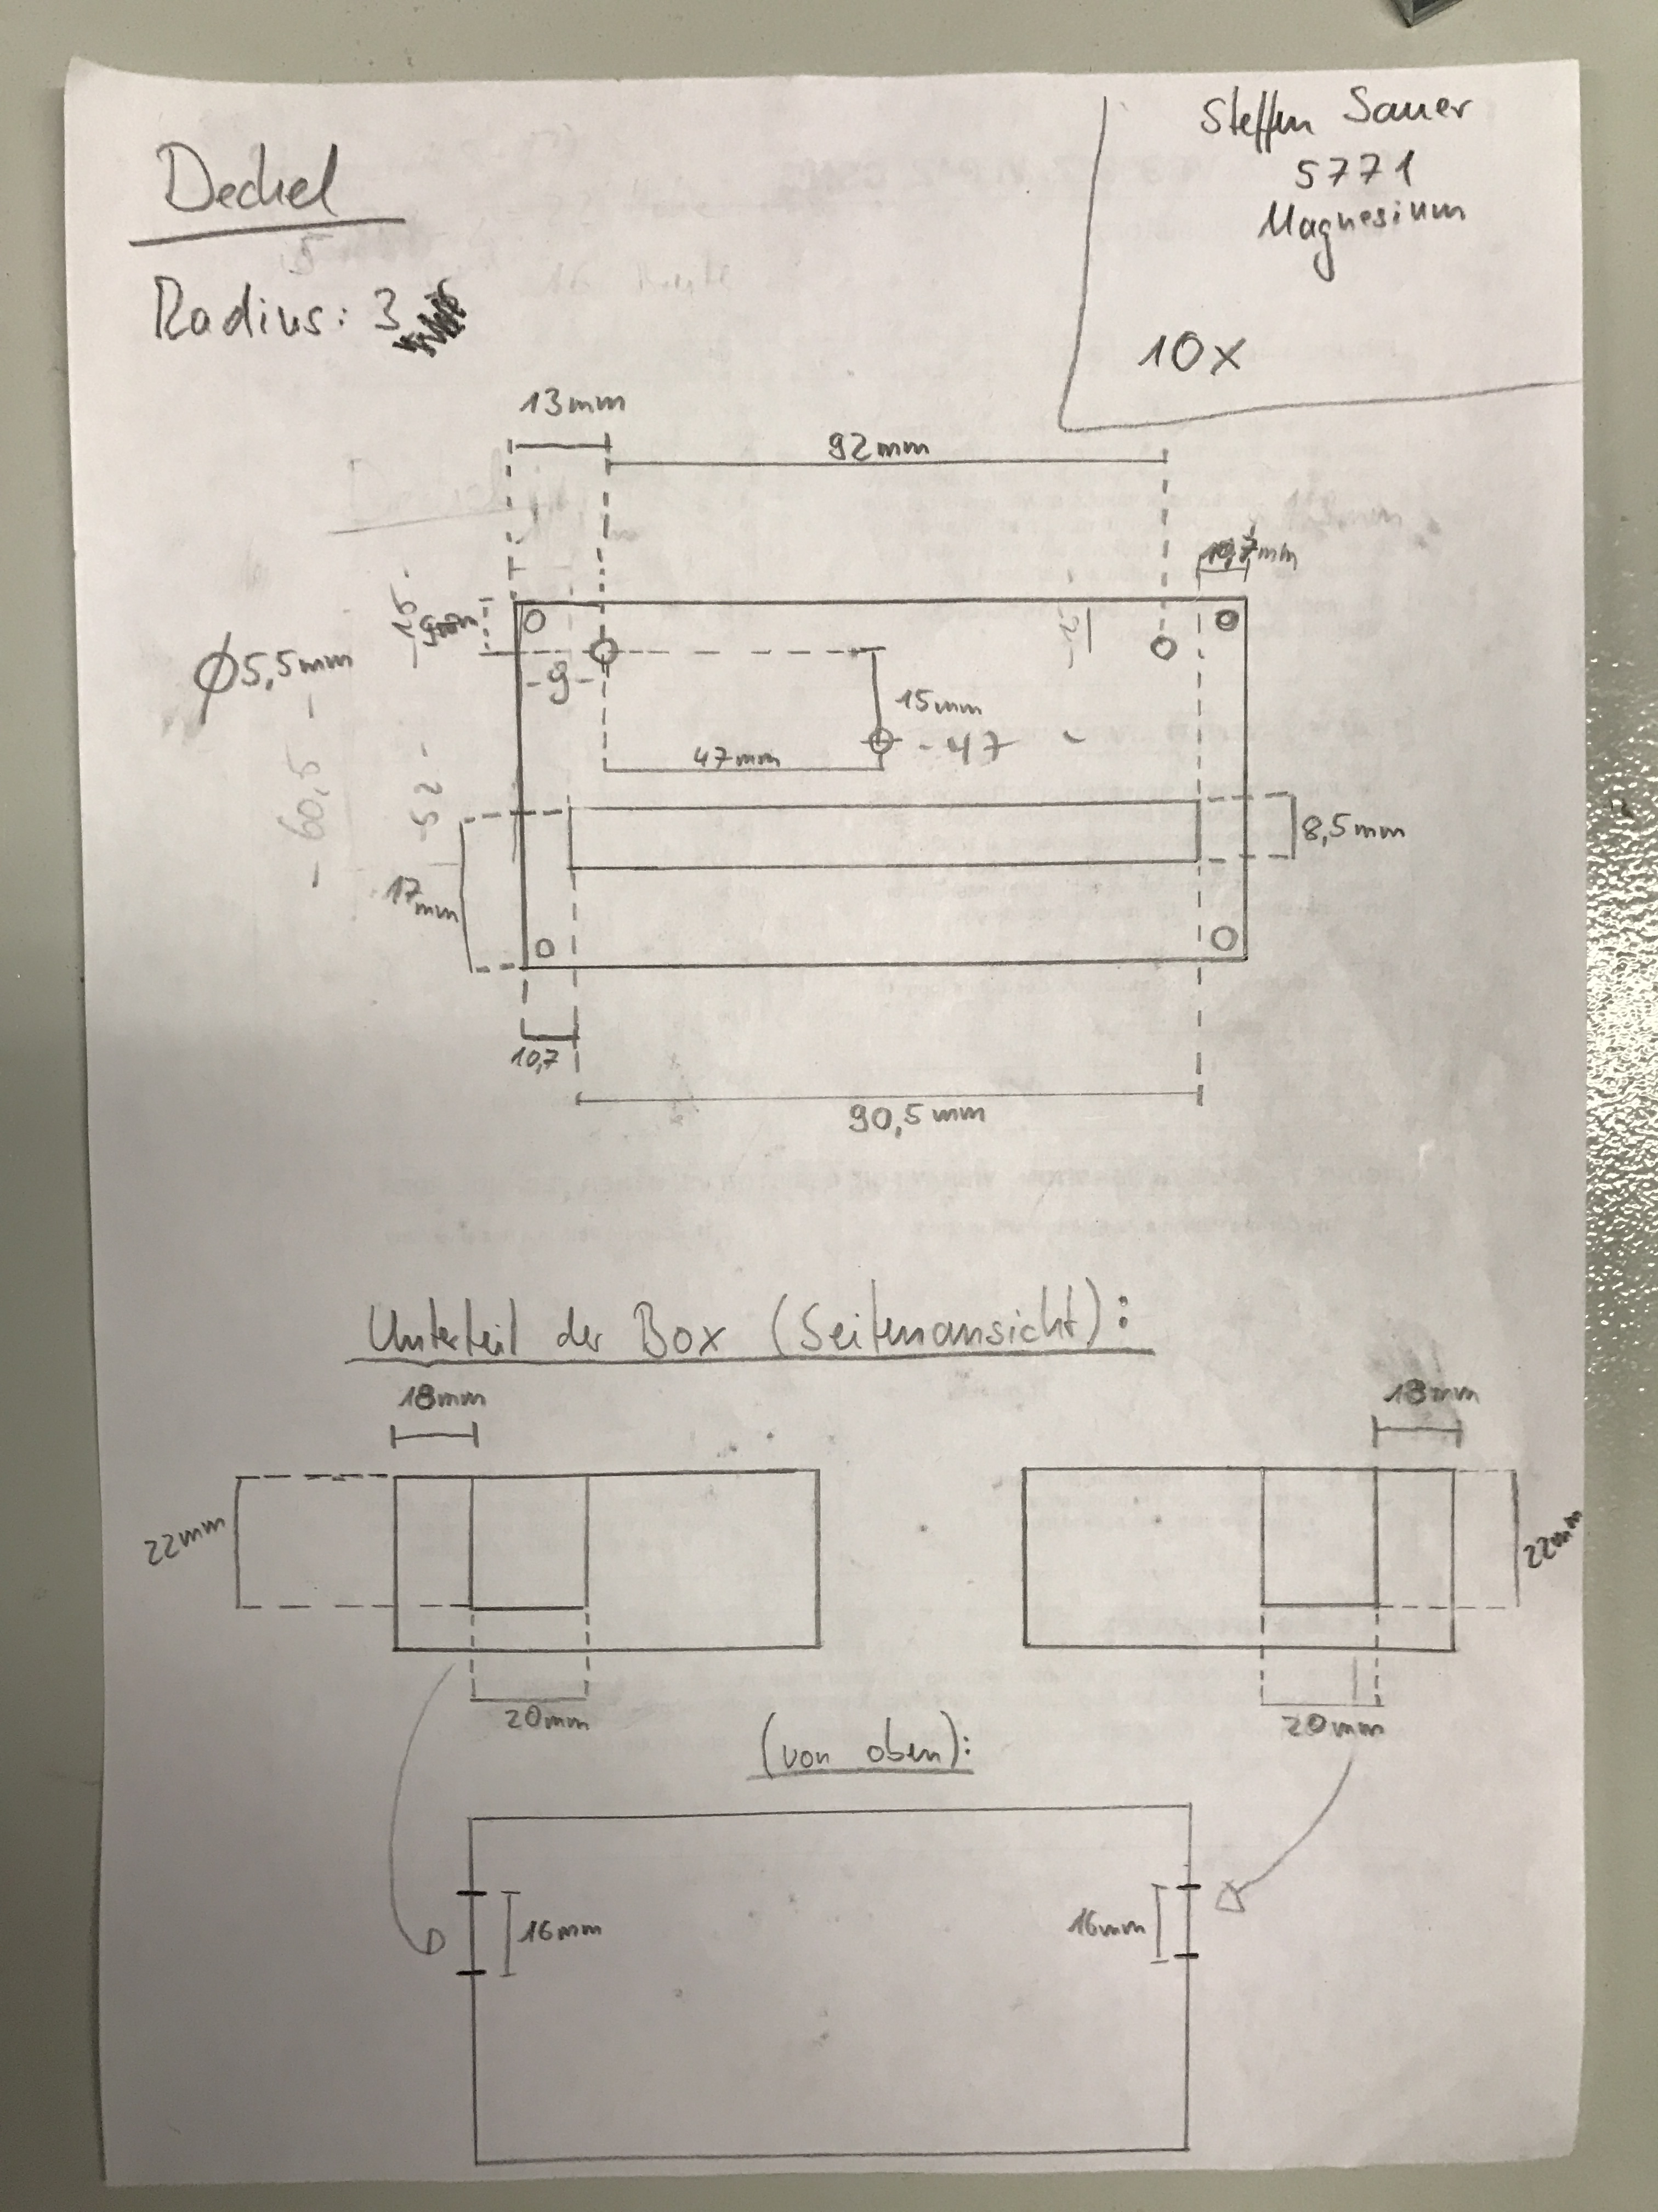

Bake out list
Item | Material | Maximum temperature [°C] | Comments
Mounting for the spacer | (Al ~ Alplan) | 660.2
Zerodur rods | Zerodur | 600 | Wikipedia
Viton balls | Viton | 280 | Wikipedia
Glas balls | Borosilikatglas | 500 | maximale Arbeitstemperatur, Wikipedia
Heat shields | Aluminium [EN AW-5083] | 660.2 | <fc #ff0000>Temperatureinsatz (max. °C bei Dauer / Kurzzeiteinsatz): 120/ 180 </fc>
Screws from the mounting and hield shield | Edelstahl A2
Windows
Window holder | Aluminium | 660.2
Vacuum chamber | Aluminium | 660.2
CF Cupper ring | Cupper | 1084.62 | Schmelzpunkt, Wikipedia
CF Flanschkit
IGP |  | 350
IGP cable |  | < 220
Vacuum pressure sensor |  | 250 without electronics and magnet
Vacuum pressure sensor cable
Angle valve |  | < = 300
Gate valve |  | open: < = 250 (max 24h)  closed: < = 200
Sub-D Socket
Sub-D Feedthrough | Peek | 230
Sub-D Kabel 37FXRR-500 | Kupferdraht versilbert  Kaptonband-isoliert | 250
CF-Kreuz
Lead wire | Lead | 327
Indium wire | Indium | 155
Indium foil | Indium | 155
Capton wires | Kupferdraht versilbert  Kaptonband-isoliert
Crimp pins | Cu vergoldet | 230
Peltier-elements |  | 200
NTC Sensors |  | 300
Vacuum glue [Torrseal] |  | 175 | Flammpunkt
ULE Spacer
Mirrors
ULE rings
Faraday rotator
Glue from faraday rotator

Bake out tips
http://vacuumtunes.co.uk/vtut1.html
3.3 Baking
Early workers baked systems only to about 200C which was effective in removing weakly bound surface water and hydrocarbon molecules. It was not long before it was discovered that baking to higher temperatures was required to remove more tightly bound species and the hydrogen diffusing from the bulk, both of which had the effect of limiting the ultimate system vacuum. The effectiveness of high temperature bakes is amply demonstrated for example by Calder and Lewin (1967), who showed that outgassing could be reduced to about E-16 mbar l/s cm2 by baking for 11 days at 300C or 1 hr only at 635C. Barton and Govier (1968), showed that baking new 18/18/1 stainless steel components at 450C in vacuo, with the exception of traces of hydrogen, successfully removes all gases resulting from the previous history . Interestingly these workers found that gas adsorbed at the surface of stainless steel on re-exposure to atmosphere could be remove by baking at this temperature for 2 to 3 hrs. If pressures only of the order of E-9 mbar were required then sufficient gas could be removed by a 12 hr bake at 200 to 300C; for some applications it is thus worthwhile to use a separate vacuum oven for baking new components at 450C thus avoiding the need for the main system to withstand high temperatures.
Santeler (1991), quotes early work by Aero Vac Corporation which gives valuable data on the effect of baking to different temperatures which is reproduced here below:
Outgassing rates in Torr l/s cm2

BAKING TIME
BAKING TEMP | 20 hrs | 40 hrs | 100 hrs | 200hrs
150C | 6.3E-11 | 5.3E-11 | 2.8E-11 | 2.0E-11
250C | 6.3E-12 | 5.3E-12 | 2.8E-12 | 2.0E-12
400C | 4.0E-13 | 1.7E-13 | 1.0E-13 | 1.0E-13
500C | 8.0E-15 | 8.0E-16 | 4.0E-17 | 8.0E-19
The data above bring home clearly the benefits of high baking temperatures and the diminishing returns from increasing baking time much beyond 20 hrs for baking temperatures up to 400C; at 500C the table shows that it is worthwhile to bake for as long as 200 hrs although one might legitimately question the unusually low value of 8.0E-19 torr l/s cm2 that is quoted. Recent work (Ishikawa, 1995; Ishikawa et al 1991; and Ishikawa and Odaka1990), confirms the values above for lower temperatures but indicates that surface treatments and raw material quality can improve these figures substantially, (section 3.2 above).

Bake out Protocol

