Mode Matching - plan and curve mirrors

Mirror configuration
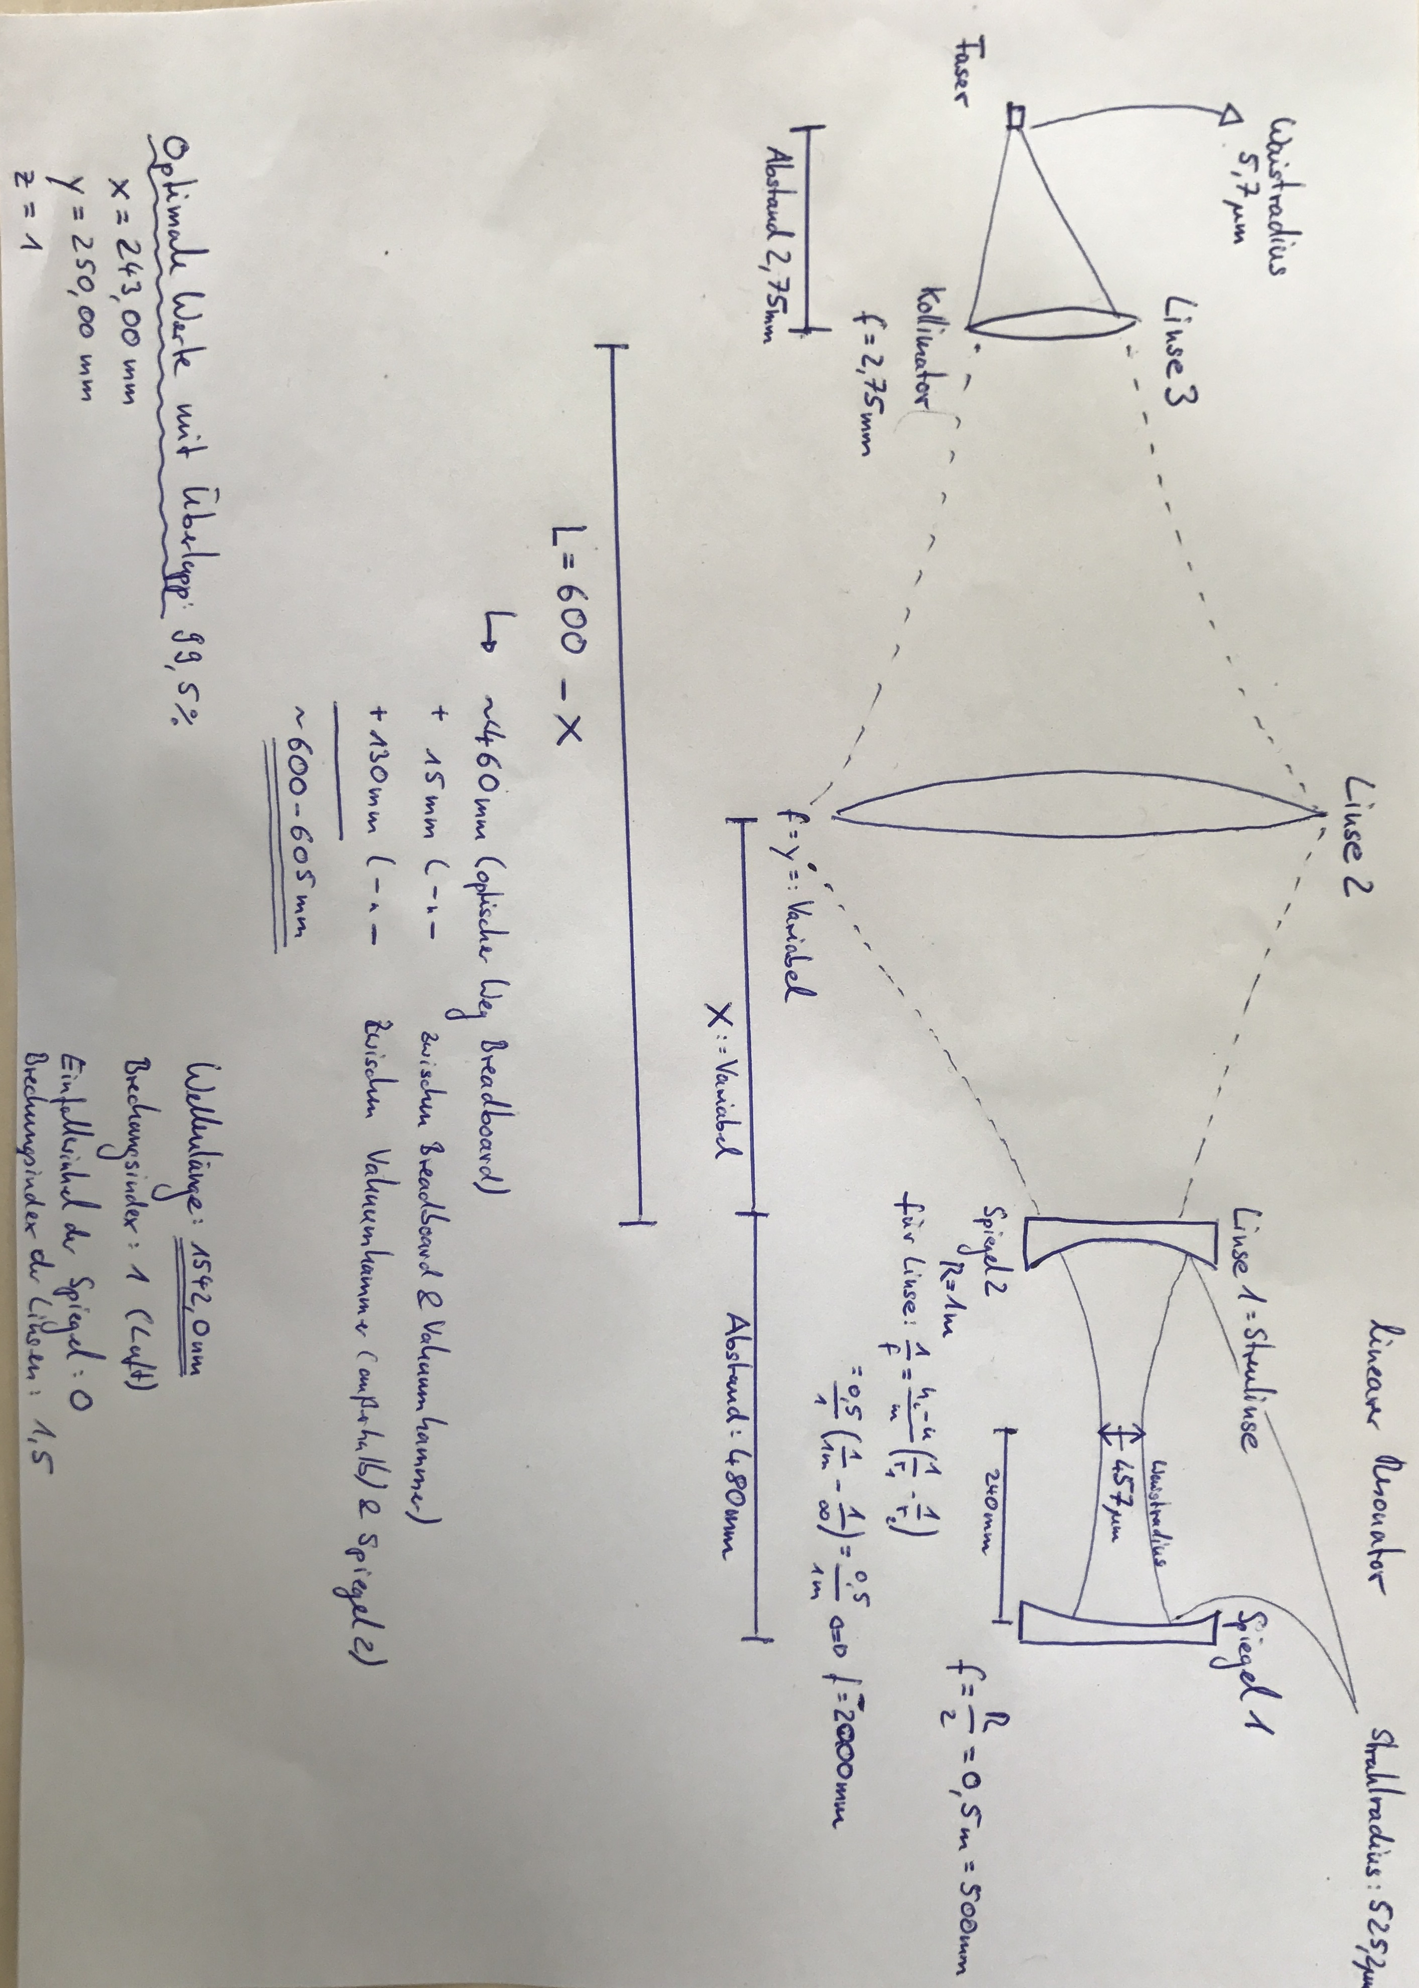

Parameter
- Radius of curvature of mirror R1: R1= 1 m
- Radius of curvature of mirror R2: R2= infinity (Incoupling side)
- Wavelength: λ= 1542.0 nm
- Length between the resonator mirrors: L= 480 mm
- Beam radius at cavity-waist: w0=w2
- Beam radius at mirror R1 and R2: w1, w2
- Distance between:
  - mirror R1 and mirror R2: L
  - mirror R2/lense 1 and lense 2: X
  - mirror R2/lense 1 and collimatorlense: 600mm - X
    - 615mm = optical way of the incoupling breadboard (450mm) + thickness breadboard (10mm) + distance between breadboard and vacuumchamber (30mm) + distance between vacuumchamber and cavity mirror R2 (130mm)
  - collimatorlense and fiber: 2.75 mm
We used the programm Strahl.exe (@IQ) or STRAHLFP.EXE (@PTB) (same software, but different names).
Step 0: Choose parameter
- Wellenlänge: 1542 nm
- Brechungsindex: 1 (Air)
- Welcher Resonatortyp: linearer Resonator
Step 1: Beam waist calculation from resonator
- Nr. 1: Spiegel 1 with Brennweite 500 mm; Einfallwinkel: 0
- Nr. 2: Abstand 480 mm
- Nr. 3: Spiegel 2 with Brennweite 10000000000 (so viel es ging) mm; Einfallwinkel: 0
→ Waistradius: w0=w2=495.2 µm; Strahlradius on the mirrors: w1=686.7 µm; w2=495.2 µm
Step 2:
- Change Spiegel 2 to Linse 1
  - Brechungsindex: 1.5
  - Brennweite: -4000000000000000000 mm
The values of the Waistradius and Strahlradius must not change!!!
Step 3:
- Nr. 4: Abstand with Variable X
- Nr. 5: Linse 2 with Variable Y
- Nr. 6: Abstand 600 - X
- Nr. 7: Linse 3 with Brennweite 2.75 mm
- Nr. 8: Abstand 2.75 mm
- Zielwaist: 5.2 µm
Step 4: Playing with the parameters X and Y for the best Überlapp
Case: Mirror R2/lense 1 and collimatorlense: 615mm - X
Lense focal length: Y [mm] | 400 | 300 | 250 | 200 | 175
Distance between mirror R2 and lense 2: X [mm] | 258 | 314 | 335 | 375 | 400
Überlapp [%] | 92.7 | 99.1 | 99.8 | 94.7 | 88.6
Step 5: Check what is happend for the wavelength 1560 nm
No effect!

