05.10.2016
- Vacuum chamber was cleaned with dishwashing detergent
- Discussion about the breadboard (M3 screw size, small passage for the light, aluminium) and spacer (3cm, plastic) for incouple and outcouple light from the cavity
- Mounting (holes for countersunk head screws) was repaired
- Countersunk head screws installed in mounting. Probably, screws made of V2A steel:
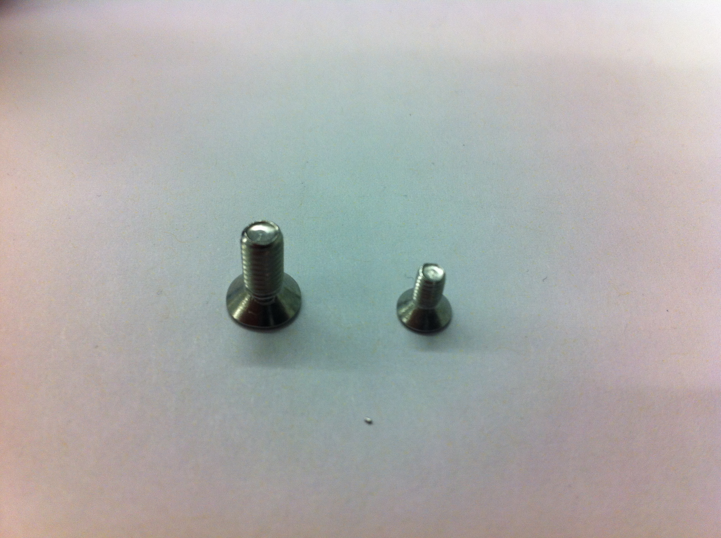
ToDo in Hannover:
- Order and design breadboard (2x)
- Order and design eccentrical spacer (1mm from centre)
Next time at PTB:
- Clean the vacuum chamber with acetone
- Drill holes in cavity breadboard
- Test the M6 holes from vacuumchamber if all threads are deep enough.

