30.09.2016 Transport from passive vibration isolation
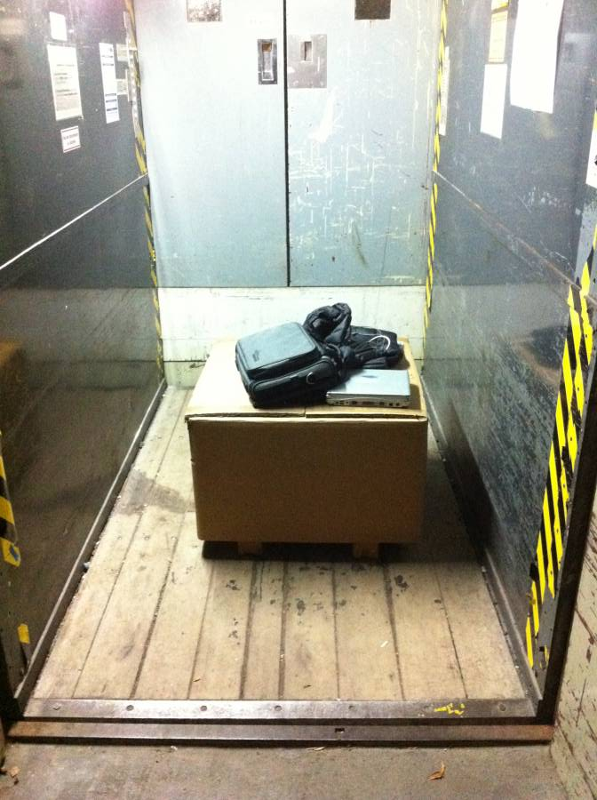
Model: MinusK 650 BM-1
Website: http://www.minusk.com/products/bm1-bench-top-vibration-isolation-platforms.html

