Fiber-Components
- How to work with fiber modulators:
  - english: Modulatorfibel_english
  - german: Modulatorfibel_german

Fiber AOM
Company: AMS Technologies AG, Gooch & Housego Torquay
- Typ: SFO4504-T-M080-0.5C8J-3-F2P
- Fiber-coupled acousto-optic modulator, model Fibre-Q http://www.amstechnologies.com/products/optical-technologies/components/optics/acousto-optics/view/fibre-coupled-acousto-optic-modulators/
  - Material: Amtir
  - Wavelength: 1550 nm
  - Operation frequency: +80 MHz
  - Polarisation maintaining fiber
  - Fibre length: 0.3M
  - Gibre-connector: FC/APC

Fiber EOM
Company: Jenoptik
Do not apply voltages higher than 40V peak-peak to RF input.
- Typ: PM1550
  - Center wavelength: 1550 nm
  - Insertion loss: 3.0 dB
  - Electonic connector: SMA, Inputimpedanz: 50 Ohm
  - U_pi@1kHz: 8.5 V
  - Fiber-typ: PM
  - Fiber-connector: FC/APC
  - Fiber length: 1m
  - Crystall: Lithiumniobat (Info_crystall)
  - Max optical input power: 300mW cw
- Datasheet:
  - german: Datasheet Fiber-Eom_german
  - english: Datasheet Fiber-Eom_english
  - supplied:
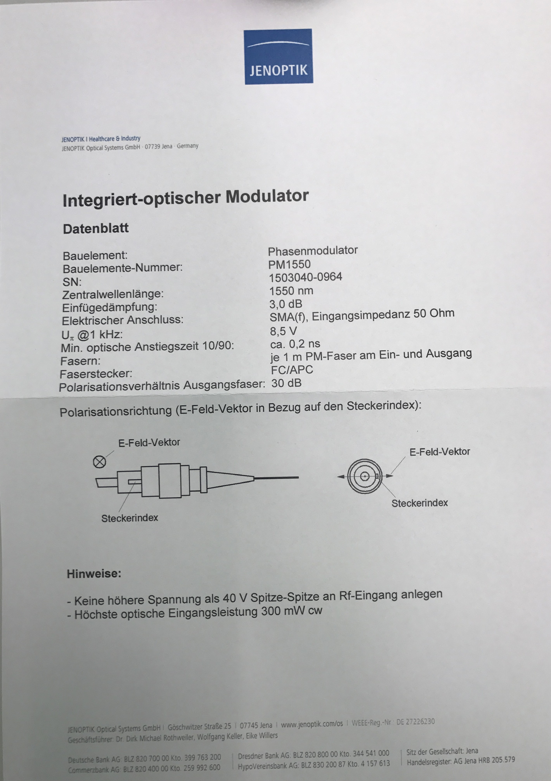

Fiber Coupler

50/50
Company: Opneti
- Typ: CS-PS-A-2×2-1550-50/50-900-5-0.25-FA-3×54
  - Type: PS=PM Fused Coupler
  - Grade: A=Grade
  - Port Type: 2×2
  - Wavelength: 1550
  - Coupling Ratio: 50/50
  - Pigtail Type: 900=900um Loose Tube
  - Fiber Type: 5=Panda Fiber
  - Length: 0.25m
  - Connector: FA=FC/APC
  - Package: φ3.0×54
- Datasheet: Datasheet Fiber-coupler_50/50_Opneti
- Test report:


