Caculates the cavity spectrum and the frequency distance between TEM_00 and higher order modes m+n. Two curved mirrors possible. Programm made by T. Legero.

Parameter
- Radius of curvature of mirror R1: R1= 1 m
- Radius of curvature of mirror R2: R2= 1 m
- Cavity Length: L= 0.48 m
- Reflectivity of mirrors: R= 0.99998
- Speed of light: c= 299792458 m/s
Step 1: Calculate the Free-Spectral-Rang and Gouy-Phase
- Free-Spectral-Rang: FSR
- Gouy-Phase: Gouy
⇒
- FSR = 312.284 MHz
- Gouy = 101.783 MHz
Step 2: Calculate the frequency difference between TEM_00 and TEM_mn
- TEM mode number: mn
- Next TEM_00: w
- Frequency difference between TEM_00 and TEM_mn: Delta
- Define maximum of mn and w:
  - mn_max = 100
  - w_max = 100
- Define maximum of shown frequency difference to TEM_00:
  - abs(delta(mn,w)) < 10E6
- Frequency difference von (q-w)ter höherer Mode mn zu q-ter TEM_00-Mode (Matrix):
⇒
Freq. diff. of m+n = 3 higher order mode to 00-mode is 6.93401 MHz
Freq. diff. of m+n = 43 higher order mode to 00-mode is -4.70713 MHz
Freq. diff. of m+n = 46 higher order mode to 00-mode is 2.22688 MHz
Freq. diff. of m+n = 49 higher order mode to 00-mode is 9.16089 MHz
Freq. diff. of m+n = 86 higher order mode to 00-mode is -9.41427 MHz
Freq. diff. of m+n = 89 higher order mode to 00-mode is -2.48026 MHz
Freq. diff. of m+n = 92 higher order mode to 00-mode is 4.45375 MHz
Step 3: Calculate the frequency difference between TEM_00 and the nearest TEM_nm
- Define the Modenumber of Higher-Order-Mode to plot (next Mode to 00):
  - mn = 3
- Define the Vary Mirror-Curvature:
  - R = 0.95:0.01:1.05
- Frequency difference between TEM_00 and TEM_mn:
- plot(R,Delta)[Important!]:
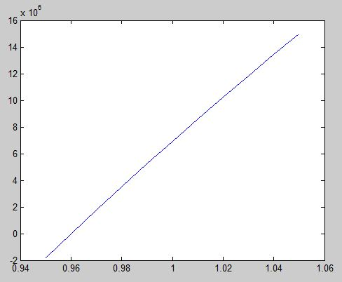
Achtung: ROC wird hoffentlich >1m werden, damit die m+n = 3 Mode weiter weg ist!
- plot(Gouy,Delta):
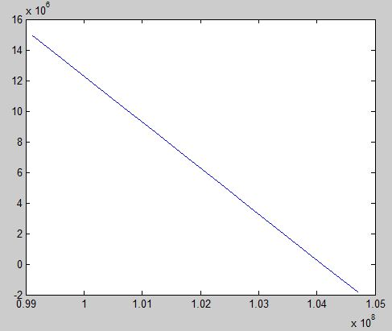
- plot(R,Gouy):


