Cavity spectrum: plan/curved mirror
Caculates the cavity spectrum and the frequency distance between TEM_00 and higher order modes m+n. Two curved mirrors possible. Programm made by T. Legero.

Parameter
- Radius of curvature of mirror R1: R1= 1 m
- Radius of curvature of mirror R2: R2= 1000000000 m
- Cavity Length: L= 0.48 m
- Reflectivity of mirrors: R= 0.99998
- Speed of light: c= 299792458 m/s
Step 1: Calculate the Free-Spectral-Rang and Gouy-Phase
- Free-Spectral-Rang: FSR
- Gouy-Phase: Gouy
⇒
- FSR = 312.284 MHz
- Gouy = 76.0824 MHz
Step 2: Calculate the frequency difference between TEM_00 and TEM_mn
- TEM mode number: mn
- Next TEM_00: w
- Frequency difference between TEM_00 and TEM_mn: Delta
- Define maximum of mn and w:
  - mn_max = 100
  - w_max = 100
- Define maximum of shown frequency difference to TEM_00:
  - abs(delta(mn,w)) < 10E6
- Frequency difference von (q-w)ter höherer Mode mn zu q-ter TEM_00-Mode (Matrix):
⇒
Freq. diff. of m+n = 4 higher order mode to 00-mode is 7.95436 MHz
Freq. diff. of m+n = 37 higher order mode to 00-mode is -4.49309 MHz
Freq. diff. of m+n = 41 higher order mode to 00-mode is 3.46128 MHz
Freq. diff. of m+n = 74 higher order mode to 00-mode is -8.98616 MHz
Freq. diff. of m+n = 78 higher order mode to 00-mode is -1.03181 MHz
Freq. diff. of m+n = 82 higher order mode to 00-mode is 6.92256 MHz
Step 3: Calculate the frequency difference between TEM_00 and the nearest TEM_nm
- Define the Modenumber of Higher-Order-Mode to plot (next Mode to 00):
  - mn = 3
- Define the Vary Mirror-Curvature:
  - R = 0.95:0.01:1.05
- Frequency difference between TEM_00 and TEM_mn:
- plot(R,Delta)[Important!]:
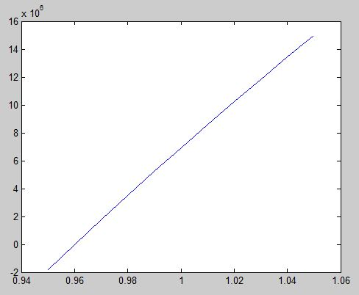
Achtung: ROC wird hoffentlich >1m werden, damit die m+n = 3 Mode weiter weg ist!
- plot(Gouy,Delta):
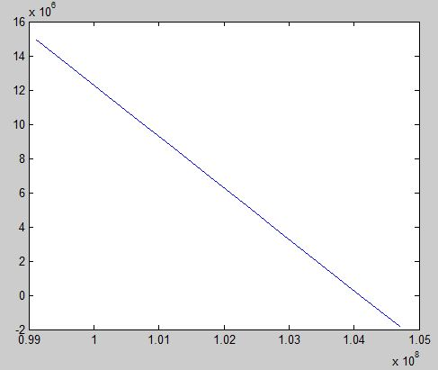
- plot(R,Gouy):


