Virtual/Transfer Beat Measurement

Scheme
Kerr-lens mode-locked lasers as transfer oscillators for optical frequency measurements, H. R. Telle et al., arXiv:physics/0107037v1 [physics.optics] (2001)
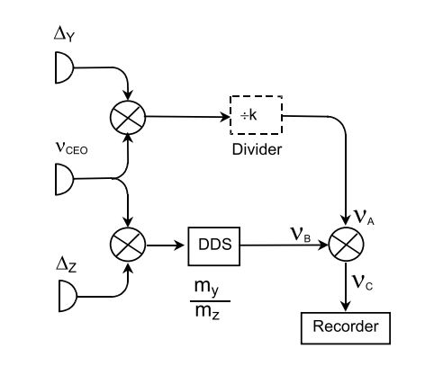

Theory
Equations for comb:
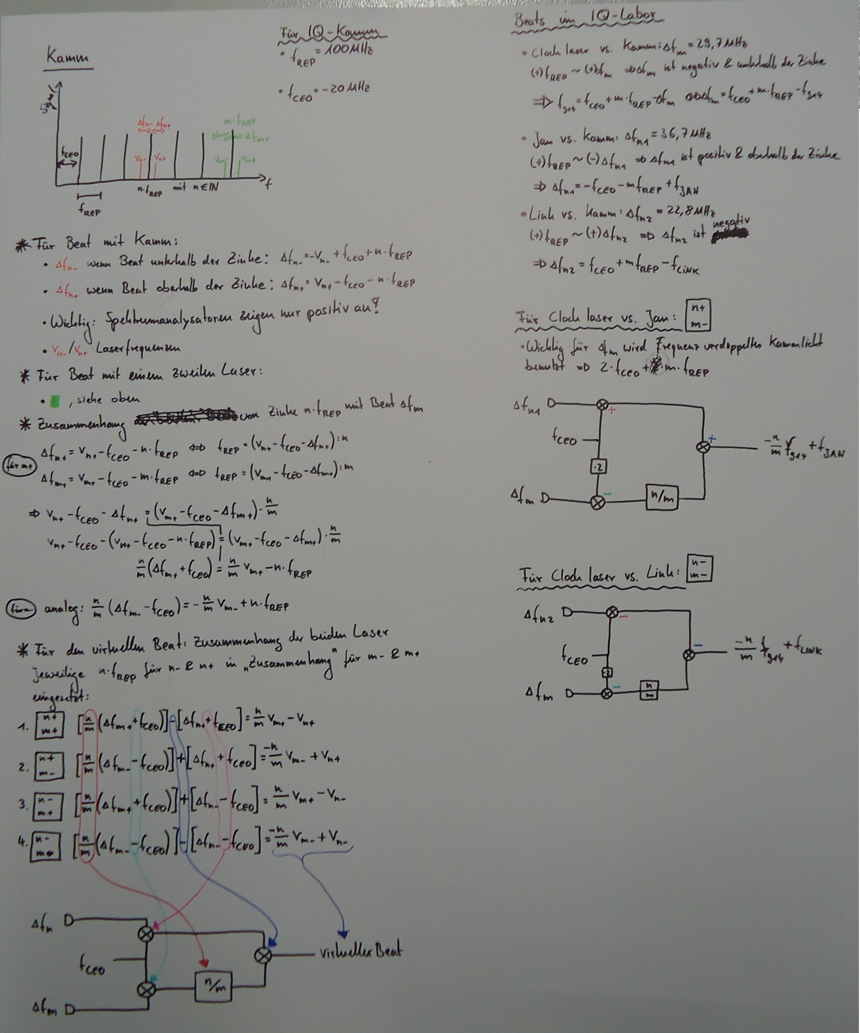
- For Total Virtual Beat double f_CEO
- Compare to Postprocessing Virtual Beat Measurement!
- You find a program, Virtual Beat, to simulate the virtuel beat under: \\afs\iqo.uni-hannover.de\projects\magnesium\Mathematica\Kamm

