TracerDAQ


DAQ Hardware settings
- Optimum: +/- 2V. If there is more voltage, then are the resolution of the fluctuation bad.
- You can change the time-range in the program TracerDAQ

Software settings
- Select Strip Chart
- Push Run
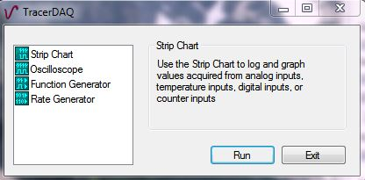
- You can change the range under: Edit → Scan Rate/Trigger Settings
- Push OK
The memory will be very fast full for high scan ranges!
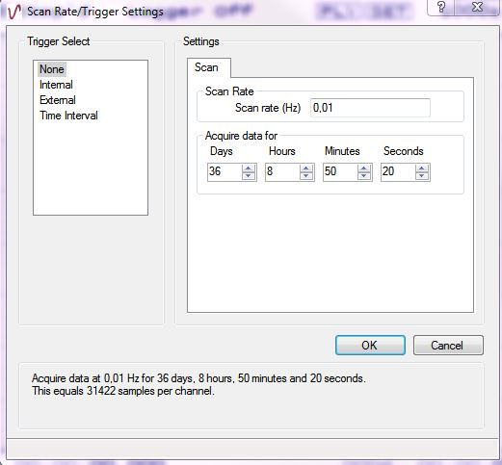
- You have to set the DAQ Range/Mode (=Input Voltage) to the right value!
- In this window, you can see the error messages, like not connected!
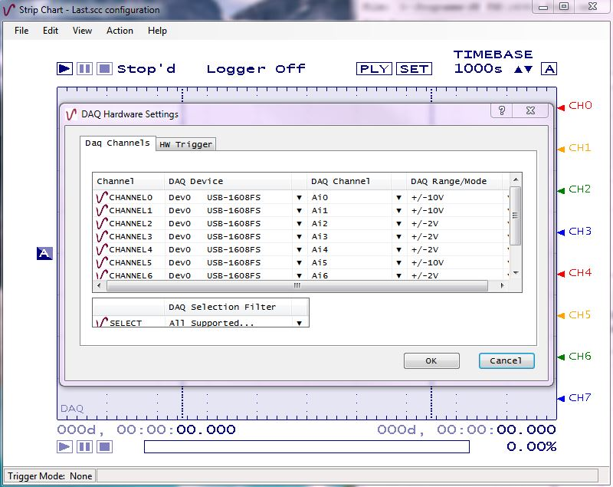
- Push Play/Start
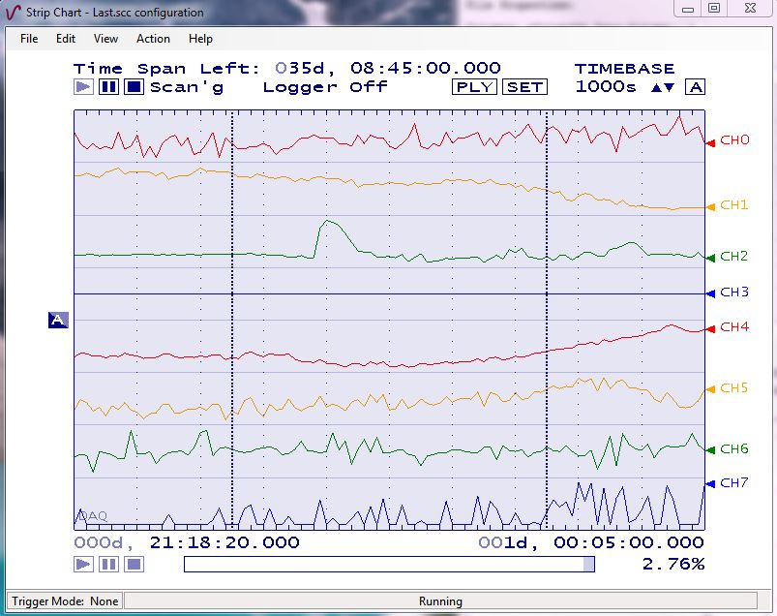
Channels on RedLab-Card:
0: R1 Inner T OOL
1: R2 Inner T OOL
2: R1 PDH Out
3: R1 Intens Out
4: R2 PDH Out
5: R2 Intens Out
6: R1 Vacuum
7: ECDL
Current Setup: Check Dokumente Folder

