NetView
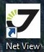
For starting Net View klick only once and wait, the program needs time !
If Net View doesn´t start, then restart the computer!
“Connection”-window:
“GPS receiver”-button must be selected.
Push “connect”-button.
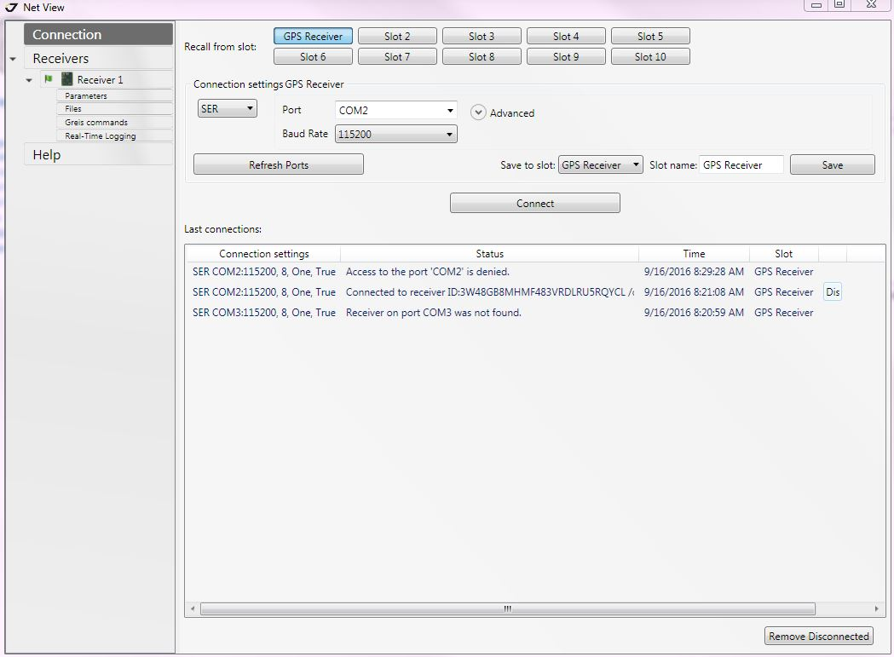
“Receiver”-window:
The “Measurements”-button/setting shows the coordinates of the satellits.
The “Skyplot”-button/setting shows the connections with the satellites and the names.
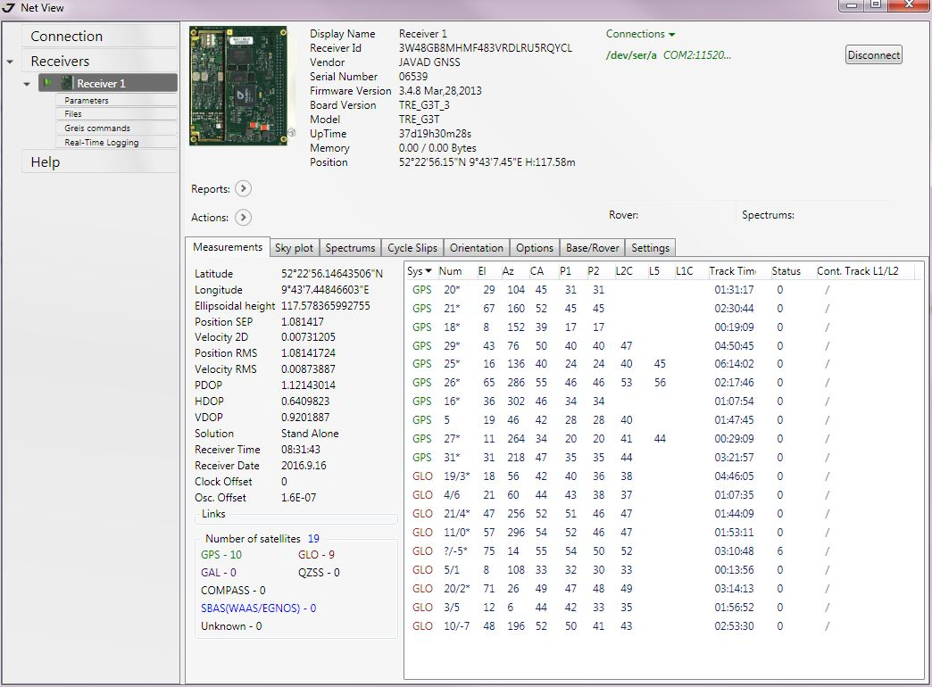 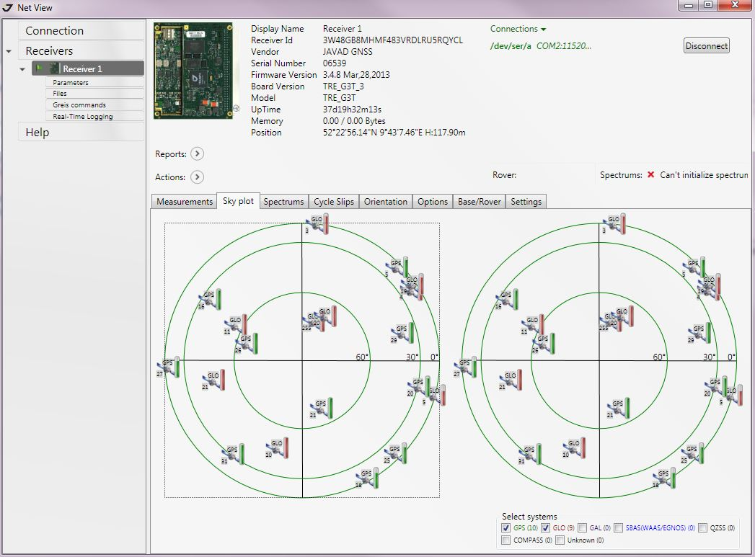
You can change the refernce frequency from “Empfänger 1” under “Parameter”-window → “Advanced”-button → “External frequency”-button.


