Monitor VCH-1006
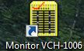
Apllication: Control Software for H-Maser
Notes:
- one entry is always red! Andreas Bauch doesn´t know the reason, but it´s okay!
Check also: HMaser (PHM-H7)

