Fiberlaser
Close the program “Fiber Comb Control” and lock out the CEO- & REP-PID in the rack, otherwise you can´t optimize the comb!
- Push Yes
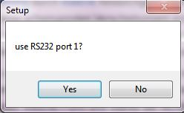
- Push OK
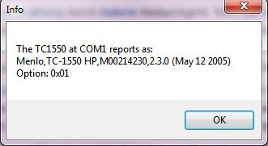
- If you turn off and on the freuqency comb, then push in the order:
  - Reset
  - Auto on
  - Enable on
The program is done, if all four boxes [Laser on, Modelocked, Autoscramble, Enabled] are green!
- For closing the software:
  - Halt
  - Freeze
  - Now you can optimize CEO-frequency, therefore play with the arrows Stg 1-Stg 4 for the squeezer. Thereby you have to show the CEO-frequency on the Specki and afterwards show the Beat-Signal with 914nm-laser. If one beat is bad, you found a bad modelock point! And don´t forget to optimize the Beat-Signal with 914nm-laser with the PCF and SHG controllers!
  - Close the window
- Possible problems:
  - If you can´t modelocked the laser. Don´t worry maybe the fs Laser and Amplifier is off. Then push:
    - Push Laser on
    - Push Amplifier on
  - If the “Scramble Settings arrows” don´t move and the step width are 0. Than change the “step width” from 0 to 3 or 5. Afterwards push the “ Send” button.


