Racks 2016

Rack 1
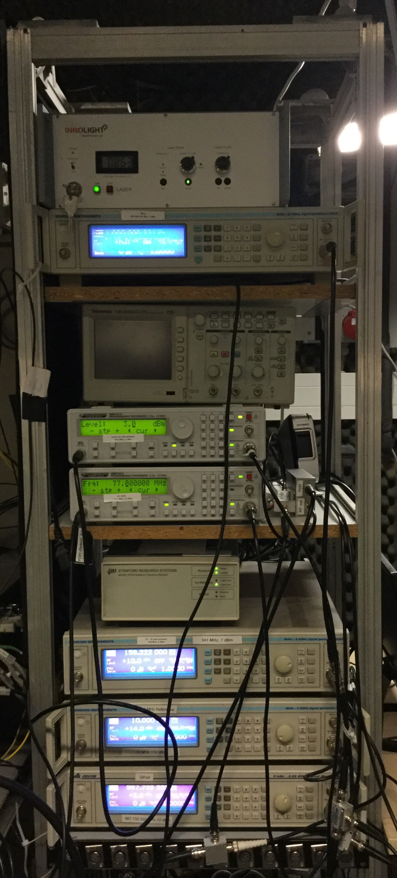
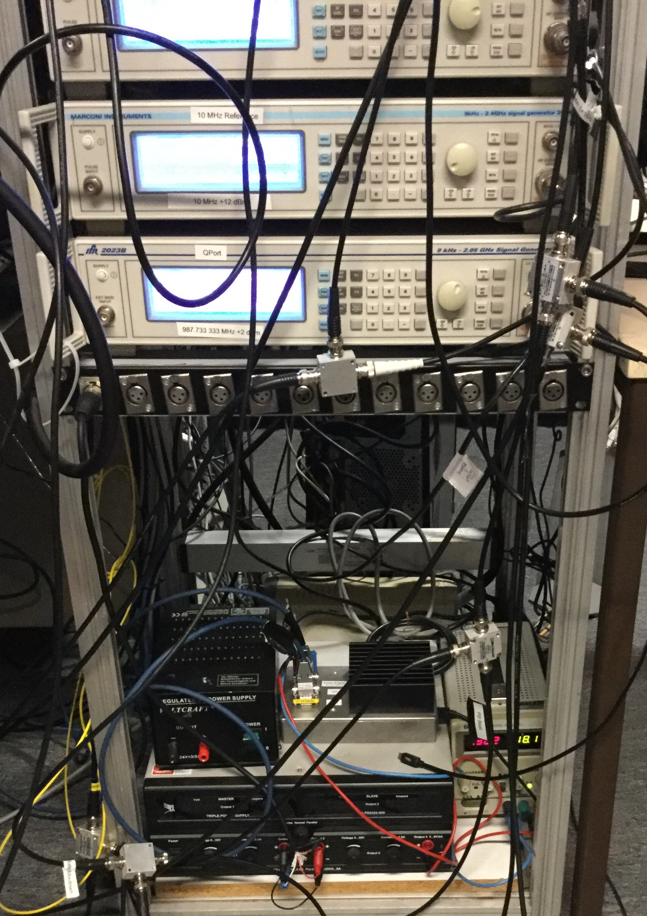
- Synthesizer (4xMarconi Synthesizer,2x “Rohde & Schwarz”)
- Rubidium clock from “Stanford research systems”
- Meerstetter temperature controller (R1&R2)
- 1064nm laser from “Innolight” (Q-Port)

Rack 2 / Frequency comb
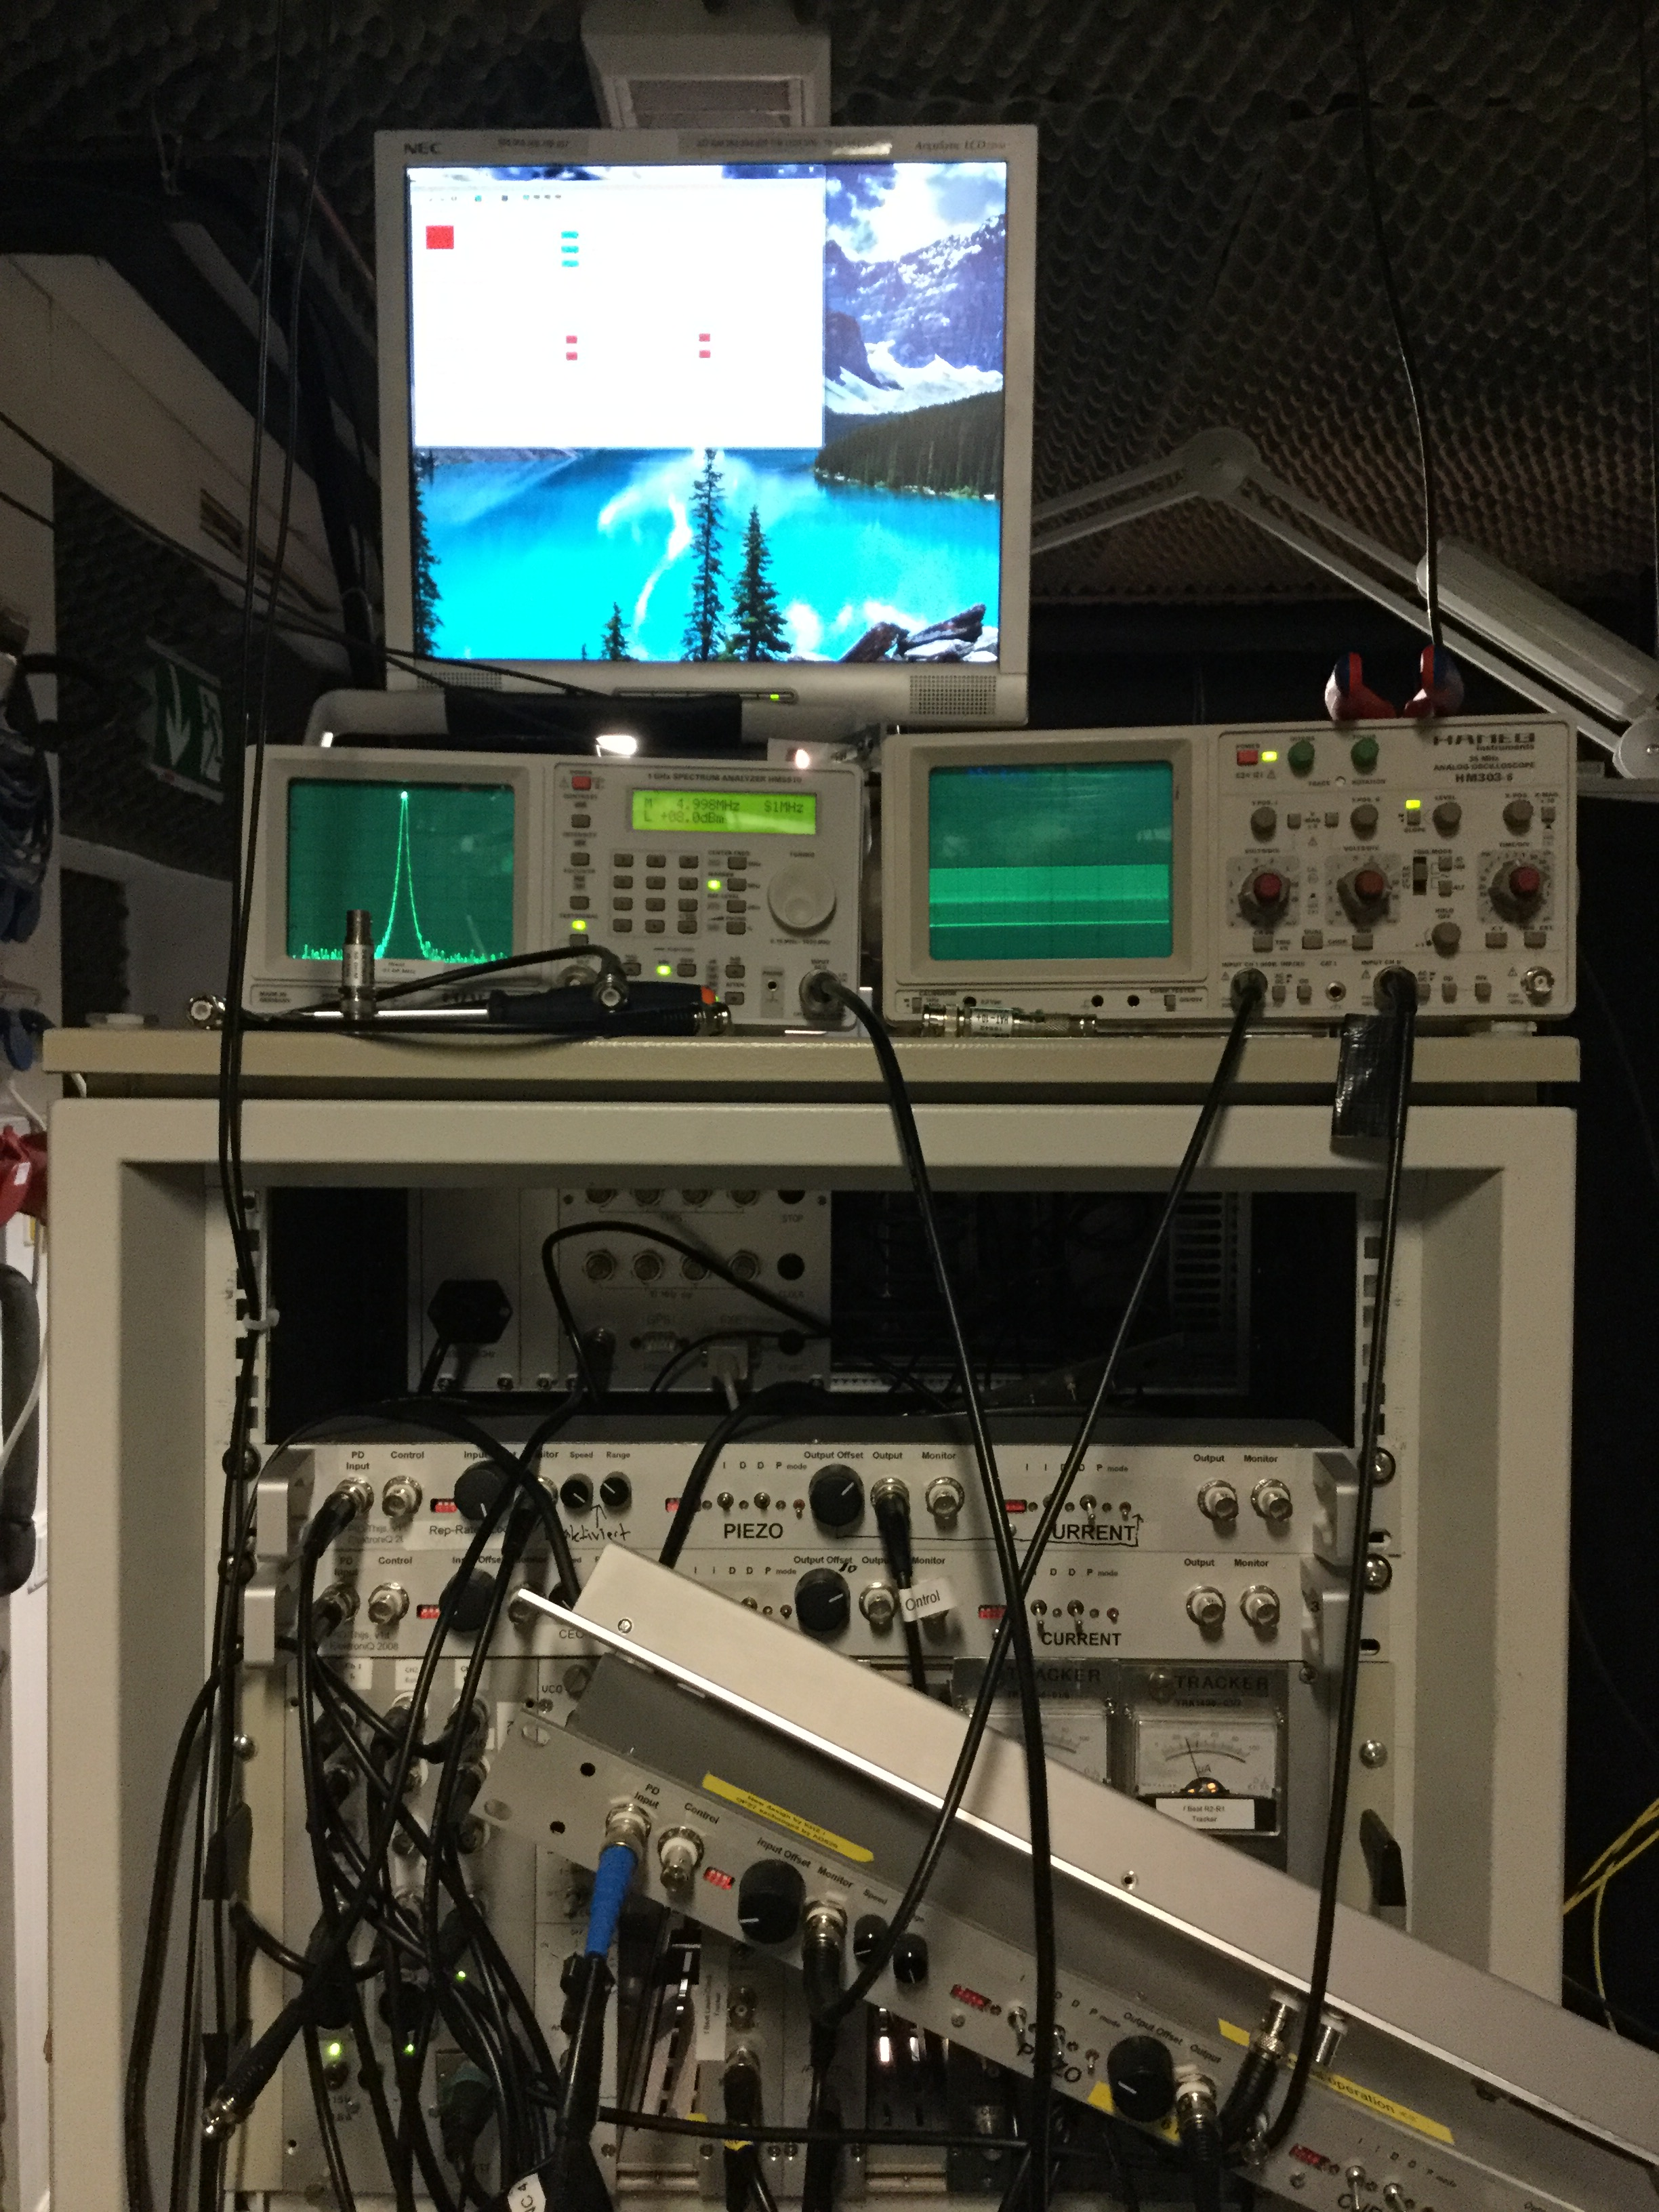
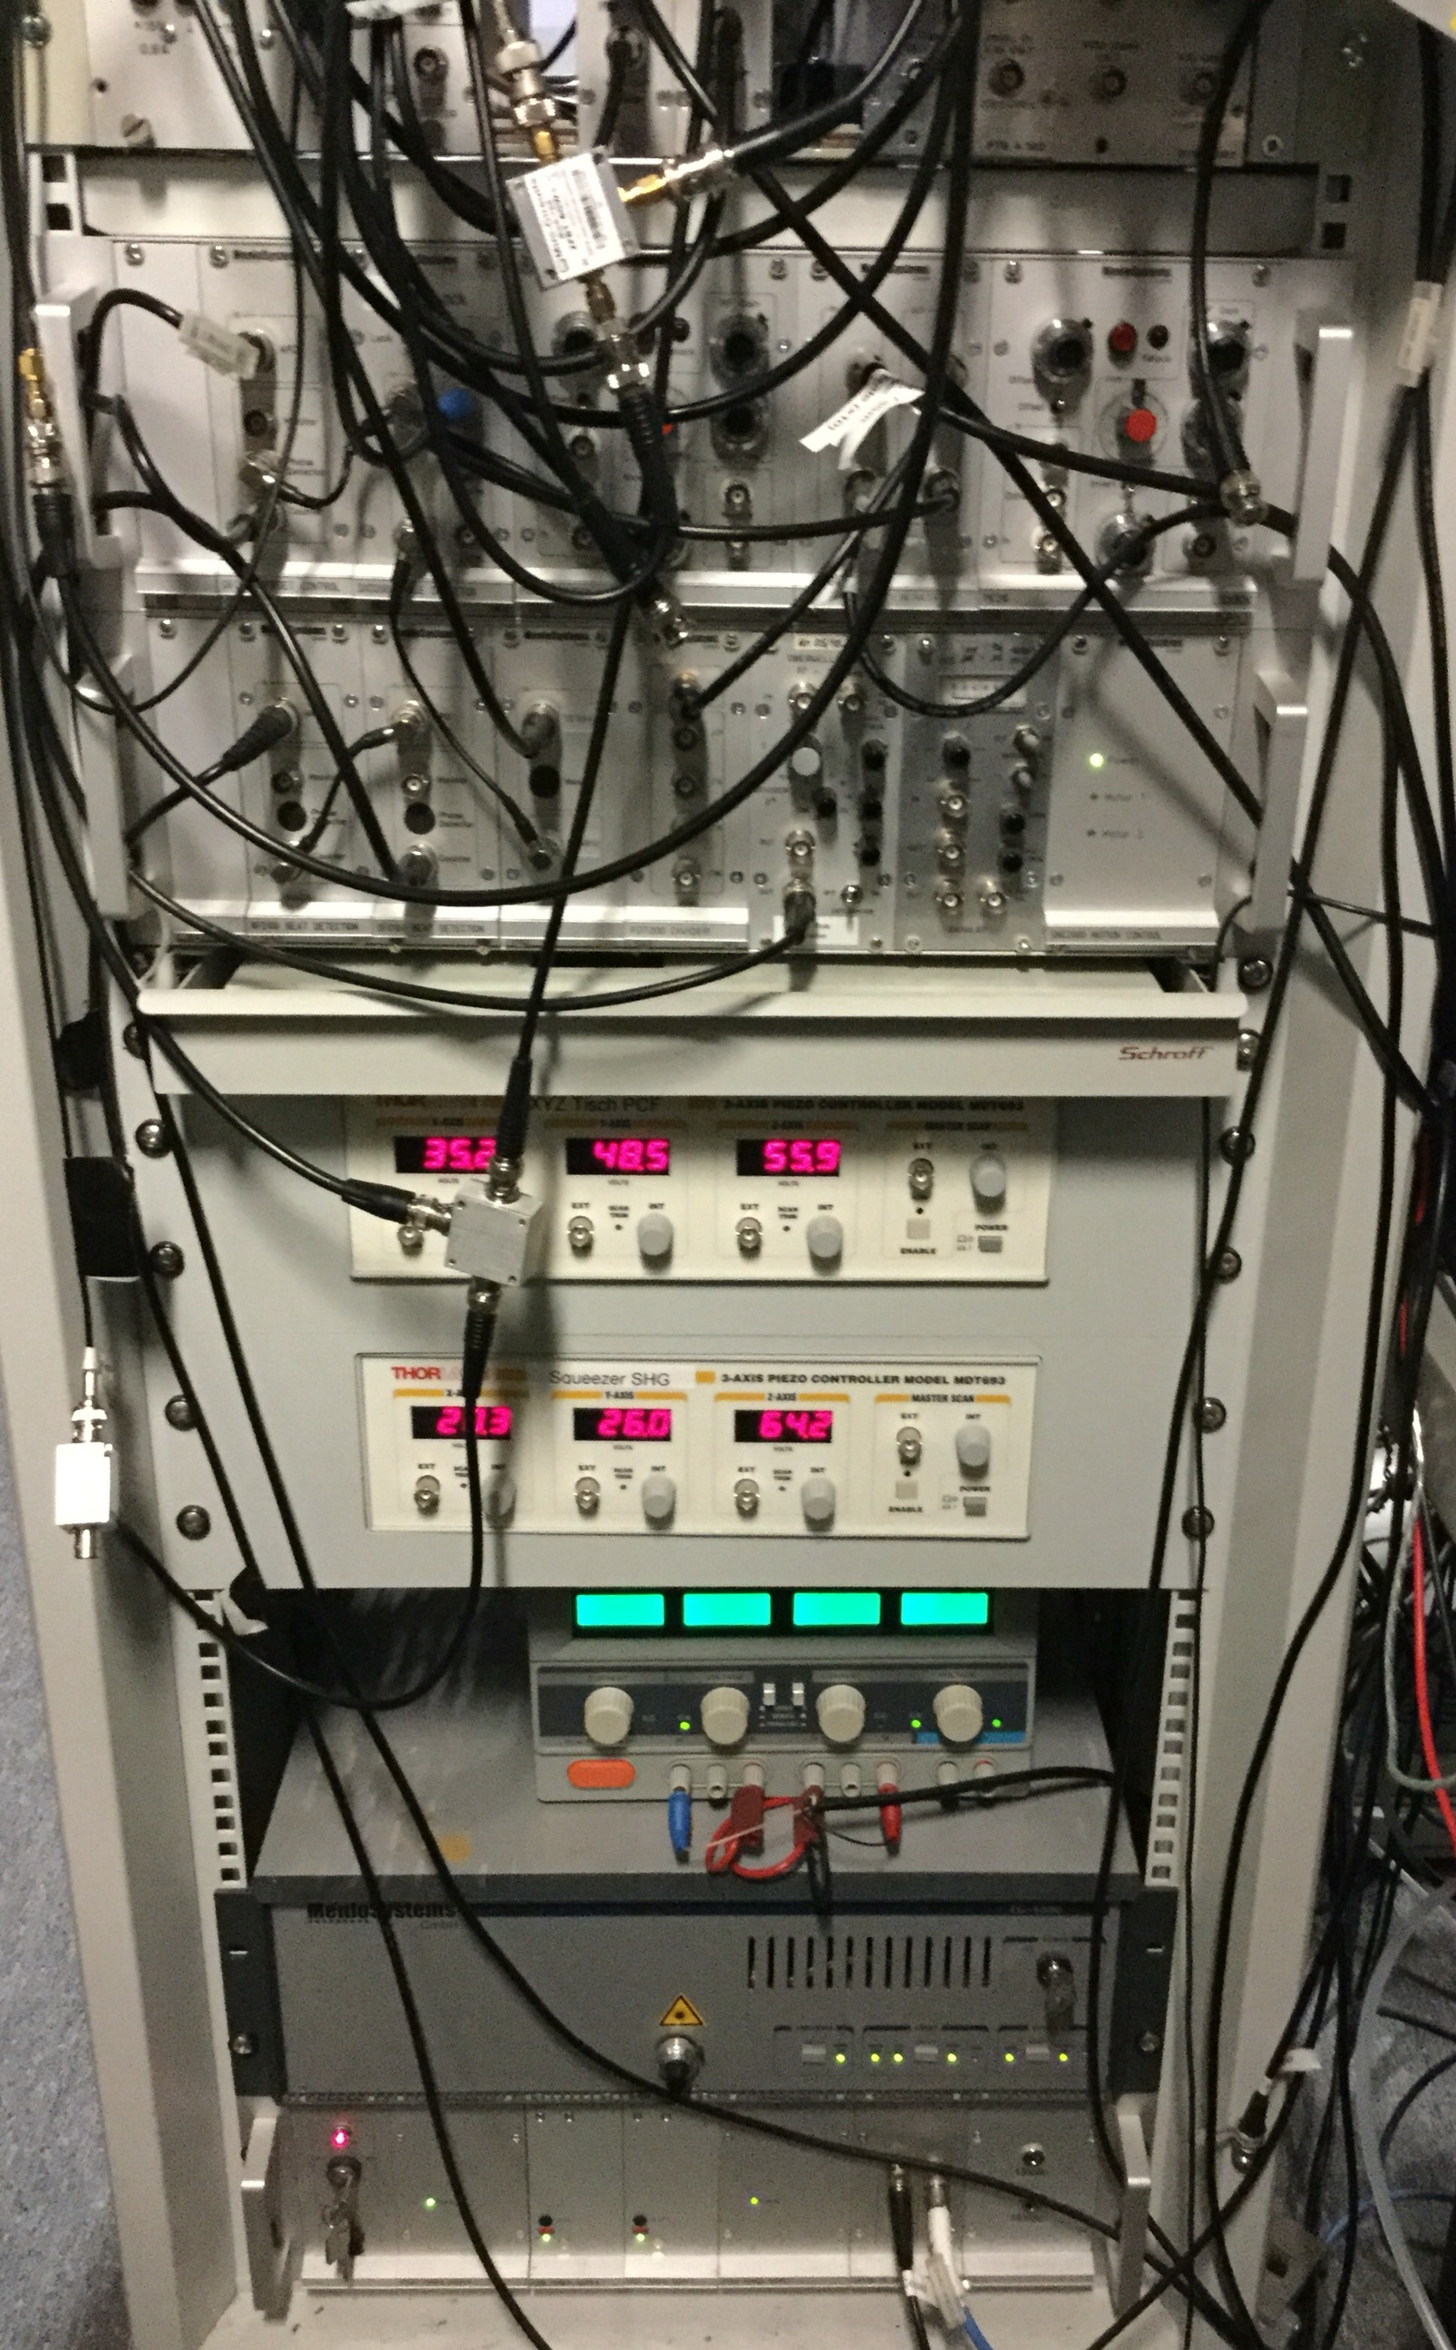
- Control electronic for frequency comb
- GPS receiver
- OCXO
- 10 MHz distributor
- K+K counter
- Tracker|Tracker
- DDS

Rack 3 / Clock laser
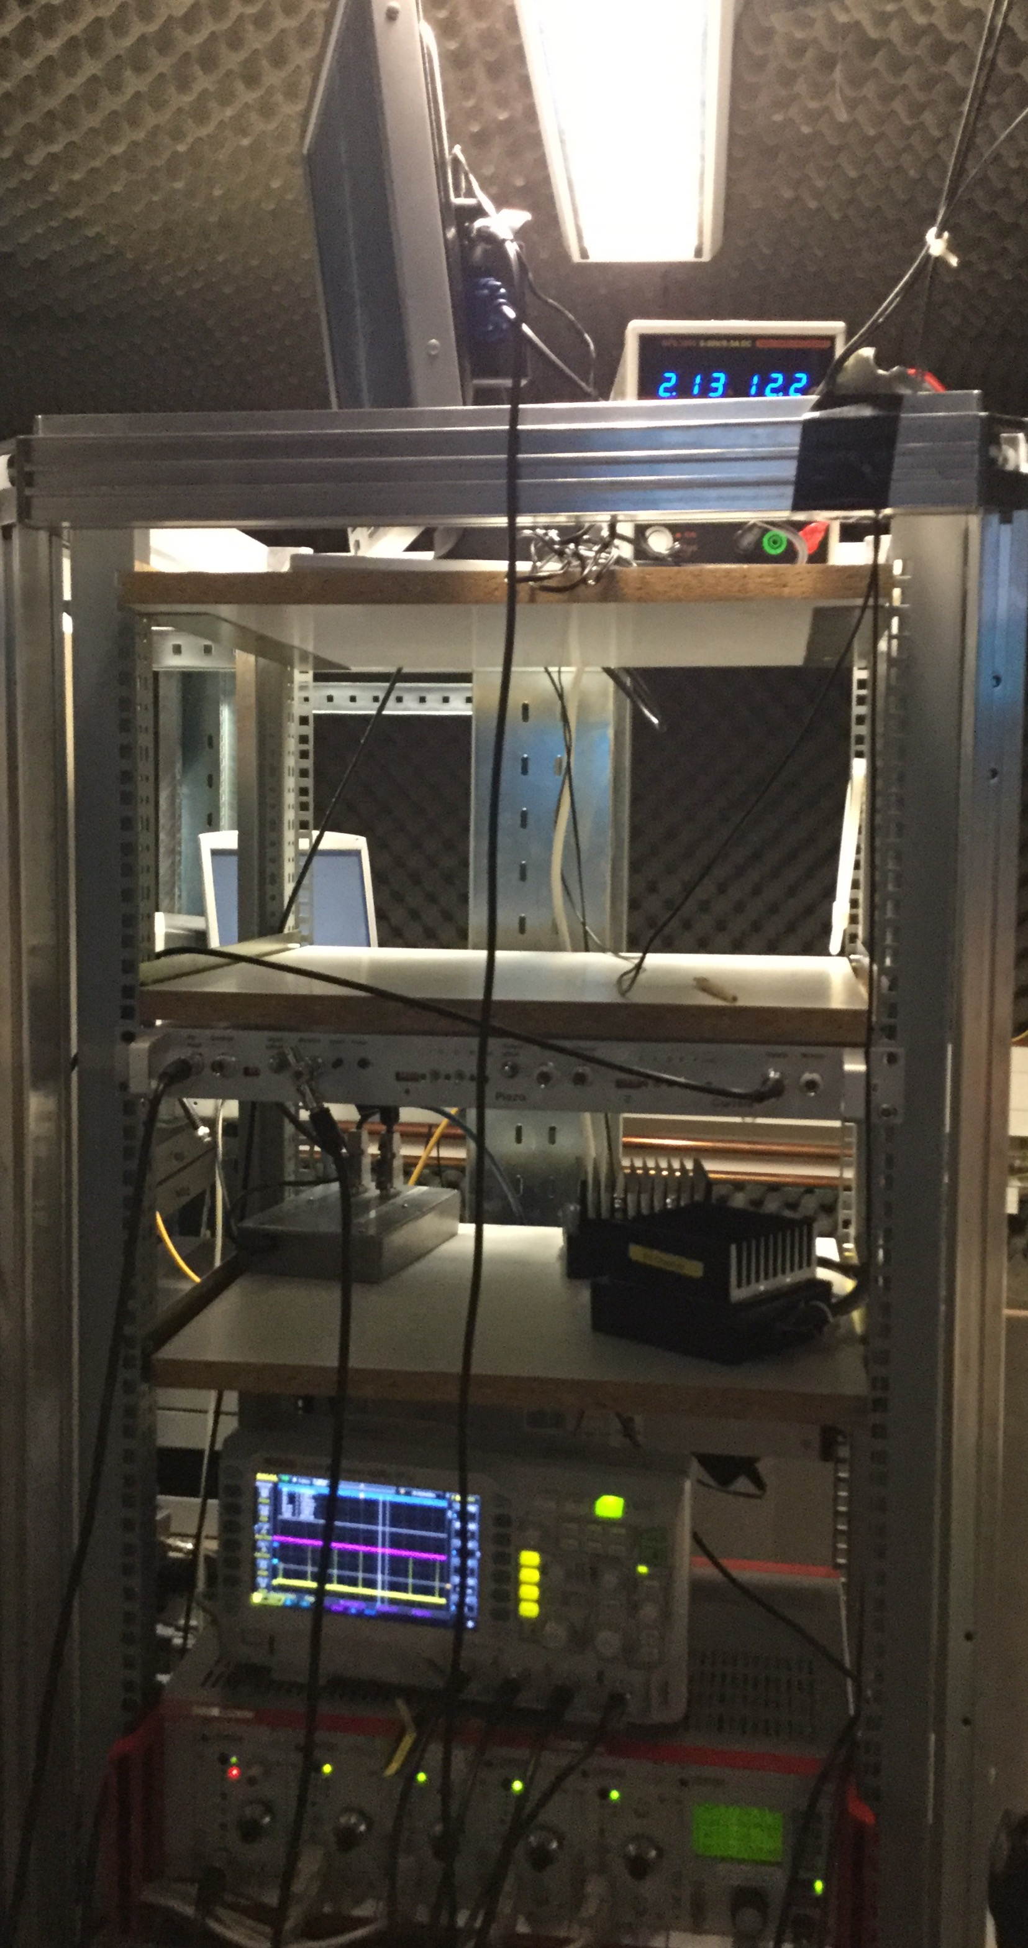
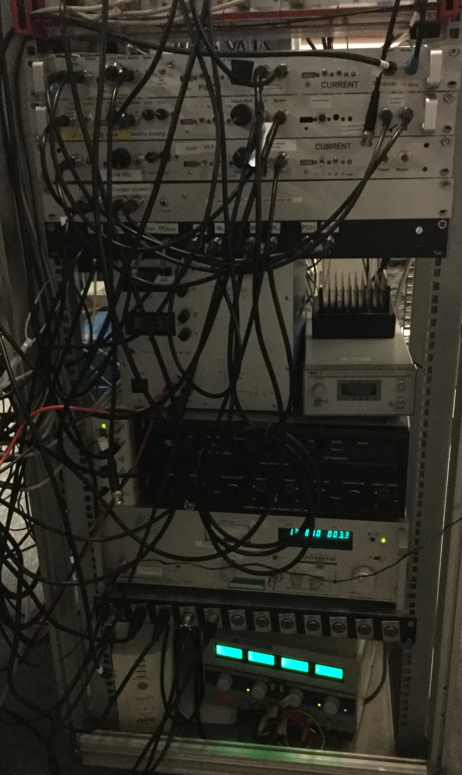
- Out of loop temperature-measuring instrument from R1 & R2 ???
- Meersteter temperature controller (ECDL)
- Fiber stabilisation PID
- RAM-PID ???
- Intensity locking for R1?
- TA stabilization???
- kleine Kiste???
- Synthesizer?
- Thorlabs control instrument for laser diode and TA
- Wavemeter (Model: Wavelength meter WS-6, Ångström, HighFinesse) Welches Model Genau?
- Laptop “ResLab Mobil”
- Monitor for CCD-Cameras (R1&R2)

Rack 4 / Cavity
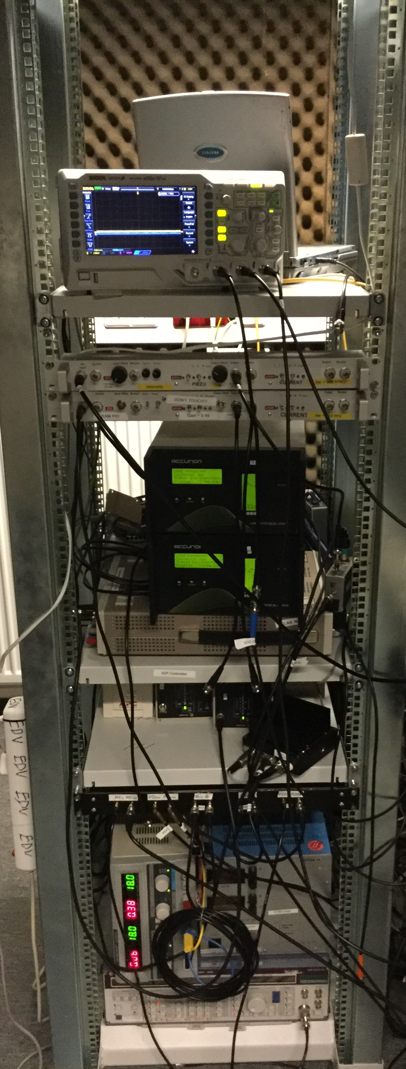
- Intensity Lock PID for R2
- RAM-PID for R2
- 2x aktiv vibration isolation controllers
- 2x IGP controllers
- ME-Redcard instrument
- Synthesizer
- PDH-Lock (Mixer, Phasenschieber, PID) R2

Rack 5 / Amplifier
- 5x amplifiers (Modelnummer, Datasheet, welchen Verstärker für was mit Eingang und Ausgang dBm)
- power supply (max. 5A)
- power distributor box

