Photodiode
- idea: Thorlabs tubus system
Some things have to be noted:
- the photodiode type Hamamatsu S5971 (Datasheet: s5971_etc_kpin1025e.pdf) was used
- The optical couplers´(OPs) are limited by non-linear behavior over 3 V
- limited by 1 MHz by Weber-PD
Differences to PD-Hobbs 1.1
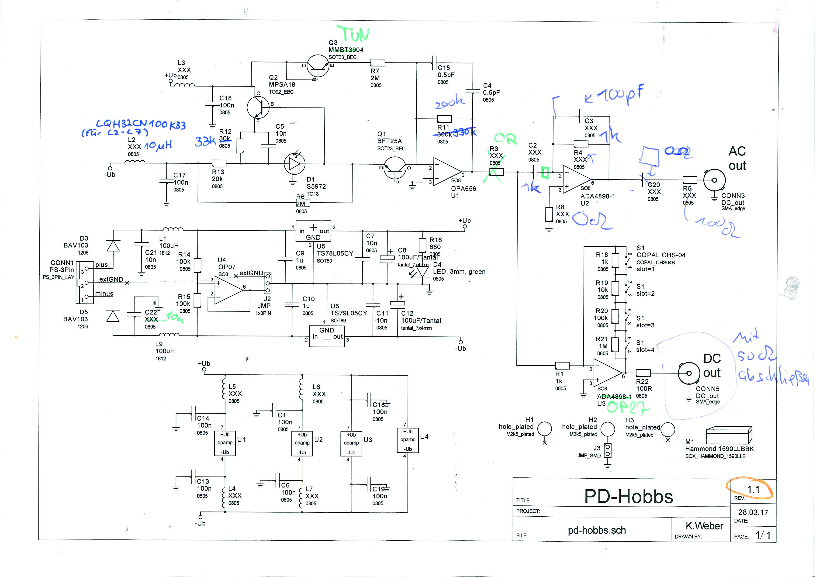
- optical amplifier:
  - 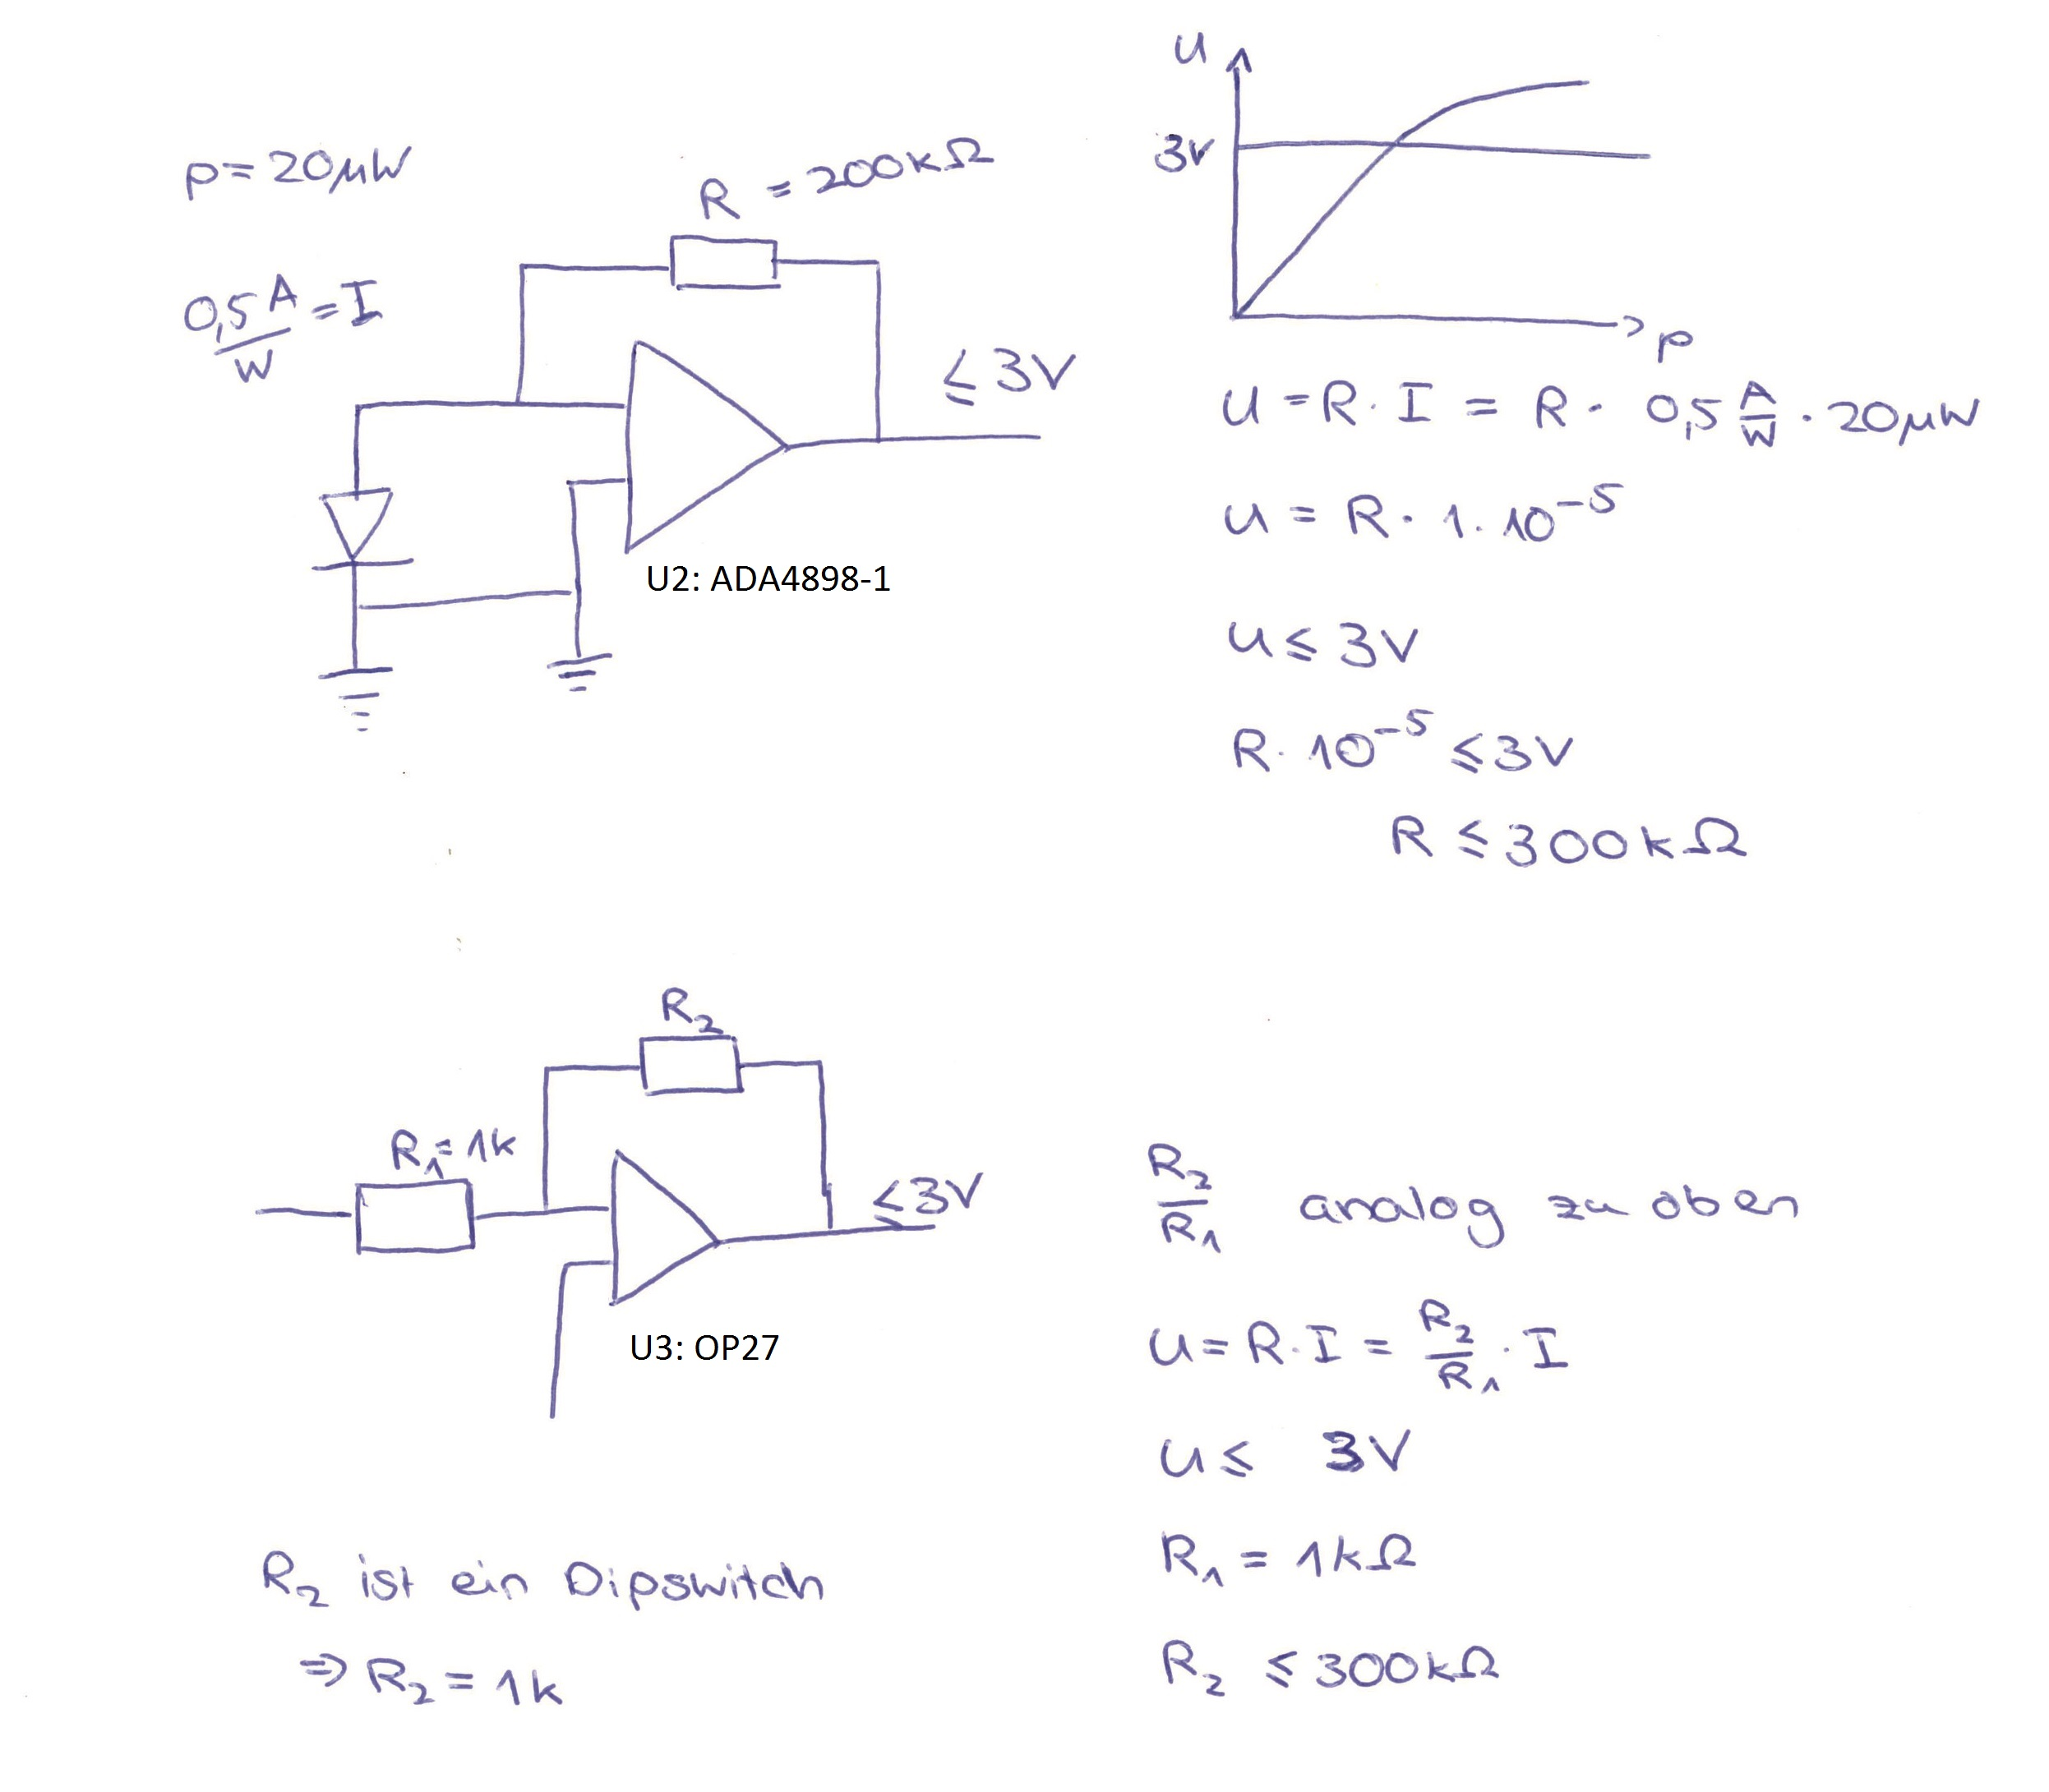
  - The optical amplifiers are limited by non-linear behavior above a voltage of 3V
  - For the optical amplifier “ADA4898-1” at U2 following resistors and capacitors have to be placed, so that 3 V aren't overridden:
C2: 1 kΩ, C3: 100 pF, R4: 1 kΩ, R8: 0 Ω, C20: 0 Ω, R5: 100 Ω
  - For the optical amplifier “OPA656” at U1 the resistor R11 has to be changed to 200 kΩ
  - instead of the optical amplifier “ADA4898-1” the “OP27” is used at the position U3
    - KMK said: “OP27” is cheaper and reacts not as fast as “ADA4898-1”, but fulfills the wanted application
  - For the optical amplifier “OP27” at U3 only slot 1 at the dipswitch has to be turned on.
During the setup of the photodiode, this dipswitch was changed, as the capacity of the incoming light was lower than expected. So now slot 2 is turned on instead of 1, so that the amplification factor is 10 instead of 1. (info: not shown in the picture below)
- for the coils L2 - L7 the type “LYH32CN100K33” with 10 μH and max. 80 mA has to be used
  - KMK said this
- instead of the transitor “MMBT3904” the transistor “NC847C” is used at the position Q3
  - KMK said this. A transistor with such high specifications isn't needed here. A “normal” one is completely enough.
- the resistor R3 is not useful in this place, so a 0 Ω resistor has to placed there.
  - The resistor R3 is used for the amplification at the AC output. But on it's current place, it also affects the amplification of the DC output. So it should be shifted behind the condensator C2 in order to work for the AC output.
- a 50 Ω resistor has to be placed at the DC output, in order to measure a signal at the AC output
  - This is used, so that the DC output doesn't work as an antenna
- if GND should be connected to the case, the soldering points J3 next to one of the screws have to be soldered together
- the position of the jumper “J2” depends on the power supply. If an external GND excists, then it should be positioned on pin 1 and 2 (like seen in the picture below)
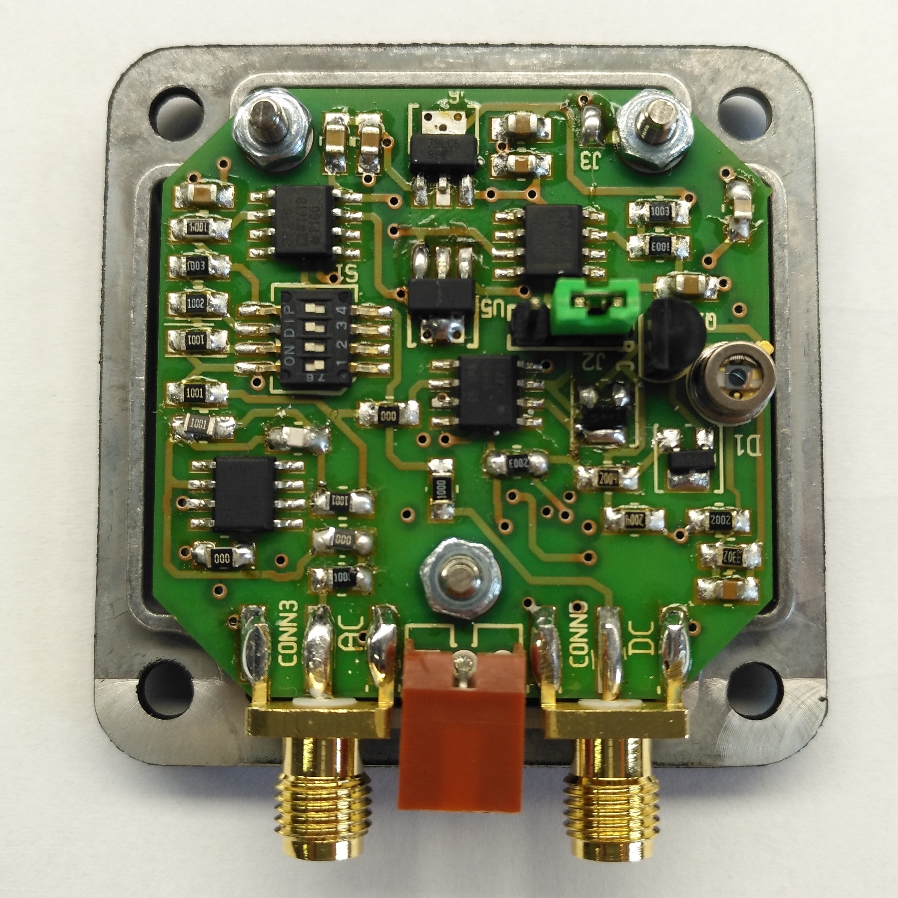Vorderseite
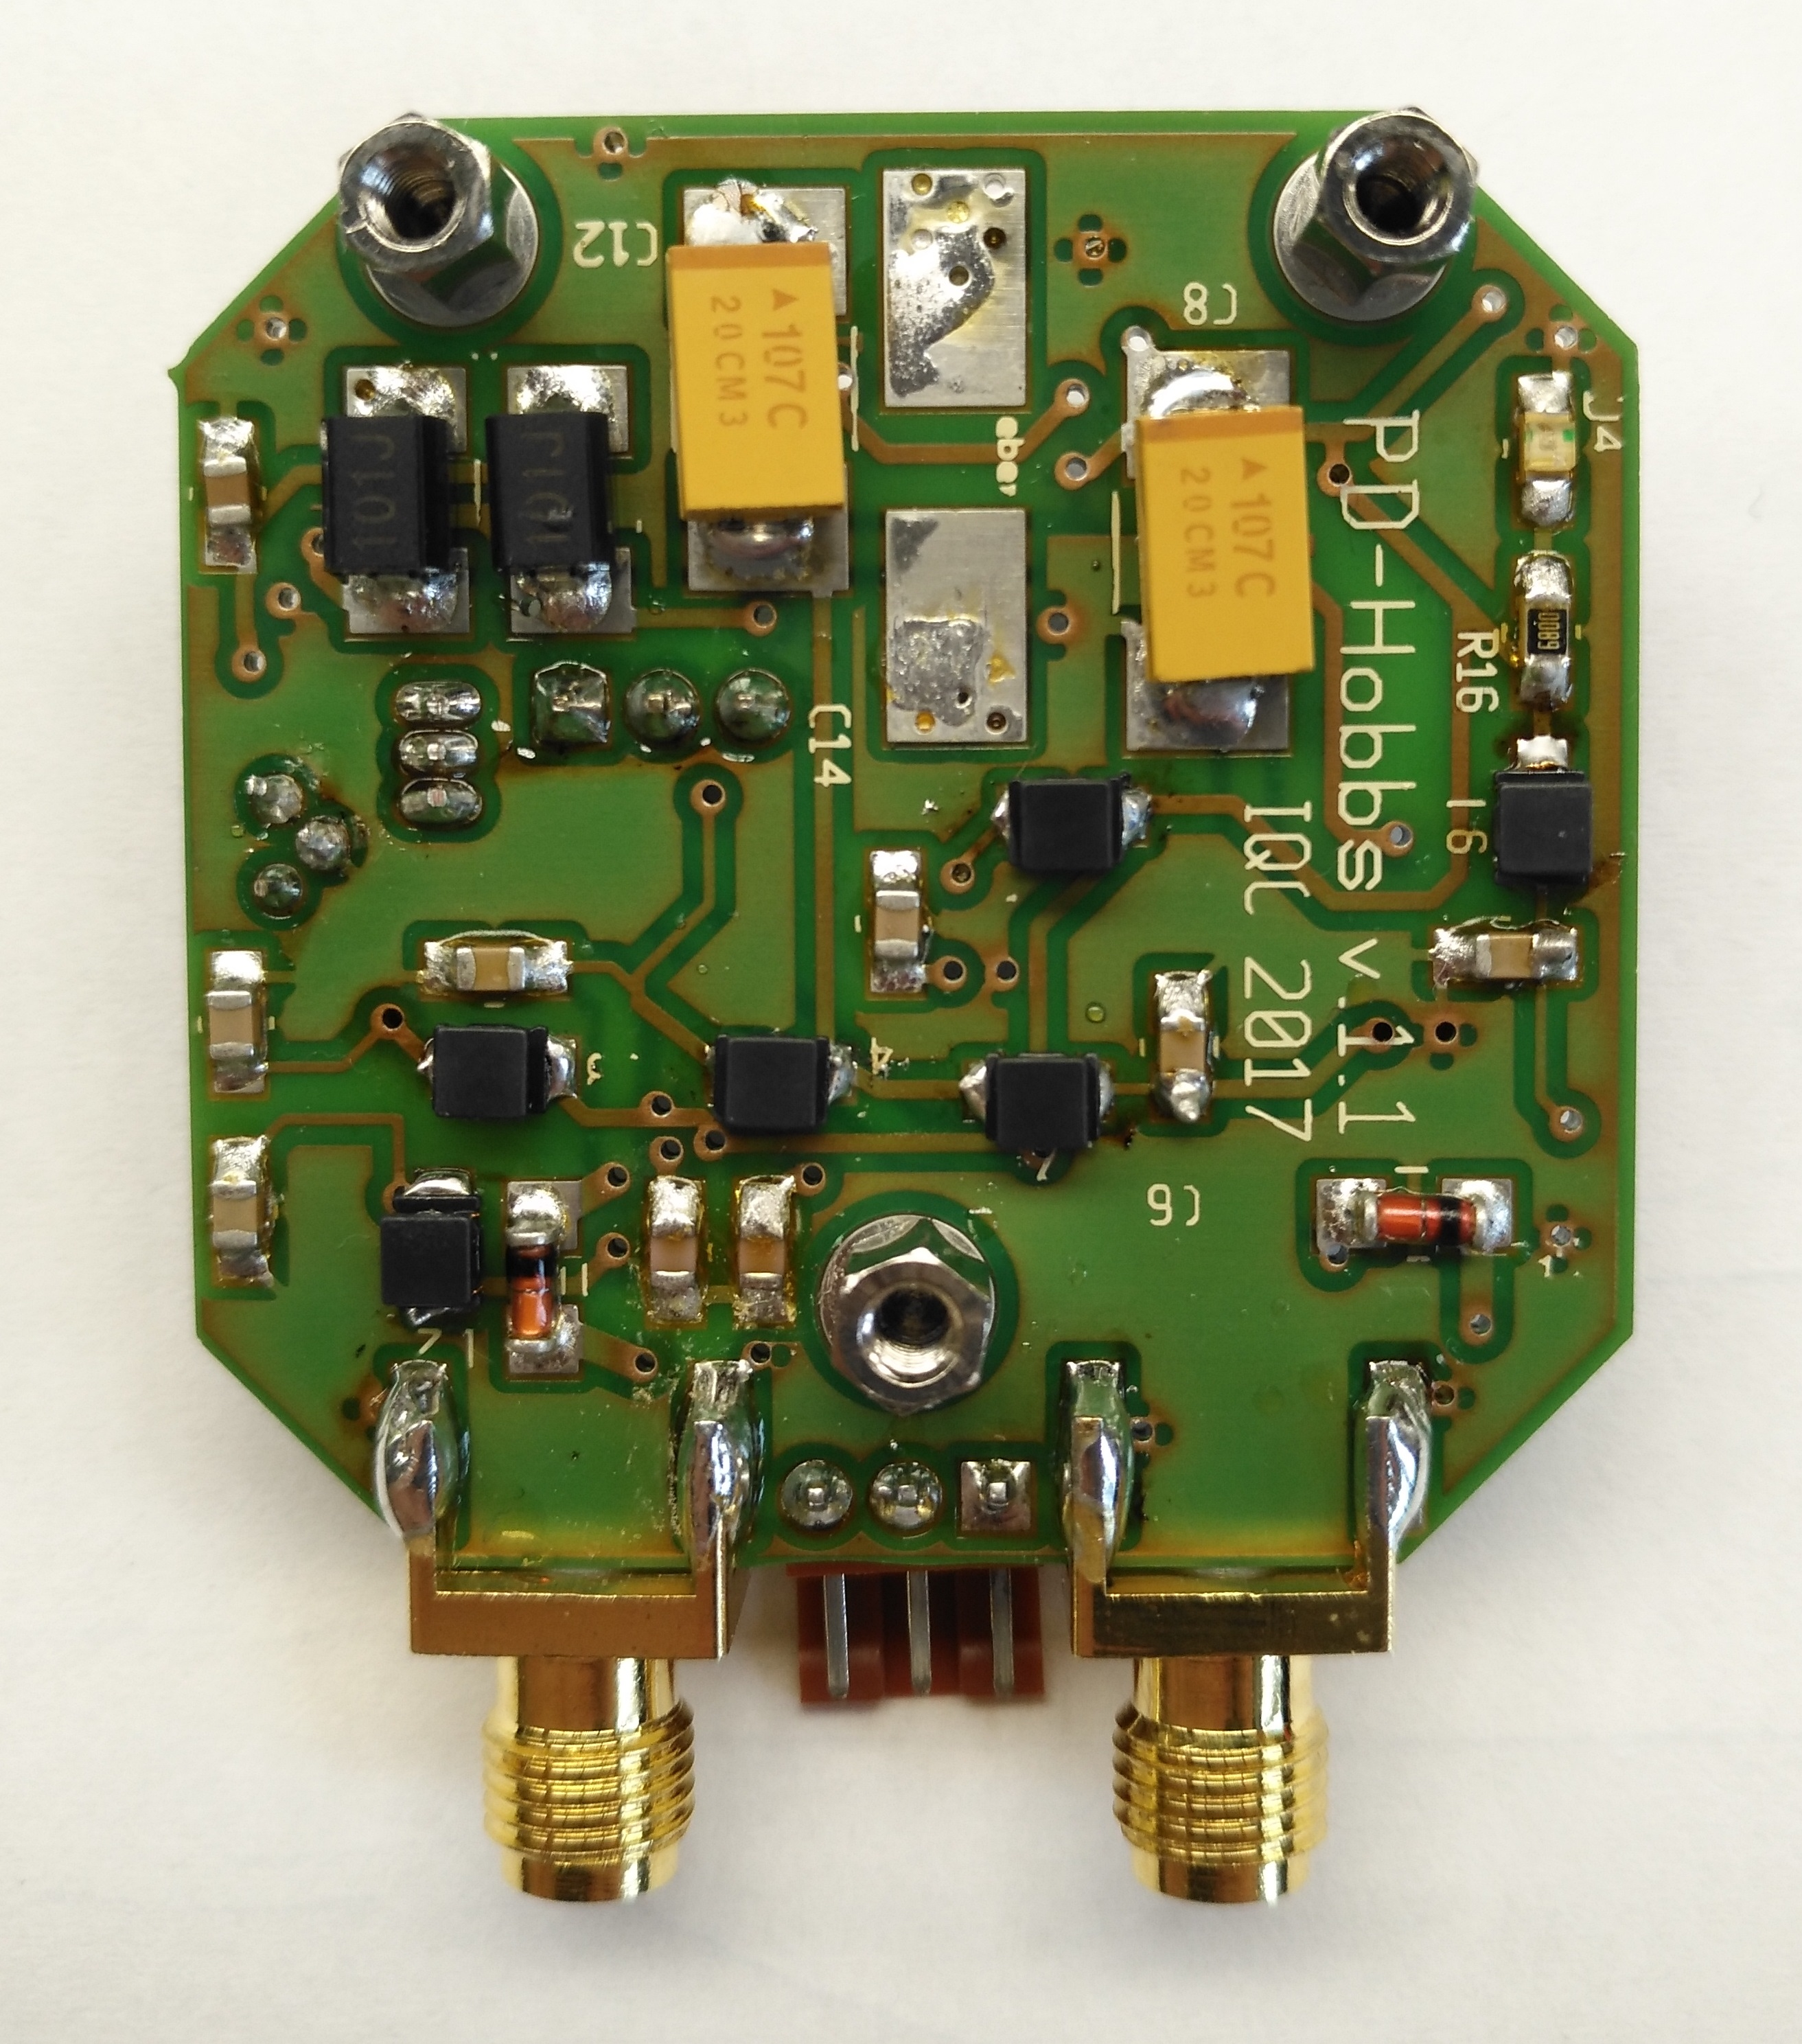Rückseite
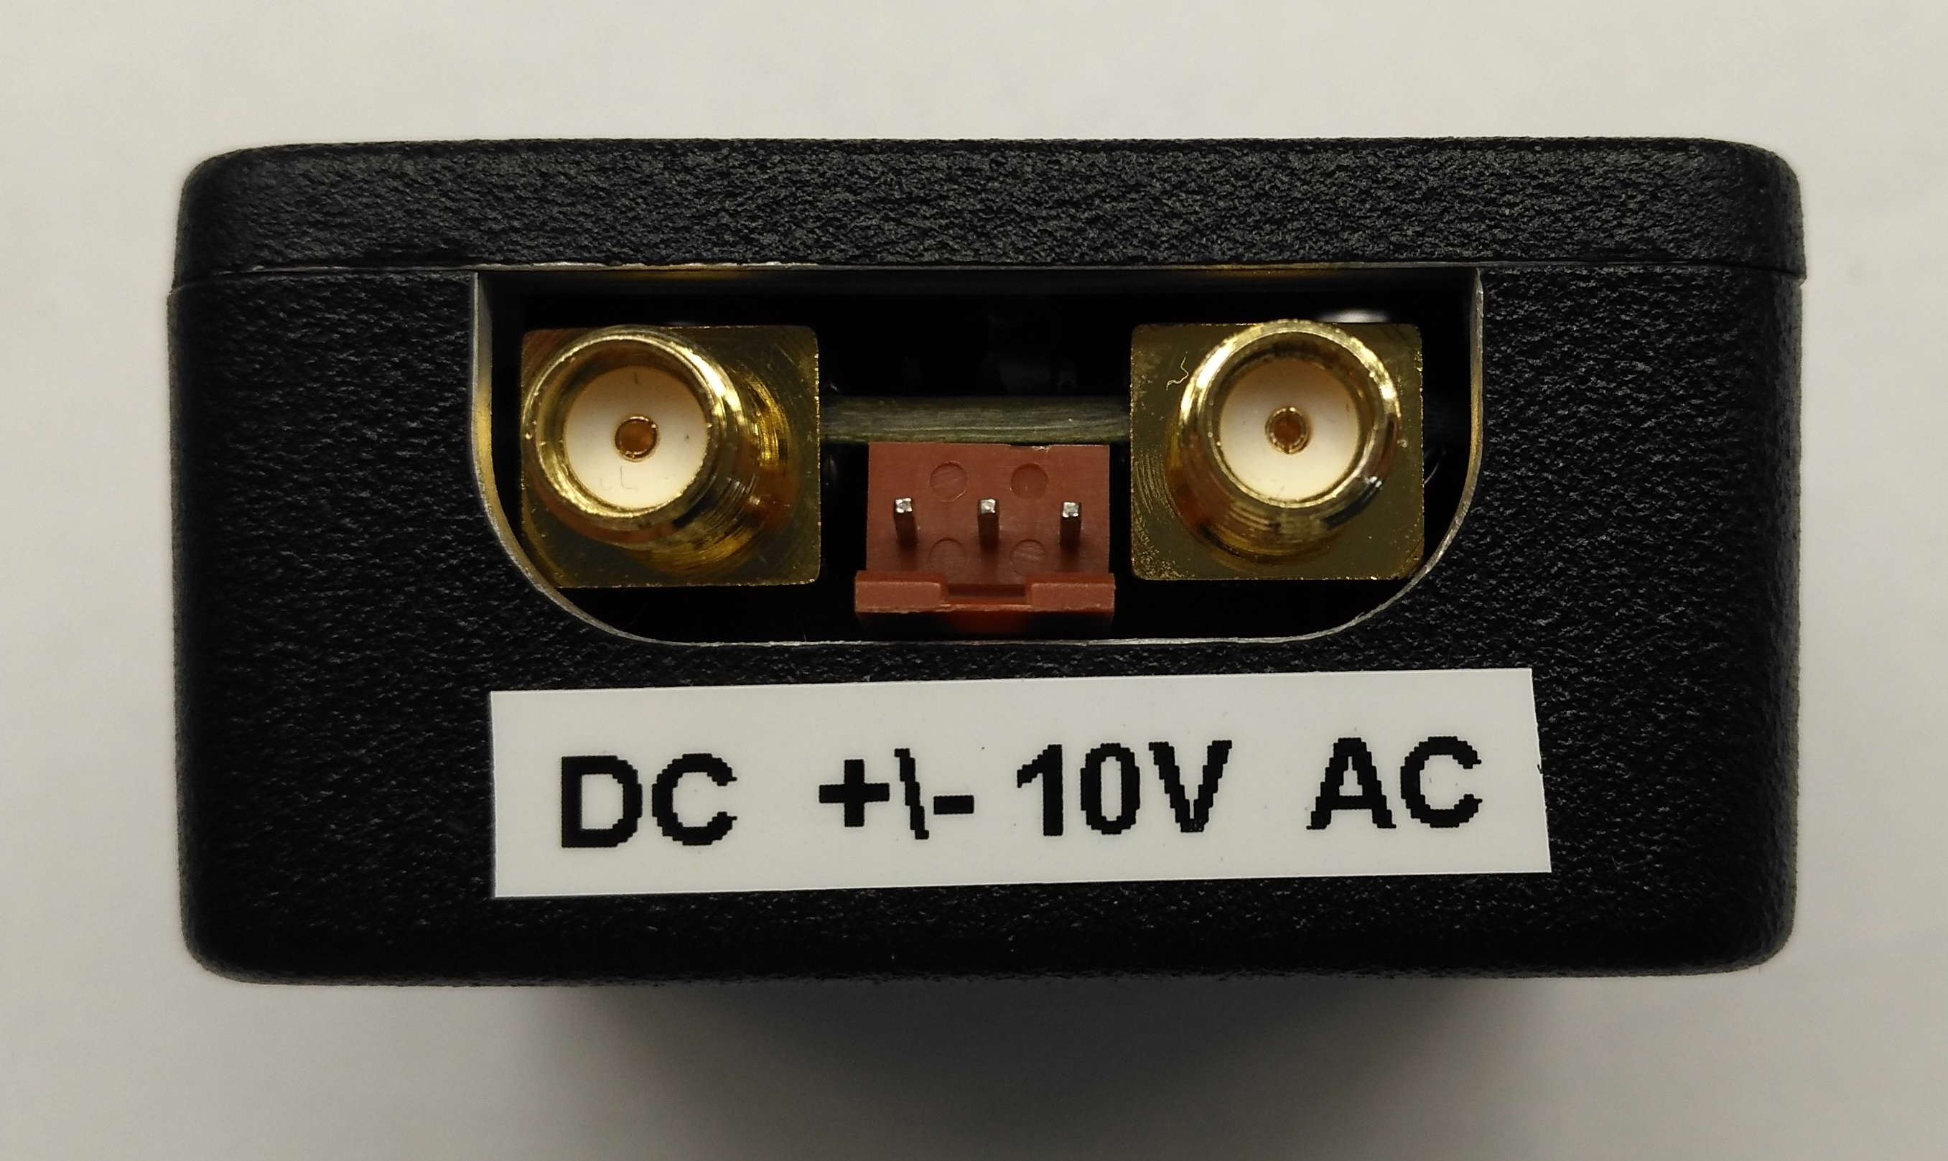
- the photodiode needs a power supply of +/- 10 V.
- The Photodiode is screwed to a post but they are not connected electrically. This is done by a plastic isolating bush and a plasitc washer
- In front of the Photodiode this filter is glued to the case: FGL850S
Update
- Vorherige wurde von Klaus basierend auf Bätje designed.
- Vorteile vom Hobbs-Design
  - driftärmere Bauteile (OPs)
  - Schaltung wurde driftarm designed
  - kleinere Photodioden (Fläche)
    - kleinere Drift
    - weniger Dunkelrauschen
    - nach Paper nahe dem Schrotrauschlimit
  - Eingangsspannung wird gefiltert (Klaus hatte dies bereits in seiner Photodiode)

