Multi lowpass filter
Multiple RC lowpass filters with different cutoff frequencies to switch between.

Application
- Vibration sensitivity measurement
- Errorsignal for Locks
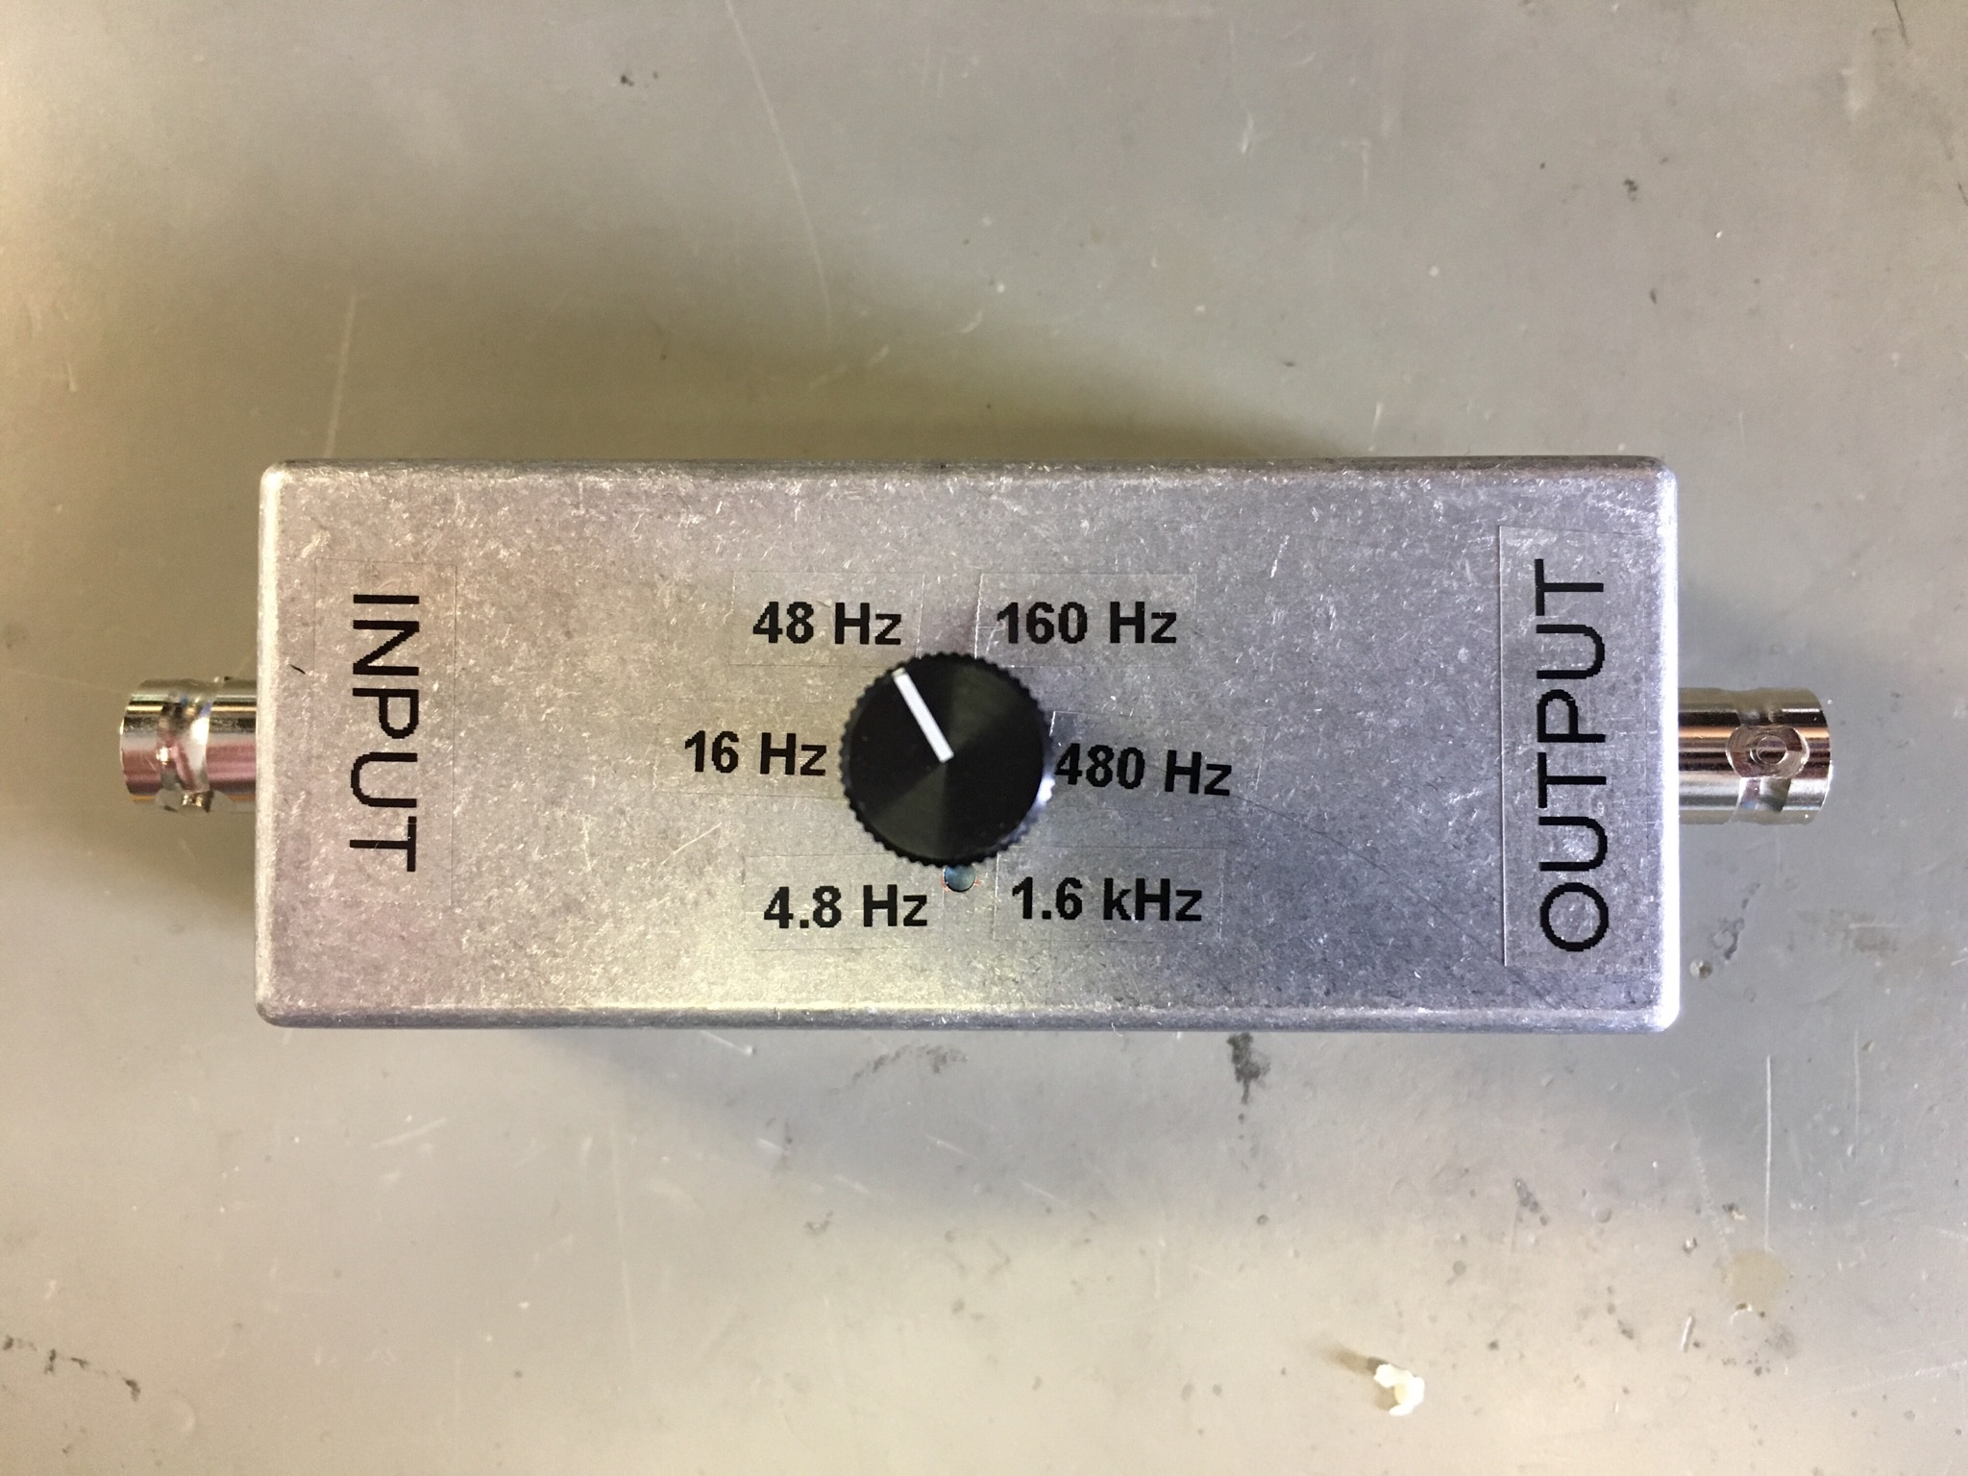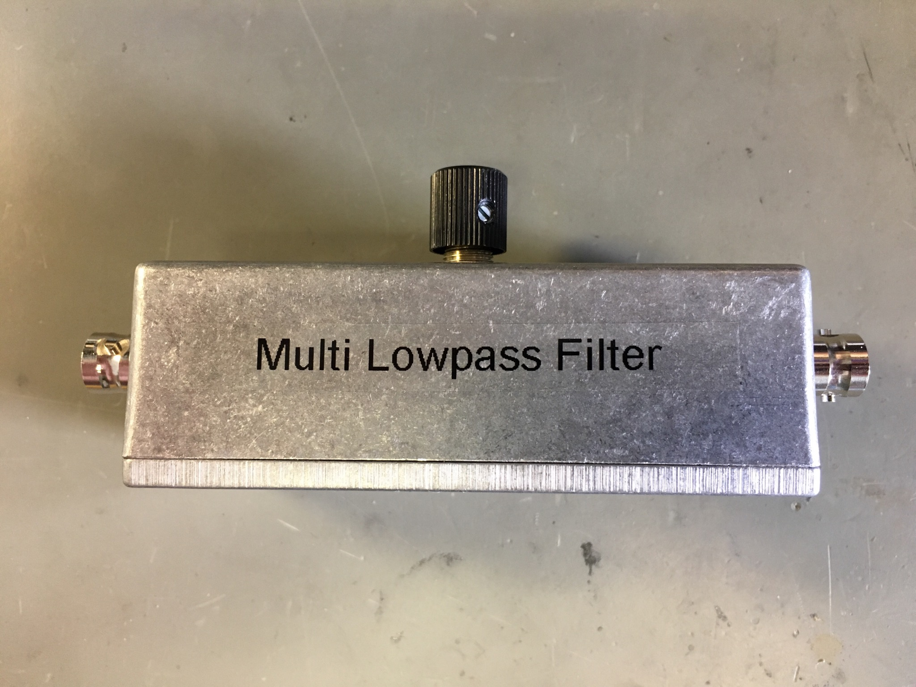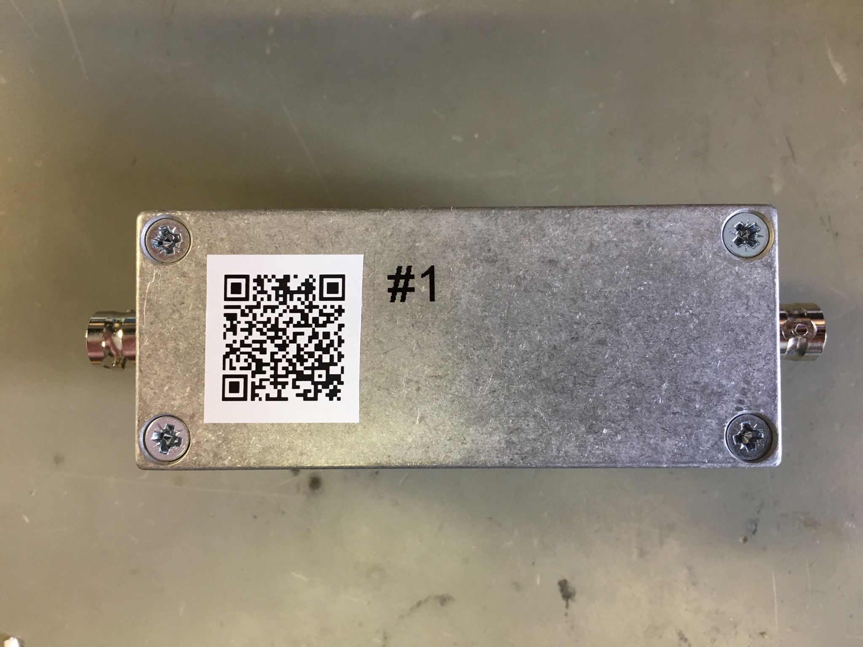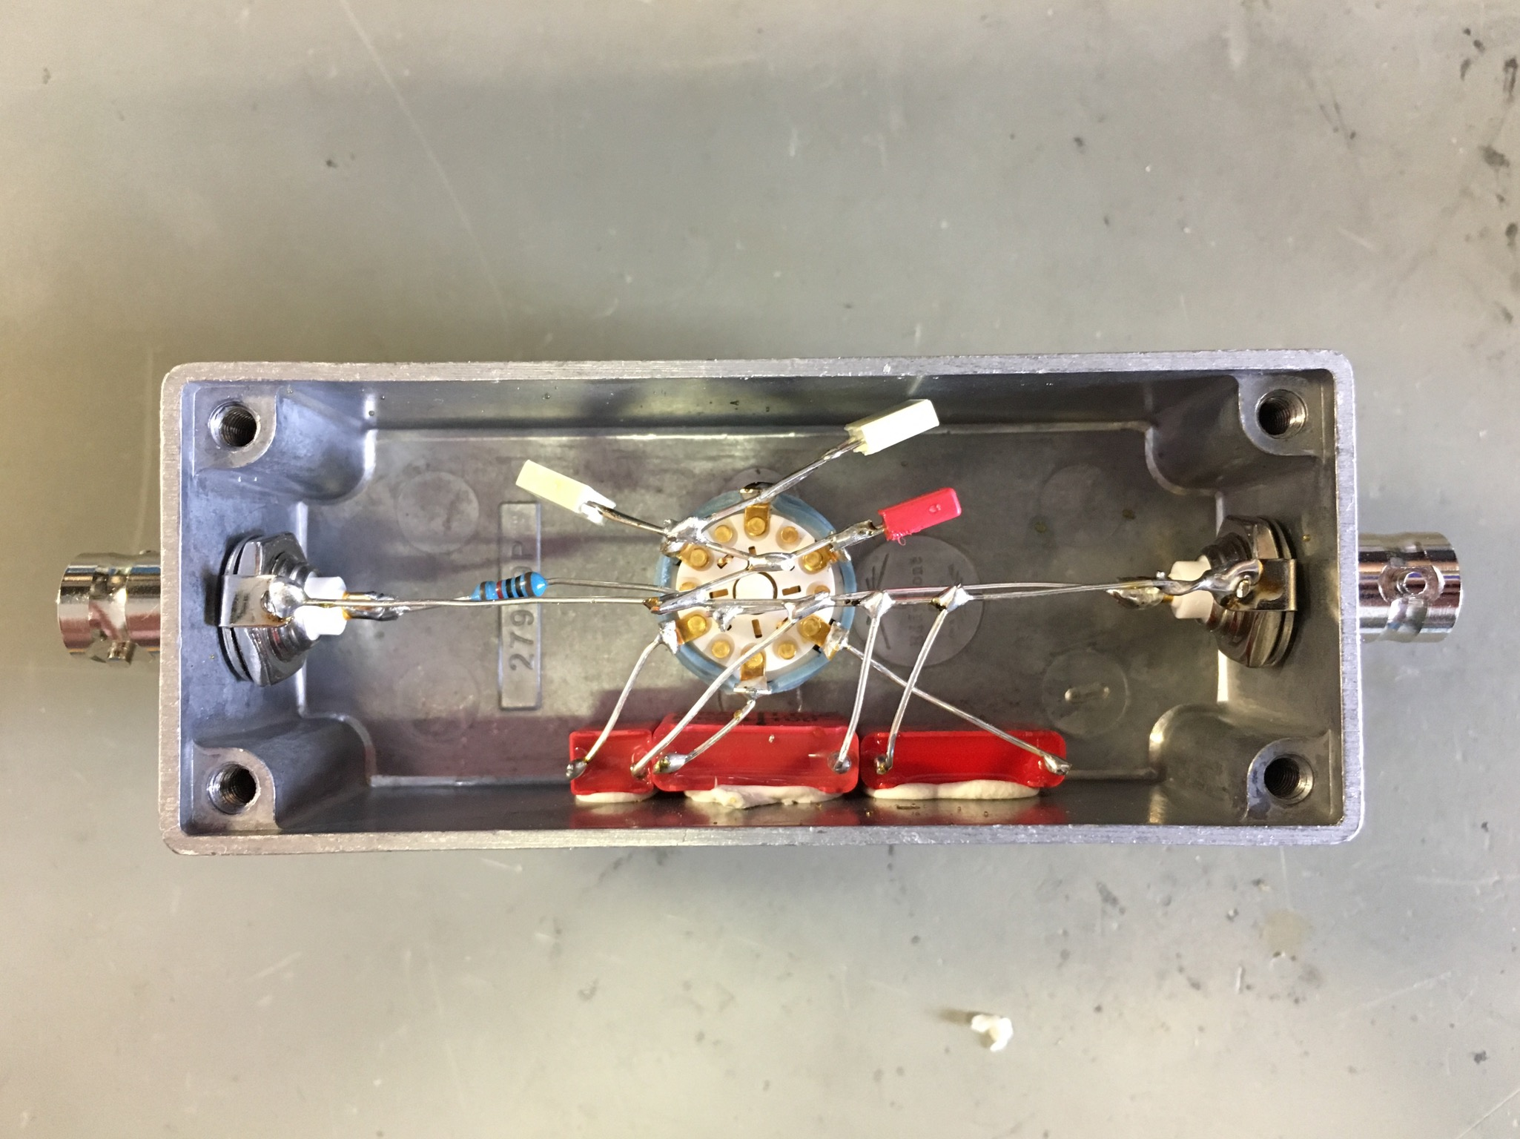

Status
: tested and working, : minor issue/not tested, : defect
# | Status | Comment
1
2
3
4
5
6
7
8
9
10
11

Setup
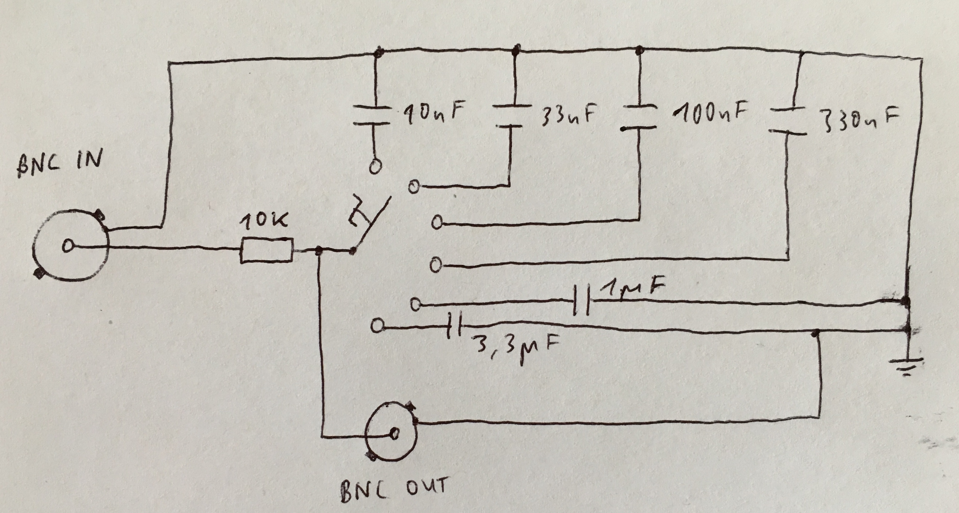
Switch: Elma 01-1104 (with gold inside), Farnell # 1876072
: cutoff frequency, : time constant, R: resistance, C: capacitance
Cutoff Frequency [Hz ] | Time Constant [ms] | Capacitance [nF] | Capacitor
4.8 | 33 | 3300 | WIMA 3,3µF 50- F6
16 | 10 | 1000 | WIMA MKS4 1,0µF 100-
48 | 3.3 | 330 | WIMA MKC4 0.33/100-
160 | 1 | 100 | µ1K100
480 | 0.33 | 33 | 33nK100
1600 | 0.1 | 10 | 10nK100

Prototype
Multi RC lowpass filters by PTB


