Fiber link

Fiber stabilization

Multipoint/Manypoint box (PTB)
Eavesdropping time and frequency: phase noise cancellation along a time-varying path, such as an optical fiber: ol-39-9-2545.pdf 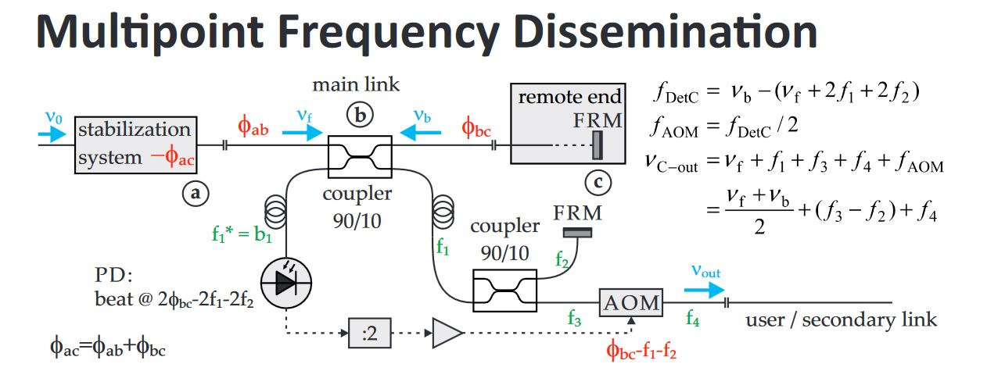
* Nach Möglichkeit sollten die Strecken f2 = f3 + f4 gleich lang sein, damit die Strecke f3 + f4 stabilisiert ist!

Paper
- http://ieeexplore.ieee.org/stamp/stamp.jsp?arnumber=6702156
- https://www.osapublishing.org/ol/abstract.cfm?uri=ol-39-9-2545

Scheme


