HTC-3000

Status
: Works fine, : is being repaired, : is fine but isn't being used, : doesn't work
HTC # | Status | Power supply options | Design
1 |  | 5-12V @ 3A max, 14-30V @ 1.2A max | Heatsinks on top
2 |  | 5-12V @ 3A max, 14-30V @ 1.2A max | Heatsinks on top
3 |  | 5-12V @ 3A max | Heatsinks on top
Number of spare ICs: 1

General Overwiew of the System

Front Panel
The front panel of the HTC looks somewhat like this:
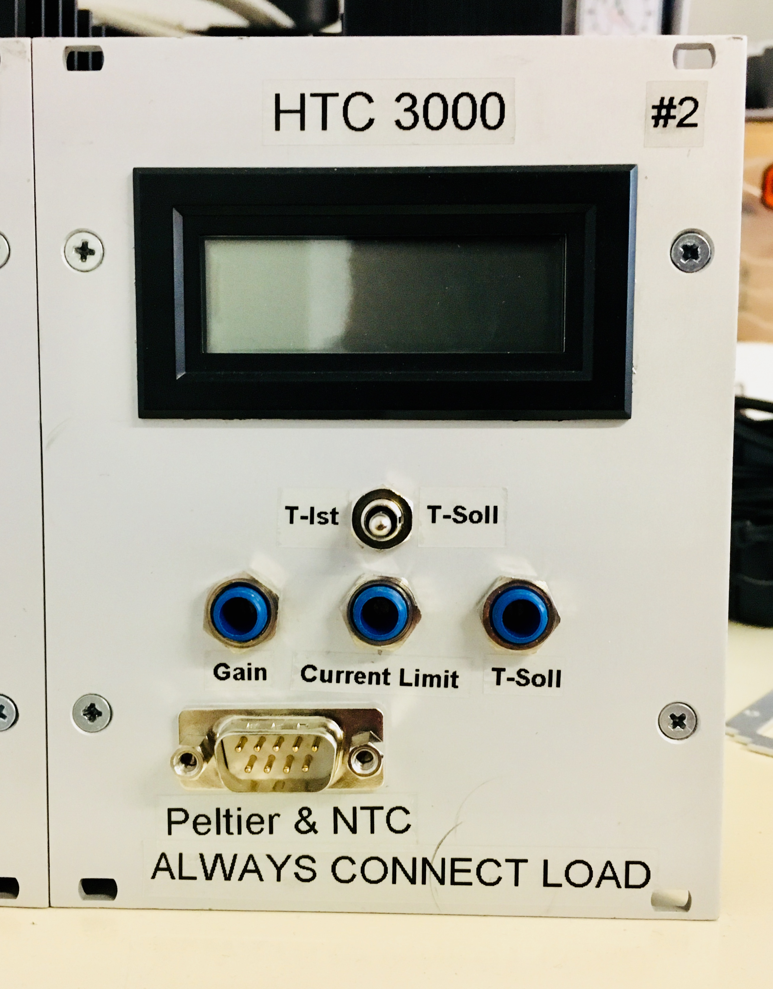 HTC 3000 Front

Number
The HTCs with heatsinks on top of their enclosure are labelled with numbers to keep track of the status of and the changes made to the individual HTCs.

Switch and Display
The switch has three positions:
- In the middle position the display is turned off. If you are not intending to use the display, consider turning it off, as this will prolong the lifetime of the battery powering it.
- In the left position the current voltage output by the HTC in order to monitor the current temperature is displayed.
- In the right position the voltage corresponding to the wanted temperature is displayed.
While you <color #ff0000>can't</fc> directly read the current temperature, the display allows you to gauge how well the system's temperature is stabilized or see if there are any problems.

Potentiometers
Turning any of the three potentiometers clockwise will increase the correspondig value:
- “Gain” controls the speed with which the HTC tries to reach the wanted temperature. High gain requires high currents flowing in order to function correctly. Too high gain can lead to overshooting the wanted temperature or oscillating around it. Too low gain can lead to very long waiting times or the HTC not being able to stabilize the system's temperature correctly.
- “Current” limits the maximum current used to regulate the system's temperature. Use this potentiometer to limit the maximum current drawn to under the maximum current allowed.
- “T-Soll” controls the wanted temperature of the system.

Connector
The SUB-D 9 connector is used to connect temperature sensor and a temperature regulating element like a heating foil or a peltier element.

Back Panel
The back panel looks approximately like one of the two following ways:
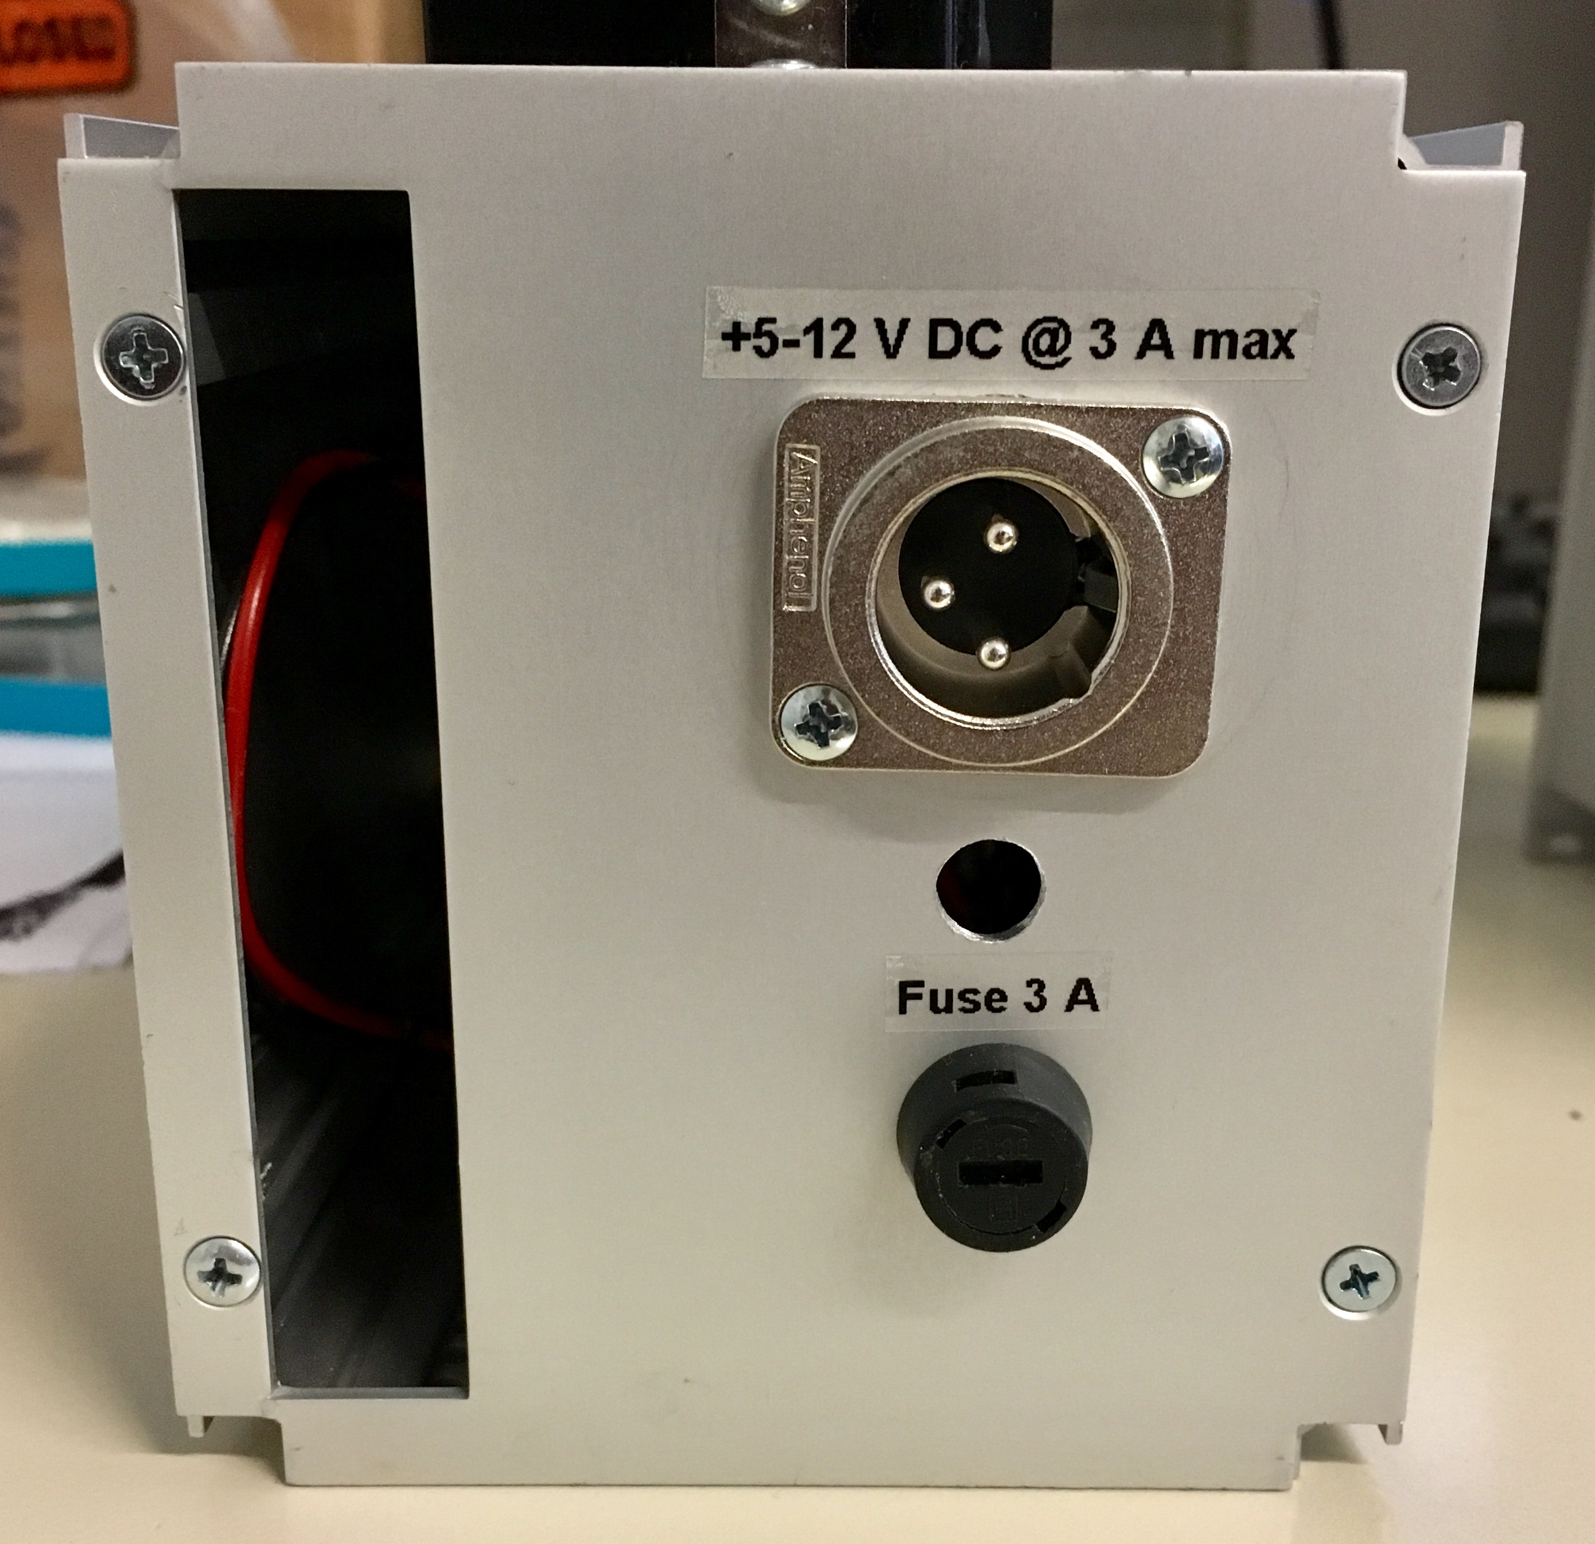
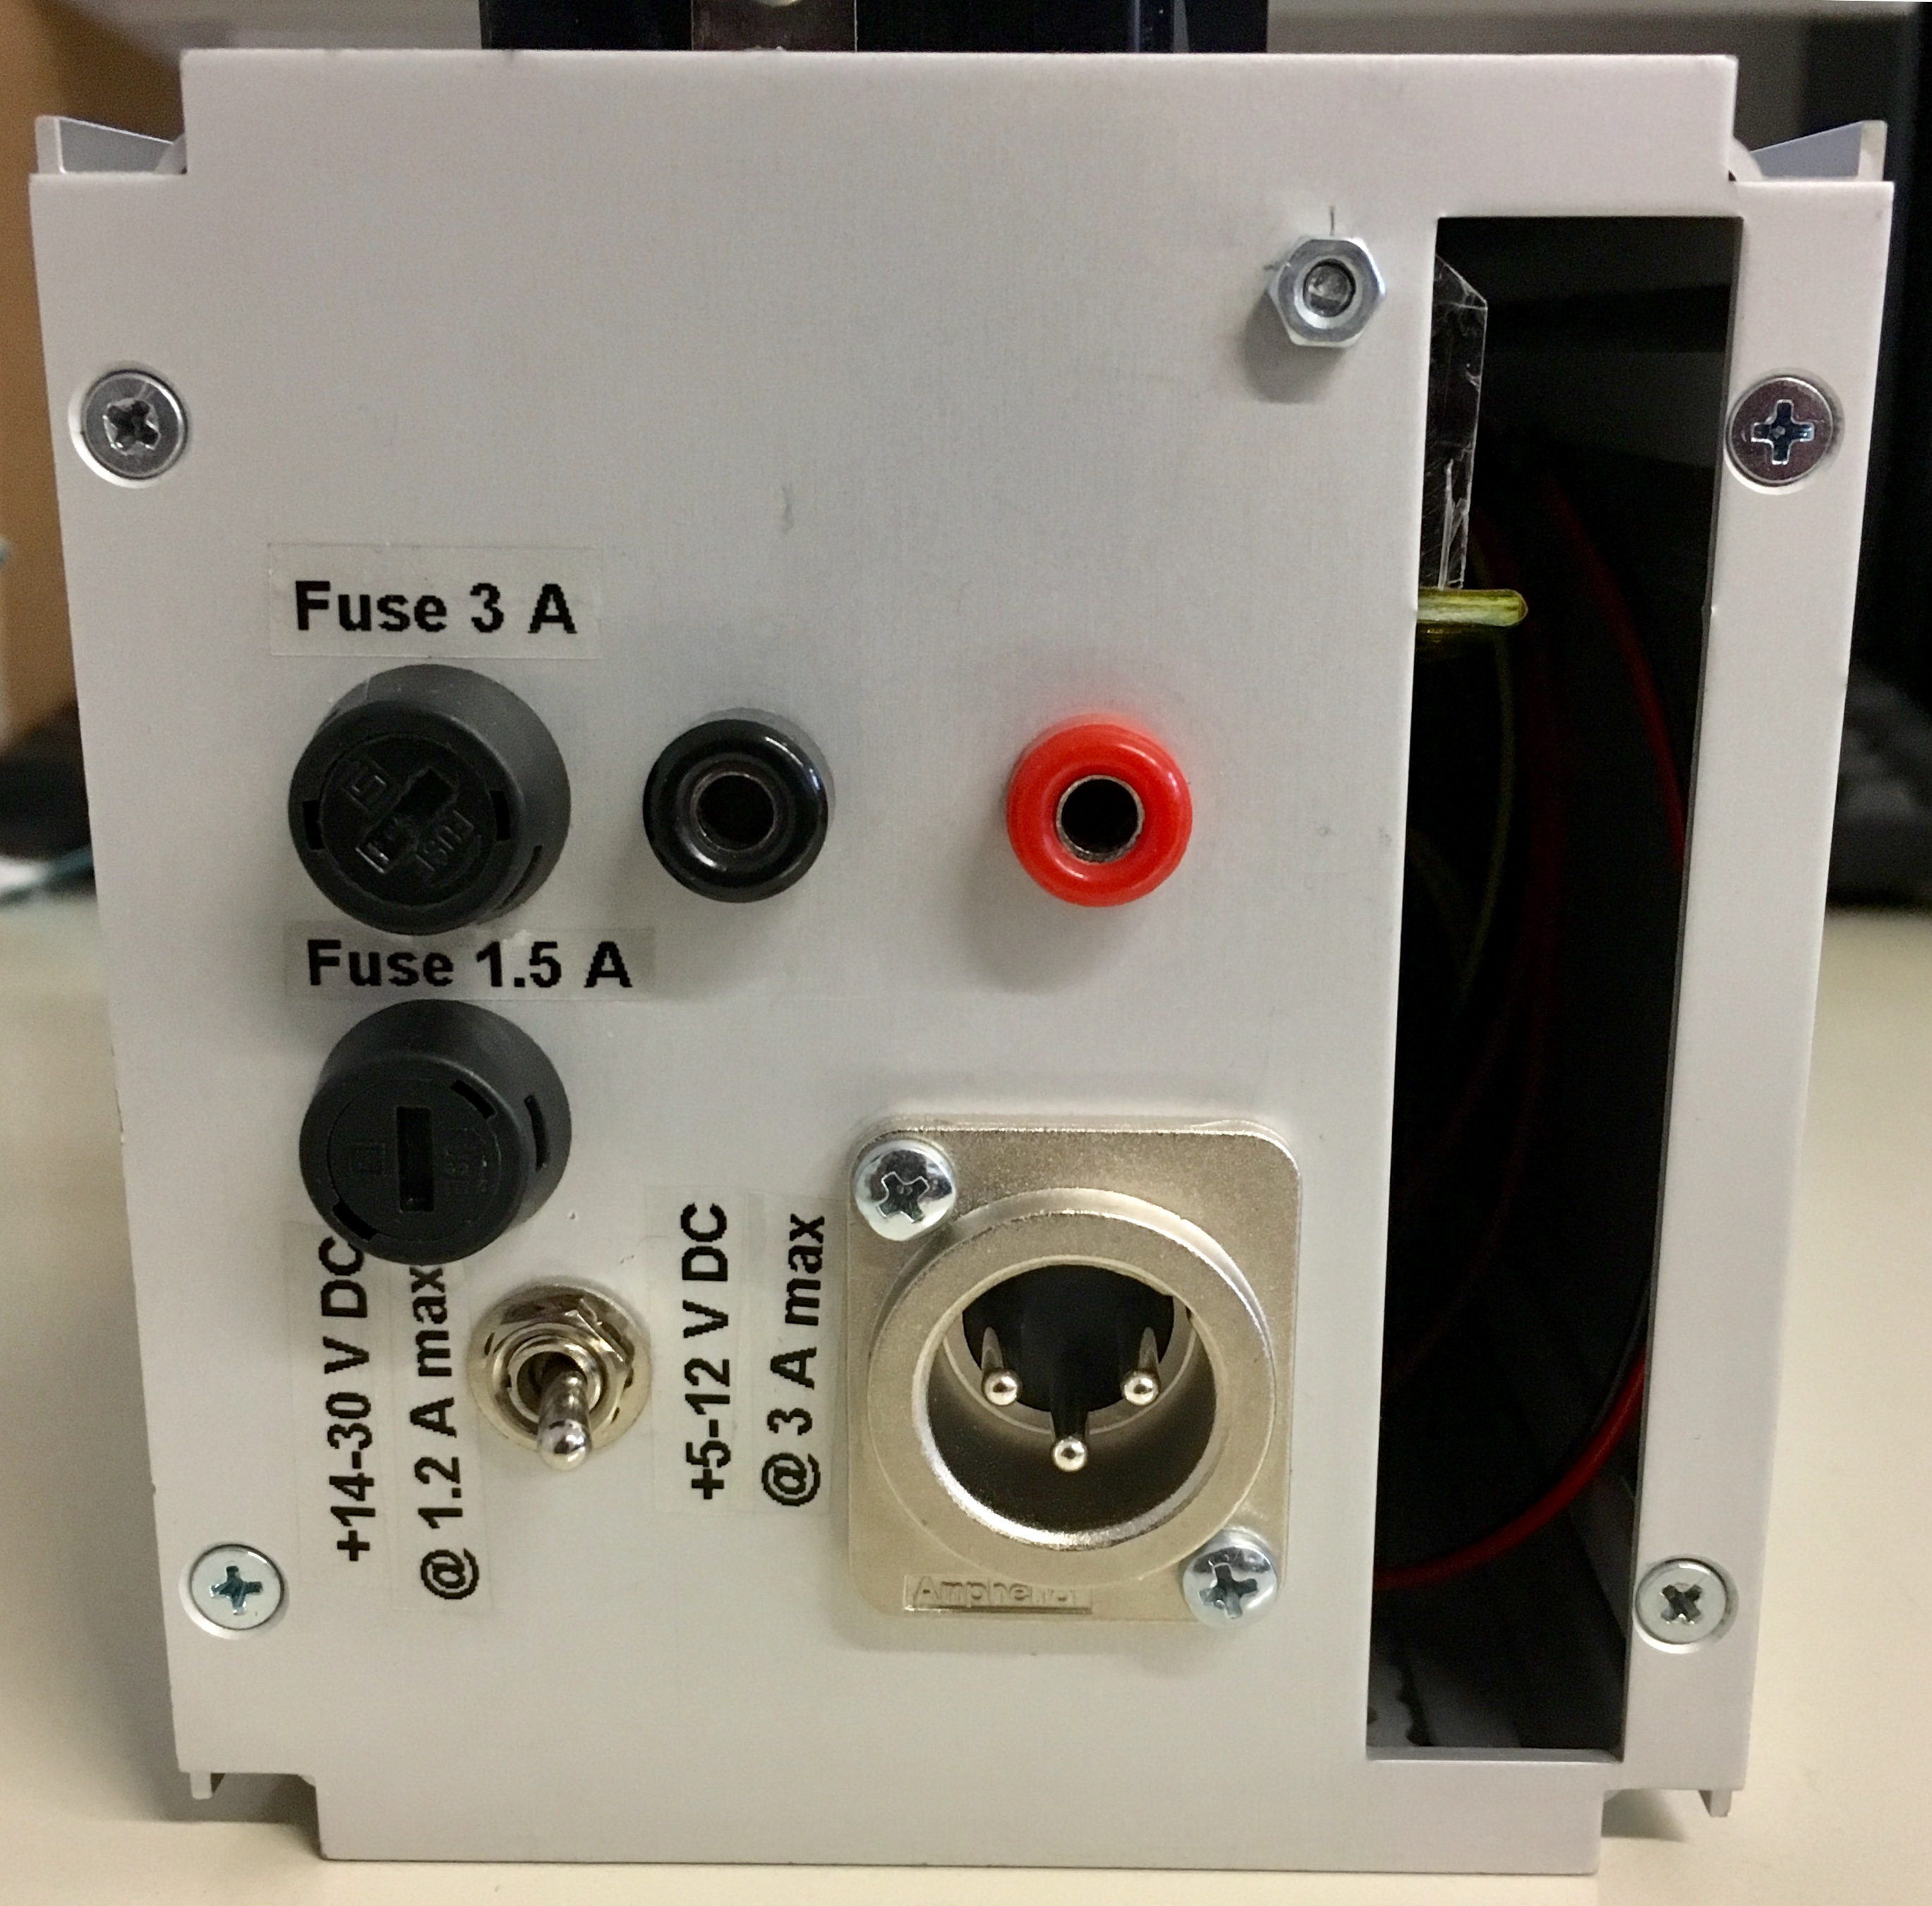
On the back displayed on the left picture you find the following:
- An XLR-Adapter for connecting a power supply
- A 1.5A and a 3A fuse, protecting the circuitry
- A switch which you can use to switch between two different voltage ranges (5-12V@3A and 14-30V@1.2A)
HTCs #1 and #2 are made like this.
On the back diplayed in the right picture you find this:
- An XLR Connector for connecting a power supply
- A 3A fuse, protecting the circuitry
HTC #3 is made like this.

SUB-D Pin Connection
HTC Pin | SUB-D Pin | Function
13 | 2 | Sensor +
14 | 3 | Sensor -
11 | 4, 6 | TEC +
12 | 5, 8 | TEC -

Power Supply
Before connecting the HTC to a power source be sure to connect a load to it first! Otherwise it will break!

Main Supply
The HTC-3000 itself is designed for an operating voltage range of 5-12V DC. If there is a switch on the back labeled with two different voltage ranges it can also be used with the voltages given on the labels.
Be sure to flip the switch in the right direction <color #ff0000>before</fc> connecting the power supply, as the HTC might be damaged by a too high voltage. If you are applying a voltage between 5-12V, make sure that the switch also is in the correct position, as otherwise the voltage might be too low for the HTC to work.
When first using the HTC, be sure to adjust the potentiometer on the front panel labelled “Current” so that the HTC won't draw any more than the maximum current given on the back of the HTC housing. In case this wasn't done, a fuse installed on the back panel will protect the circuitry but will have to be changed after the first few cooling/heating cycles. Using the current limiter on a lab power supply will NOT have the same effect as the supply voltage will drop in order to reduce the current flowing which might lead to the voltage dropping out of the operating range of the HTC, basically turning it off.

Display Supply
The Display is powered by a 9V rechargeable battery mounted within the enclosure of the HTC. If the display is not working, the battery might need to be recharged.

Configuration for Peltier Elements and Resisitive Heaters
The HTC can be used with peltier elements as well as with resistive heaters like heating foils.
When using heating foils or other resistive heaters, a diode needs to be installed between pins 2 and 3 of the HTC, like this:
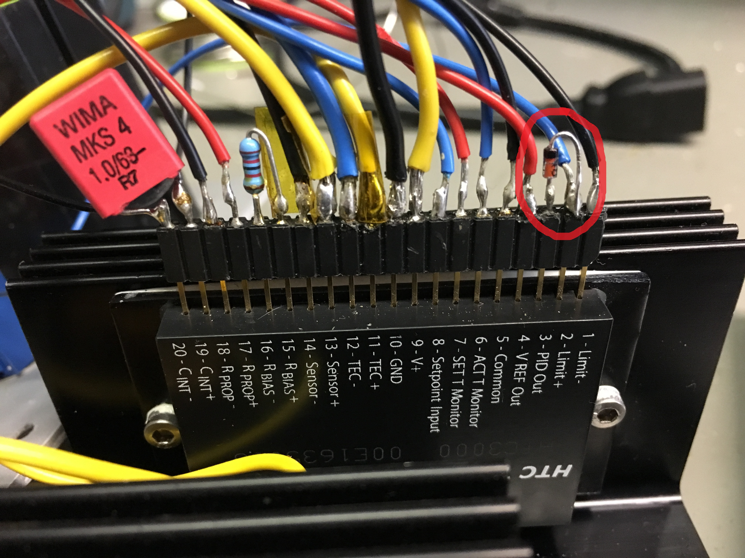
The direction of this diode is determined by whether you are using an NTC or a PTC sensor.
When using a peltier element, using a diode will lead to the peltier element either only cooling or only heating the system. To do both, the diode has to be removed and replaced with a jumper cable.
Detailed information on this topic can be found in the datasheet on pages 2, 7, and 8.

Replacing the HTC
Depending on the design of the enclosure, there are different ways in which to replace the HTCs.

HTC on top of enclosure
- unscrew the heatsink from the top of the enclosure
- pull the heatsink with the HTC on it from the socket
- unscrew the HTC
- add thermal grease
- screw the new HTC onto the heatsink
- plug the HTC back in
- screw the heatsink onto the top of the eclosure

HTC inside the enclosure
- unplug the module
- disassemble the enclosure
- unplug the HTC IC
- remove the heatsink from the metal grid (mark the old position)
- remove the HTC from the heatsink
- mount the new HTC IC on the heatsink (be sure to use thermal grease)
- mount the heatsink on the metal grid (in the old position)
- plug the HTC IC back in
- assemble the enclosure (it's a tight fit, but it should work if you mounted the heatsink in the correct position)
When plugging the HTC back in, be sure to plug it in like this:
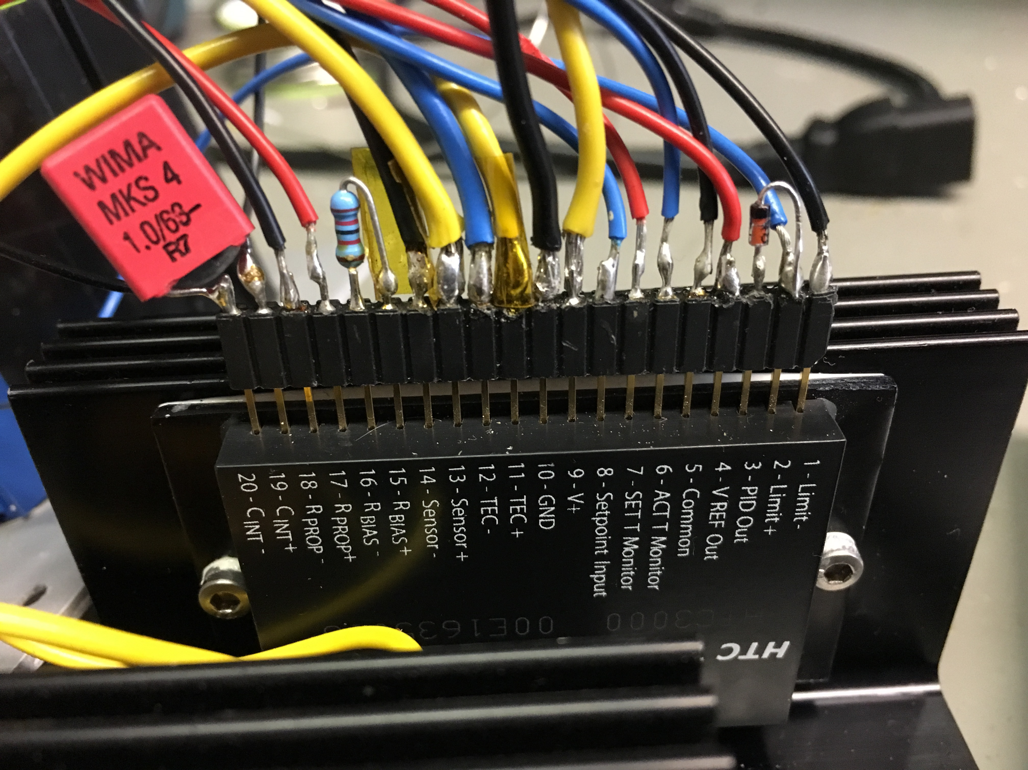 HTC Plug
If it is plugged in correctly, the two wires coming from the back panel should connect to pin 9 “V+” and pin 10 “GND” of the HTC.

Heatsinking
The HTC can only operate up to a maximum Temperature of 50°C. Due to this the HTC must be properly heatsunk.
- Original heat sink: https://www.teamwavelength.com/products/product.php?part=4&view=specs#tabs
- Currently used on #1, #2, #3: Fischer SK 92/50 (100x50x40 mm, 1.8 K/W)
To check if the setup you are using is safe for operating the HTC, you can use the online calculator provided by team wavelength. To find out under which temperature your enclosure for the HTC must be, enter the parameters required by your setup and adjust the temperature until the load line is in the safe operating area. With this temperature you can calculate the maximum thermal resistance of the heatsink for the HTC.

Troubleshooting

Display Related Problems
Problem | Possible Solution(s)
The display doesn't show anything | Make sure that the switch isn't in the middle position. Check the voltage of the 9V battery mounted in the enclosure. Check the connection of the 9V battery.
When viewing “T-Soll”, the display only shows “1” | Try turning the “T-Soll”-potentiometer in one direction for a while. If this doesn't help, try the other direction. Otherwise check the connections of the potentiometer

Peltier Element Related Problems
Problem | Possible Solution(s)
Heating and cooling are mixed up | Change the polarity of the peltier element. See page 8 of the datasheet for detailed instructions.
The element only heats/only cools | Remove the diode between pins 2 and 3 of the HTC and replace it with a jumper cable. See Configuration for Peltier Elements and Resistive Heaters as well as pages 2, 7, and 8 of the datasheet for further information
The Element neither heats nor cools | Check the connector, test the element. Otherwise see Power Supply Related Problems

Resistive Heater Related Problems
Problem | Possible Solution(s)
No matter if the temperature is too high or too low, the module heats | Install a diode between pins 2 and 3 of the HTC. See Configuration for Peltier Elements and Resistive Heaters as well as pages 2 and 7 of the datasheet for detailed information
The module heats when it shouldn't and doesn't heat when it should | The diode between pins 2 and 3 of the HTC is installed in the wrong direction. Reverse it's polarity. See Configuration for Peltier Elements and Resistive Heaters as well as pages 2 and 7 of the datasheet for detailed information

Power Supply Related Problems
If there are any Problems with the power supply, this should probably fix them:
- Check if a power supply is plugged in
- Check if the power supply ouputs power in the required voltage range
- Check if the correct voltage range is selected on the HTC
- Check if the fuse is intact. If it isn't, replace it
- If you are using the 14-30V range, check if the voltage regulator works
- Check if the cable connections within the module are intact

Upgrading to 3 Ampere
Some of the Electronics for the HTC are built to work with 1.5A max. This section covers this
In theory the HTC-3000 is able to untilize full 3A for cooling/heating, in contrast to the HTC-1500 which can only use 1,5A. In practice it can't as the whole module was designed for the HTC-1500, so everything is layed out for 1,5A. To upgrade to 3A for faster cooling and heating, these things need to be done:
- The fuse needs to be exchanged with a 3A fuse
- If there is a switch labeled “Eingangsspannung” on the back, the voltage regulator needs to be replaced with one capable of delivering 3A at 5-12V or a second fuse with 1.5A must be added
- It might be necessary to install a fan for active cooling, as the heatsink size is limited by the size of the enclosure or the heatsink must be placed on the outside of the enclosure
- The potentiometer labeled “Current” on the front panel needs to be adjusted, so that the current limit can be increased to 3A

Datasheet
If you want to read up anything else, there is an easy to understand datasheet for the HTC series here:
htcseries_datasheet.pdf

Parts List
These are the parts needed for building a new HTC:
- HTC-3000 IC
- a large heatsink
- a temperature sensor
- a 1 MOhm trim-potentiometer
- a 500 kOhm trim-potentiometer
- a 100 kOhm trim potentiometer
- a … µF capacitor, depends on the integrator time used
- a … Ohm resistor, depends on the type of temperature sensor used
- a voltmeter
- a 9V-block to power the voltmeter
- a 9V-block adapter
- cables
- a d-sub 9 male connector
- a three way switch switching two things at the same time
- a XLR-socket
- a fuse socket
- a fuse

