DDS
We have two types of DDS (Direct Digital Synthesis) with USB port or Serial port.
Use the right software for programming!
Default values:
- For generate a fix output frequency you can use two reference possibilities:
  - “Internal Clock Frequency: 400 MHz”
  - “External Clock Frequency: 100 MHz”. Input power should be 10 dBm < P < 20 dBm.
- The output frequency can be only less than the reference frequency!
- When using divider setup with any input and output frequency, the input power should be:
  - f_in < 150 MHz ⇒ 10 dBm < P < 20 dBm
  - f_in > 150 MHz ⇒ P ~ 0 dBm
  - Devided by 2 isn't possible! (said Andreas from PTB)

USB-DDS
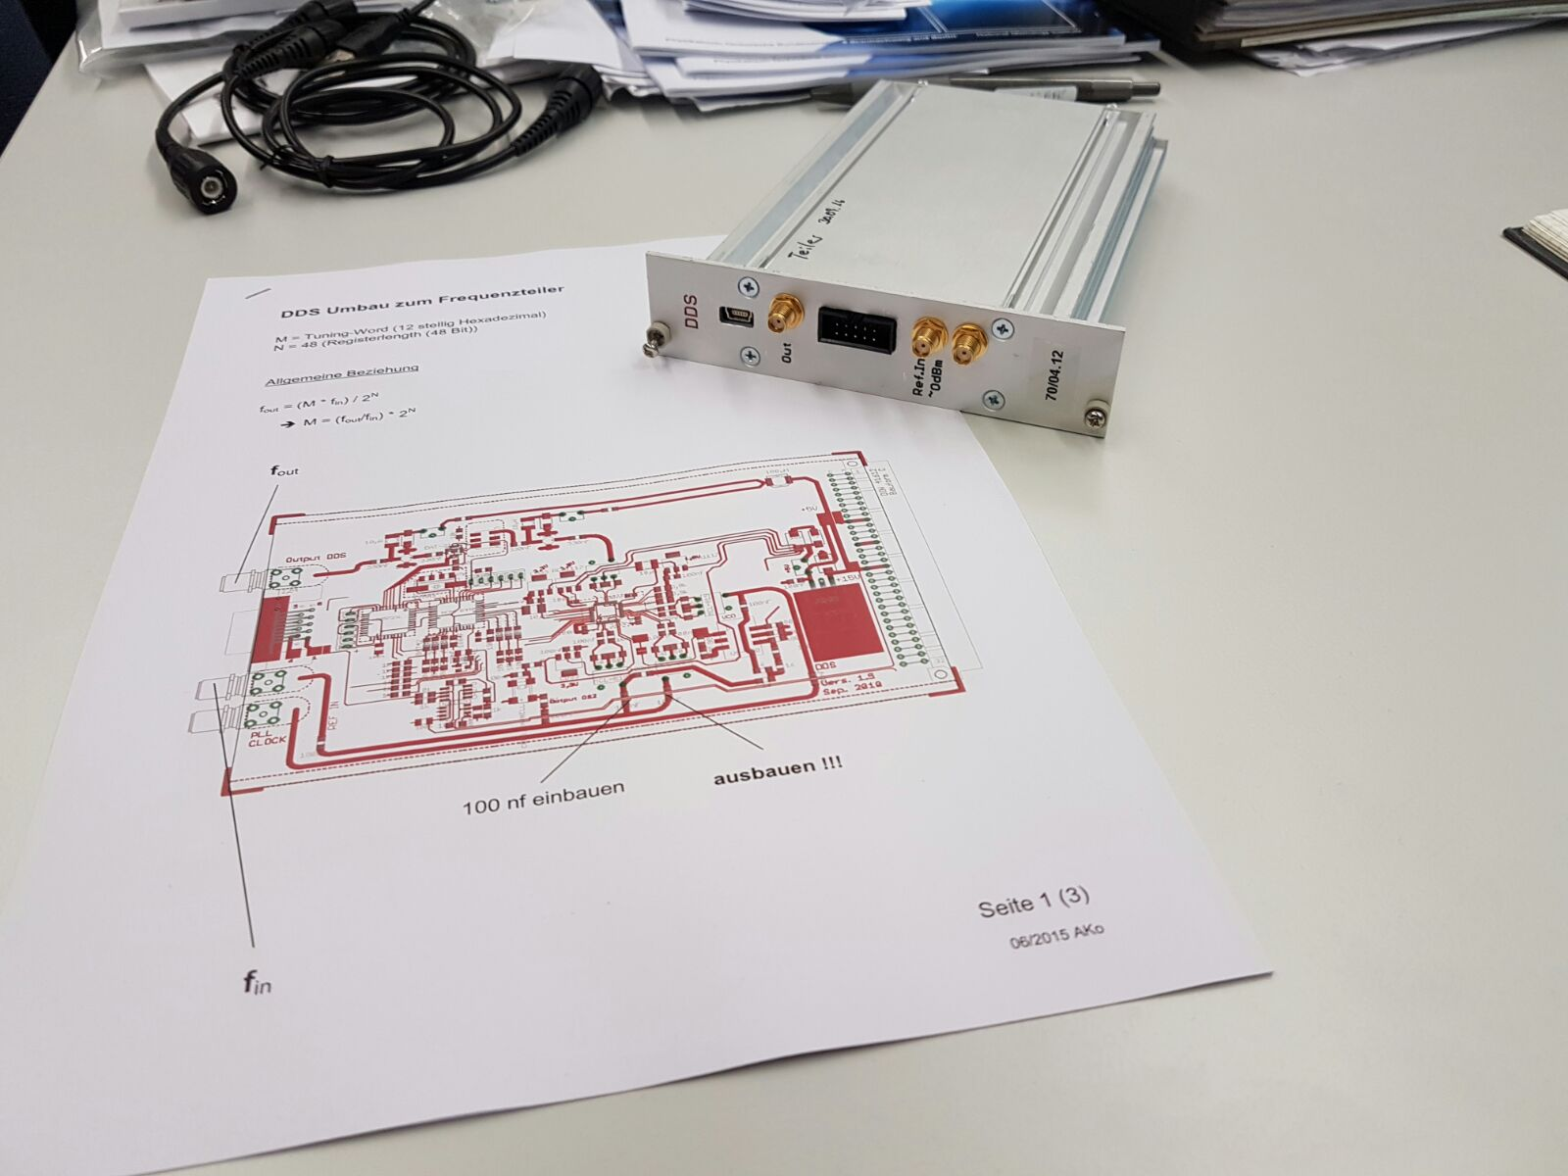
- Software DDS for USB Type PTB DDS
- Datasheet/Manual:
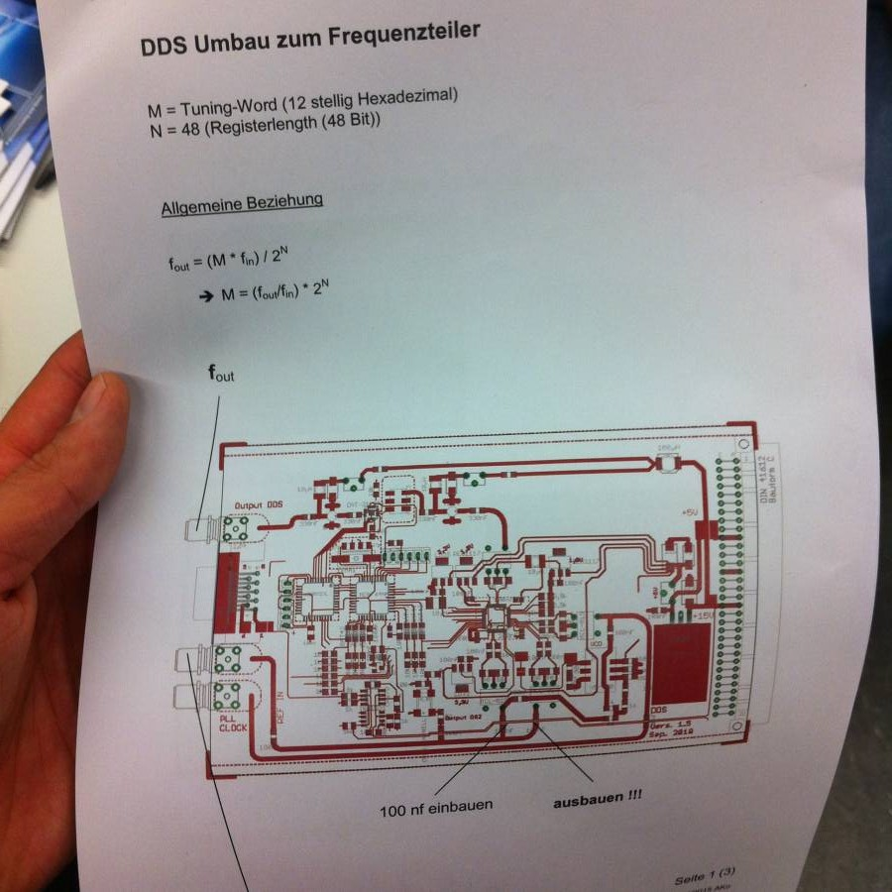
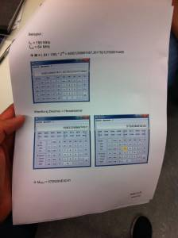
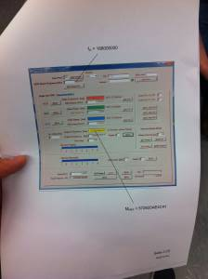

Modifikation to frequency divider
- Datasheet/Manual: Anleitung zum Teilerumbau

Serial-DDS
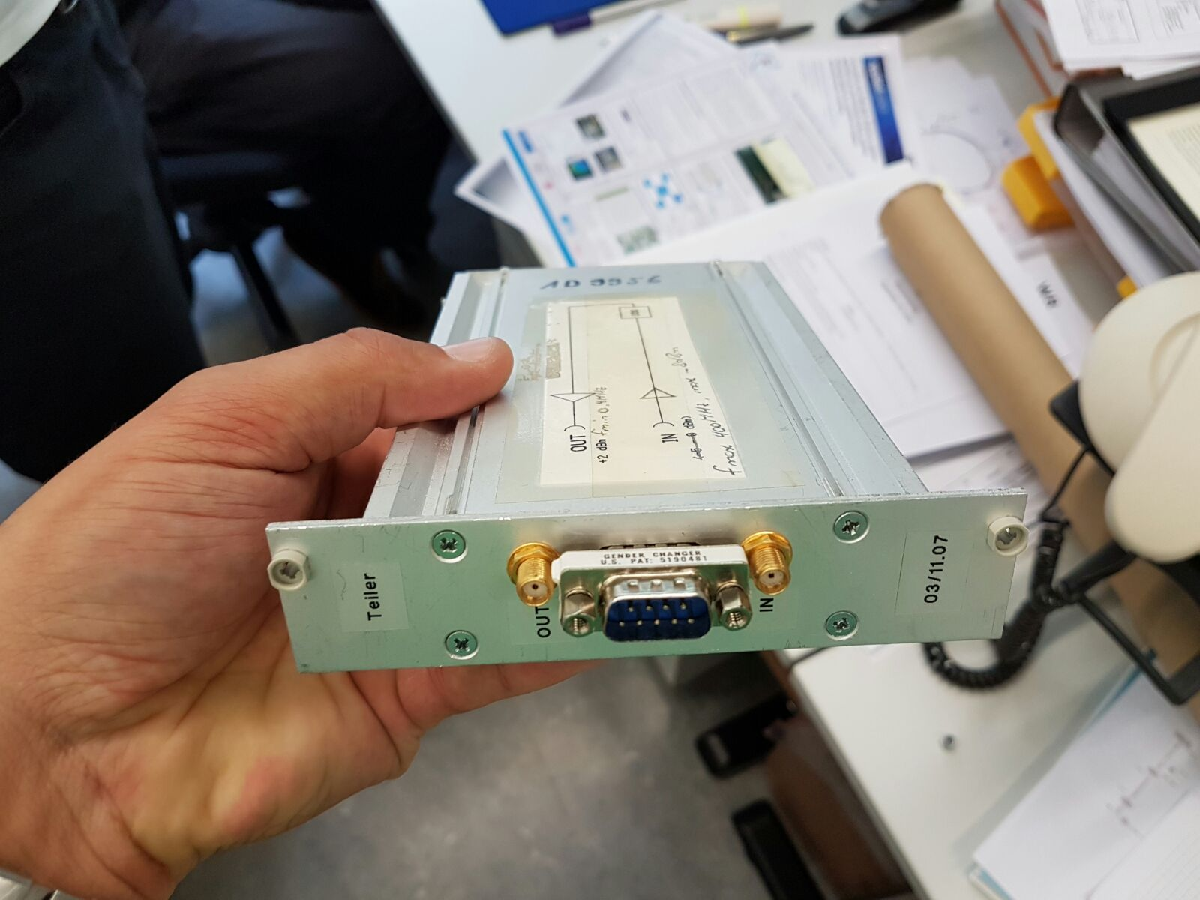
- Software Terminal for Serial Type DDS
- Datasheet/Manual:


