CCD camera
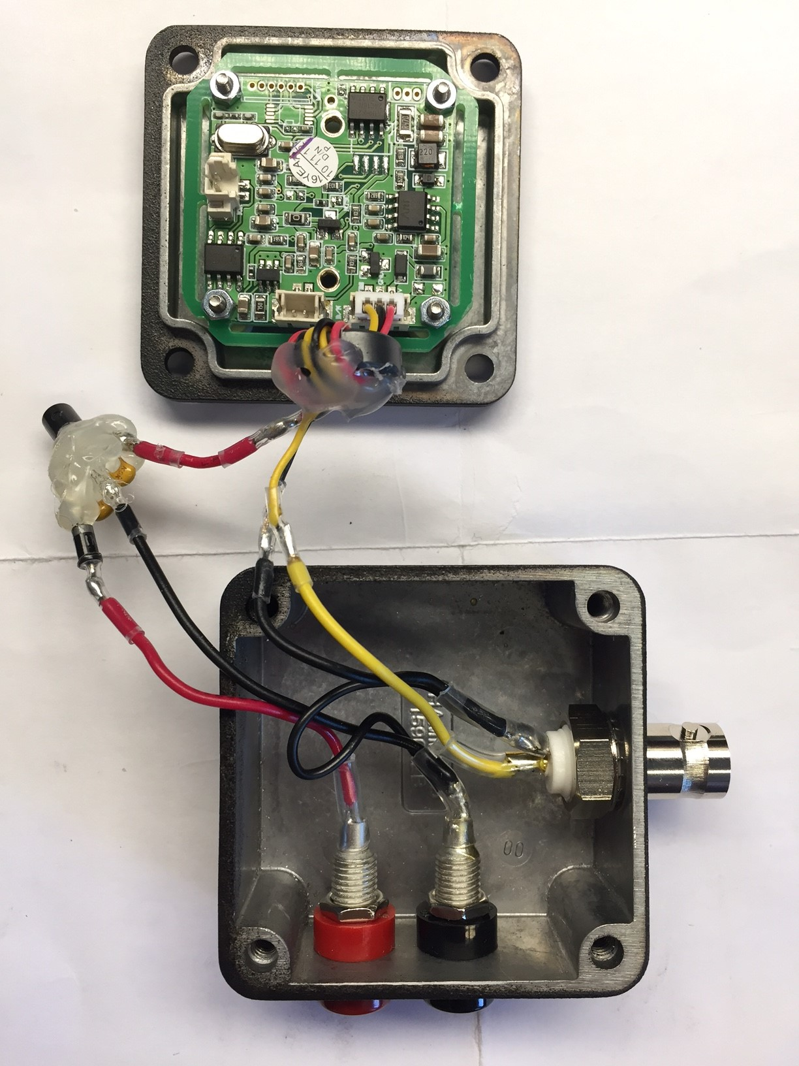
Typ: https://www.voelkner.de/products/696151/Platinenkamera-Components-BC-713-720-x-576-Pixel-12-V-DC.html

Advantages compared to the old one
- less heating
- less complex

Power supply
- Cables
  - red: Plus
  - black: GND
  - yellow: signal
- Connections
  - Banane: power supply
  - BNC: signal
- ferrit core: cables wrapped around two times and fixed with hot glue
- GND of the box is separated from GND of the Mount with plastic washers
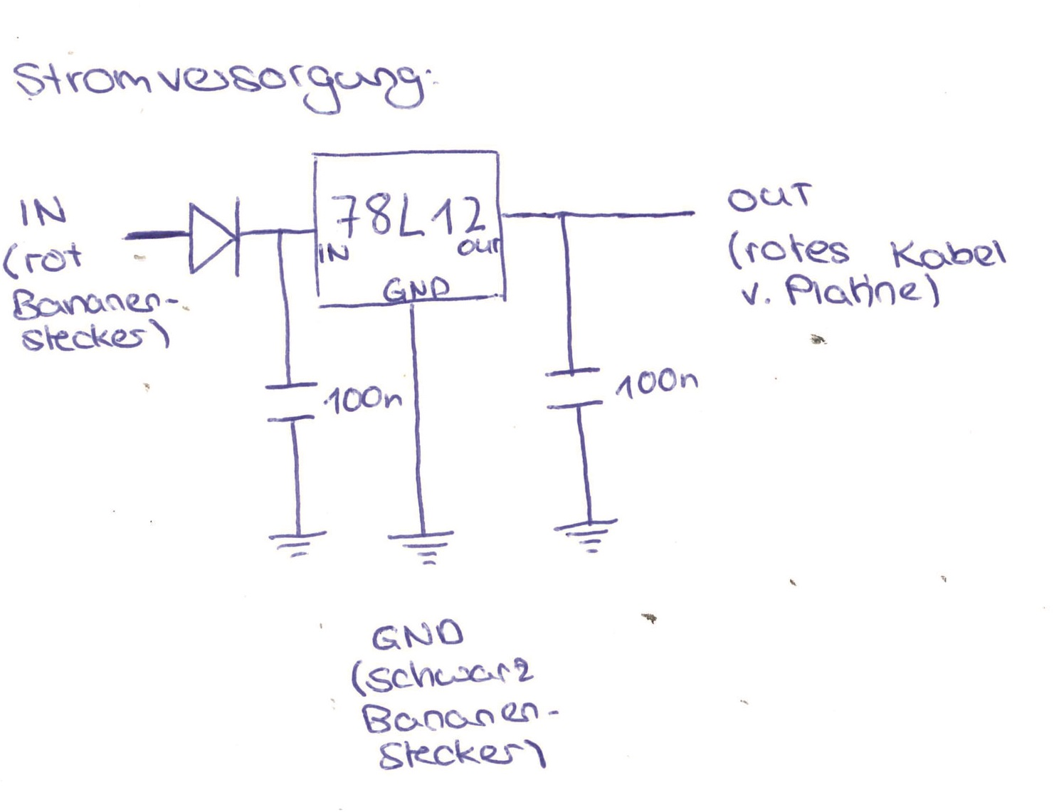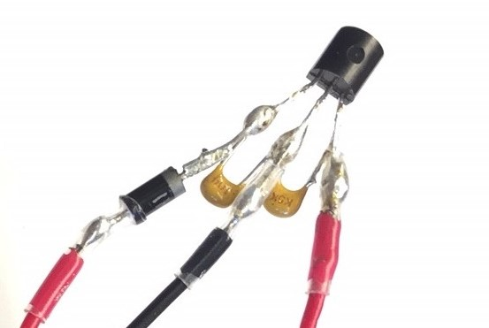
Next time: no Banana!

