Aktive vibration isolation
Max 100kg!
We have two stages: R1 & clock laser are on one stage and R2 is on another stage. It is a special design because the electronics have been removed of the vibration platform for thermal reasons.
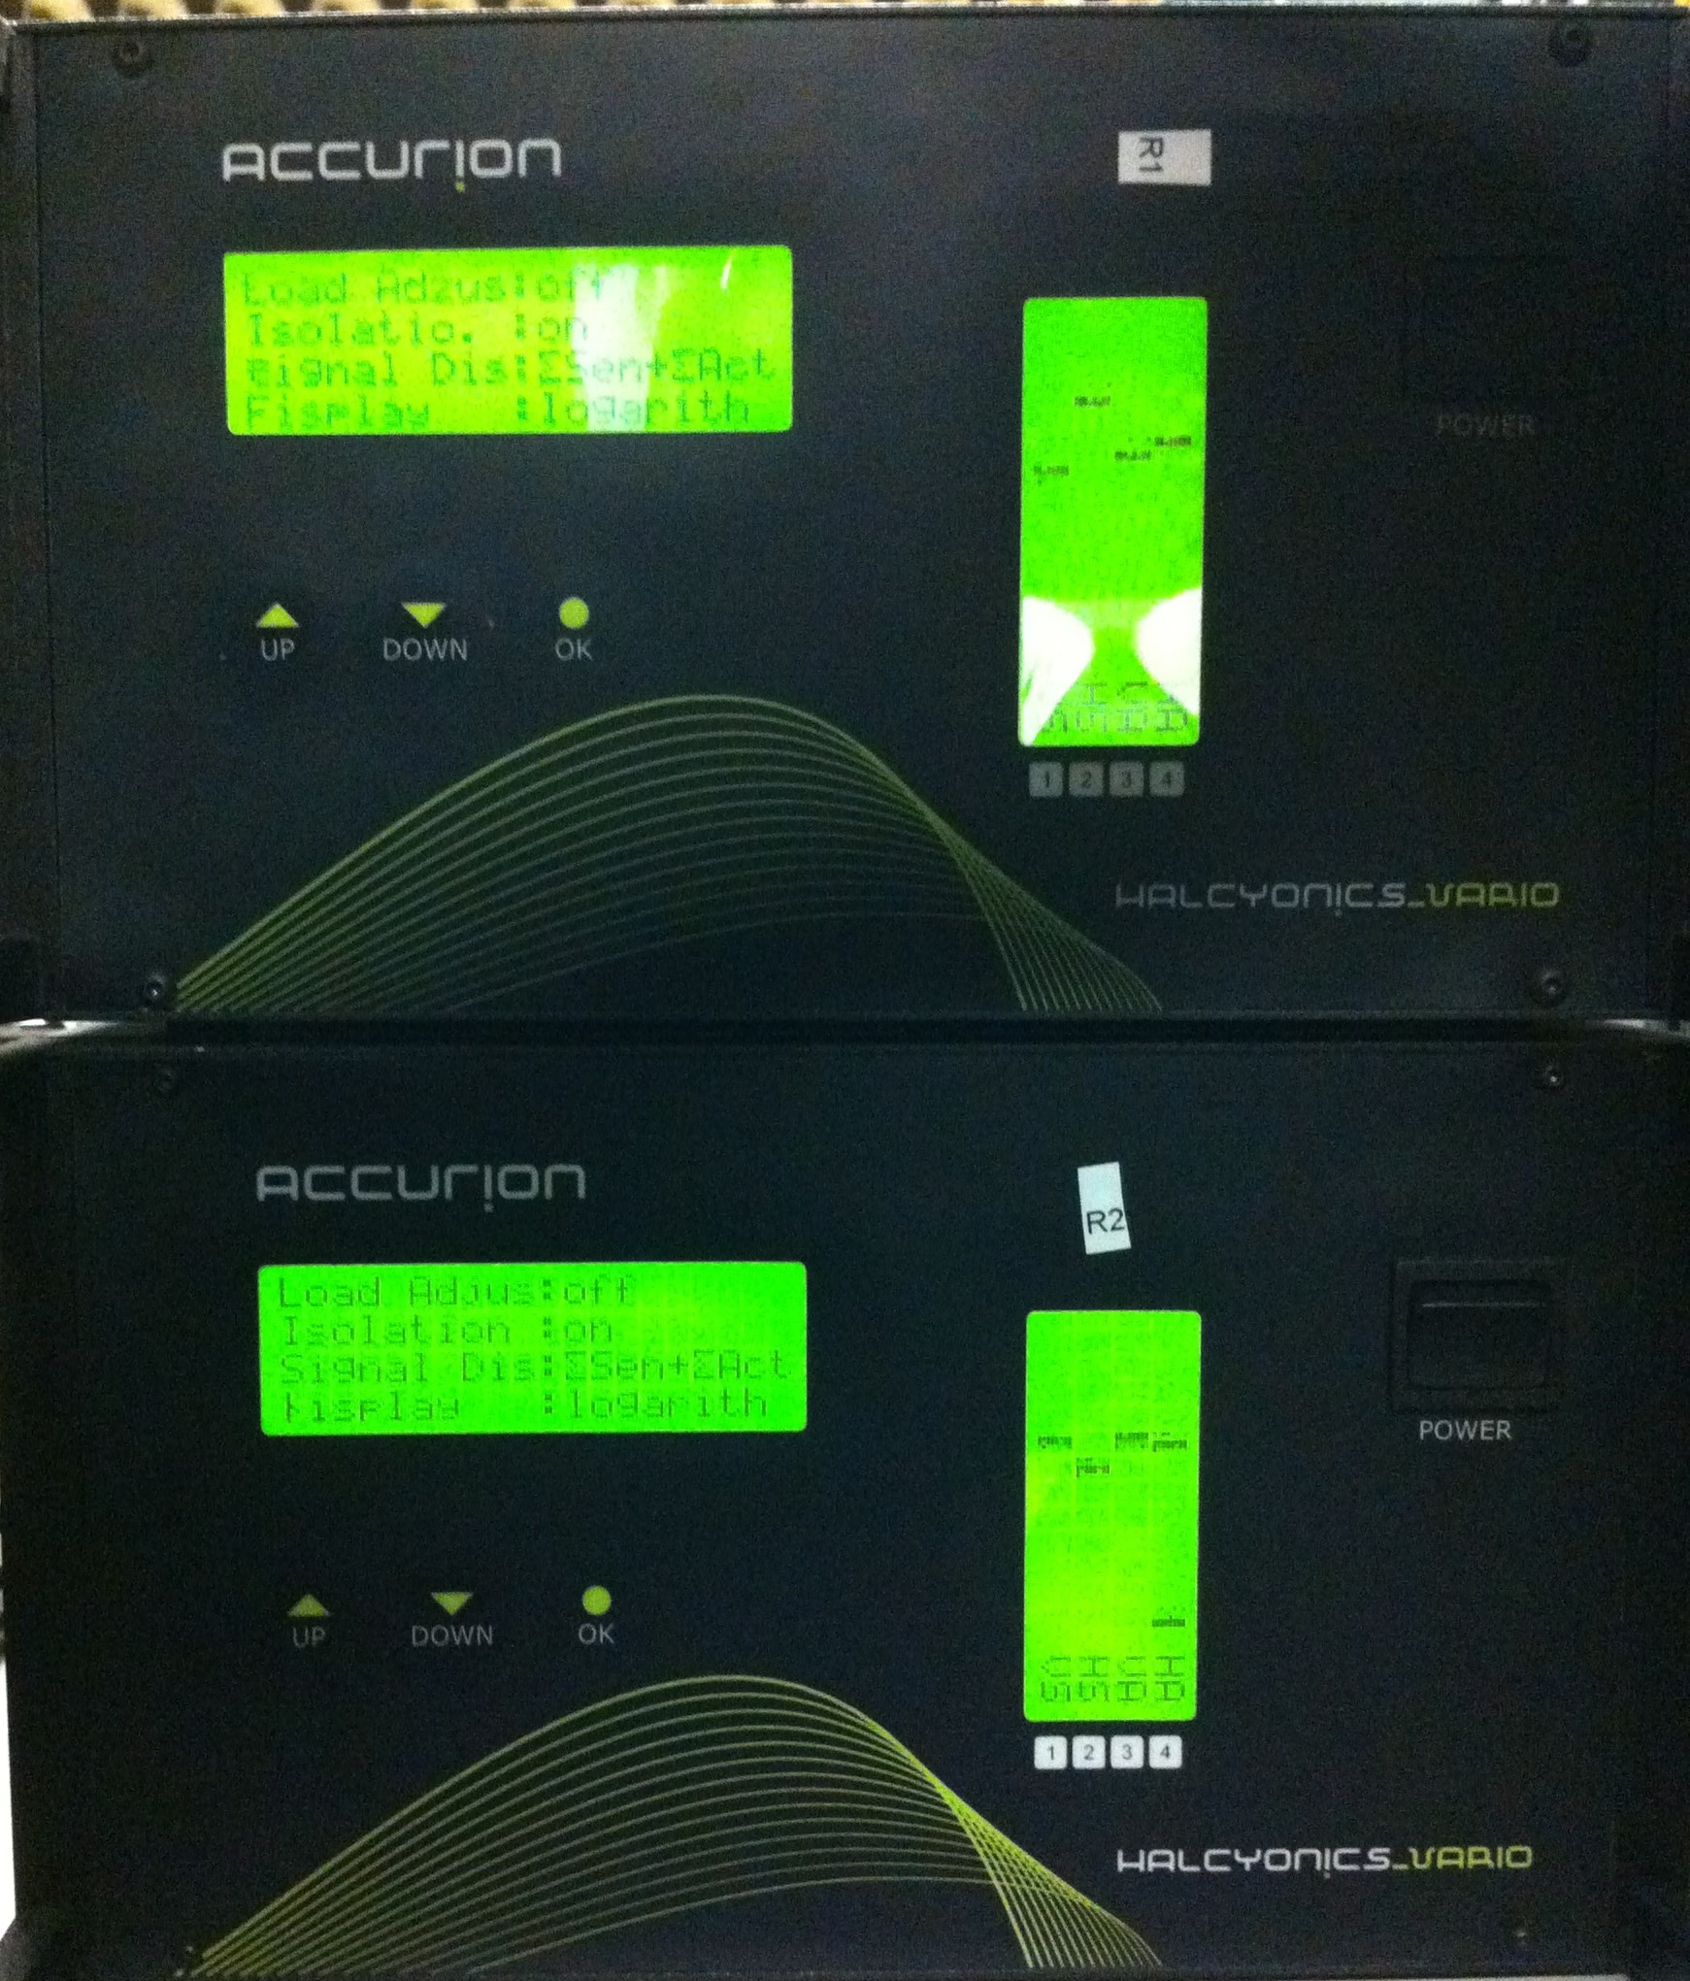

Modi
- three modi available: aktive, transportable, off
- Information on aktive modus:
- First step: Complete load adjust with “up”-button
  - load adjust: on or off or locked
- Second step: Activate isolation with “down”-button
  - isolation on or off
Important in aktive modus: The “four bars” VS, HS, VA, HA should be in the upper third of the range for an adequate control range.
- Information on transportable modus: Mechanic is decoupled. Now is working, for example optics screw down, possible.
- Information on off modus: -
Movements in the room have influence of the vibration isolation!

Manual and datasheet
- Flyer
- Datasheet
- Manual

