Notes/Informations

Frequency-Comb Hannover
Channel | Measured | Frequency | Sign | Interval (axis) | Max outliers (Alarmschwelle) | F(x)
CH1 | IQ-Resonator (R1) vs. Comb | 29.347 MHz | - | ± 900 Hz | 500 Hz | -fx
CH2 | CEO | 20 MHz | - | ± 0.24 Hz | 0.15 Hz | -fceo
CH3 | Reprate/16 | 6.250001 MHz |  | ± 0.0018 Hz | 0.001 Hz | frep/16
CH4 | Link vs. Comb | 22.432 MHz | - | ± 900 Hz | 500 Hz | -fy
CH5 | Virtualer Beat (Link vs. IQ-Laser) | 21,27173 MHz |  | ± 18 Hz | 10 Hz | fv
CH6 | Manypoint-AOM | 36 MHz |  | ±18 Hz | 10 Hz
CH7 | Stell-AOM vom IQ-Laser | 35.0X MHz |  | ± 4000 Hz | 2000 Hz (+ correction of Offset) | f_Stell
CH8 | Rubidiumuhr referenziert auf GPS | 10 MHz |  | ± 0.0018 Hz | 0.001 Hz
- Modenverhältnis: Ratio: N=n916/nLink = 3275292/1944000 = 1.684820987654321…
- Repetitionsrate: 100,0000226 MHz
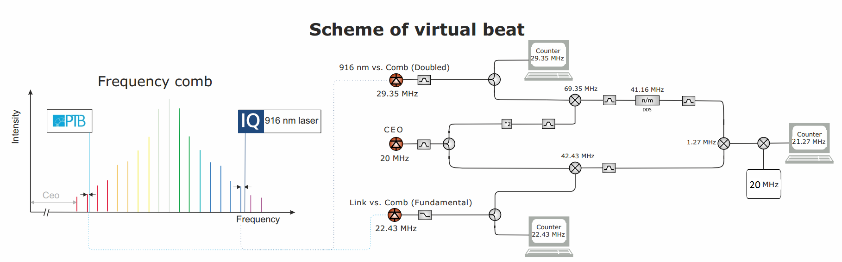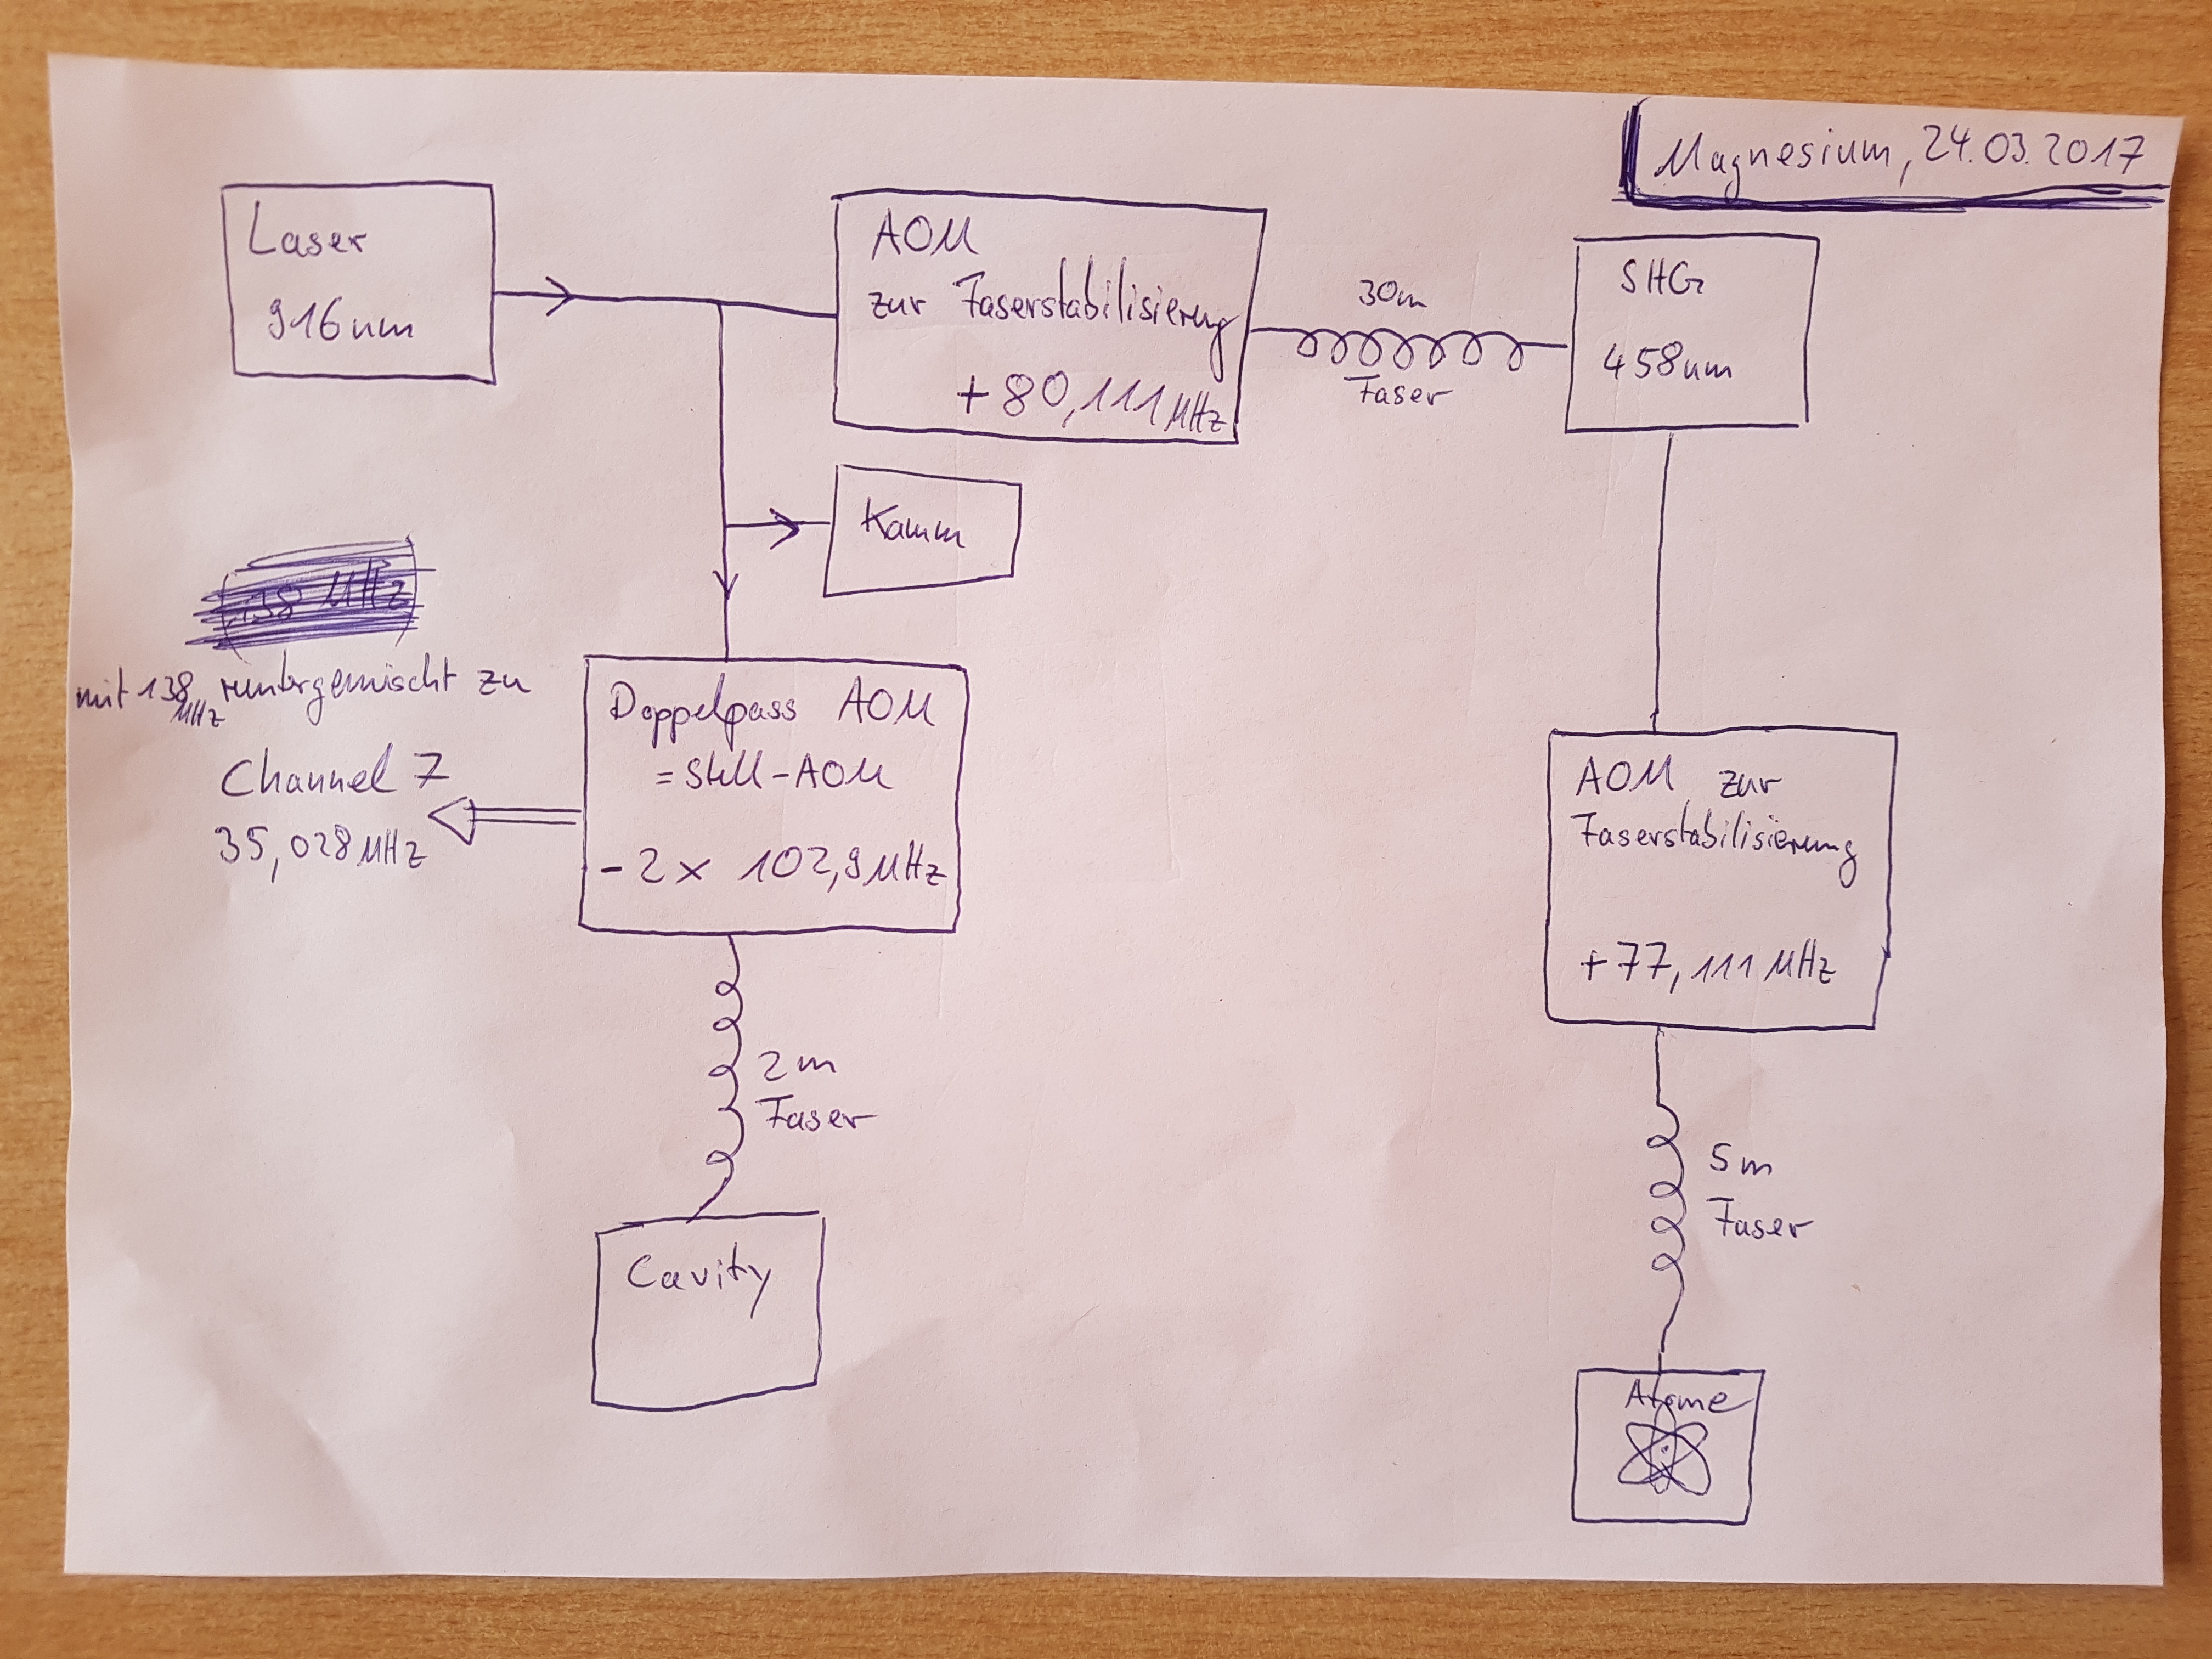
- AOM (+77.111 MHz) used for atom-lock + fiber stabilization(5m)
- AOM (+80.111 MHz) used for fiber stabilization(30m)
- Double-pass AOM (-2*102,XX MHZ) used for spectroscopy (frequency shift), feedback-loop!!!
- Channel 7 = 138 MHz (Synthesizer, referenced by 10 MHz GPS) - Double-pass AOM
- Atom frequency: nu_opt(Mg = ( 3275292*col(e)*16 - 2*col(d) - col© + 80,111e6)*2 + 77,111e6
- Laserfrequency: f_laser = 3275292*frep*16 - 2*fceo - fx
- Resonator 1 frequency: f_R1 = 3275292*frep*16 - 2*fceo - fx + (-2*f_AOM_R1)
- Double-pass AOM: f_AOM_R1 = 138 MHz - f_Stell

Virtual-Beat
- fv = (fy + fceo) - ( (fx + 2*fceo) / (3275292/1944000) ) + (2*10 MHz)

Evaluation (PTB)
- fx= col© (#1, negatives fx)
- fceo=col(d) (#2) (negatives fceo)
- frep=col(e) (#3, frep/16)

Test analysis
- nu_opt(Mg) - nu_(Mg2015)[Hz] = nu_opt(Mg) - 655058646691000
→ nu_opt(Mg) - nu_(Mg2015)[Hz] = ( f_laser + 80,111e6)*2 + 77,111e6 - 655058646691000

Frequency-Comb Braunschweig

Clocks hight in respect to the geoid
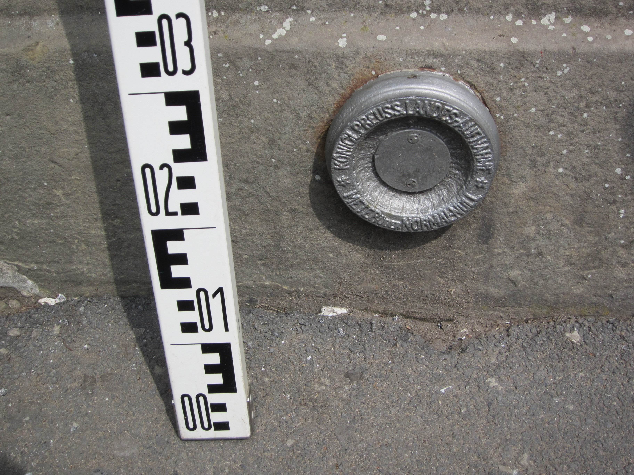
In front of the university are studs which are used as a reference. In the PDF everything is explained and is given by Dr. Heiner Denker (Institut für Erdvermessung (IFE)), he will also estimate the experiments height with higher precision soon. afisbuchnachweis362400016.pdf

