Monitor VCH-1006
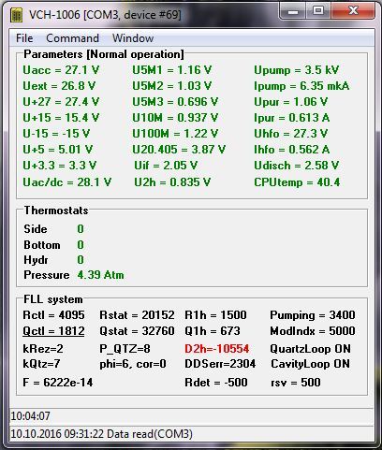
one entry is always red! Andreas Bauch doesn´t know the reason, but it´s okay!

