Mode Matching Resonator 2 - plan and curve mirror
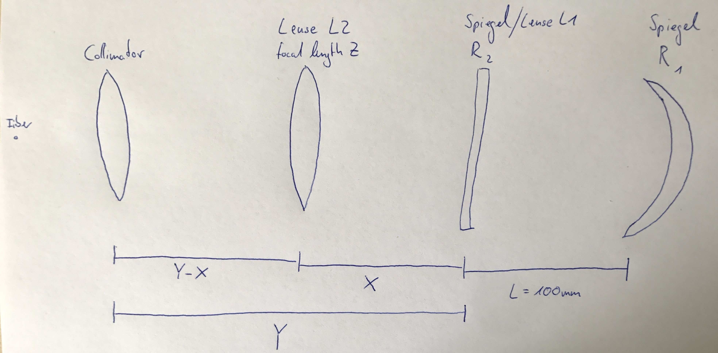

Mirror configuration

Parameter
- Radius of curvature of mirror R1: R1= 500 mm
- Radius of curvature of mirror R2: R2= infinity (Incoupling side)
- Wavelength: λ= 916.0 nm
- Length between the resonator mirrors: L= 100 mm
- Beam radius at cavity-waist: w0=w2
- Beam radius at mirror: w1, w2
- Distance between:
  - mirror R1 and mirror R2: L
  - mirror R2/lense 1 and lense 2: X
  - lense 2 focal length: Z
  - mirror R2/lense 1 and collimatorlense: Y
  - collimatorlense and fiber: 4 mm
We used the programm Strahl.exe (@IQ)
Step 0: Choose parameter
- Wellenlänge: 916 nm
- Brechungsindex: 1 (Air)
- Welcher Resonatortyp: linearer Resonator
Step 1: Beam waist calculation from resonator
- Insert
- Nr. 1: Spiegel 1 with Brennweite 500 mm <fc #ff00ff>250mm</fc>; Einfallwinkel: 0
- Nr. 2: Abstand 100 mm
- Nr. 3: Spiegel 2 with Brennweite 10000000000000 mm (so groß es ging) <fc #ff00ff>Planspiegel</fc>; Einfallwinkel: 0
→ Waistradius: w2= 270 µm, w1= 241.5 µm
→ FSR
Step 2:
- Change with “Change” Spiegel 2 to Linse 1 - Radius Spiegel verw?=ja y
  - Brechungsindex: 1.5
  - Brennweite: -400000000000000 mm
The values of the Waistradius and Strahlradius must not change!!!
<fc #ff00ff>Fenster?\\</fc>
- Abstand S2 zu “Grenzfläche” Fenster
- Grenzfläche: Brechungsindex 1.5 Einfallsw=0 Radius=0 bei unendl
- Abstand dicke Fenster: 6.35mm
- Grenzfläche: Brechungsindex 0 Einfallsw=0 Radius=0 bei unendl
- Programm berechnet hieraus Strahlrad.-1ym (Nicht realistisch)
2. Ansatz
- Berechnung der opt.Dichte → Weglängenänderung → Korrektur Abstand Spiegel zu Linse (wird größer) D(λ)=log[1-e^(-αλ)]=9,45mm → neuer Abstand X+3,15mm
Step 3:
- Nr. 4: Abstand with Variable X <fc #ff00ff>ausgemessen 530mm</fc>
- Nr. 5: Linse 2 with Variable Z (<fc #ff00ff>500mm=f</fc>)
- Nr. 6: Abstand Y - X
- Nr. 7: Linse 3 with Brennweite 4 mm (?)
- Nr. 8: Abstand 4 mm
- “Zielwaist” (Strahlrad.an Faserausgang): 5.2 µm
Step 4: Playing with the parameters X, Y and Z for the best Überlapp
- with “Variable”
Lense focal length of Lense 2 Z [mm] | 400 | 300 | 250 | 200 | 175 | 150 | 100 | 50
Distance between mirror R2 and lense 2 X [mm] | 86 | 100 | 65 | 100 | 100 | 104 | 124 | 99
Distance between mirror R2 and collimator Y [mm] | 210 | 272 | 230 | 250 | 245 | 240 | 216 | 141
Überlapp [%] | 98.1 | 99.6 | 99.8 | 98.3 | 95.8 | 91.5 | 73.3 | 41.3

