Temperature Monitoring with Raspberry Pi
use ''...'' for folders or names and <code>...</code> for actual commands or text documents
add grafana
add overview of all important files and services
Write down account names and passwords somewhere
add overview of the general structure of the setup
add “Important: it gets automatically new slaves but doesn't support removing slaves while running.”
add console prompt to code segments
The monitoring setup was developed by Etiénne Wodey. It is explained in this talk by him. The main aspects on how to set it up are documented in this email.

Database and Visualisation
- thingol (server name)
  - debian 9
  - influxdb
    - time series database
    - used for storing temperature values
    - set up as decribed in getting started section
  - Grafana
    - used for visualisation of the values stored in influxdb

Raspbery Pi

Basic principle
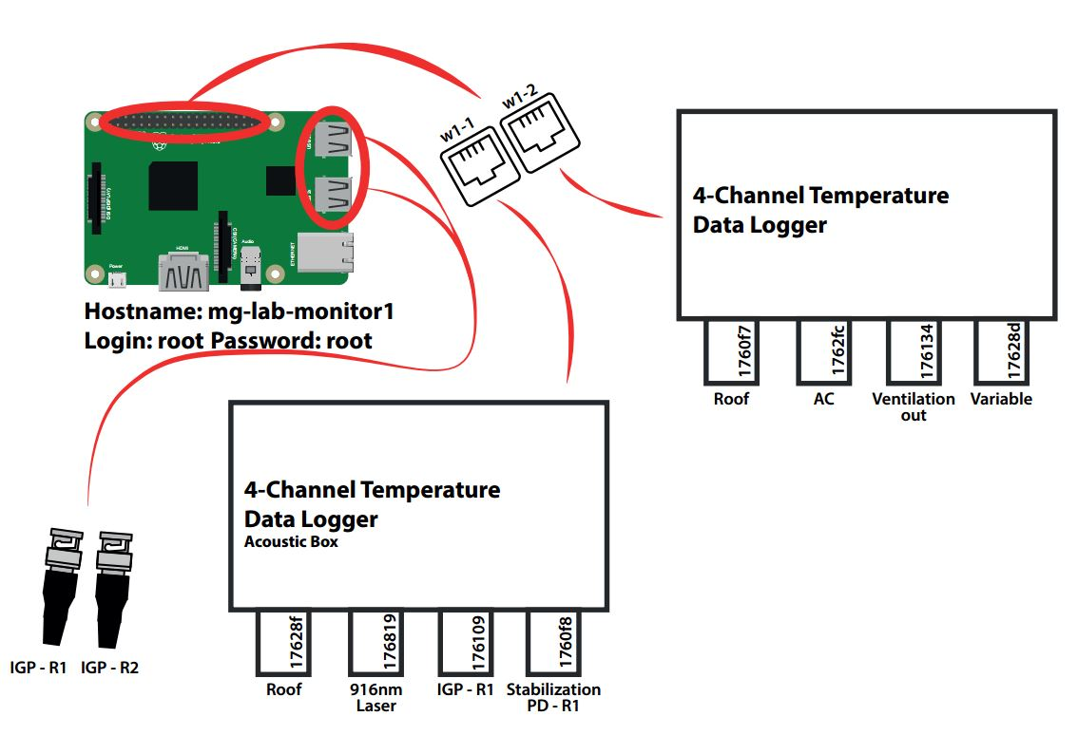
rasptemp1.pdf

Hardware setup
pictures and schematics

Installing Raspbian

Enabling One-Wire-Bus
Edit /boot/config.txt:
sudo nano /boot/config.txt
and add the line
dtoverlay=w1-gpio
Edit /etc/modules:
sudo nano /etc/modules
and add the lines
w1-gpio
w1-therm
Reboot the System:
sudo reboot
There should be folders w1_bus_master<N> in /sys/devices:
ls -l /sys/devices/
Check if there are devices connected:
ls -l /sys/devices/w1_bus_master1/
Replace w1_bus_master_1 with any of the folders listed previously.
There should be folders named something like 3b-0000001760f8/. These are the devices connected. Make sure there is a file named w1_slave for every device connected. This file is used to read from and write to the connected devices.
In case the folders or the files don't exist, make sure your devices are connected correctly, the steps above were done and/or reboot the system.

collectd
https://collectd.org/index.shtml
collectd is run on the raspberry pi to read out the temperature sensors and send the messages to the influxdb database located on another server.
install collectd:
sudo apt-get update
sudo apt-get install collectd
check the status of the daemon:
sudo systemctl status collectd
if the status is running, stop the daemon:
sudo systemctl stop collectd
to view all systemlog messages by collectd:
journalctl -u collectd -b
The collectd configuration file is located at /etc/collectd/collectd.conf. Edit it:
sudo nano /etc/collectd/collectd.conf
Copy the contents of this file into there.
Make sure to adjust the name of the server in the network plugin section to your needs.

Python Plugin
The temperature sensors are read out by a python module using the python plugin for collectd. Place the script w1_therm_monitor.py in the folder /home/pi/ or change the ModulePath option for the python plugin in /etc/collectd/collectd.conf if you want to place it in another folder.
The collectd module reads w1_master_slaves, takes all the serial numbers starting with 28 (DS18B20 family) or 3b (MAX31850 family) and reads the corresponding slave files (i.e. the temperatures).

Starting collectd
Start the collectd service using:
sudo systemctl start collectd
Check if it runs without errors by reading
sudo systemctl status collectd
or checking
journalctl -u collectd -b
The system automatically gets new slaves but doesn't support removing slaves while running

influxdb
https://www.influxdata.com/time-series-platform/influxdb/

Setup
set up as decribed in getting started section

Creating the database
Create a database in which you later wish to store the temperatures measured, for now we call it collectd_test.
In influxDB execute:
CREATE DATABASE collectd_test
Check if it was created properly using:
USE collectd_test
Exit using
EXIT

Configuring for collectd
Stop the influxdb server by running:
sudo systemctl stop influxd
The configuration file is /etc/influxdb/influxdb.conf. The documentation can be found here: https://docs.influxdata.com/influxdb/v1.6/administration/config/
The config file we use is this.
The interesting part is:
[[collectd]]
enabled = true
bind-address = ":25826"
database = "collectd_test"
security-level = "none"
This enables the collectd plugin for influx and writes to the database we specify without any privileges required.
adjust the configuration file to be the same as above.

types.db
The collectd plugin for influx requires a types.db document. Copy this from /usr/share/collectd/ on the raspberry pi to /usr/local/share/collectd/ on the server running influxDB.

Restarting the server
Start the server by typing
influxd
and leave the terminal open. If there are any errors, these should be displayed now.
To check if there are values being written into the database, use another terminal or ssh to log into influx:
influx
and check for values in the database:
USE collectd_test
SHOW SERIES
If something is displayed, try listing those values by using
SELECT * FROM <name of the time series>

