Fiber link
Fiber stabilization

Scheme
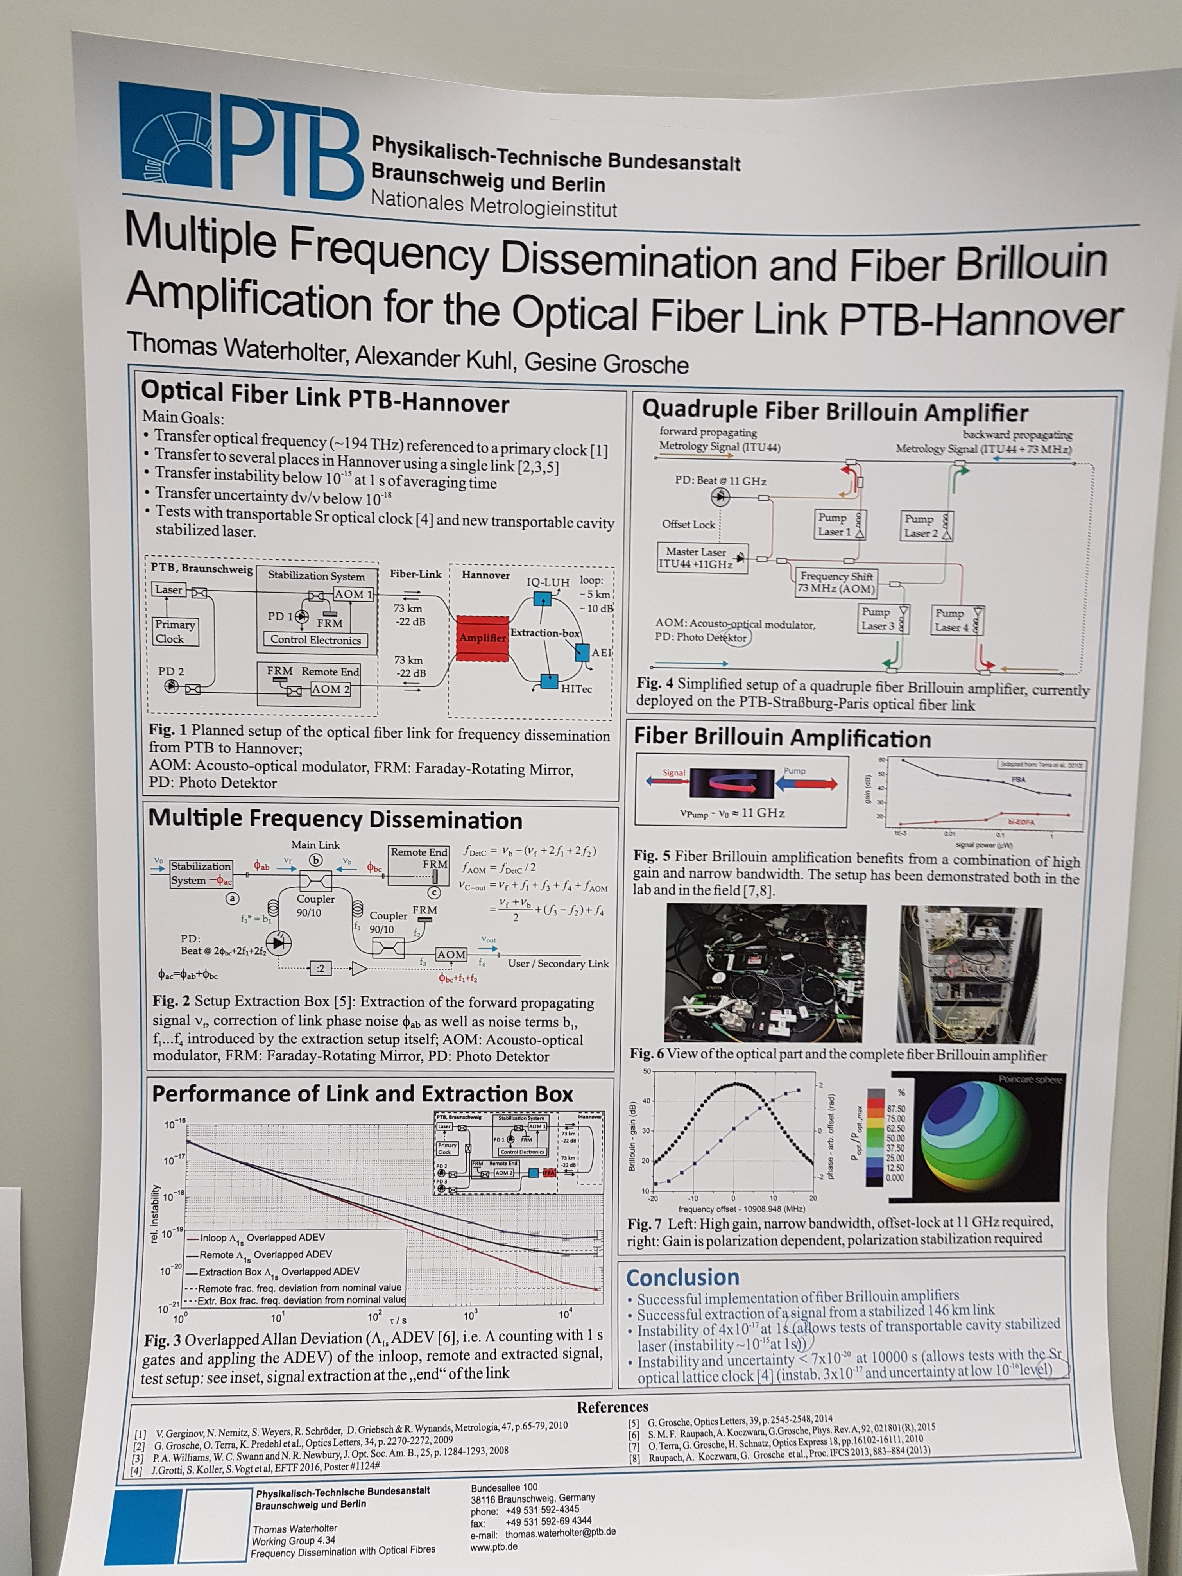

Next steps (06.10.2016)
- Comparison measurement with strontium/caesium
- Link to AEI (contact partner: Michael Tröbst?)
- Link HighTec, but how?

