Meerstetter Temperature Controller
Refer to the official documentation of the Meerstetter for an in-depth guide to setting up and operating the system. The manual is very rigorous and covers everything required. This article just covers the main relevant points.
- Official Website - Further information
- Datasheet - Concise data
- Manual - In depth guides
- Setup guide - Quick guide for the first setup

Overview

Basic Concept
The Meerstetter temperature controller is used to stabilize objects to a given temperature. It measures the temperature of the object using a thermal resistor and adjusts the object temperature accordingly by driving a heating/cooling element connected to the object.

Functionality
- Temperature stabilisation to sub mK range
- Exact control through software environment
- Easy configuration using autotuning funtion
- Custom programmable temperature ramps
- Temperature monitoring and data logging
- Programmable multi purpose pins for different applications

Hardware
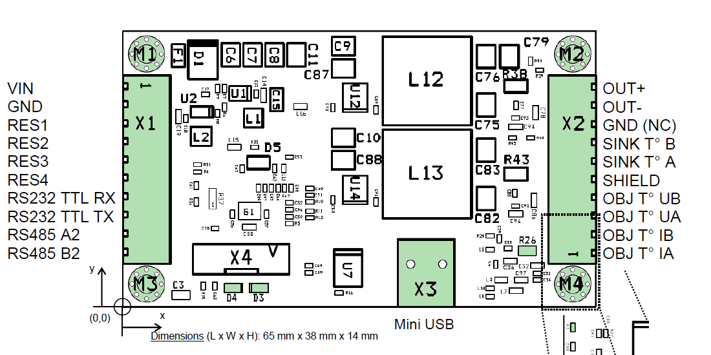
X1: General connections
- power supply
- multi purpose pins
- serial connection
X2: Connections for temperature measurement and control
- peltier element/heating foil etc.
- temperature measurement
X3: USB for connection to PC

Software
Meerstetter provides a software for their temperature controller. This software is used to set up and monitor the temperature controller. It also provides a option for data logging.
The newest version can be downloaded in the software section of the Official Website.

Basic Setup
If you are setting up a Meerstetter temperature controller for the first time, refer to the official setup guide. It takes you through all main steps and introduces you to the service software.
The manual also covers this topic extensively. Refer to chapter 2.

Power supply
The Meerstetter can operate in a voltage range of 5-24V DC at a maximum current of 4A. The current setup for the 1560 nm rio laser diode runs at 18V.
Connect the pins VIN and GND on X1 to a suitable lab power supply to power the meerstetter.

Peltier Element/Heating Foil
The Meerstetter can run with a peltier element as well as a resistive heating element like a heating foil. To use it correctly, you must configure the meerstetter accordingly using the service software.
The peltier element/resistive heater is connected to the pins OUT+ and OUT-.

Temperature Sensor
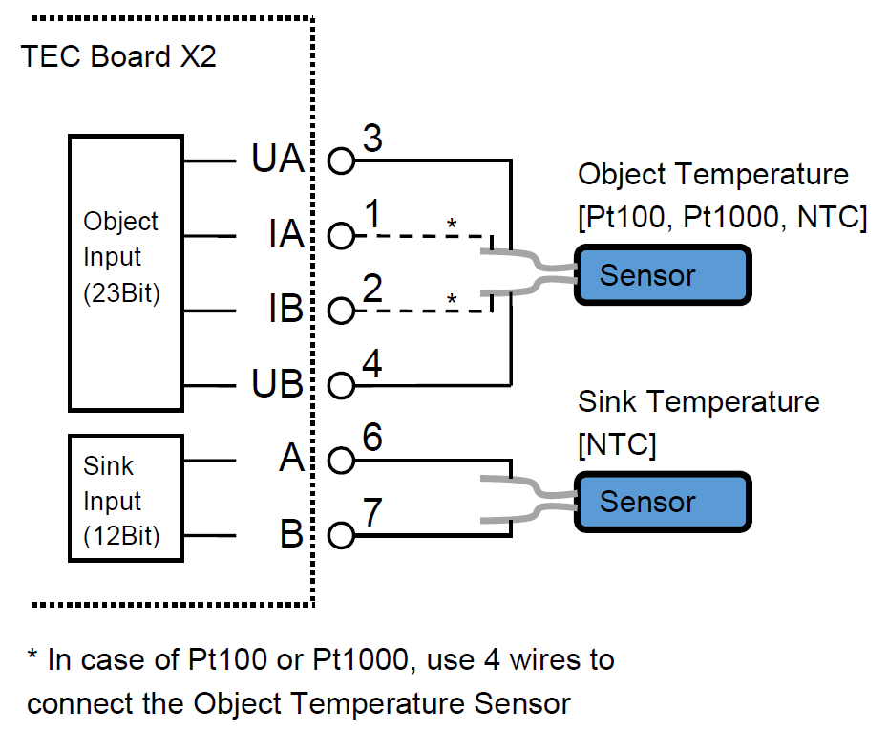
See page 4 of the Datasheet.

Object Temperature
The Meerstetter can do two-wire as well as four-wire measurement. For this the pins OBJ T° IA, OBJ T° IB, OBJ T° UA and OBJ T° UB on X2 are used. UA and UB for two wire, all four for four wire. Compatible temperature sensors are NTC, PT100 and PT1000.

Sink Temperature
The Meerstetter can also monitor the temperature of itself. This is optional. The temperature sensor is connected to SINK T° A and SINK T° B on X2. For this an NTC is used.

Software
The newest version can be downloaded in the software section of the Official Website.

Further Options

Status LEDs
To add a status LED to the Meerstetter, you can follow this step-by-step guide:
- connect its anode to any of the pins labelled “RES” using a resistor
- connect its cathode to GND
- connect the Meerstetter to your PC via a mini-USB B cable
- connect a power supply
  - <fc #ff0000>ensure the Meerstetter is connected to a load, otherwise it might be damaged“”“”“”“”“”“”“”“”!</fc> Information on what these options exactly mean can be found on pages 47 and 48 of the manual
- write the settings to the Meerstetter using the button in the bottom right corner

Pufferkondensatoren

Data Logging

