List of Computer-Programs
Save a backup file from each program in AFS!
Name | Description | Computer | Information
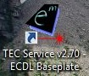TEC Service XY | TEC Control Sofware | “ | Meerstetter Control Software for ECDL baseplate, active shieldings of resonators R1 and R2
Allan-Live with time graph | - | ” | -
TracerDAQ | RedLab Card Counter | ResLab | Can count Voltages; Limited Capacities / Time;
RbMon | Rubidium clock software | “ | -
Net View | GPS receiver | ” | Control software for GPS signal.
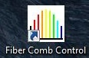Fiber Comb Control | … | “ | This Software can control Repetition Rate Stepper Motor and CEO Tuner
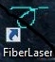FiberLaser | First start this | ” | First start this, better Autotuning
Kamm-Frequenzneu kombiniert.nb | - | “ | -
allen-combined | - | ” | -
Spyder | Pyhton Compiler | “ | Code for Einstein-Telescope
Pyhtonberechnungen von und mit Schlippi Folder | - | ” | -
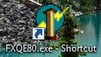K&K FXE / FXQE80 | Counter | “ | Maximal 8 Com Ports
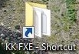KK FXE Folder | Folder of Counter | ” | Counter Daten werden hier gespeichert
… | … | … | …
… | … | … | …
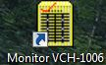Monitor VCH-1006 | Control Software for H-Maser | ResLab Maser | one entry is always red! Andreas Bauch doesn´t know the reason, but it´s okay!
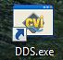DDS USB | Programming the USB-DDS | ResLab Maser | -
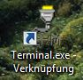USB Serial | Programming the USB-Serial | ResLab Maser | - okay!
… | … | … | …
Highfinesse Wavemeter WS/6-200 | Wavemeter | ResLab Mobil | Push the “Start Measurement” button
Laser Frequency ResLab.vi | Wavemeter | “ | Shows Laser Frequency, also for Atom Lab
K&K FXE / FXQE80 (currently not in use!) | Counter | ” | Default Settings: 8 Com Ports, Trimmer: Auto Trimmer, Measurement Method: Phase; Push buttons before measurement to erase RAM: Clear Buffer, Reset; Start Measurement via Häckchen setzen auf frequency;
KK FXE Folder (currently not in use!) | Folder of Counter | “ | Counter Daten werden hier gespeichert
… | … | … | …

