K&K FXE / FXQE80
Company: http://www.kplusk-messtechnik.de/index.html
Installation CD is in the ResLab (cabinet/computer manual)!
K+K FXE02 wurde zu einem FXE07

Counter
- Possible range: 4kHz - 65MHz
- Recommented Input: 4-17 dBm (1-5V)

Program
Default Settings: 8 Com Ports
Trimmer: Auto Trimmer
Measurement Method: Phase

Intervall length
You can change the length of the interval:
- Range: ~1 ms - 1 s
- For shorter length [shortest: 1ms] the memory would fill up very fast.
- Don´t forget to adapt the length in the program Allan-Live with time graph!

Select your measuring method
Difference between π- and Λ-measurement. Set under Report Mode:
- π-measurement = Phase
- Λ-measurement = Phase Average (usually)
“ Please note that I distinguish between the raw measurement results generated by the hardware, and the reports to the PC which are produced by the microprocessor.
Internally, the FXE counters continuously take raw measurements of the phase (relative to the 10MHz reference) of each channel every millisecond.
The on-board microprocessor can evaluate these raw measurements in different modes for presentation to the PC. I shall try to describe this by giving examples for each mode, where Pc(i) shall be the current raw 'P'hase measurement of channel 'c' at millisecond 'i', and I assume a report interval of 1s (=1000ms):
a) Instantaneous phase report mode: The on-board microprocessor reports to the PC at the selected report interval only the latest raw measurement result. All other intermediate results are ignored. Measurements reported (@ interval 1s) will be
Pc( i )
Pc(i+1000)
Pc(i+2000)
Pc(i+3000) ...
b) Averaged phase report mode: The on-board microprocessor calculates the average of all raw measurements taken during the report interval and reports to the PC at the end of the interval. All raw measurements contribute to the reported result. This helps to reduce measurement noise. Results reported (@ interval 1s) will be
Sum(n=0..999){Pc( i + n )}/1000
Sum(n=0..999){Pc(i+1000+n)}/1000
Sum(n=0..999){Pc(i+2000+n)}/1000
Sum(n=0..999){Pc(i+3000+n)}/1000 ...
c) Phase difference report mode: Inter-channel phase differences Pc-P1 are reported. These differences are the 'best possible' measurements, as any uncertainties of the reference cancel and most temperature effects cancel, as they are common to all channels. Measurements reported (@ interval 1s) will be
Pc( i ) - P1( i )
Pc(i+1000) - P1(i+1000)
Pc(i+2000) - P1(i+2000)
Pc(i+3000) - P1(i+3000) ...
d) Averaged phase difference report mode: Inter-channel differences of averaged phase Pc-P1 are reported. Measurements reported (@ interval 1s) will be
Sum(n=0..999){Pc( i + n ) - P1( i + n )}/1000
Sum(n=0..999){Pc(i+1000+n) - P1(i+1000+n)}/1000
Sum(n=0..999){Pc(i+2000+n) - P1(i+2000+n)}/1000
Sum(n=0..999){Pc(i+3000+n) - P1(i+3000+n)}/1000 ...
e) Frequency report mode: Frequency is Phase advance per time. The on-board microprocessor calculates the difference of the current phase measurement and the measurement taken one report interval earlier, and divides it by the report interval. Measurements reported (@ interval 1s) will be
[Pc( i ) - Pc(i-1000)]/1000ms
[Pc(i+1000) - Pc( i ) ]/1000ms
[Pc(i+2000) - Pc(i+1000)]/1000ms
[Pc(i+3000) - Pc(i+2000)]/1000ms ...
f) Averaged frequency report mode: Averaged frequency is advance of averaged phase per time. The on-board microprocessor calculates the difference of the currents averaged phase and the averaged phase calculated one report interval earlier. Measurements reported (@ interval 1s) will be
[Sum(n=0..999){Pc( i + n )} - Sum(n=0..999){Pc(i-1000+n)}]/1000ms
[Sum(n=0..999){Pc(i+1000+n)} - Sum(n=0..999){Pc( i + n ) } ]/1000ms
[Sum(n=0..999){Pc(i+2000+n)} - Sum(n=0..999){Pc(i+1000+n)}]/1000ms
[Sum(n=0..999){Pc(i+3000+n)} - Sum(n=0..999){Pc(i+2000+n)}]/1000ms ...
By just re-arranging these sums you can also write
... = Sum(n=0..999){[Pc(i+n) - Pc(i-1000+n)]/1000}
Hence, averaged frequency can be thought of either as 'advance of averaged phase' or as the average over 1000 non-averaged frequencies (@ interval 1s), in 1ms spacing.
Consequently, data measured during two(!) report intervals contribute to the averaged frequency value reported.
”

Start a measurement
Push buttons before measurement to erase RAM:
- Clear Buffer-button = Reset
- Rename the data file in KK_FXE Folder
- Start new measurement via “Häckchen” at Frequency
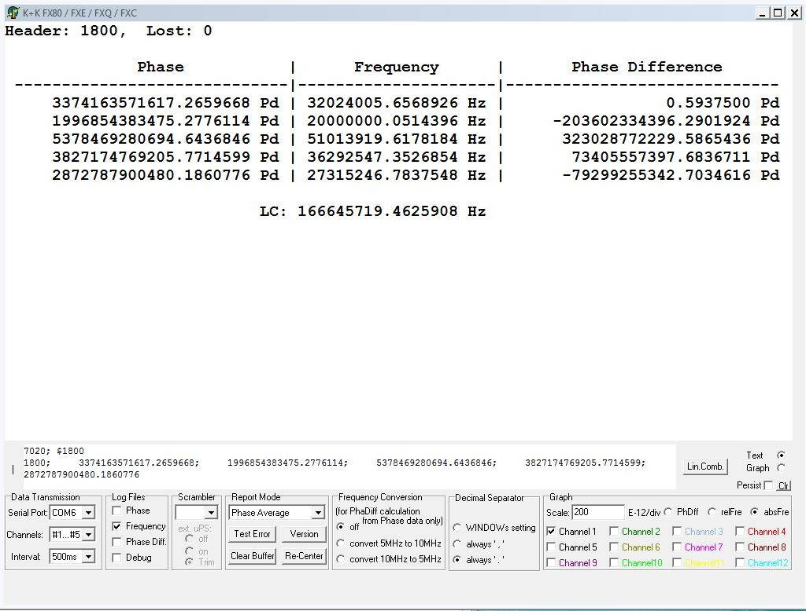

For understanding and communication with PTB


