HTC-3000

General Overwiew of the System

Front Panel
The front panel of the HTC looks somewhat like this:
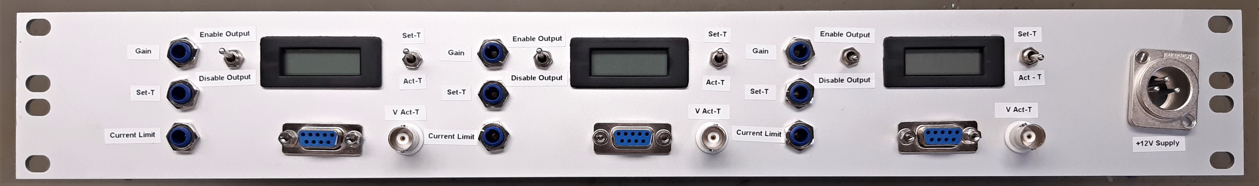Front

Switches and Display
The right switch has two positions:
- In the upper position the current voltage output by the HTC in order to monitor the current temperature is displayed.
- In the lower position the voltage corresponding to the wanted temperature is displayed.
While you <fc #ff0000>can't</fc> directly read the current temperature, the display allows you to gauge how well the system's temperature is stabilized or see if there are any problems.
The left switch enables or disables the output temperature. Turn off while changing the set temperature.

Potentiometers
- “Gain” controls the speed with which the HTC tries to reach the wanted temperature. High gain requires high currents flowing in order to function correctly. Too high gain can lead to overshooting the wanted temperature or oscillating around it. Too low gain can lead to very long waiting times or the HTC not being able to stabilize the system's temperature correctly.
- “Current Limit” changes the maximum current used to regulate the system's temperature. Use this potentiometer to limit the maximum current drawn to under the maximum current allowed.
- “Set-T” controls the wanted temperature of the system.
Turning any of the potentiometers clockwise will increase the maximum current, gain or temperature.

Connectors
The BNC connector displays the voltage signal of the current temperature. The SUB-D 9 connector is used to connect temperature sensor and a temperature regulating element like a heating foil or a peltier element.
HTC Pin | SUB-D Pin | Function
13 | 2 | Sensor +
14 | 3 | Sensor -
11 | 4, 6 | TEC +
12 | 5, 8 | TEC -

Power Supply
Before connecting the HTC to a power source be sure to connect a load to it first! Otherwise it will break!
The HTC-3000 itself is designed for an operating voltage range of 5-12V DC. Here we use a potential of 12 V.
When first using the HTC, be sure to adjust the potentiometer on the front panel labelled “Current Limit” so that the HTC won't draw any more than the maximum current given on the back of the HTC housing. In case this wasn't done, a fuse installed on the back panel will protect the circuitry but will have to be changed after the first few cooling/heating cycles. Using the current limiter on a lab power supply will NOT have the same effect as the supply voltage will drop in order to reduce the current flowing which might lead to the voltage dropping out of the operating range of the HTC, basically turning it off.
The Display is powered by a 9V supply

Back Panel
The back panel looks like this:
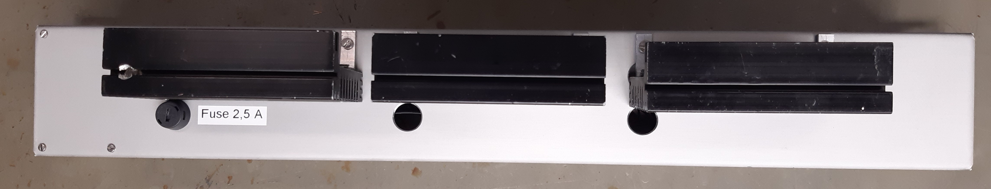Back
Here you find a 2,5 A fuse, protecting the circuitry and the heatsinks for the controllers.

Configuration for Peltier Elements and Resisitive Heaters
The HTC can be used with peltier elements as well as with resistive heaters like heating foils.
When using heating foils or other resistive heaters, a diode needs to be installed between pins 2 and 3 of the HTC. Detailed information on this topic can be found in the datasheet on page 7.
The direction of this diode is determined by whether you are using an NTC or a PTC sensor.
When using a peltier element, using a diode will lead to the peltier element either only cooling or only heating the system. To do both, the diode has to be removed and replaced with a jumper cable, what was realized here.
This temperaturecontroller is being used for the SHG's #1, #2 and #3 of the T-MOT. The necessary temperatures are:
SHG | Temperature | Voltage
#1 | 38,6 °C | 0,48 V
#2 | 29,3 °C | 0,97 V
#3 | 18,8 °C
(Status of 04.02.2020)

Replacing the HTC
Unscrew the HTC and detach the pins. You may also have to unscrew the heatsink from the metal shroud. Then plug the new HTC back in and tighten all screws firmly.
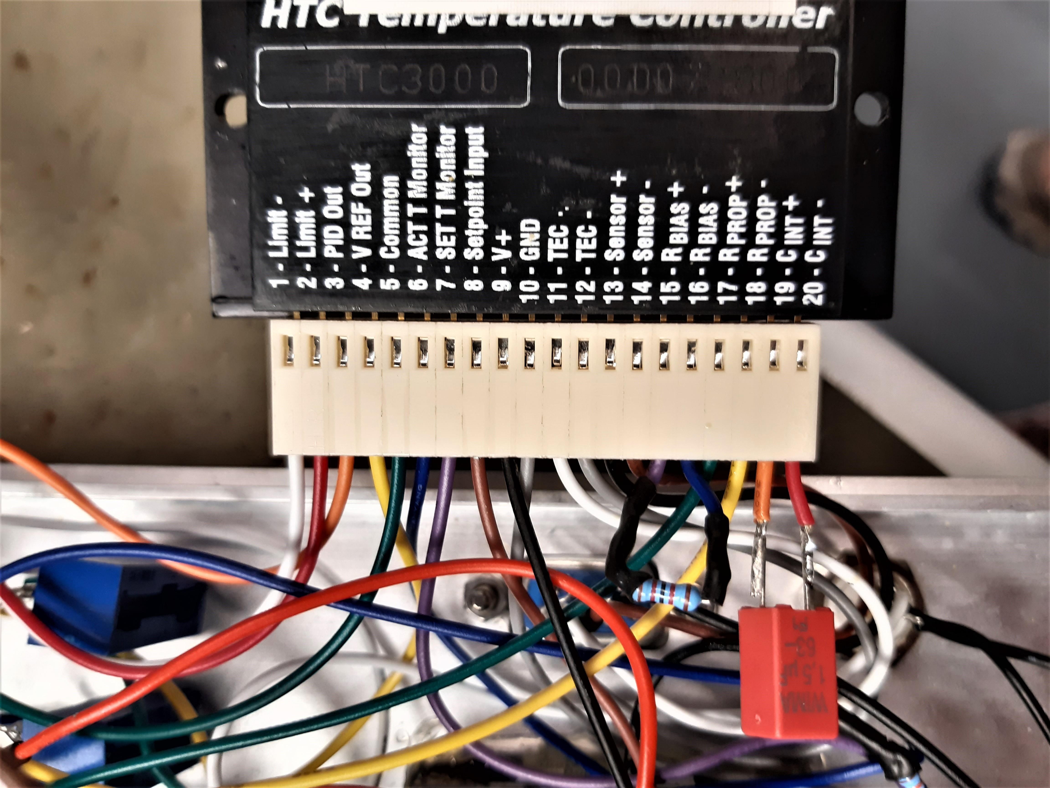

Troubleshooting
Problem | Possible Solution(s)
When viewing “T-Soll”, the display only shows “1” | Try turning the “Set-T”-potentiometer in one direction for a while. If this doesn't help, try the other direction. Otherwise check the connections of the potentiometer
Heating and cooling are mixed up | Change the polarity of the peltier element. See page 8 of the datasheet for detailed instructions.
The Element neither heats nor cools | Check the connector, test the element. Otherwise see Power Supply Related Problems

Resistive Heater Related Problems
Problem | Possible Solution(s)
No matter if the temperature is too high or too low, the module heats | Install a diode between pins 2 and 3 of the HTC. See the pages 2 and 7 of the datasheet for detailed information
The module heats when it shouldn't and doesn't heat when it should | The diode between pins 2 and 3 of the HTC is installed in the wrong direction. Reverse it's polarity. See the pages 2 and 7 of the datasheet for detailed information

Power Supply Related Problems
If there are any problems with the power supply, this should probably fix them:
- Check if the power supply outputs power in the required voltage range
- Check if the fuse is intact. If it isn't, replace it
- Check if the voltage regulator works
- Check if the cable connections within the module are intact

Parts List
These are the parts needed for building a new HTC. In this box there are 3 HTC-3000, so every part except the power supply and the fuse was used 3 times.
- HTC-3000 IC
- a large heatsink
- a NTC-temperature sensor
- a 1 MOhm trim-potentiometer (“Set-T”)
- a 10 kOhm trim-potentiometer (“Gain”)
- a 100 kOhm trim potentiometer (“Current Limit”)
- a 10 MOhm and a 500 kOhm resistor for the display
- a 1 µF capacitor for an integrator time of 1 second (the integral time constant can be set between 0 to 10 seconds, see page 8 of the datasheet for further information)
- a 12,1 kOhm resistor, for a 10 kOhm sensor (see page 7 of the datasheet for further information)
- a voltmeter
- cables
- a Sub-D 9 male connector
- a BNC male connector
- two two way switches
- a XLR-socket
- a fuse socket
- a fuse

