Good-Scientific-Practice
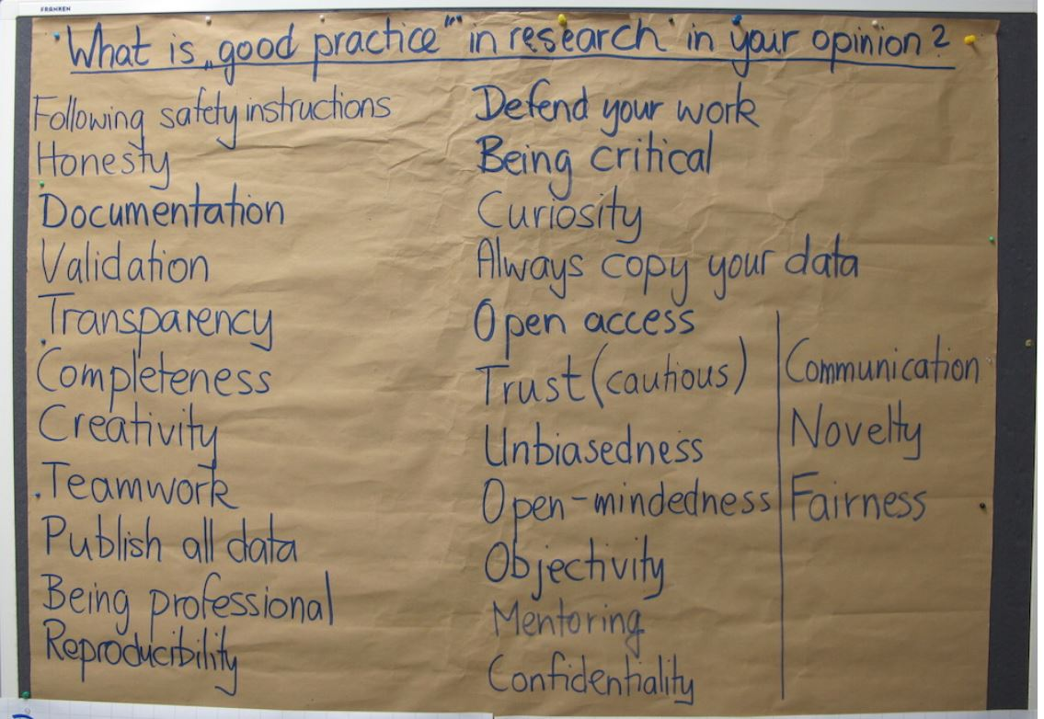
Here you will find information about Good-Scientific-Practice (=GSP).
- Documentation: documentation_gsp_hannover_2016-11.pdf
- Handout:
- Regulations for Safeguarding Good Scientific Practice:
- European code of conduct: european_code_of_conduct.pdf
- Plagiarism guidelines: plagiarism_guidelines.pdf
- Zigmond Fischer laboratory notebooks: zigmond_fischer_laboratory_notebooks.pdf
- Downloads for further reading on GSP: please_download_for_further_reading_on_gsp.pdf
- Informations about GSP for the Universität Hannover:Sicherung guter wissenschaftlicher Praxis

