Tapered amplifier
- Model: EYP-TPA-0925-01500-3006-CMT03-0000
- Serial: DC-033694
- Manual: https://www.eagleyard.com/fileadmin/downloads/data_sheets/EYP-TPA-0925-01500-3006-CMT03-0000.pdf

P-I-Curve
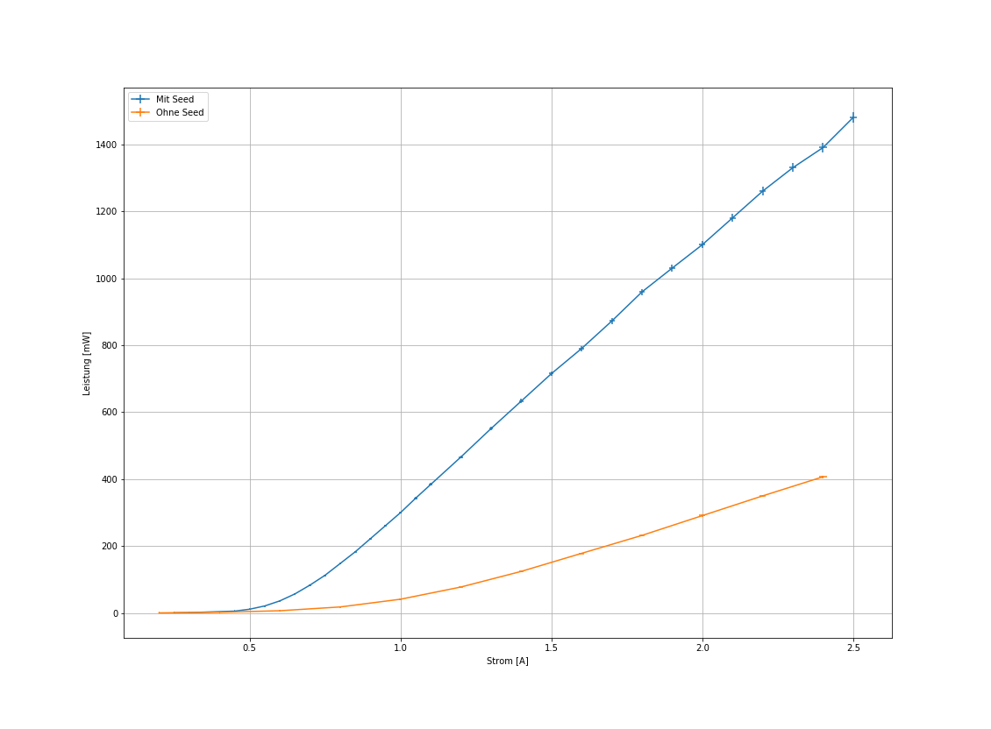

Incoupling efficiency


