Laser diode
Model: RLT940-100GS

Housing
NTC: 10 kOhm

Frequency
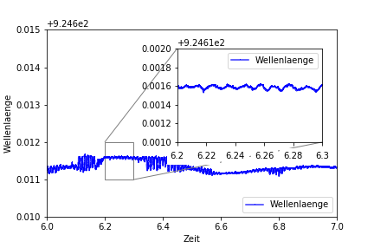Frequency measurement with KMK temperature PID (Peltier PID)
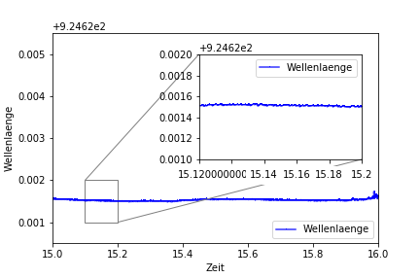Frequency measurement with Thorlabs temperature PID (LDC8040)

