1064 nm-Laser (Dipole Trap)
This is a 50 W linearly polarized CW fiber laser at 1065 nm from IPG Photonics (Model: YLR-50-1064-LP, Serial: PL1727994). The detailed specifications can be seen in the test report file attached below. The manual is saved on AFS in the folder: \\AFS\iqo.uni-hannover.de\projects\magnesium\Manuals\Lasers &#38; Laser-Controls\IPG YLR-50-LP Fiber-Laser
To make sure that the laser performance was as listed in the specifications, we tested the most important properties of the laser and the results are listed below.

Laser parameters
Test Report from IPG Photonics: final_test_data_ylr-50-1064-lp_pl1727994_.pdf
Manual of the laser system: p21-010106_rev_d_ylr_series_user_s_guide_sled_chassis.pdf
In this version of the laser, power is set by giving a setpoint on the touch screen or by giving a voltage of 1-10 V to the current modulation input. Both inputs essentially set a percentage of current which in turn gives roughly the same percentage of the maximum power. To test the laser power vs setpoint behavior, we measured the laser power with the ThorLabs power meter S322C sensor and the result is plotted below:
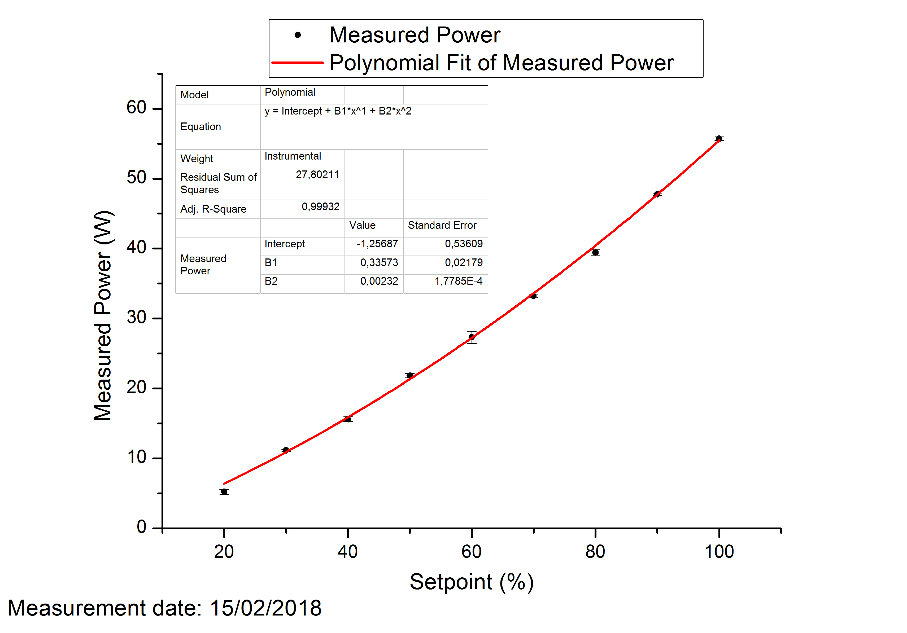
Beam diameter measurement by knife-edge technique was performed at the maximum power setpoint and also at the 65% setpoint and in both case results were very similar. These measurements were done on the 16th February 2018 and the data files can be found on Xabbu folder from this day. The average value for horizontal and Vertical (horizontal and Vertical is arbitrarily defined here, not according to how the collimator will be placed in the experiment) 1/e^2 beam radius were: 2.34 +- 0.11 mm and 2.48 +- 0.23 mm.
The spectrum of the laser was also recorded to corroborate the test report from IPG. The optical spectrum analyzer Advantest Q8384 was used for this measurement. The spectrum was measured in HiSens1 setting with an average of 16 scans. The resulting recorded spectrum was:
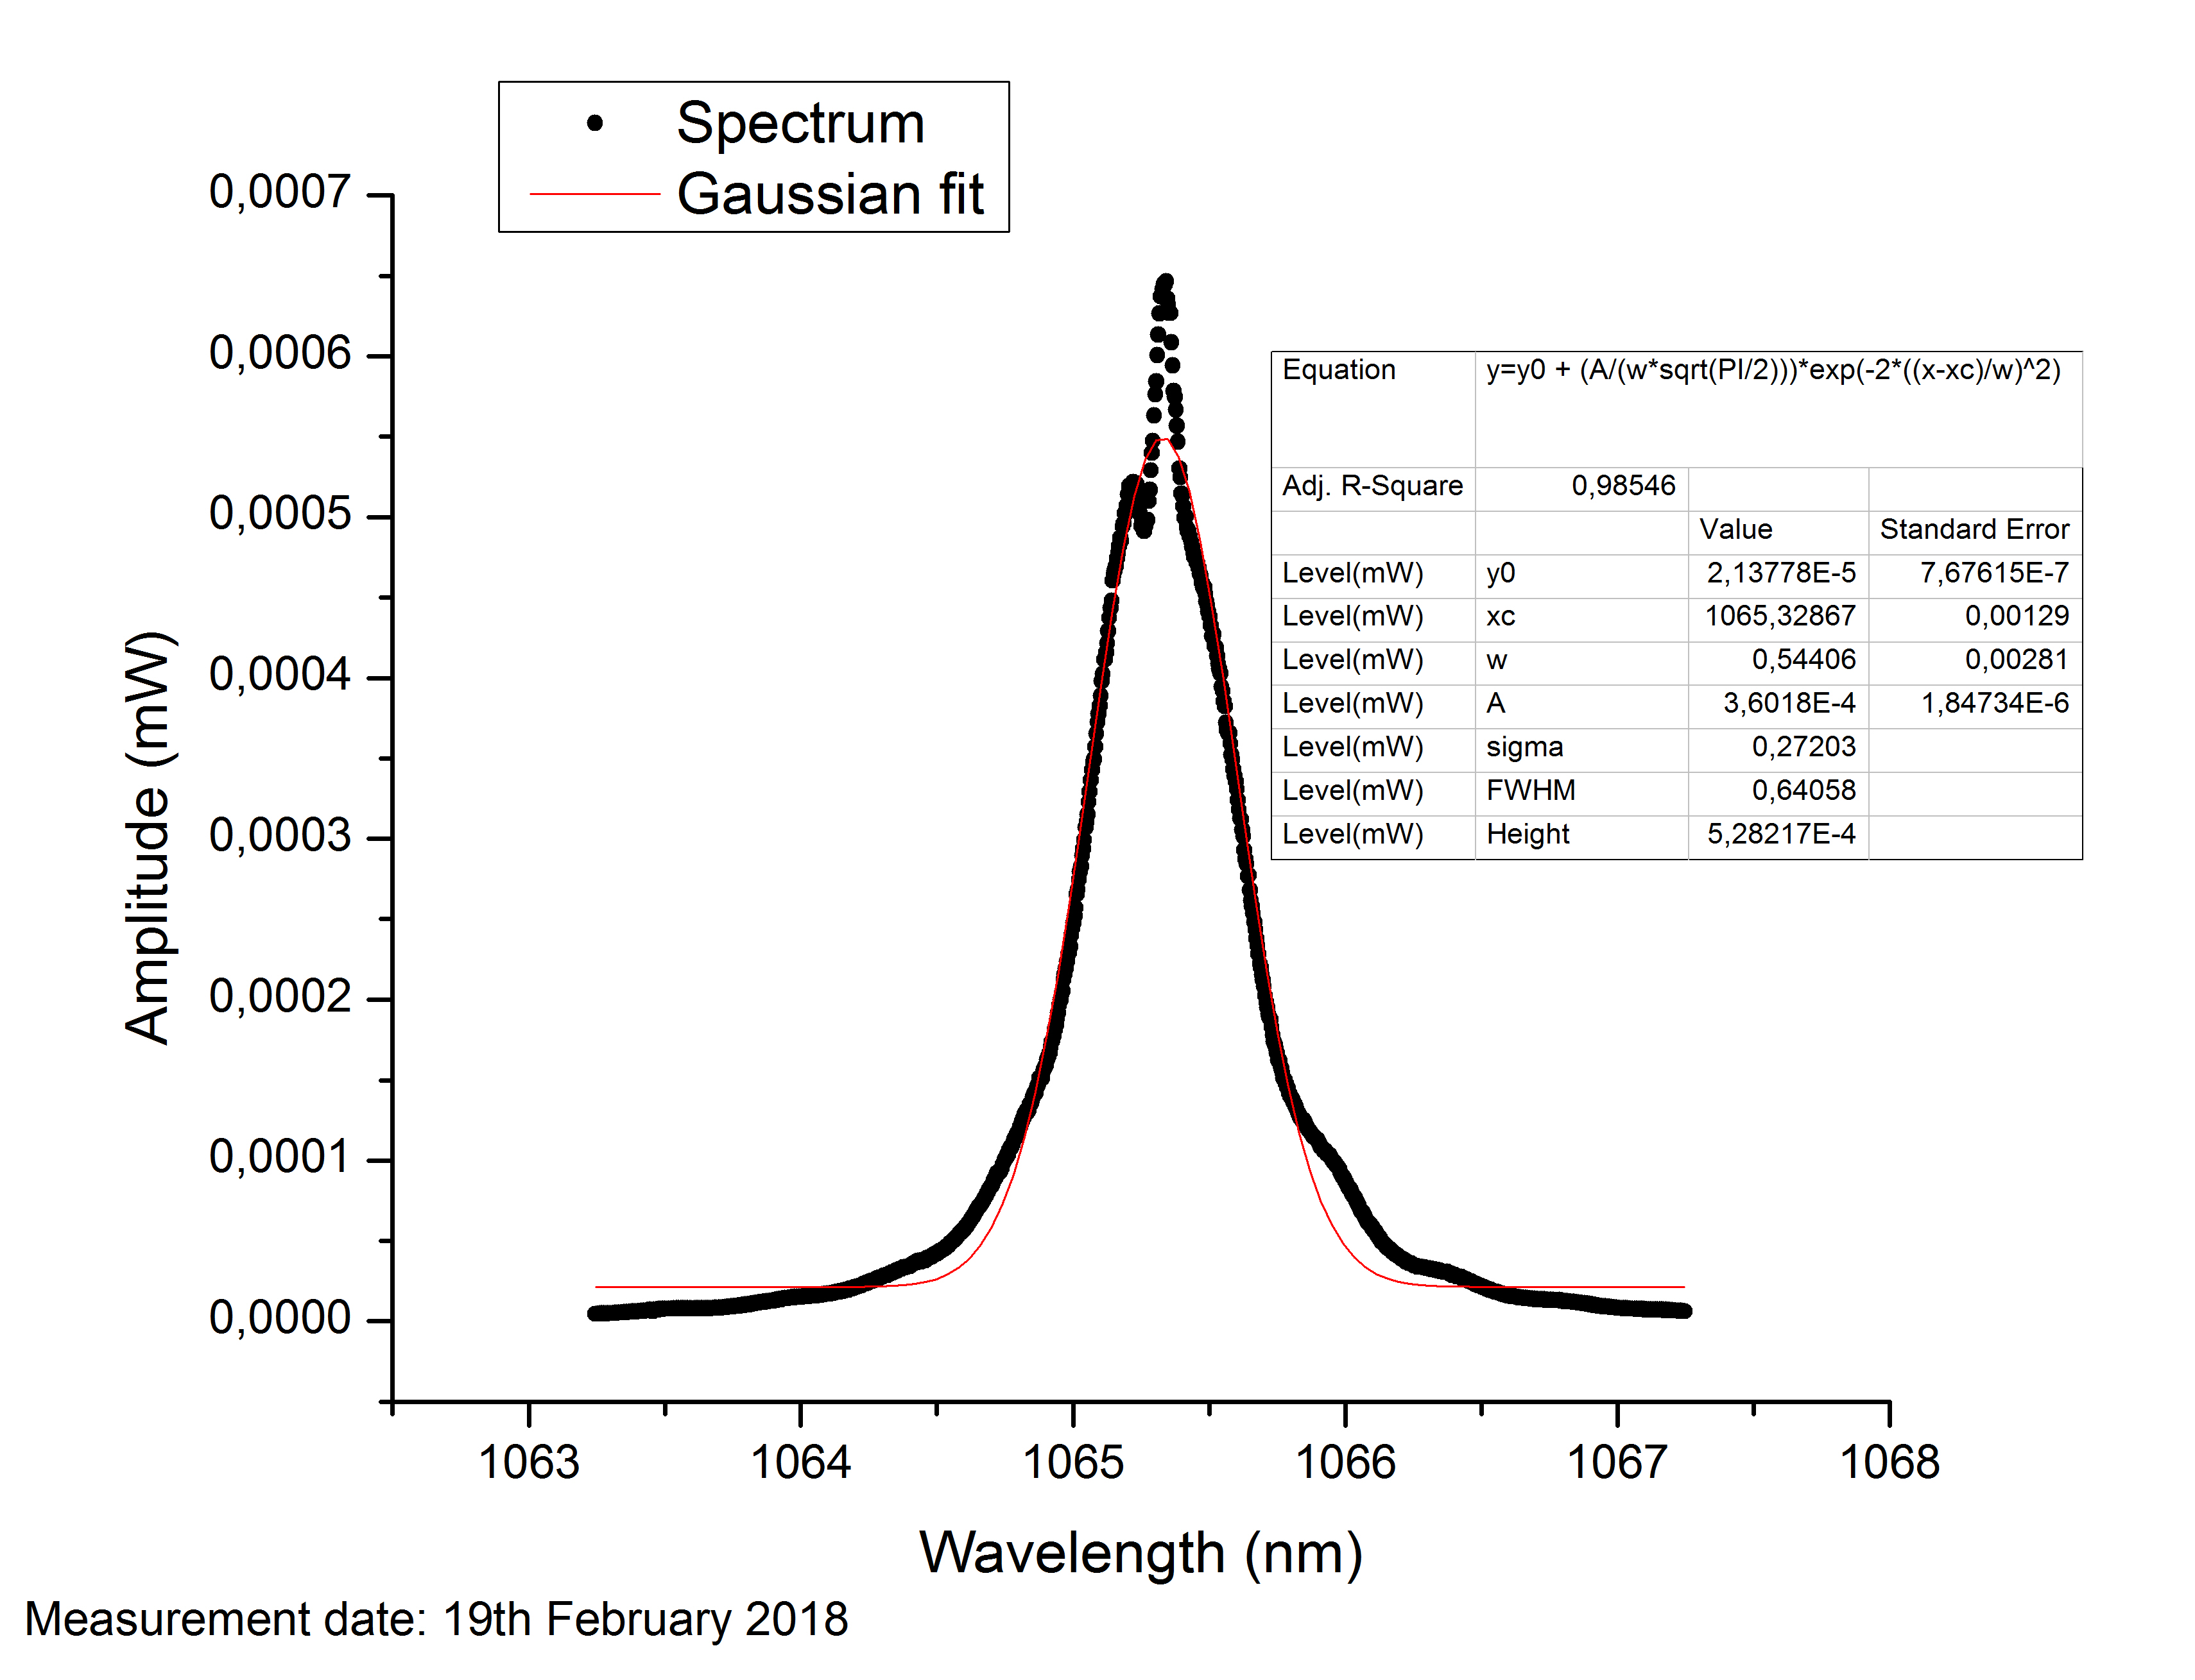
To measure the long term stability, power was sampled after a half wave plate-PBS combination by a glass plate and was sent to THorLabs power meter (S120VC). This measurement was done for both 55 W setpoint as well as 30 W setpoint. It seems that the laser power is more stable if we run it at the maximum power setpoint. Nevertheless, the fluctuations for both cases were below 1 % level for 700 seconds.
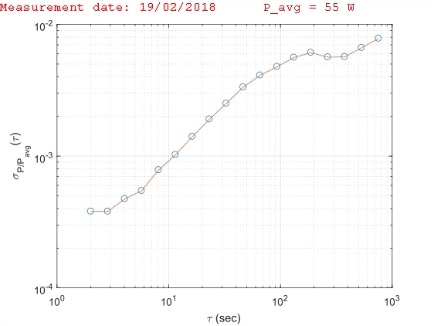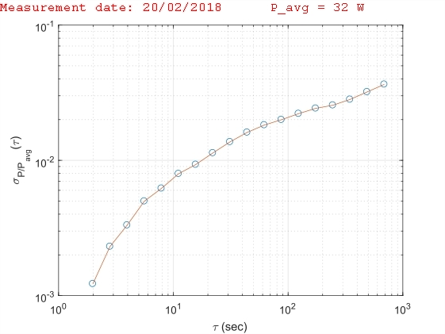
Polarization extinction ratio was measured by measuring the maximum and minimum transmitted power from a PBS by rotating a half-wave plate. This measurement was also done on 20th February 2018 and the PER was approximately 24 dB.
We also tested how fast the laser can be switched on and off, or how fast we can ramp the power. The power could be switched on-off in less than 50 microseconds. For ramping, we only tried 1 ms ramps, but from datasheet, this could also be done in 50 microseconds.
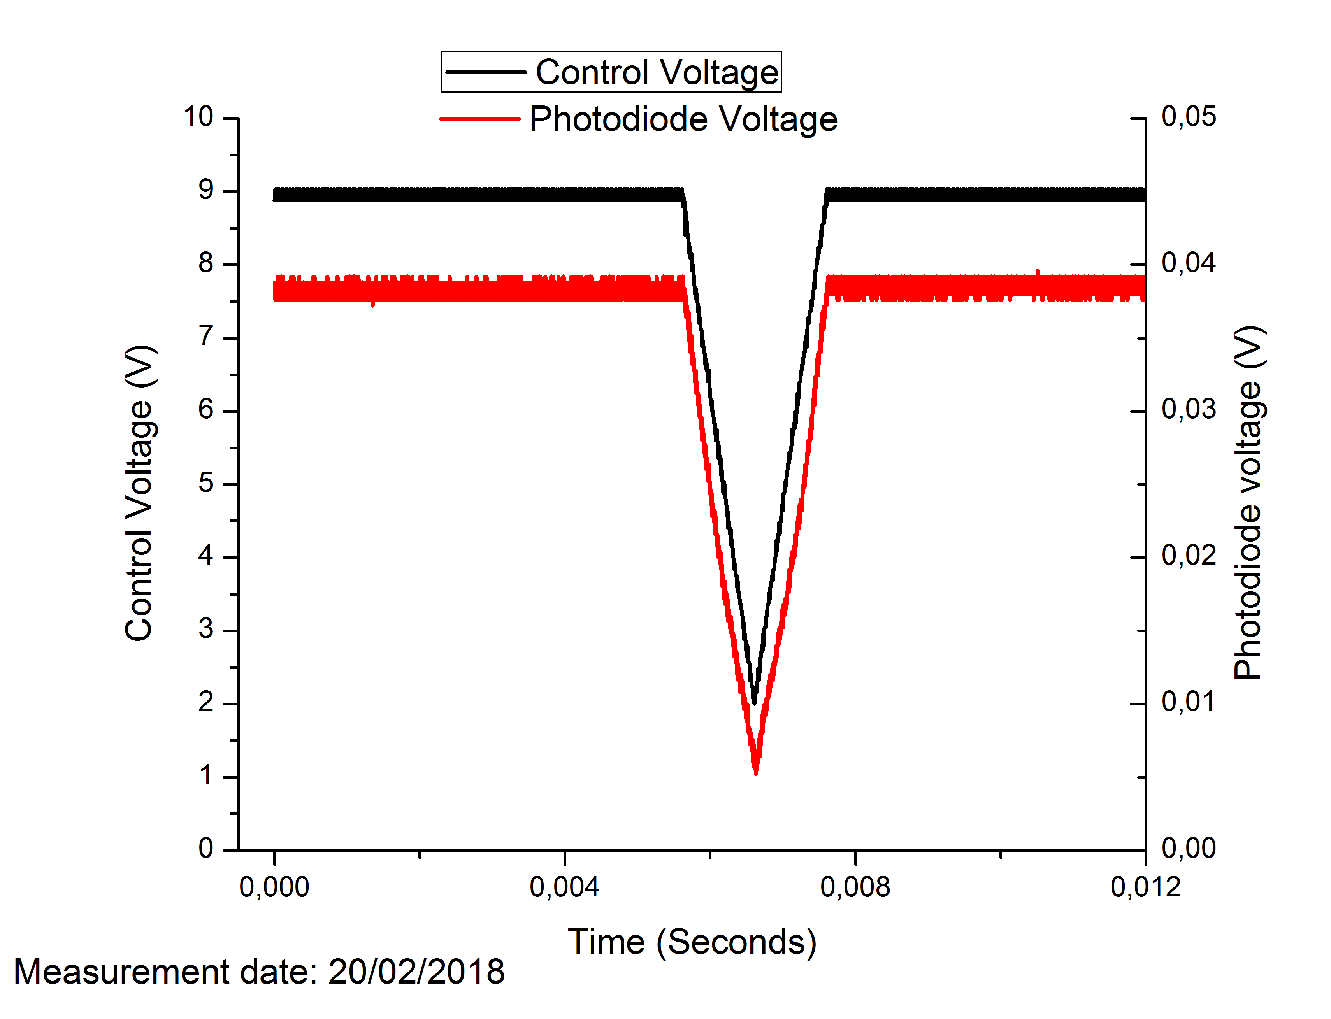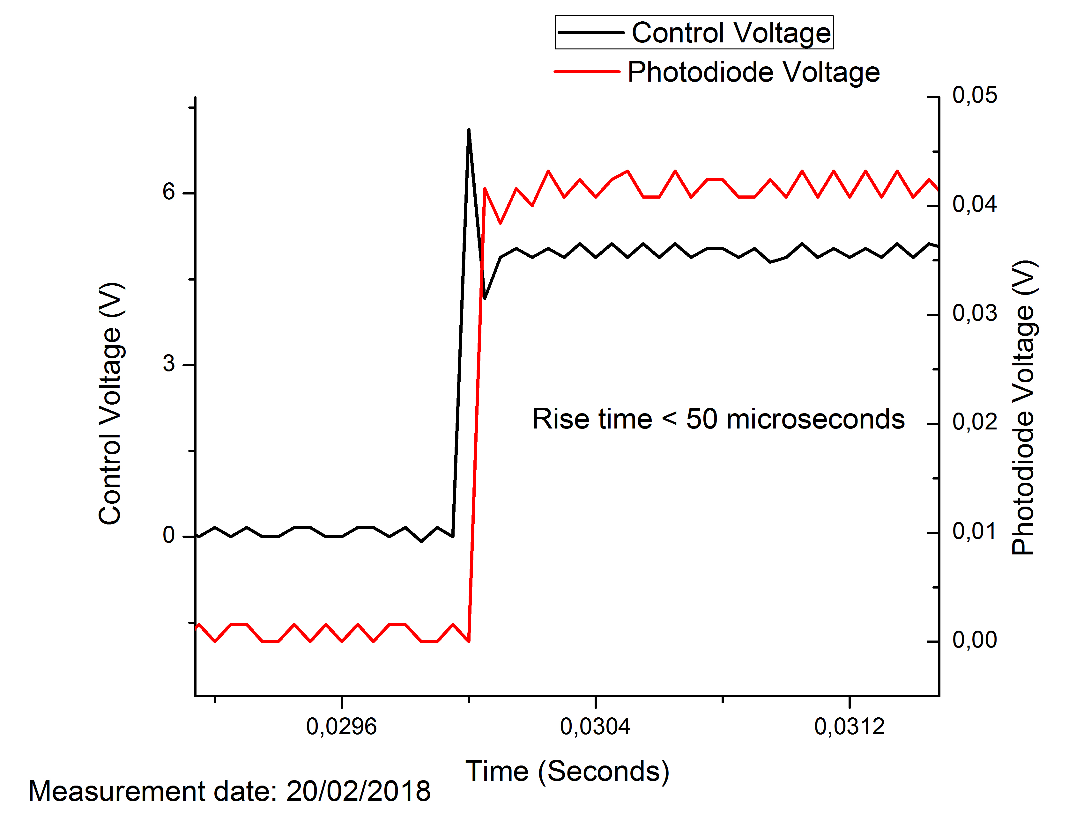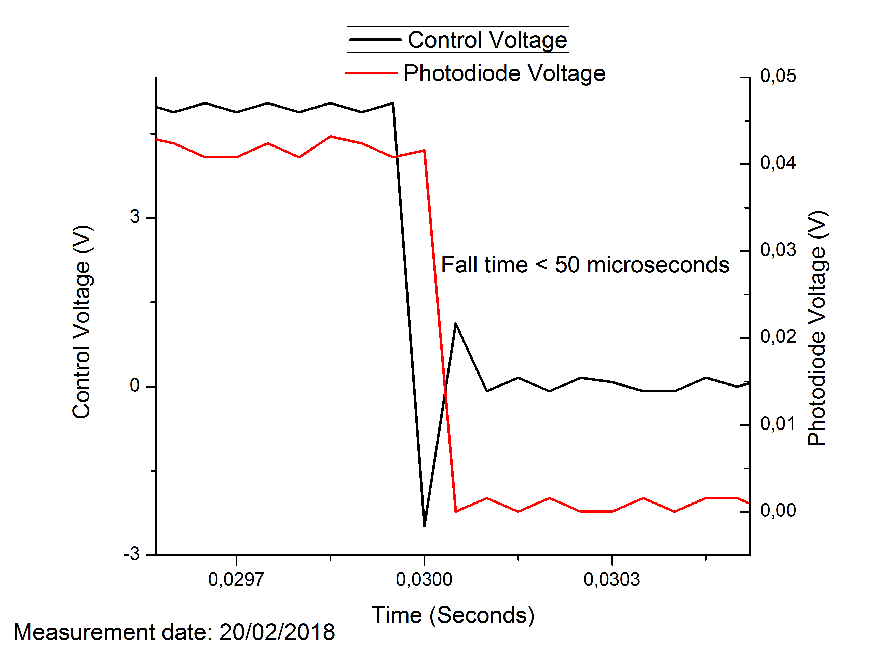
We also measured the short-term power fluctuations by diverting some of the light passing through a half-wave plate and PBS setup with a glass plate to detect on the ThorLabs photodiode DET10A/M. The spectrum was then recorded for different frequency ranges and finally combined into one long data set to integrate under the curve and obtain the high frequency fluctuations. The obtained fluctuation in power was 2.8 % between 1 kHz and 10 MHz, which is a little larger than the laser specification of 2% between 1 kHz-20MHz. The spectrum is shown below:


