Clocklaser

Turning on the Laser

Turning off the Laser

Locking to the resonators

Littmann design
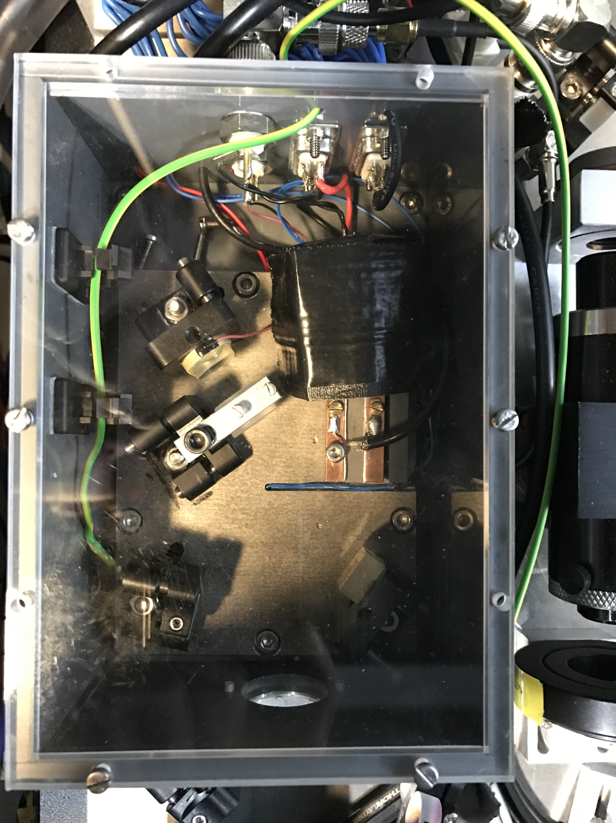
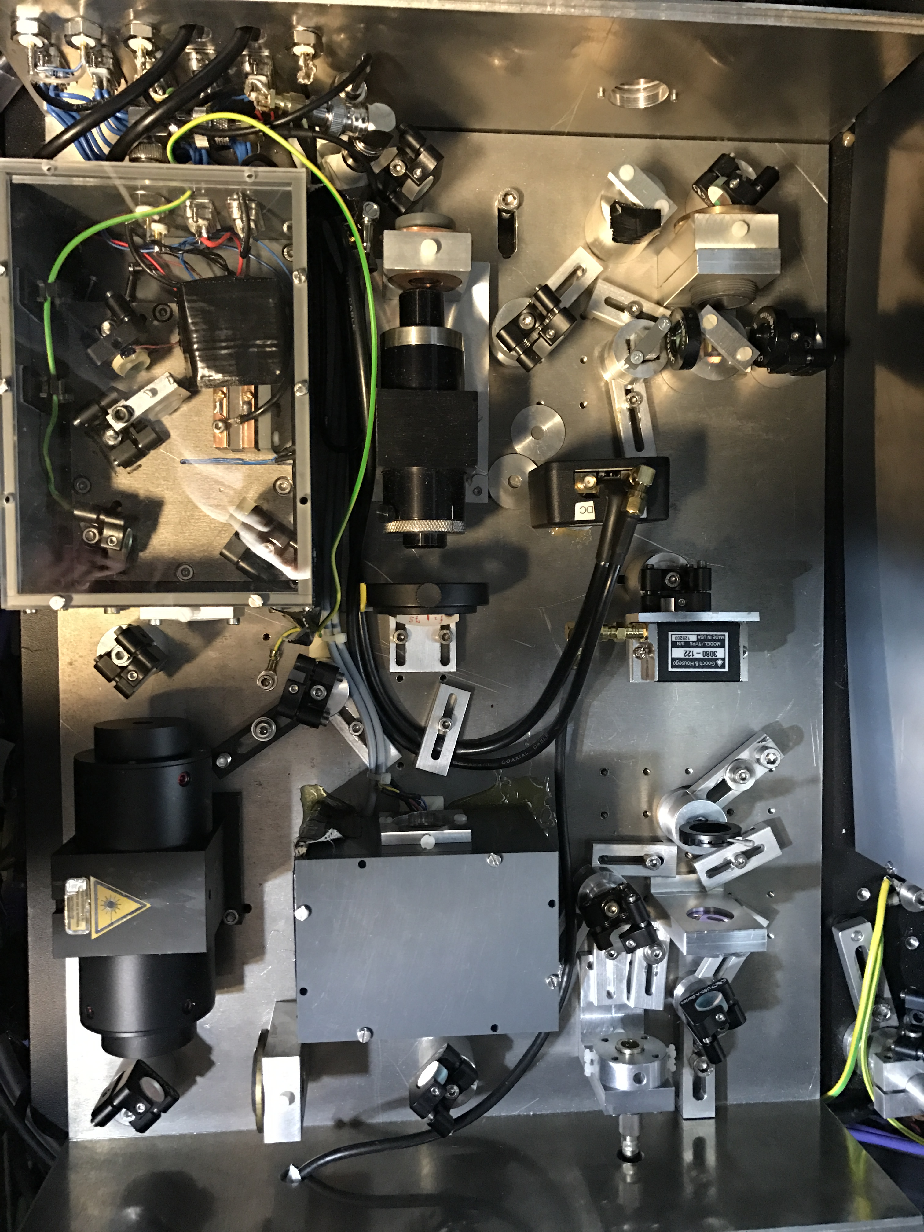
Typical efficiencies at 916 nm:
- Isolators: 80 %
- AOMs: 50-60 %
- Fiber coupling: 50 %
Typical values for the laser:
- Frequency: 327.5293 THz (doubled upstairs directly behind SHG: 655.058 566 THz)
- Power after ECDL: ~12 mW (@ ~90 mA)
- Power after TA: ~200 mW (@ ~1000 mA)
Typical values in front fibers:
- Power before fiber for wavemeter/comb/mode analysis cavity:~12 mW
- Power before AtomLabFiber: ~30 mW → 15 mW upstairs before TA
- Power to R2: ~2.5 mW
Typical values for the resonators:
- In front of telescope: 2.2 mW
- In front of AOM: 1.5 mW
- In front of fiber: 450 µW
- 100 µW between Isolator and BS
- 50 µW in front of Resonator
Typical values for locking signals:
- PDH error signal locked ~500 mV PP / unlocked ~200 mV PP
- Intensity Error signal ~2 mV PP / DC:
- Fiber Stabilization Locked ~200 mV PP / Unlocked ~2 Volt PP
Manuals and Datasheets

