10MHz frequency source

Possible sources
All sources exist in ResLab.
- Passive Hydrogen Maser
- OCXO
  - OXCO 5 MHz
  - OXCO 10 MHz (broken)
- Rubidium Frequency Standard
- GPS receiver
- Marconi Synthesizer, Model: 2024
- Selfmade distributor [Klaus]
- K+K distributor (not for high quality distribution)
- HighTec Fiber ???

Current Setup [30.05.2017]
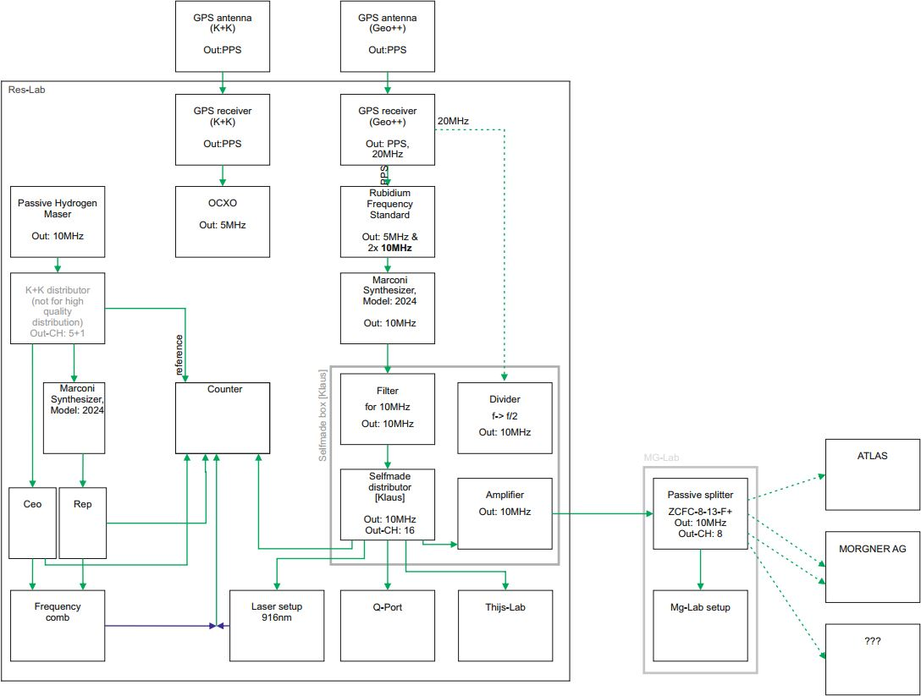
Current 10MHz setup.pdf

Future Setup
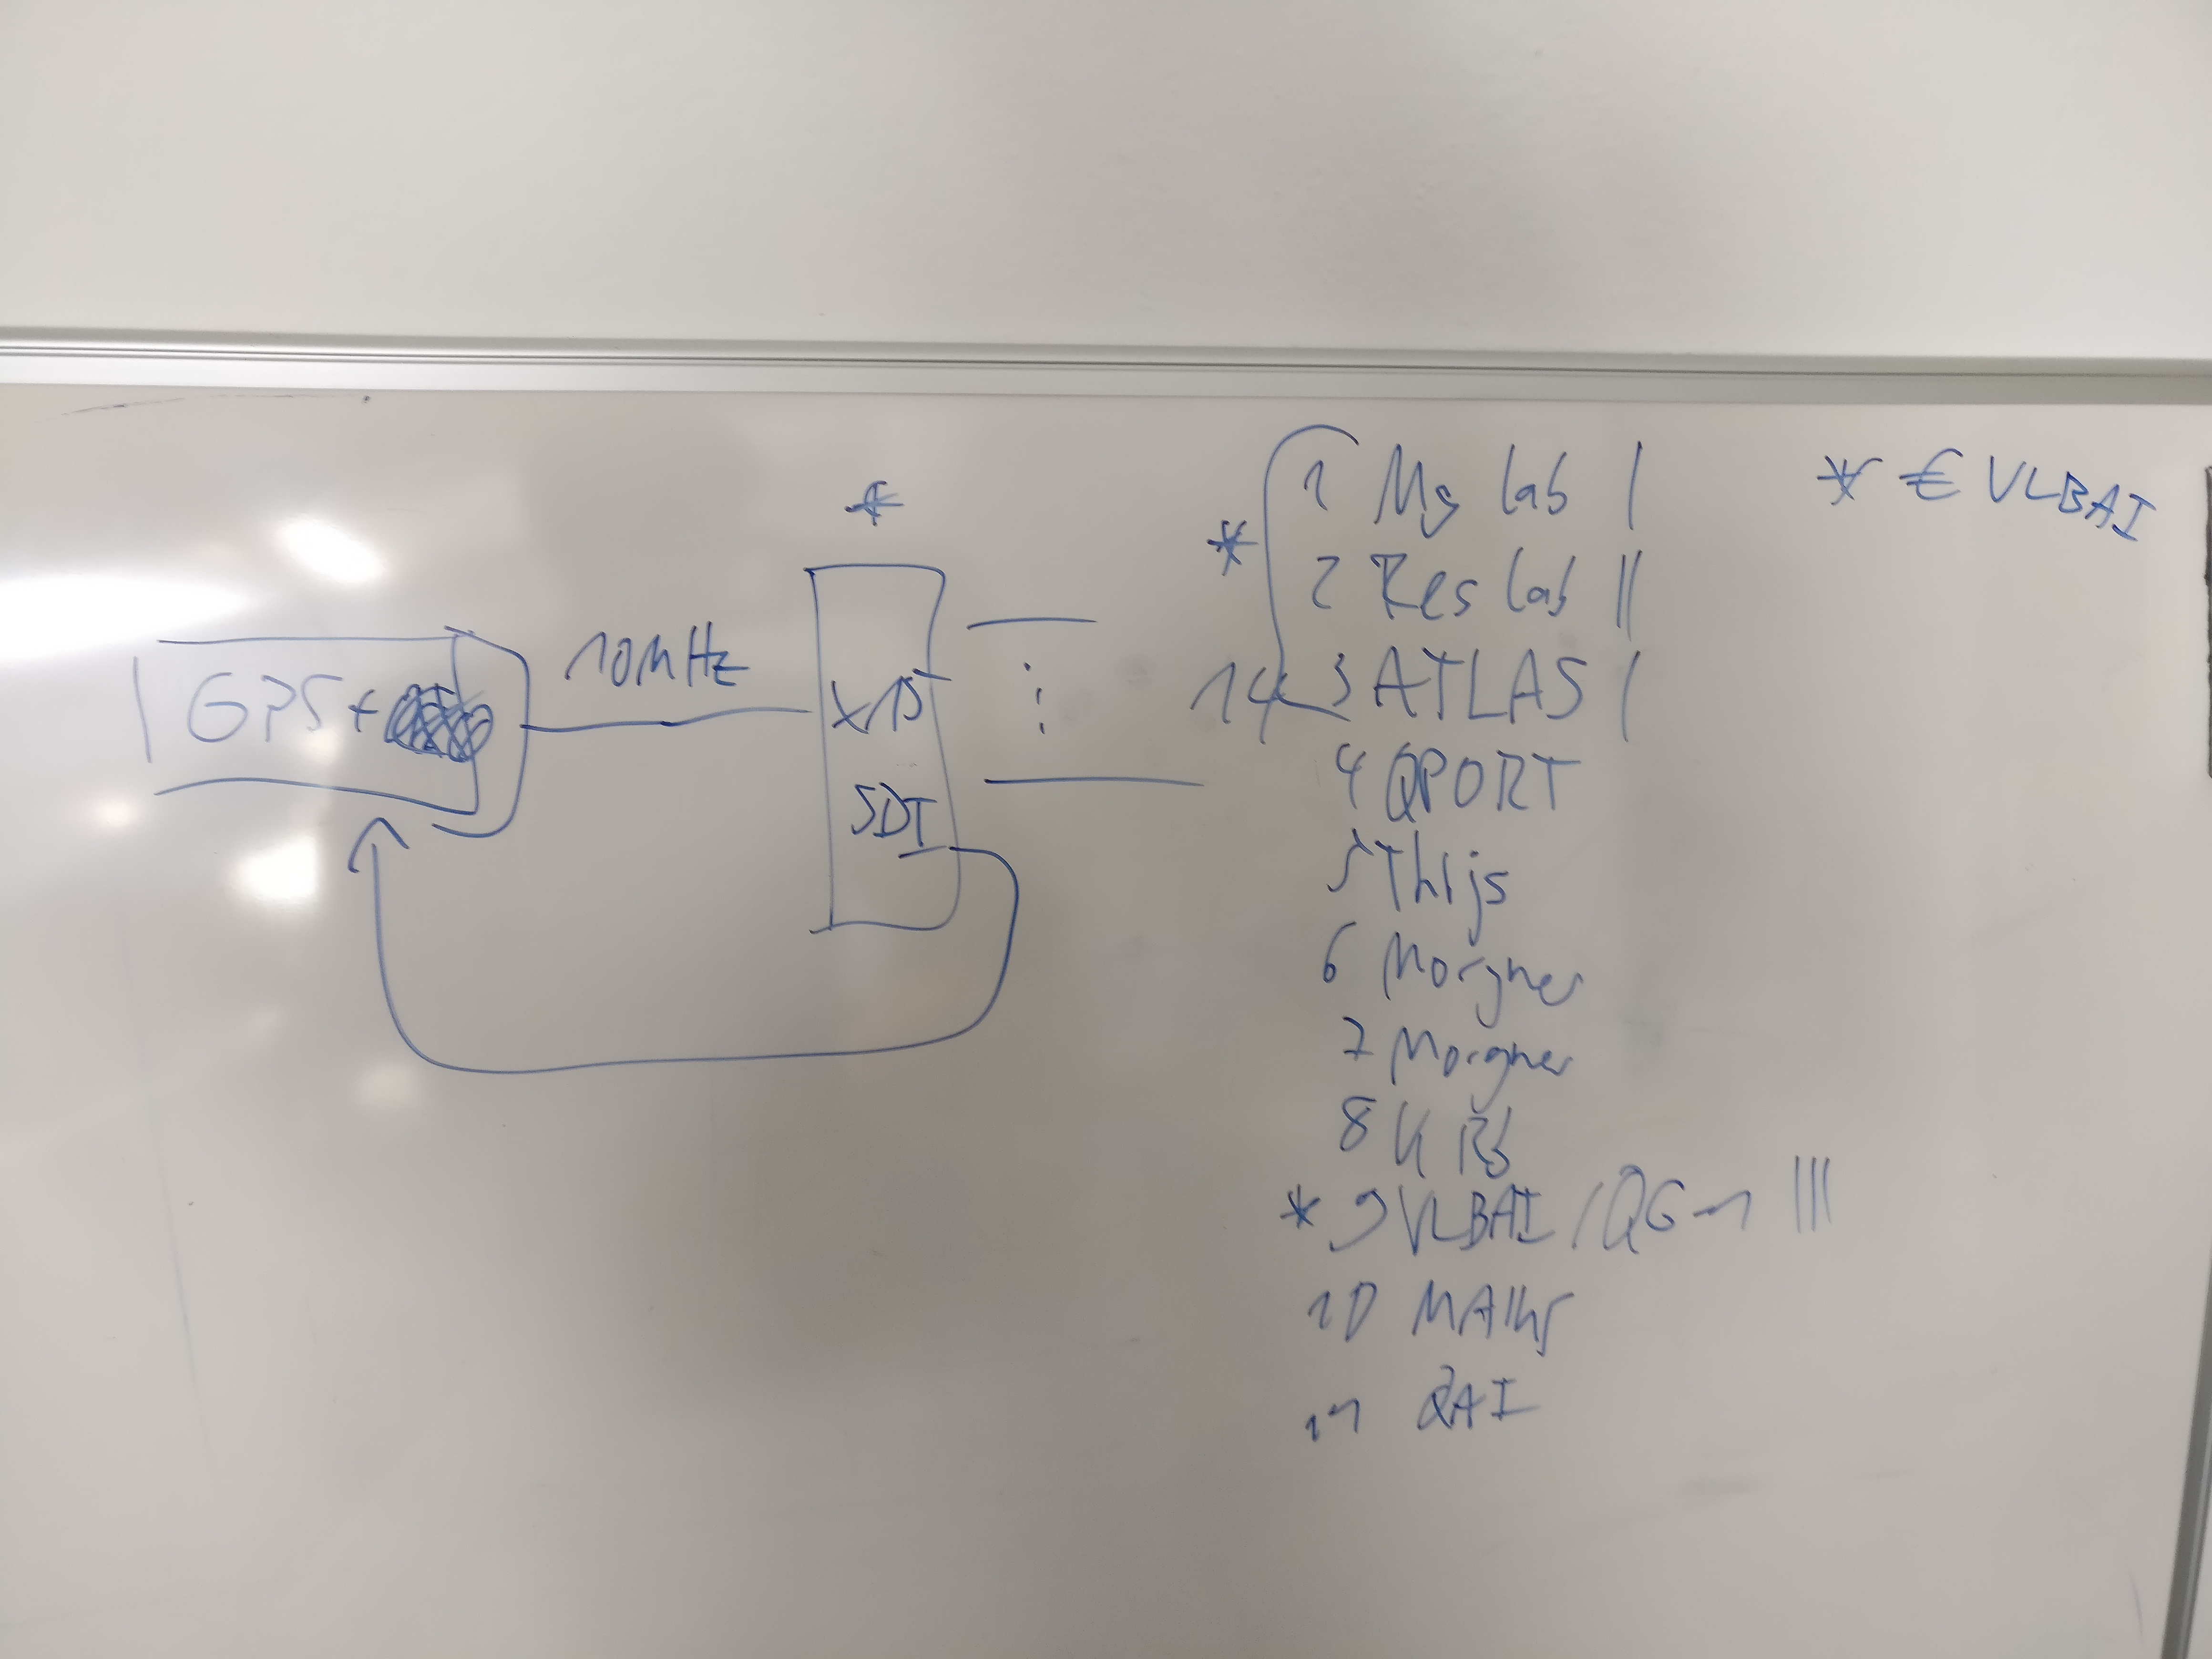
- Raumpläne IQO
- 10_MHz_Verlegung_IQ_08_2017
Experiment  Ansprechperson Experiment  Ansprechperson Kabelverlegeung | Raumnummer | Number of cables [new = , old = ]  Mean cable  Lab cable | Number of distributors (Number of outputs) | Cable length + “Lab cable Length” [m] | Holes [Number, size, place] | Notes
ResLab  S. Sauer  S. Sauer | D215 | 2 []  16 [] | 2 (16) | 1 (OXCO-Mean distributor)  + 1 (Mean distributor - Reslab distributor)  + 16*5 | 1, Ø=?, Reslab-Q-Port | -
Atom-Lab-Mg  S. Sauer  W. Friesen | D320 | 1 []  8 [] | 1 (16) | 25(Reslab - Mg-Lab)  + 10(Mg-Lab)  + 8*5 | 1, Ø=5-10cm, Q-Port-Atom-Lab-Mg | -
KRb  J. Peise  A. Igel | E311 | 1 + ? [] | 1 (16) | 25(Reslab - Mg-Lab)  + 20(Mg-Lab)  + 60(Mg-Lab-KRB) | - | * KRB_10MHz_Kabel_08_2017  * Die Durchführungen sind alle groß genug, nur auf höhe des Elektroniklabors liegen die Kabel in der Nähe von Heizungsrohren.  * Im Flur befindet sich ein offener Kabelkanal.
QAI,EPR  J. Peise  C. Pür | D313 → D315 | 1 + ? [] | 1 (16) | 25 (Reslab - Mg-Lab)  + 20(Mg-Lab)  + 25(Mg-Lab-QAI)  + 25(QAI-EPR) | - | -
ATLAS  H. Albers  H. Albers | D330 | 1 + ? [] | 1 (16) | 25(Reslab - Mg-Lab)  + 25(Mg-Lab)  + 50 (Mg-Lab-ATLAS)  + 5(ATLAS-Lab) | ?, Ø=10cm, ? | * ATLAS_10MHz_Habel_08_2017  * Gibt keine Information wie es über den Seminarraum verlegt ist  → Neue Löcher bohren oder zusätzlicher Durchgang zu VLBAI
VLBAI  E. Wodey  ? | D323 | 1 [] | 1 (16) | 25(Reslab - Mg-Lab)  + 25(Mg-Lab)  + 20 (Mg-Lab-VLBAI)  + 5 (VLBAI) | - | -
AG S.& C. Ospelkaus  Mirko Sierke  S. Grondwoski | E304A → E104A | 1 []  2 [] | 2 (min. 8) | 25(Reslab - Mg-Lab)  + 25 (Mg-Lab)  + 100 (Mg-Lab - E-Trakt = vorhanden!)  + E-Trakt | - | *AG_Ospelkaus_10MHz_Habel_08_2017  * Das vorhandene Kabel ist 100 Meter lang und hat bei 10 MHz eine Dämpfung von etwa 4,3 dB.  * Kabelnanfang im Mg-Labor ist mit “CW Tiemann” und das Ende im E-Trakt ist mit “MG ERT” beschriftet
Q-Port  S. Bode  ? |  | 1 [] | - | - | - | Vorhandene Kabel ist verlegt, muss noch getestet werden
Lasus  Thejs  ? | D220 | 1 [] | - | - | - | * Vorhandene Kabel ist verlegt, Aircell 7, muss noch getestet werden  * Sein vorhandener Verteiler ist ein SRS FS710
Maius  D. Becker |  | keine Antwort | keine Antwort | - | - | -
AG Morgner  B. Kreipe |  | 0 | 0 | - | - | -
Gesamt |  |  | 7 (16)  2 (min 8) | 587

To Do
1)
- “GPS →” Rb-10Mhz [right Output] → BNC cable → BNC-I-connector → BNC-SMA-connecotor → long cable → PNA
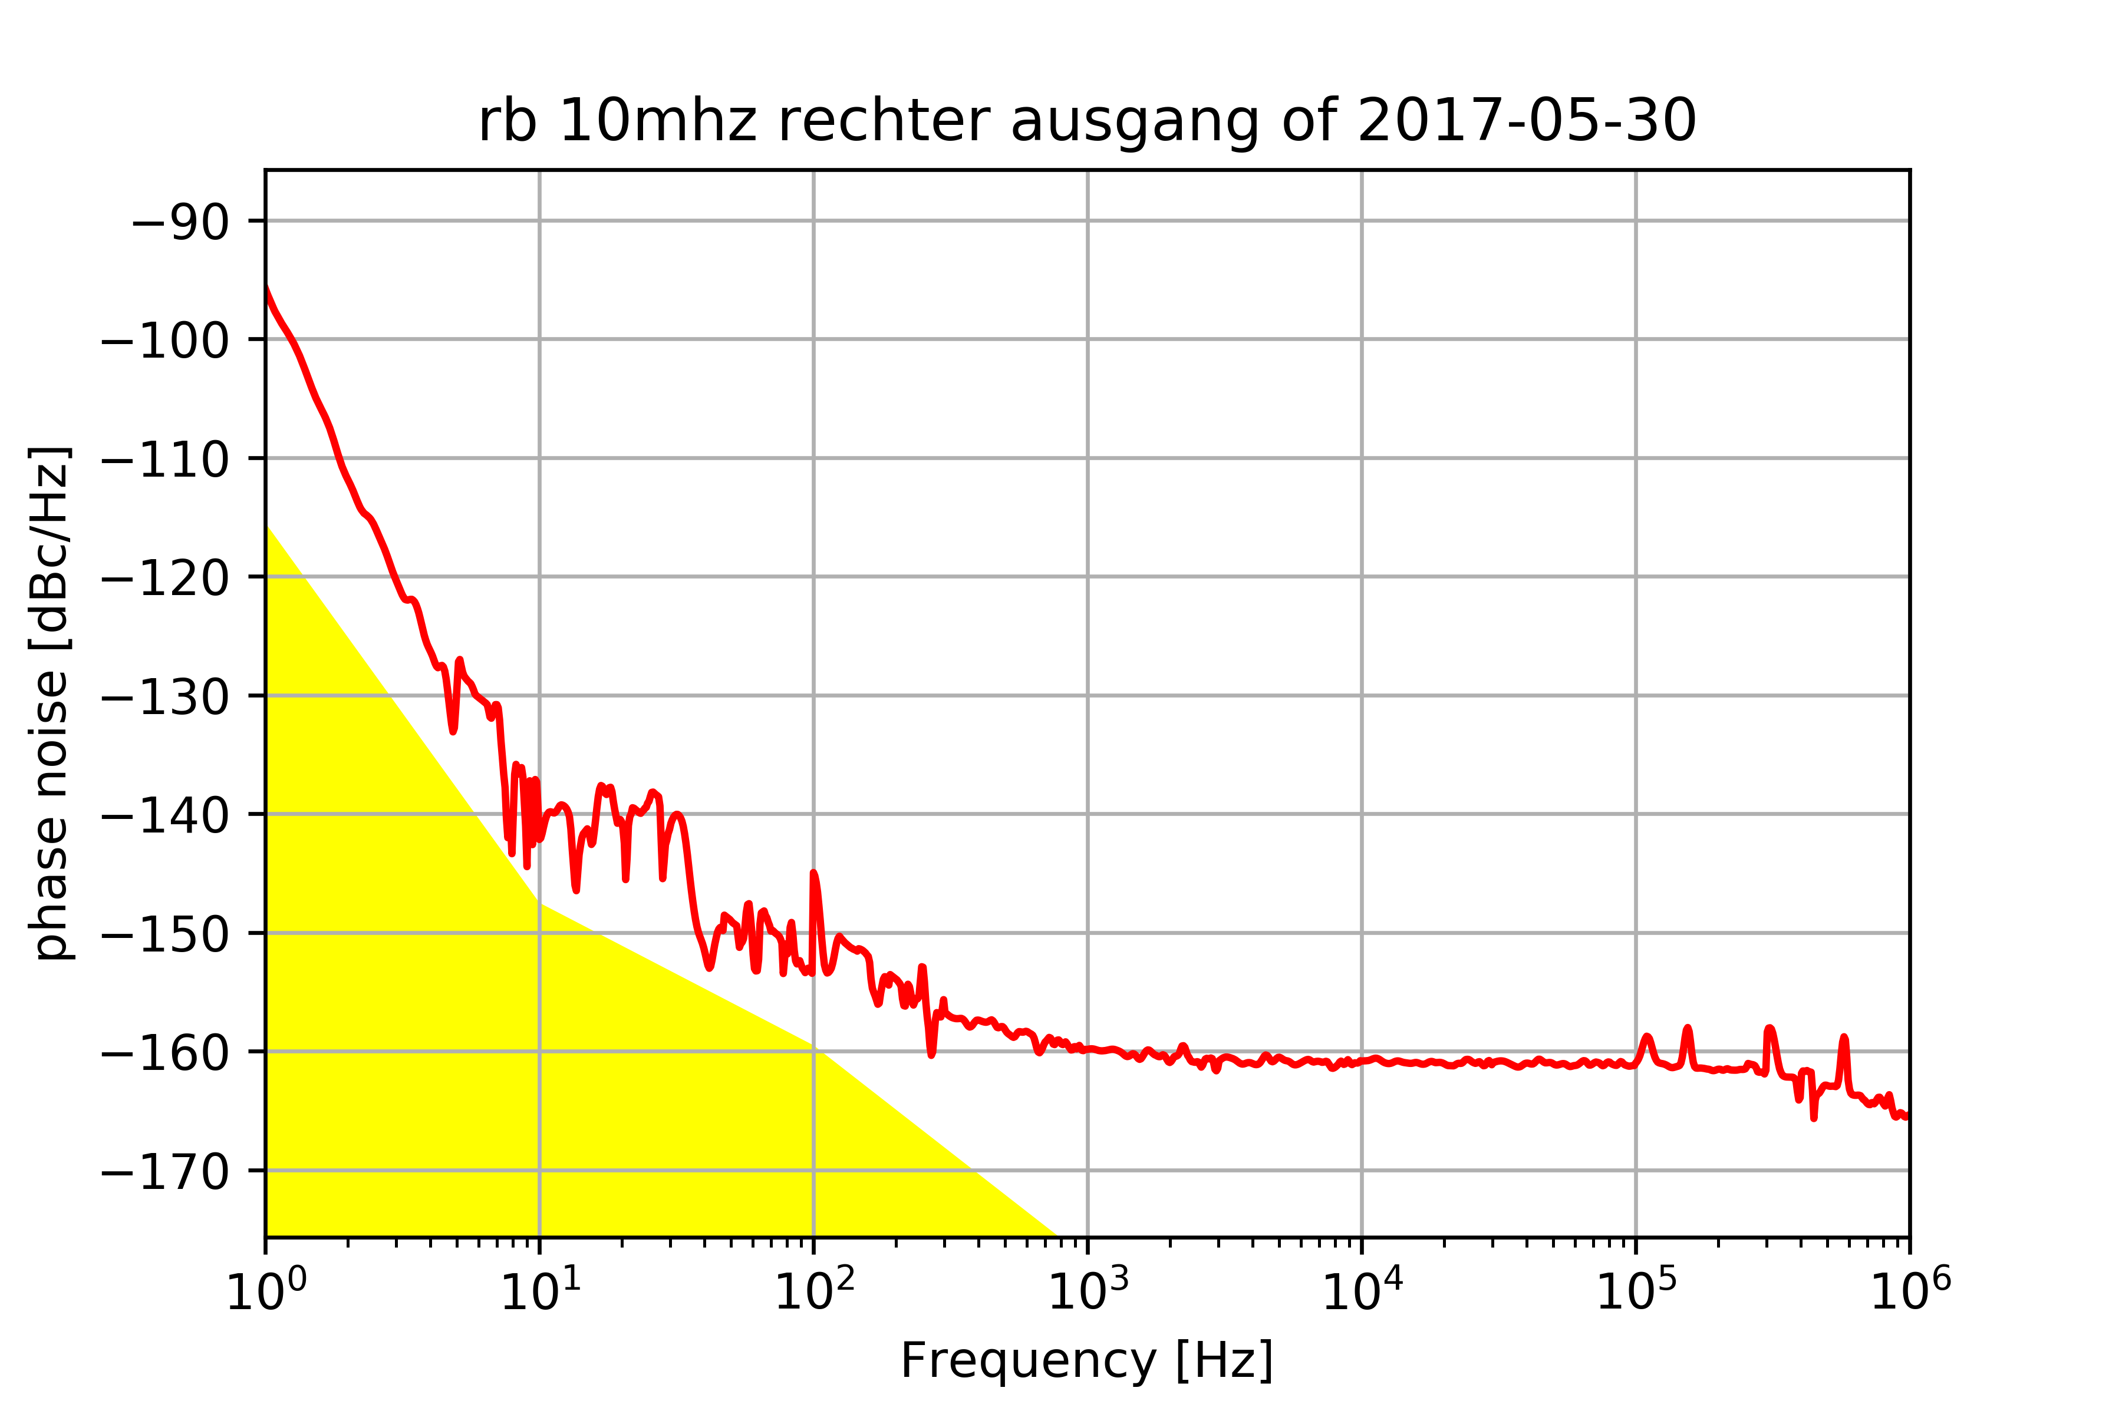
- Channel J1 and J2: OCXO → short cable → SMA-I-connector → long cable → PNA
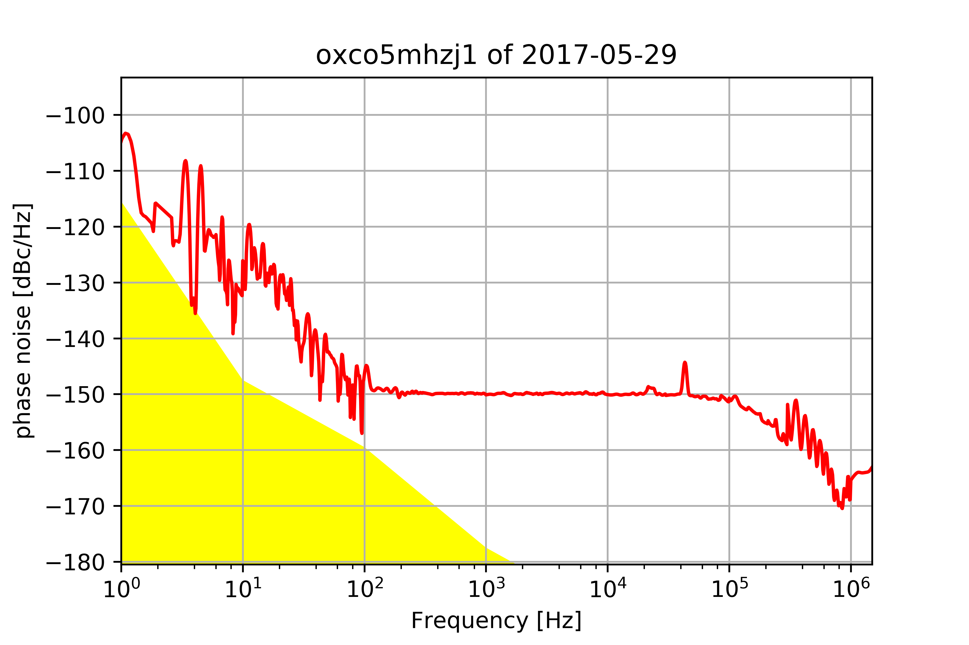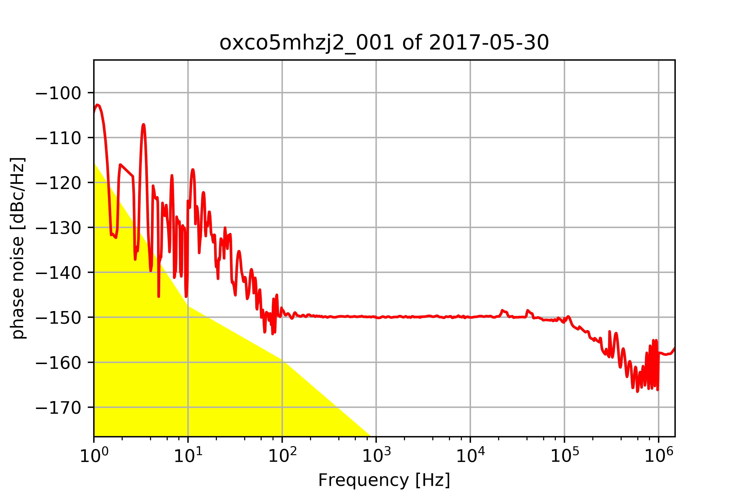
- J1 → short cable → SMA-BNC-connector → TP [6MHz] → long cable → PNA
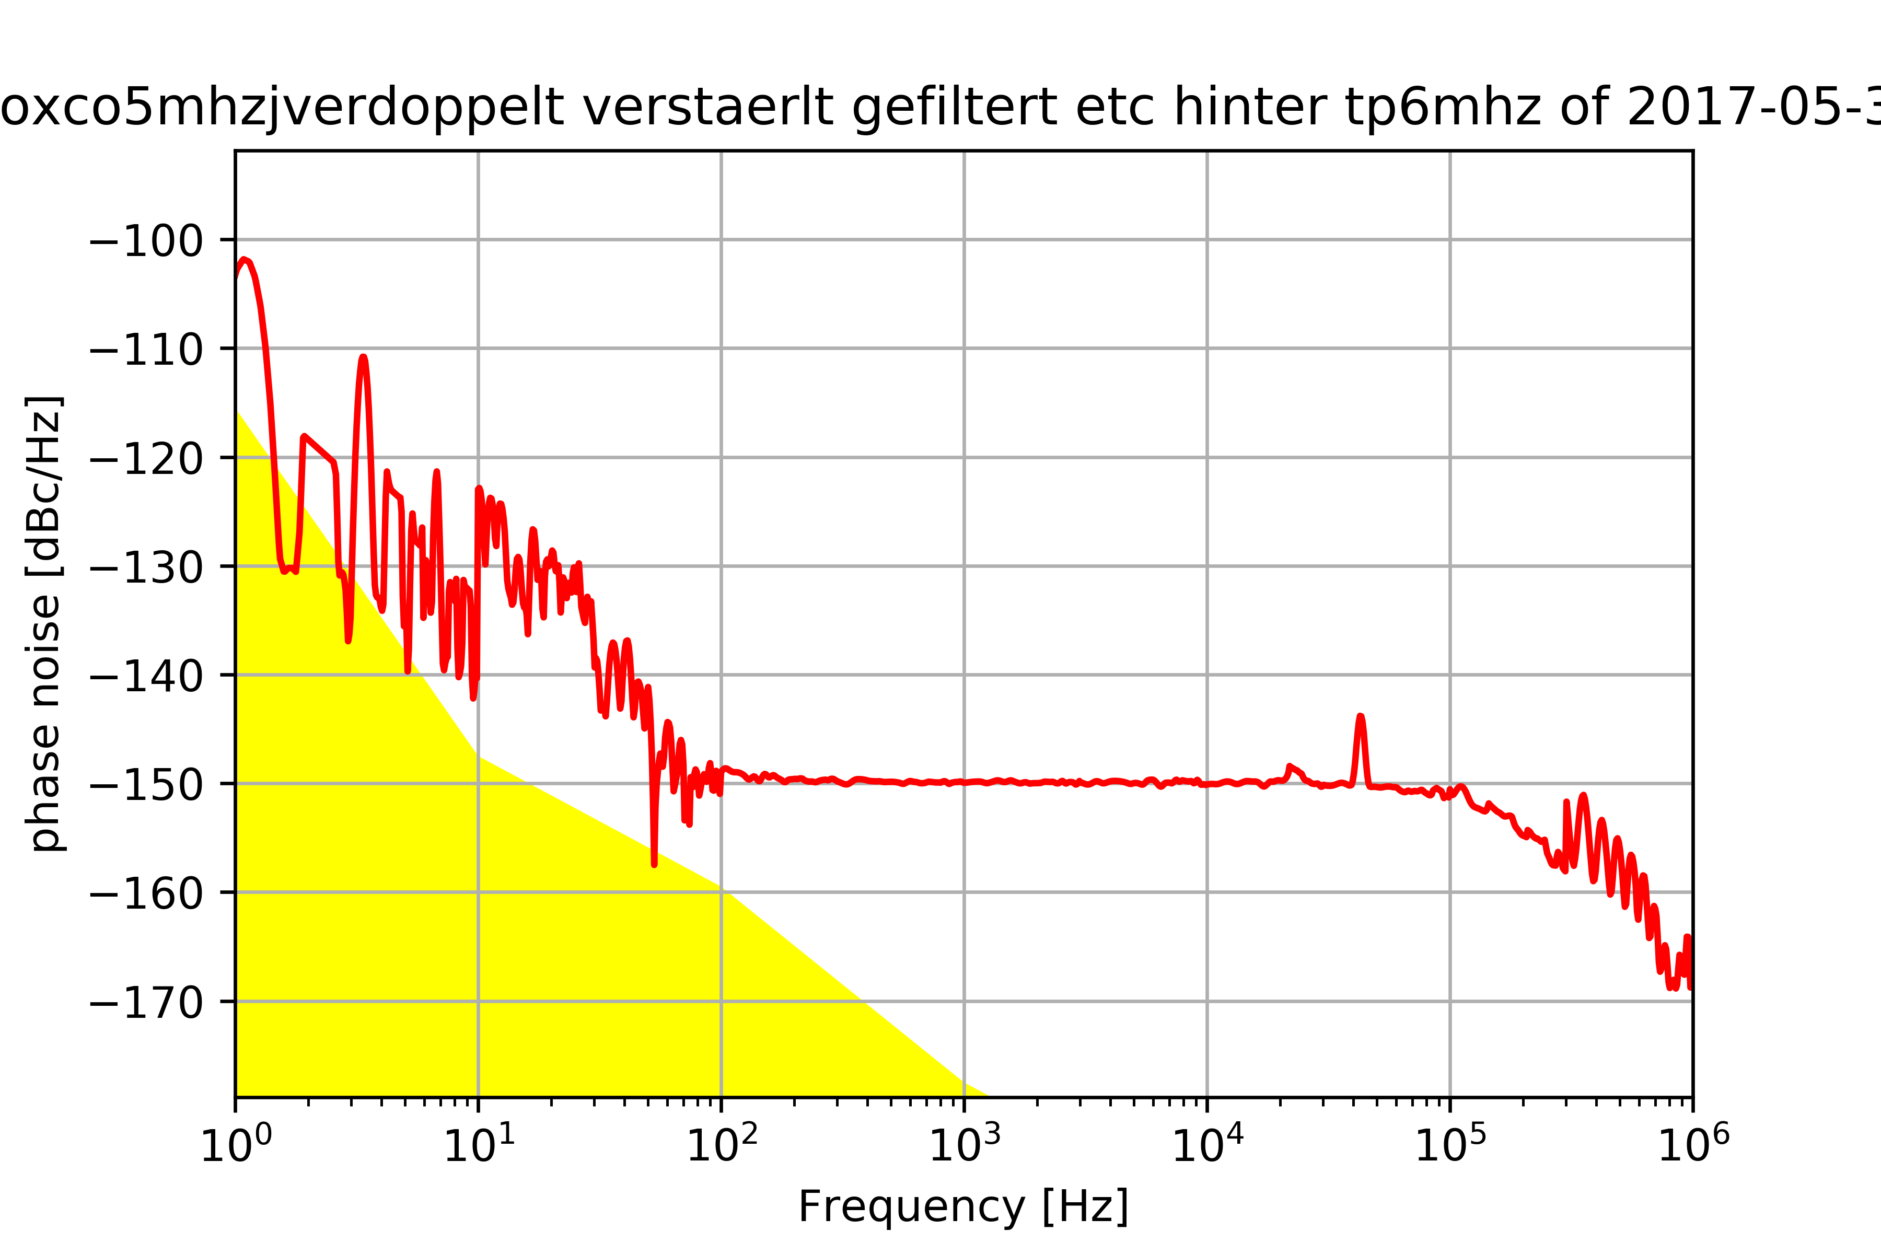
- J1 → short cable → SMA-BNC-connector → TP [6MHz] → Doubler [FD-2+] → BNC-SMA-connector → long cable → PNA
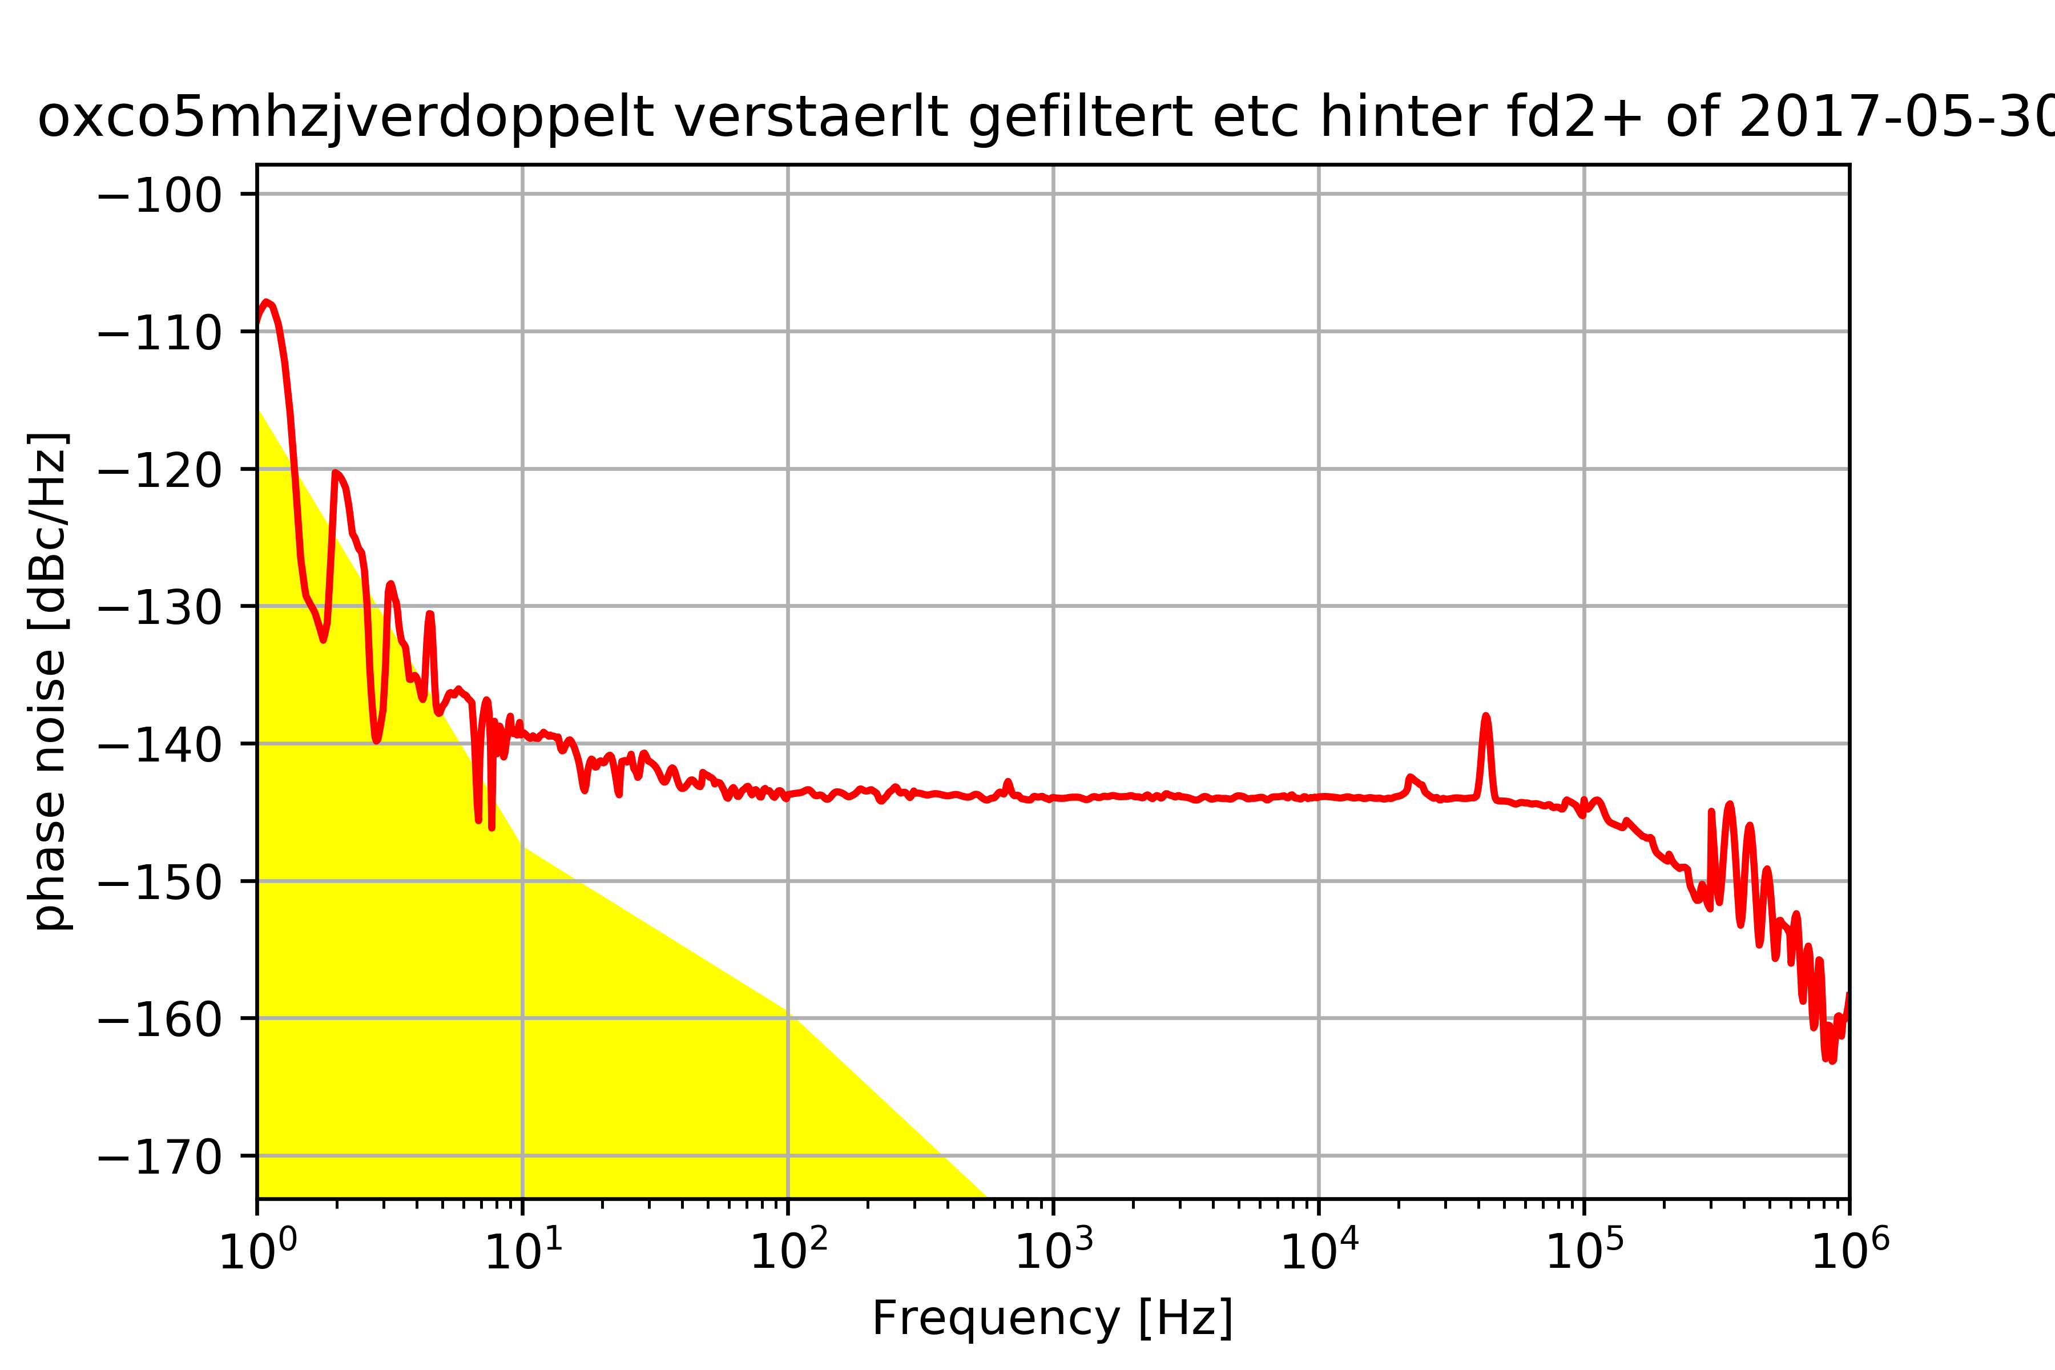
- J1 → short cable → SMA-BNC-connector → TP [6MHz] → Doubler [FD-2+] → BNC-SMA-connector → BP [SBP-10.7+] → long cable → PNA
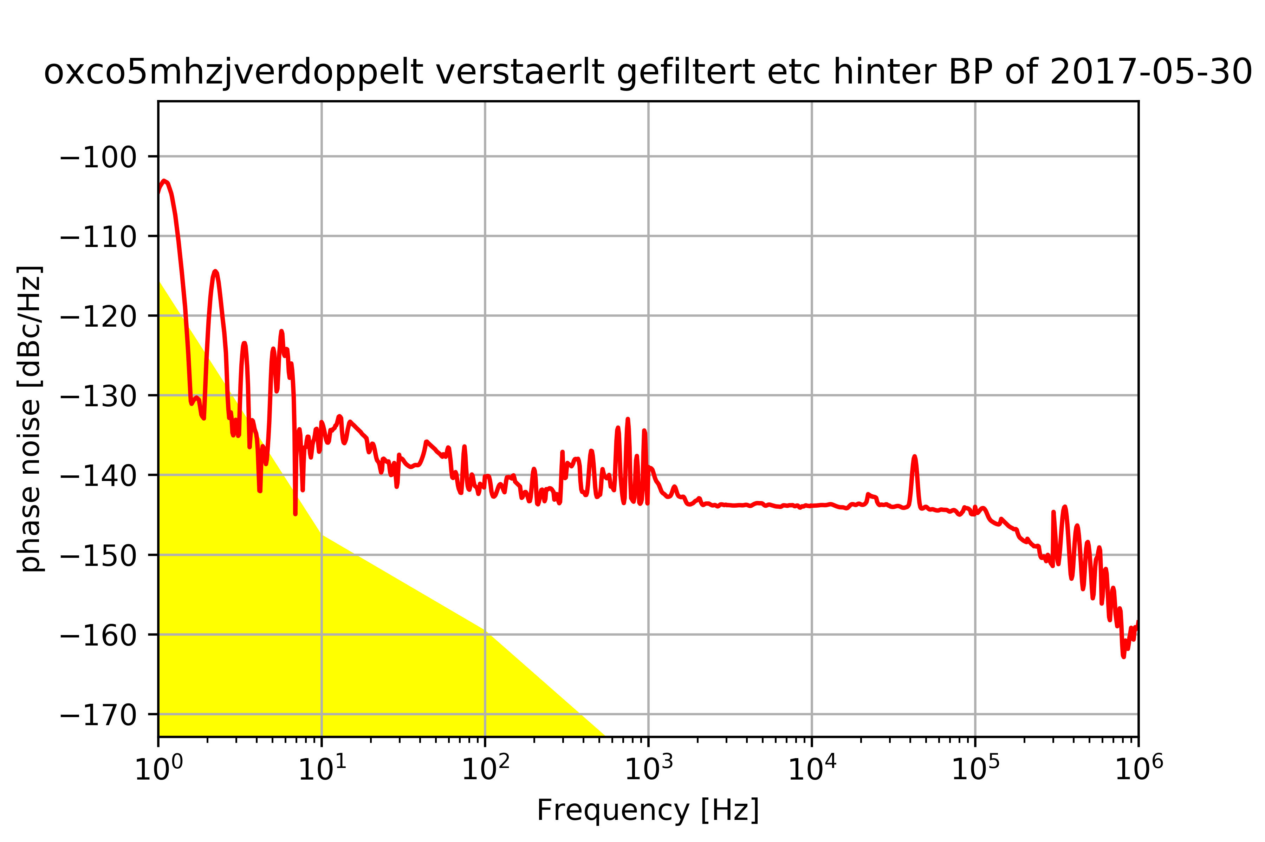
- J1 → short cable → SMA-BNC-connector → TP [6MHz] → Doubler [FD-2+] → BNC-SMA-connector → BP [SBP-10.7+] → BNC-SMA-connector → Att. [10dB] → BNC-SMA-connector → long cable → PNA
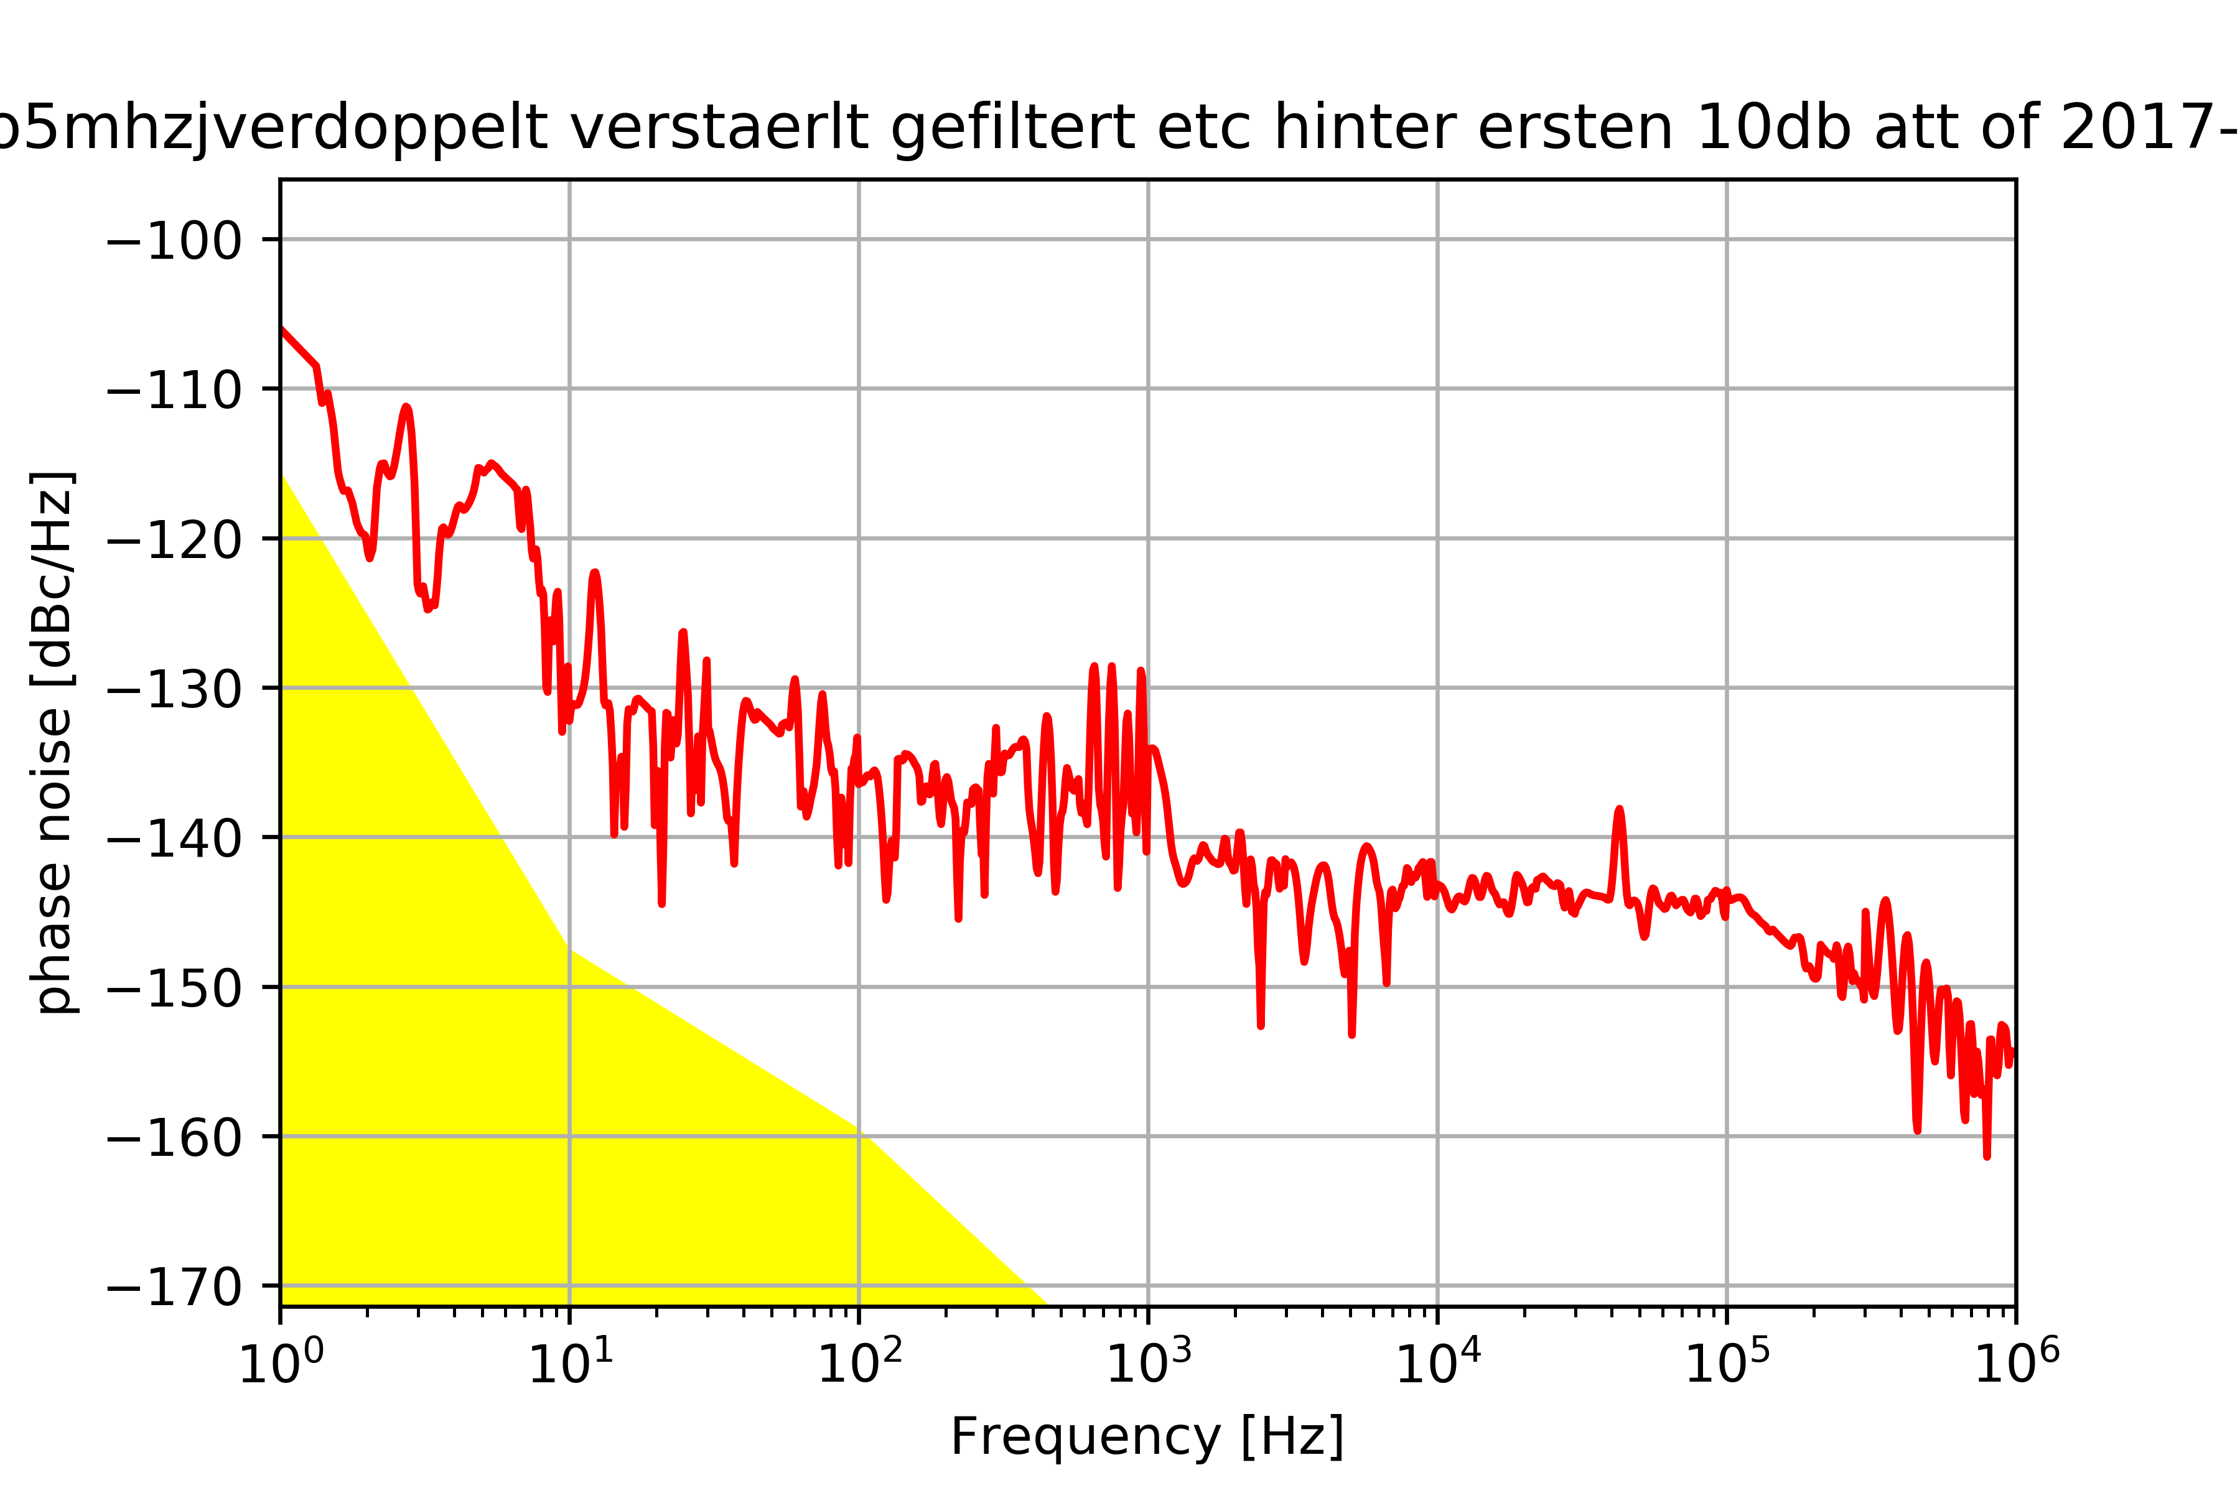
- Overall setup: J1 → short cable → SMA-BNC-connector → TP [6MHz] → Doubler [FD-2+] → BNC-SMA-connector → BP [SBP-10.7+] → BNC-SMA-connector → Att. [10dB] → short BNC-cable → Amplifier [ZFL-500LN-BNC+] → LP [BLP-15] → Att. [20dB] → Att. [3dB] → BNC-SMA-connector → long SMA cable → PNA
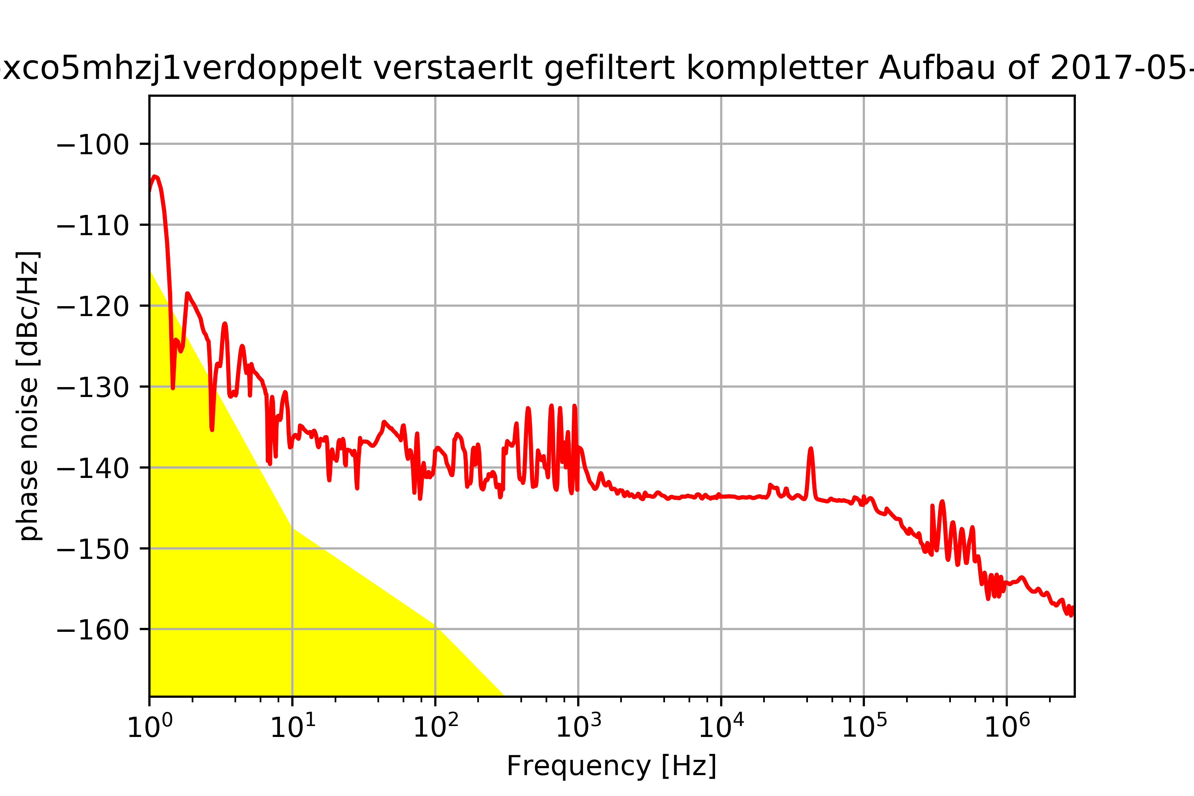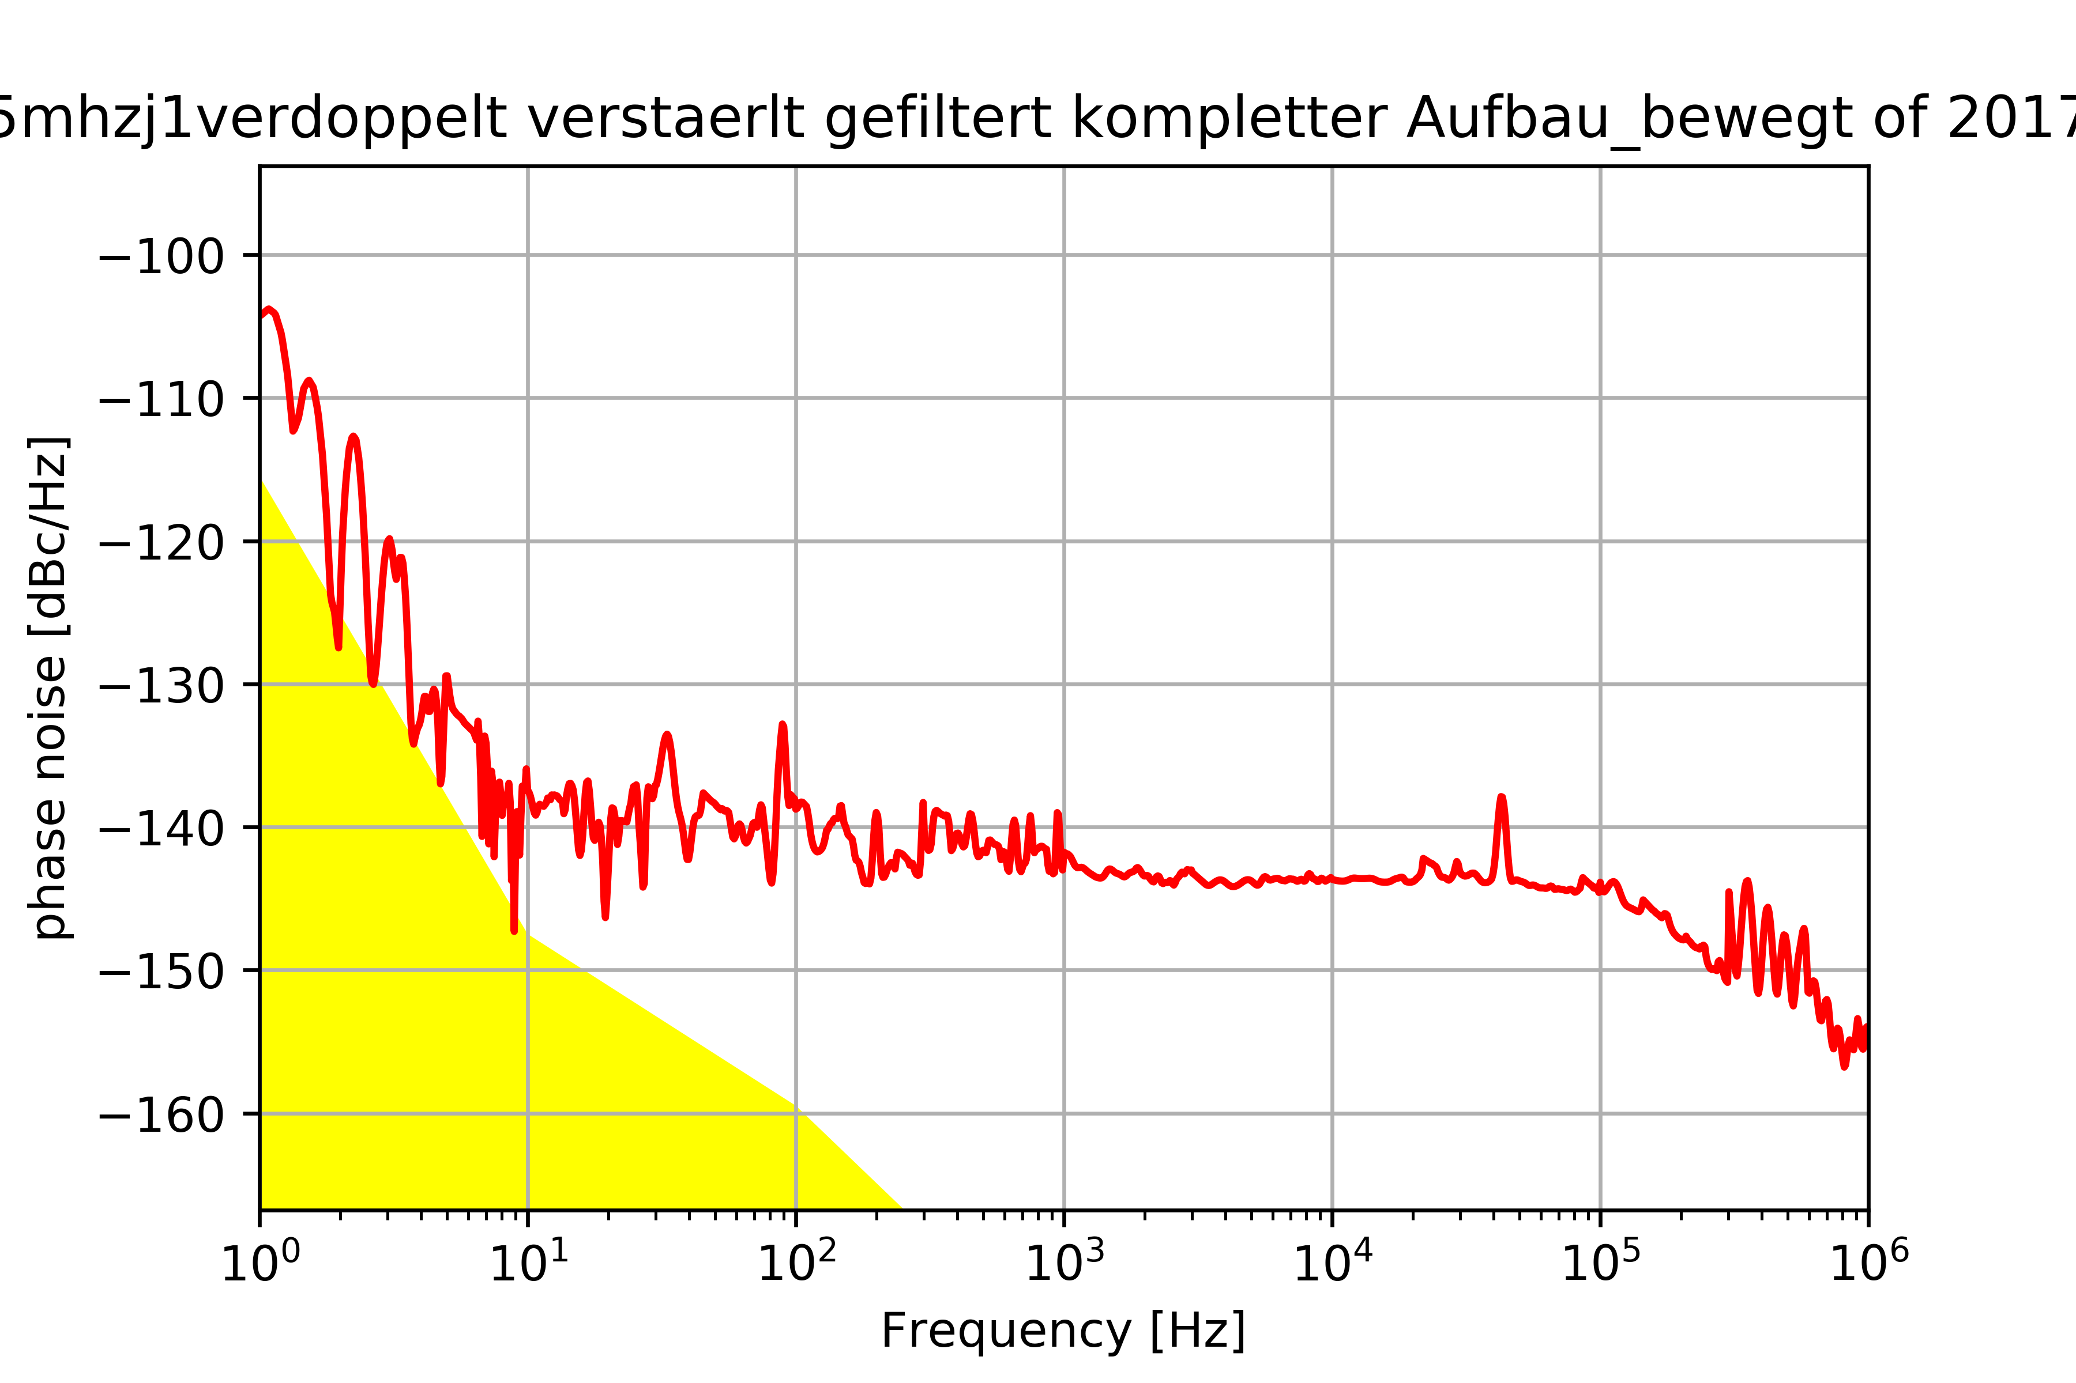
- Currently not possible.
2)
3)
4)
5)

Distibution
- Timetech distributor: Timetech distributor_datasheet
- Spectra dynamics distributor: HPDA-15RMi Datasheet_HPDA-15RMi
Feature | TimeTech | Spectra dynamics HPDA-15RMi
Phase Noise [dBc] | @ 10MHz  1Hz -148  10Hz -160  100Hz -165  1000Hz -166  10000Hz -166 | @ <hi #ed1c24>???</hi> MHz  1Hz -155 (max -150)  10Hz -165 (max-160)  1000Hz -170 (max 168)  10000Hz -171 (max -170)
Channel/Channel isolation [dB] | 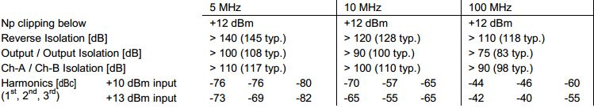- | Out-out: 130 (min 130)\\Out-in: 140 (min 145)
Groundloops | <hi #ed1c24>???</hi> | <hi #ed1c24>???</hi>
RF-Bandwidth [MHz] | 5 to 100 MHz  sine wave  useable from 100kHz to 200 MHz | +/- 1 dB  0.5-65 (min 1-50)
Input Level [dBm] | Input level working: +6 to +17 (+14 dBm @ 100 MHz)  Input level nominal: +13 | 1 dB compression  18 (min 17)  @ <hi #ed1c24>???</hi> MHz
Output Level [dBm] | <hi #ed1c24>???</hi> | +18  @ <hi #ed1c24>???</hi> MHz
Gain [dB] | Gain: 0 (+0.15/-0.1 dB, 1 – 100 MHz, +0.15 to –0.5 dB @ 200 MHz)  Gain variation: < 0.1, output vs. output | @5MHz  0.2 (max 0.5)
Impedance [Ω] | Input: 50, nominal  Output: 50, nominal | Input: 50  Output: 50
Return loss [dB] | Input: >45 @5MHz and 10 MHz, >30 @100 MHz  Output: >50 @5MHz and 10 MHz, >30 (typ –35) @ 100 MHz | Input(S11): -35 (max -30)  Output(S22): -35 (max -30)
Distortion [dBc] | <hi #ed1c24>???</hi> | +13 dBm: -48 (max -45)  +17 dBm: -42 (max -40)
Temp. Delay Coefficient | +15…+30°C  1K pp with maximum slopes 0.5K/h | 0-50°C  1.2 (max 1.5) [ps/ºC]
Connectors | only BNC <hi #ed1c24>???</hi> | SMA for input and output
Power connectors | Power Consumption (all outputs loaded):  AC: < 0.2 A Priority on AC supply input  DC: < 0.9 A, Stand-By: < 50 mA DC is used as back-up supply  Supply voltage AC: 100 to 240 V AC, 50/60 Hz, LED indicating AC voltage  Supply voltage DC: 18 to 36 V DC, DC isolated, LED indicating DC voltage  2 redundant DC power input connectors, automatic switchover | AC Operation: 100-240 VAC, 47-63Hz  DC Operation: 12-36 VDC-Available for some models
Number of Outputs | 16 or 15 | 5-15
Number of Inputs | 1 or 2 | 1-3
More | 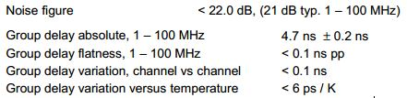 | -
6)
7)

Which cables?
- Best choise (cost-effectiveness) < 150 MHz: RG223 - DatasheetRG223 - conrad
- Aircell 5 for > 100 MHz, low attenuation for higher frequecies: Aircell 5 - Datasheet Aircell 5 - conrad
- For high frequencies <10 GHz: accuphasebrochure.pdf
- Testing cable:
  - Offenes Ende vermessen, dann sollte es Hochohmig sein
  - Auf einer Seite mit 50 Ohm verbinden und vermessen: 50 Ohm+Kabelwiderstand (<3-4 Ohm ist ok)
    - Wenn der Kabelwiderstand höher ist, dann wurden vermutlich beim Crimpen (Luft-)Übergangswiderstände erzeugt

Which connectors?
- BNC or SMA?
8)

OCXO
- Vibration isolation for the OXCO?
- Frequency double, how?

Filters
- 5MHz
- 10MHz

